- C++ Basic Input/Output
- Libraries
- iostream – used for I/O functions. It belongs to standard namespace. Use \n (faster) or endl (slower, flushes output buffer) to print on new lines
- math.h – used for math functions
- bits/stdc++.h – Includes almost all standard libraries, useful for CP not recommended for production (due to compile-time overhead)
- Data Types
It is a way for languages to understand what type of values a variable can hold, the operations to be performed and memory to be allocated.
In some languages data types need to be explicitly defined (Java & C++), while in others they are interpreted at run time (Python & JavaScript)
- C++
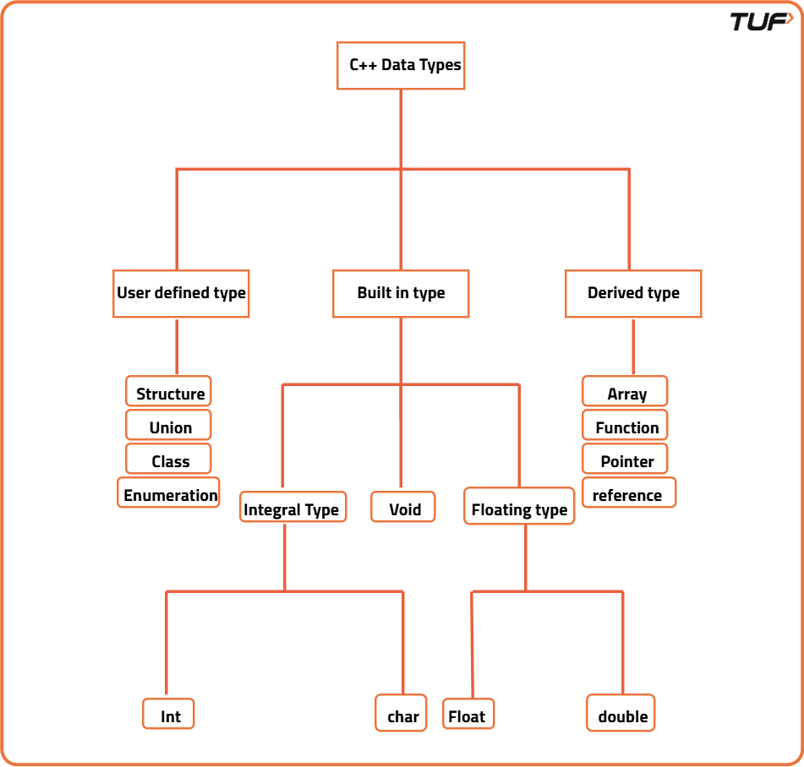

- Java
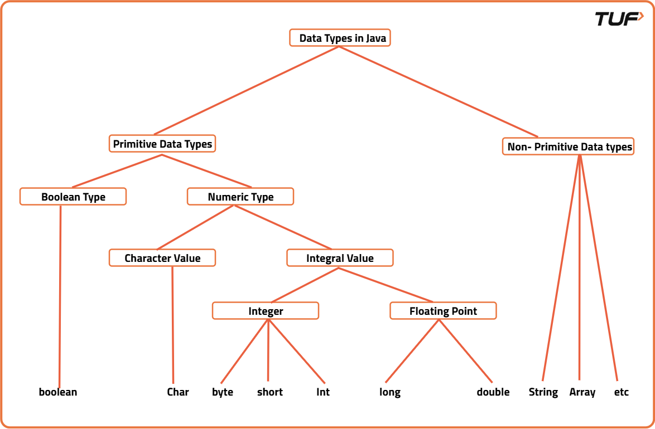
- Python
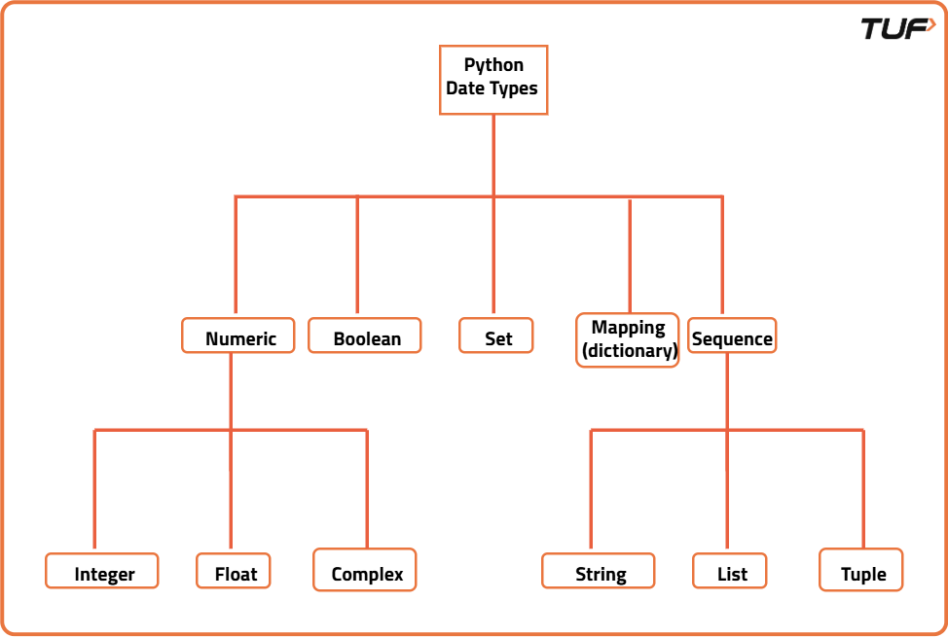

- JavaScript
typeof null returns "object"
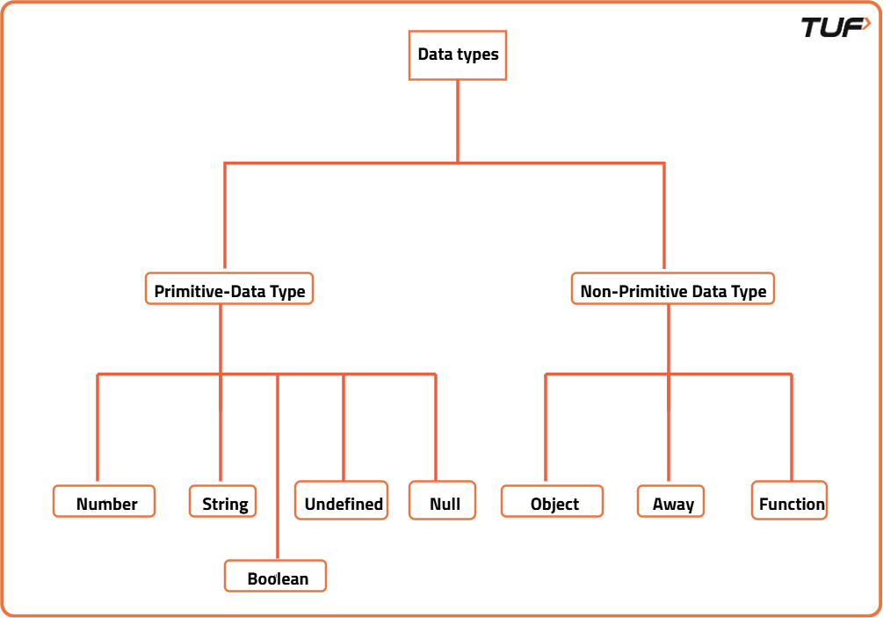

- Time Complexity
Rate at which time taken increases with respect to the input size is known as the Time Complexity

