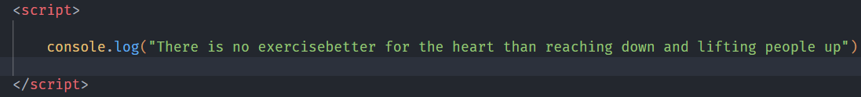**Q.1 Using console.log() print out the following statement: The quote 'There is no exercise better for the heart than reaching down and lifting people up.' by John Holmes teaches us to help one another. Using console.log() print out the following quote by Mother Teresa**

**Q.2 Check if typeof '10' is exactly equal to 10. If not make it exactly equal.**

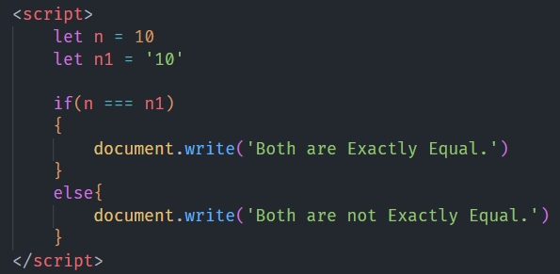

**3. Write a JavaScript Program to find the area of a triangle.**

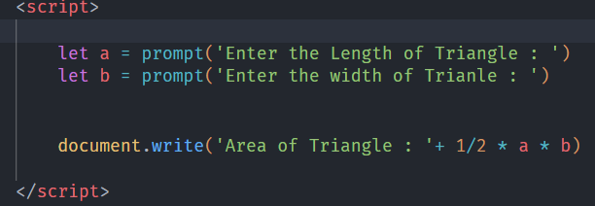

**4. Write a JavaScript program to calculate the days left until next Christmas.**

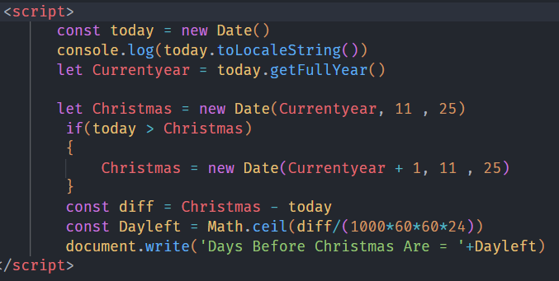

**5. What is a Conditional Statement?**

**Ans. :** A Condition Statement is a programming construct that allows you to control the execution flow in a program based on whether a specific condition or set of conditions is true or false. These statements evaluate a logical expression or condition and execute different blocks of code based on the result.

**6. Find the circumference of the Rectangle formula: C = 4 * a.**

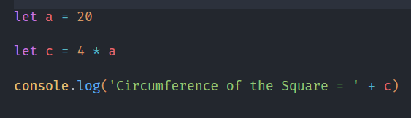

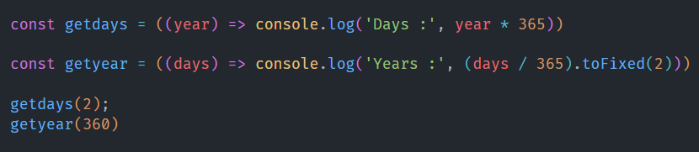**7. WAP to convert years into days and days into years?**

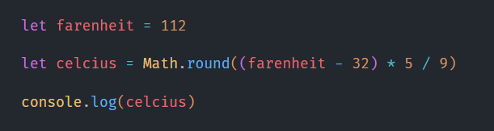**8. Convert temperature Fahrenheit to Celsius. (Conditional logic Question)**

**9. Write a JavaScript exercise to get the extension of a filename.?**

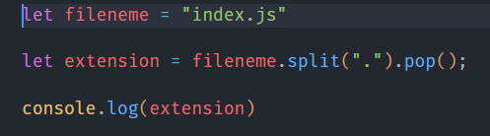

**10. What is the result of the expression (5 > 3 && 2 < 4)?**

**Ans.: True**

**11. What is the result of the expression (true && 1 && "hello")?**

**Ans.:** hello

**12. What results from the expression true && false || false && true?**

**Ans.:** False

**13. Check if the Number Is Positive or Negative in JavaScript.**

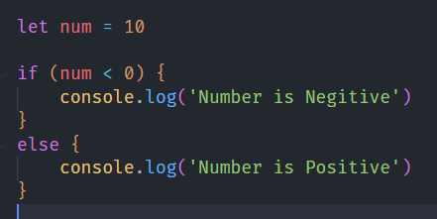

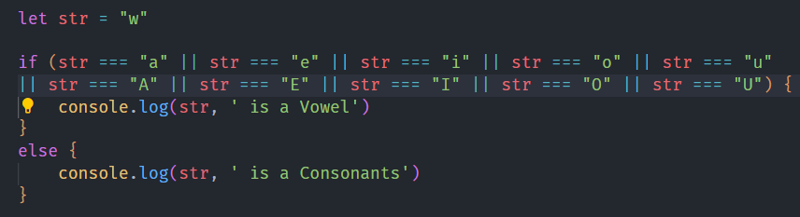**14. Find the Character Is Vowel or Not?**

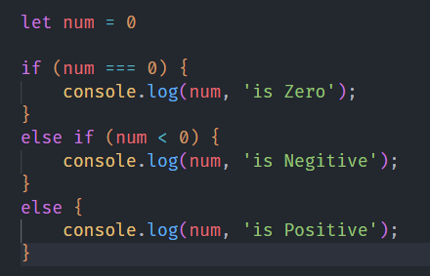**15. Write to check whether a number is negative, positive, or zero.**

**16. Write to find the number is even or odd using the ternary operator in JS.**

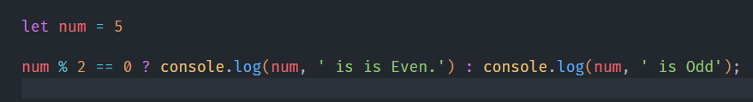

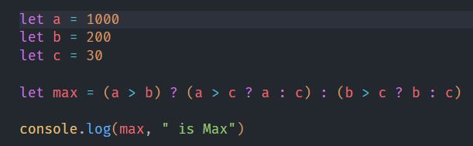**17. Write find maximum number among 3 numbers using ternary operator in JS.**

**18. Write to find the minimum number among 3 numbers using ternary operator in JS.**

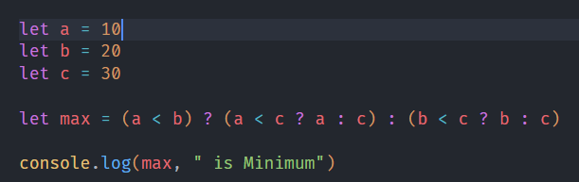

**19. Write to find the largest of three numbers in JS.**



**20. Write to show**

**i) Monday to Sunday using switch case in JS?**

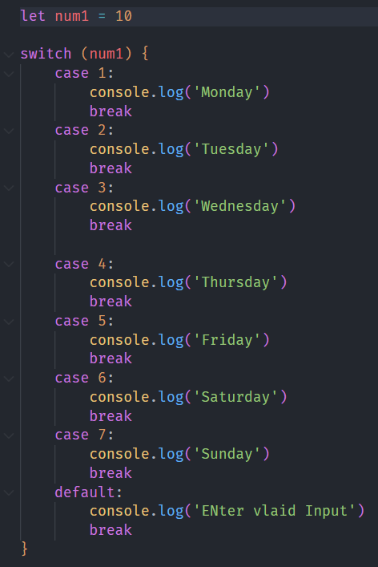

**ii)Vowel or Consonant using switch case in JS?**

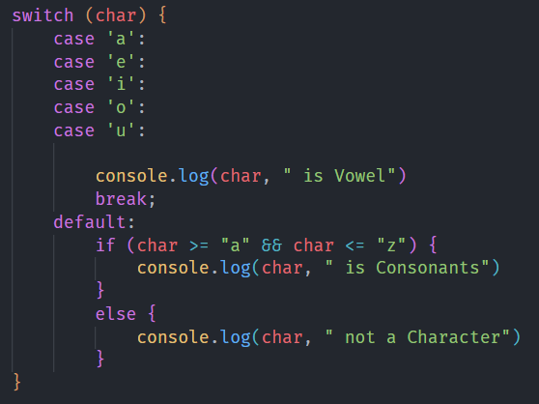

**21. What are the looping structures in JavaScript? Anyone Example?**

**Ans.:** JavaScript provides several looping structures that allow you to execute a code block multiple times.

**22. Write a print 972 to 897 using a for loop in JS.**

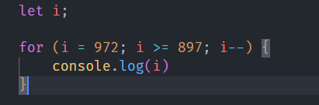

**23. Write and print the factorial of the given number.**

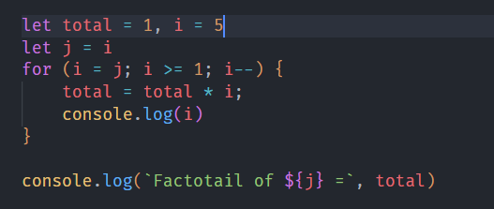

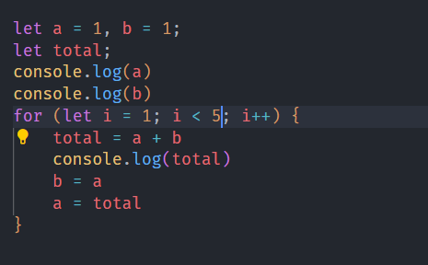**24. Write to print the Fibonacci series up to given numbers.**

**25. Write to print number in reverse order**

**e.g.: number = 64728 ---> reverse =82746 in JS?**

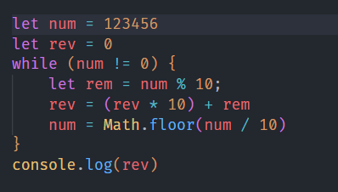

**23. Write to print the factorial of a given number.**

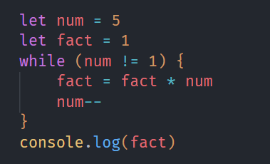

**24. Write to print the Fibonacci series up to given numbers.**

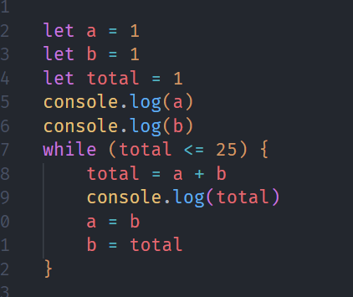

**25. Write to print number in reverse order e.g.: number = 64728 ---> reverse =82746 in JS?**



**26. Write a program make a summation of given number (E.g., 1523 Ans: - 11) in JS?**

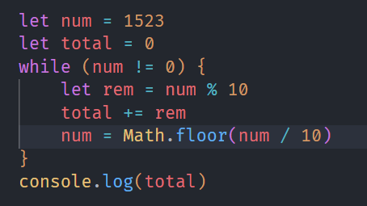

**27. Write a program you have to make a summation of first and last Digit. (E.g., 1234 Ans: - 5) in JS?**

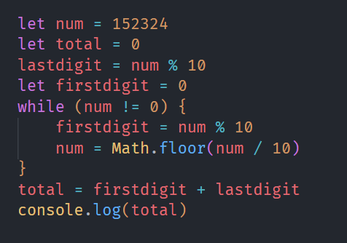

**28. Use console.log() and escape characters to print the following pattern in JS?**

**1 1 1 1 1**

**2 1 2 4 8**

**3 1 3 9 27**

**4 1 4 16 64**

**5 1 5 25 125**

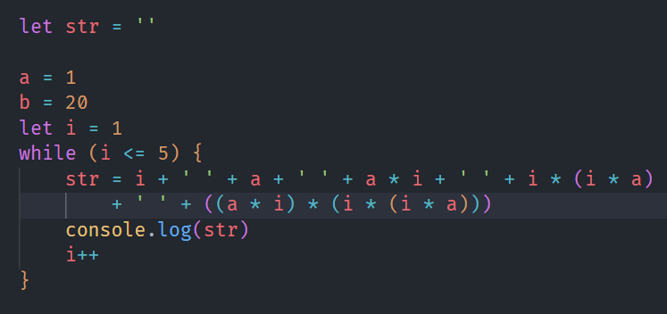

29. Use pattern in console.log in JS?

1) 1

1 0

1 0 1

1 0 1 0

1 0 1 0 1

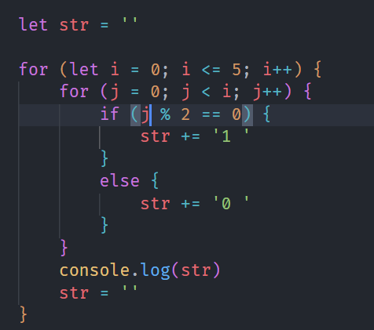

2) A

B C

D E F

G H I J

K L M N O

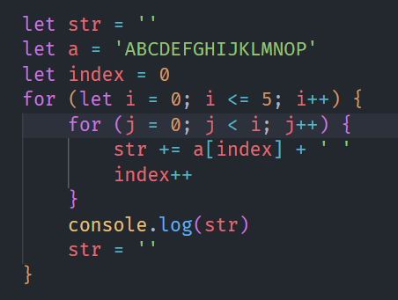

3) 1

2 3

4 5 6

7 8 9 10

11 12 13 14 15

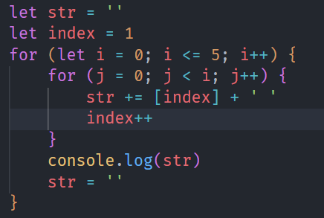

**Q.30 Accept 3 numbers from the user using the while loop and check each number palindrome**

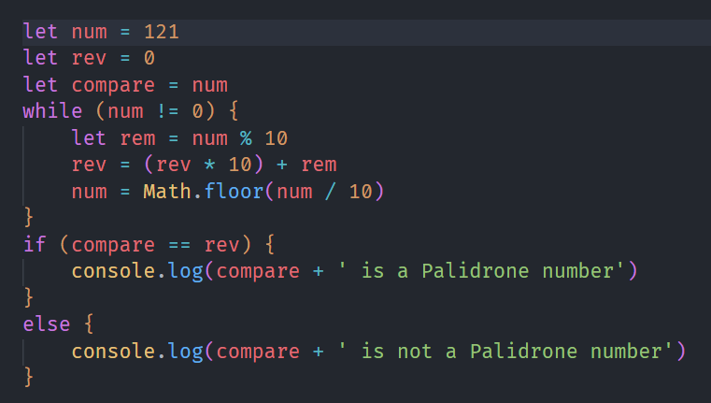

**Q.31 Write a JavaScript Program to display the current day and time in the following format. Sample Output: Today is Friday. Current Time is 12 PM: 12: 22: 2**

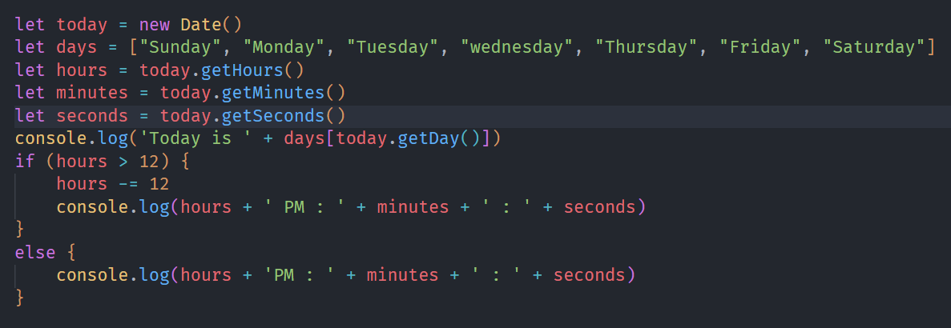

**32. Write a JavaScript program to get the current date**

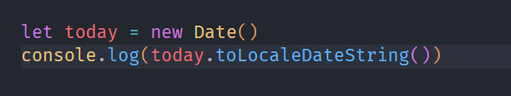

**34. Write a JavaScript program to convert an array of objects into CSV string?**

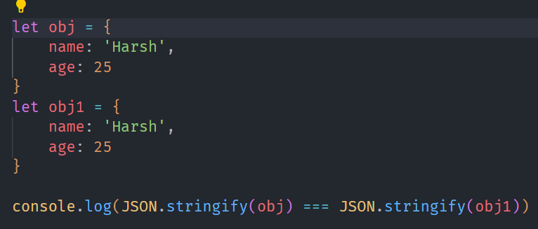

**35. Write a JavaScript program to capitalize the first letter of a string.**

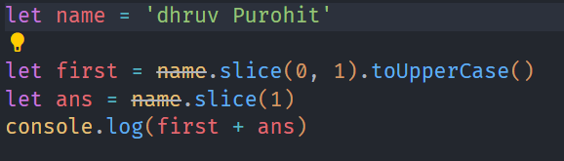

**45. Write a JavaScript program to determine if a variable is an array.**

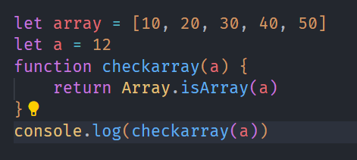

**46. Write a JavaScript program to clone an array?**

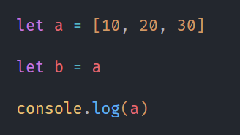

**47. What is the drawback of declaring methods directly in JavaScript objects?**

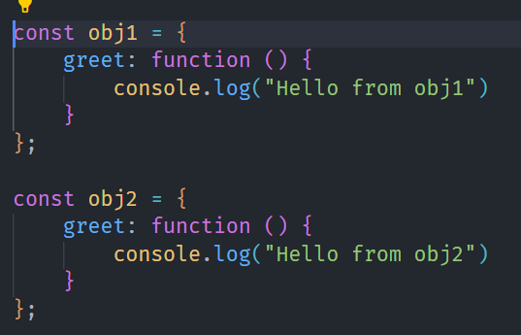

**48. Print the length of the string on the browser console using console.log()?**

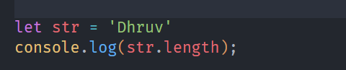

**49. Change all the string characters to capital letters using the to Upper Case method**

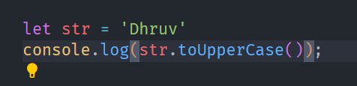

**50. What is the drawback of declaring methods directly in JavaScript objects**?

**Ans.**

1. **Repetitive Function Definitions** (Memory Usage)

2. **Performance Overhead**

3. **Difficult to Override/Extend**

4. **Potential for Method Duplication**

**51. Write a JavaScript program to get the current date. Expected Output : mm-dd- yyyy, or dd/mm/yyyy?**

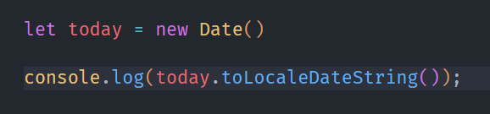

**52. Use indexOf to determine the position of the first occurrence of a in 30 Days Of JavaScript.**

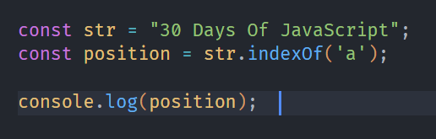

**53. Use lastIndexOf to determine the position of the last occurrence of a in 30 Days Of JavaScript**.

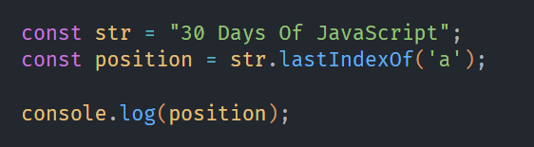

**54. Form Validation in JS?**

**Ans.** Form validation in Java Script ensures that user inputs meet the required conditions before submission, enhancing security and user experience. JavaScript provides various techniques for validating the form data, including checking if fields are empty, verifying Email formats, confirming password lengths, etc.

**55. Form in Email, number, Password, Validation?**

**Ans.** Form validation in JavaScript ensures user inputs are correct before submission. It checks fields like email, phone number, and password using regular expressions and length checks. If any input is invalid, the form submission is prevented with a false return.

**56. Dynamic Form Validation in JS?**

**Ans.** Dynamic form validation in JavaScript validates user input in real time using events like input or blur. It provides immediate feedback for fields like email, phone, and password. This improves user experience by checking data as it's entered.

**57. how many types of JS Events? How to use it?**

**Ans.** <button onclick="alert('button clicked')">click me</button>

**59. What is Bom vs Dom in JS?**

**Ans.** BOM vs DOM : Key Differences

|  |  |  |
| --- | --- | --- |
| **Aspect** | **DOM (Document Object Model)** | **BOM(Browser Object Model)** |
| Purpose | Represents the Documents  And content | Represents the Browser and it’s features. |
| Interaction | Allows manipulation of html and XML documents. | Allows insertion with browser window and properties. |
| Objects | Documents, Elements, text ,etc. | Window, Navigator, Location, etc. |
| Standardization | Standardized across all modern browsers. | Less standardized, with some validations between browsers |
| Focus | Focus on the control of the Web Pages | Focus on the enviroment in which webpages Delayed. |

**6`.Array vs Object difference in JS?**

**Ans.:**

* Array : An Array is an Ordered Collection of Elements, Where each elements can be accessed by it’s numeric index. Array is Typically used when the order of elements is Important or when you need to store a list of items example arr[1,2,3,4,5]
* Object : An object is a collection of key-value pairs each key is properties is a string or symbol the maps to value. Objects are typically used for sorting data with properties and mathods.obj={name:Dhruv , age:22}

**62. Split the string into an array using split() Method?**

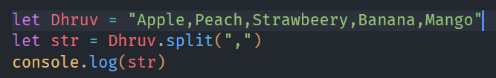

**63. Check if the string contains a word Script using includes() method?**

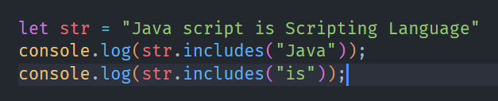

**64. Change all the string characters to lowercase letters using toLowerCase() Method**

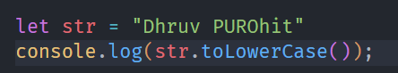

**65. What is Character at index 15 in ’30 Days of JavaScript’string? Use charAt() method**

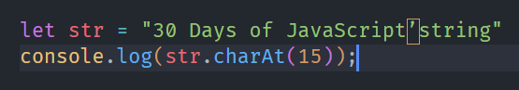

**66. copy to one string to another string in JS?**

