**Module 1**

**(Q.1) What is software? What is software engineering?**

* Software is a set of instructions, data, or programs used to operate computers and do specific tasks.
* Software engineering is the branch of computer science that deals with the design, development, testing, and maintenance of software applications. Software engineers apply engineering principles and knowledge of programming languages to build software solutions for end users.

**(Q.2) Explain types of software.**

* Application software
* System software
* Driver software
* Middleware software
* Programming software

**(Q.3) What is SDLC? Explain each phase of SDLC.**

* 1. **SDLC (Software Development Life Cycle) :**

The Software Development Life Cycle (SDLC) is a well-defined process that software development teams use to create high-quality software solutions. It involves several phases, including design, development, testing, and deployment. Let me give you a summary of each phase in SDLC:

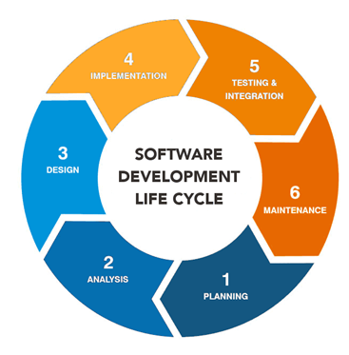

1. **System Planning :**

The first phase of the SDLC is the project planning stage where you are gathering business requirements from your client or stakeholders. This phase is when you evaluate the feasibility of creating the product, revenue potential, the cost of production, the needs of the end-users, etc.

To properly decide what to make, what not to make, and what to make first, you can use a feature prioritization framework that takes into account the value of the software/update, the cost, the time it takes to build, and other factors. Once it is decided that the software project is in line with business and stakeholder goals, feasible to create, and addresses user needs, then you can move on to the next phase.

1. **Requirements Gathering & Analysis :**

This phase is critical for converting the information gathered during the planning and analysis phase into clear requirements for the development team. This process guides the development of several important documents: a software requirement specification (SRS) or  Product specification, a Use Case document, and a Requirement Traceability Matrix document.

1. **System Design :**

The design phase is where you put pen to paper—so to speak. The original plan and vision are elaborated into a software design document (SDD) that includes the system design, programming language, templates, platform to use, and application security measures. This is also where you can flowchart how the software responds to user actions.

In most cases, the design phase will include the Development of a prototype model. Creating a pre-production version of the product can allow the team to visualize what the product will look like and make changes without having to go through the hassle of rewriting code.

1. **Coding & Implementation :**

The actual development phase is where the development team members divide the project into software modules and turn the software requirements into code that makes the product.

This SDLC phase can take quite a lot of time and [specialized development tools](https://theproductmanager.com/tools/product-development-software/). It’s important to have a set timeline and milestones so the software developers understand the expectations and you can keep track of the progress in this stage.

In some cases, the development stage can also merge with the testing stage where certain tests are run to ensure there are no critical bugs. Keep in mind, different [types of product development software](https://theproductmanager.com/topics/types-of-product-development-software-an-essential-guide/) will have different specialties so you’ll want to pick the one that suits you best.

1. **System Testing :**

Before getting the software product out the door to the production environment, it’s important to have your quality assurance team perform validation testing to make sure it is functioning properly and does what it’s meant to do. The testing process can also help hash out any major user experience issues and security issues.

In some cases, software testing can be done in a simulated environment. Other simpler tests can also be automated.

1. **Maintenance :**

Maintenance in the Software Development Life Cycle (SDLC) is a critical phase that occurs after the initial deployment of the software. This phase ensures that the software continues to operate correctly and efficiently after its release. It involves various activities to improve and update the software to meet new requirements, fix issues, and enhance performance.

**(Q.4)** **What is DFD? Create a DFD Diagram on Flipkart.**

A data flow diagram (DFD) is a graphical or visual representation using a standardized set of symbols and notations to describe a business's operations through data movement. They are often elements of a formal methodology such as the Structured Systems Analysis and Design Method (SSADM).

* + **DFD Diagram on Flipkart :**
  + **O Level DFD for Flipkart**

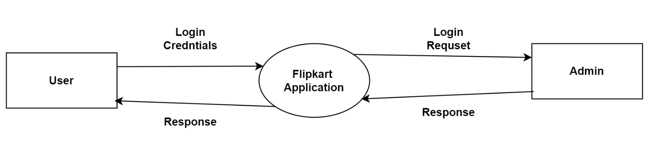

* + **1st Level DFD for Flipkart**

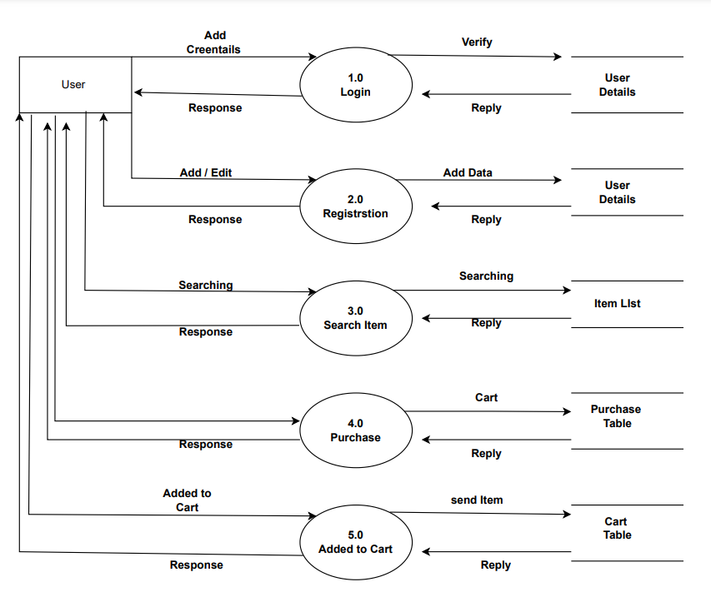

* + **2nd Level DFD for Flipkart**

**2.1 Login**

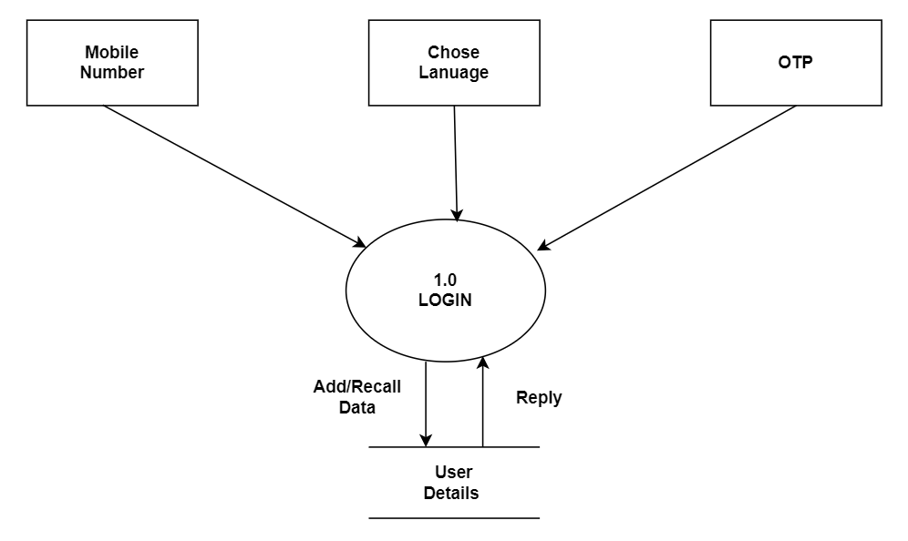

**2.2 Registration Process**

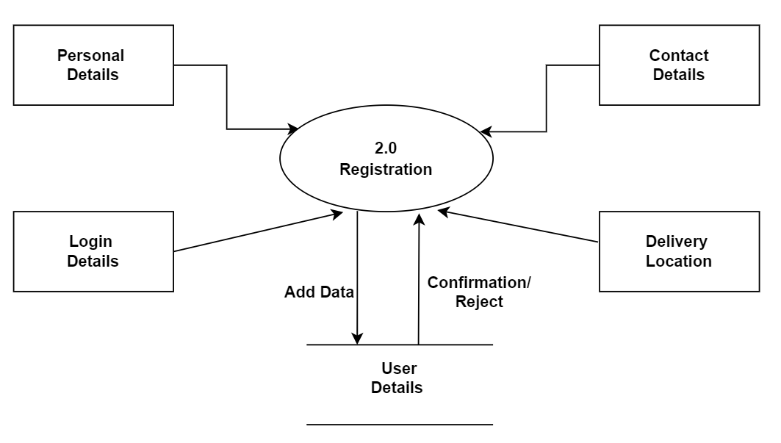

**2.3 Search Item**

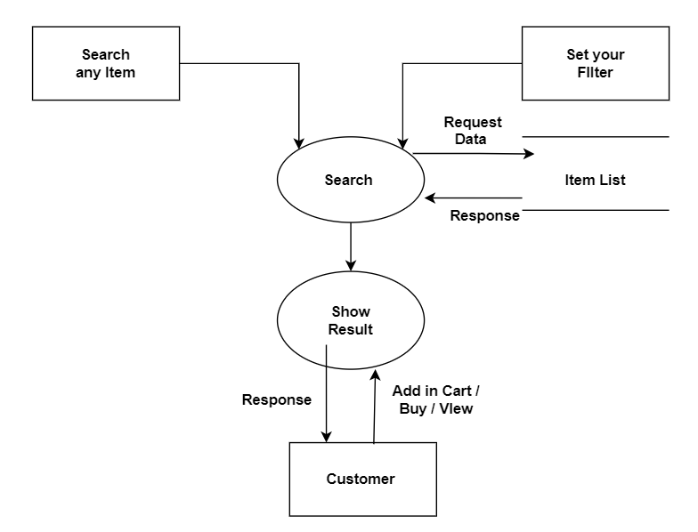

**(Q.5) What is a Flowchart?** **Create a flowchart to add two numbers.**

* **About Flowchart**

A flowchart is a picture of the separate steps of a process in sequential order. It is a generic tool that can be adapted for a wide variety of purposes, and can be used to describe various processes, such as a manufacturing process, an administrative or service process, or a project plan.

* 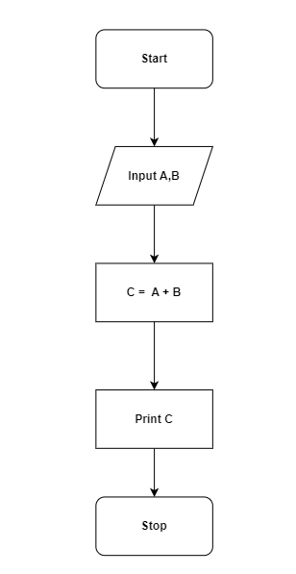 **A flowchart to add two numbers.**

**(Q-6) What is a Use case Diagram? Create a use case on bill payment on Paytm.**

In the Unified Modeling Language (UML), a use case diagram can summarize the details of your system's users (also known as actors) and their interactions with the system. You'll use a set of specialized symbols and connectors to build one.

* **A use-case on bill payment on Paytm.**

