**Report**

**On**

**Make your shop online, Website**

**Under the Guidance of**

**Akash Technolab**

**Student Name Faculty Mentor**

Dhruv Acharya(190163107001) Prof.Minal Chauhan

**Submitted to**

**Department of Computer Engineering& Information Technology**

**Government Engineering College, Modasa**



**Year:2021**



**CERTIFICATE**

This is to certify that **Dhruv Acharya (190163107001),** of COMPUTER ENGINEERING, has successfully completed the Summer Internship(3170001) during 26th May 2021 to 9th June 2021.

Signature of Faculty Mentor Signatureof Head of Department

**Prof. Minal Chauhan Prof. M. B. Chaudhari**

**ACKNOWLEDGEMENT**

This is to place on record our appreciation and deep gratitude to the persons without whose support this project would never be seen the light of the day. We express sincere thanks to **Prof. M. B. Chaudhari** Head of the Department, in Computer Engineering, GEC Modasa for extending his help.

I have immense pleasure in expressing thanks and a deep sense of gratitude to My Faculty **Prof.Minal Chauhan** of Computer Engineering, GEC Modasa for his valuable suggestion and guidance throughout this summer internship program.

Apart from the college support, I would also like to appreciate the effort of Akash Technolabs’s CEO **Akash Padhiyar** sir. Thank you so much for your assistance and help with the project during the internship.

Finally, at the outset, I would like to thank all those who have directly or indirectly helped us to accomplish this summer internship successfully.

Signature of Student

**Dhruv Acharya**

**(190163107001)**

**DECLARATION**

I, hereby declare that the project/work submission is my own work and that, to the best of my knowledge and belief, it contains no code/material previously published or written by another person as a part of the completion of the Summer Internship.

**Place: Government Engineering College, Modasa**

**Date: 16th JUNE 2021**

Signature of the Student

**Dhruv Acharya**

**190163107001**

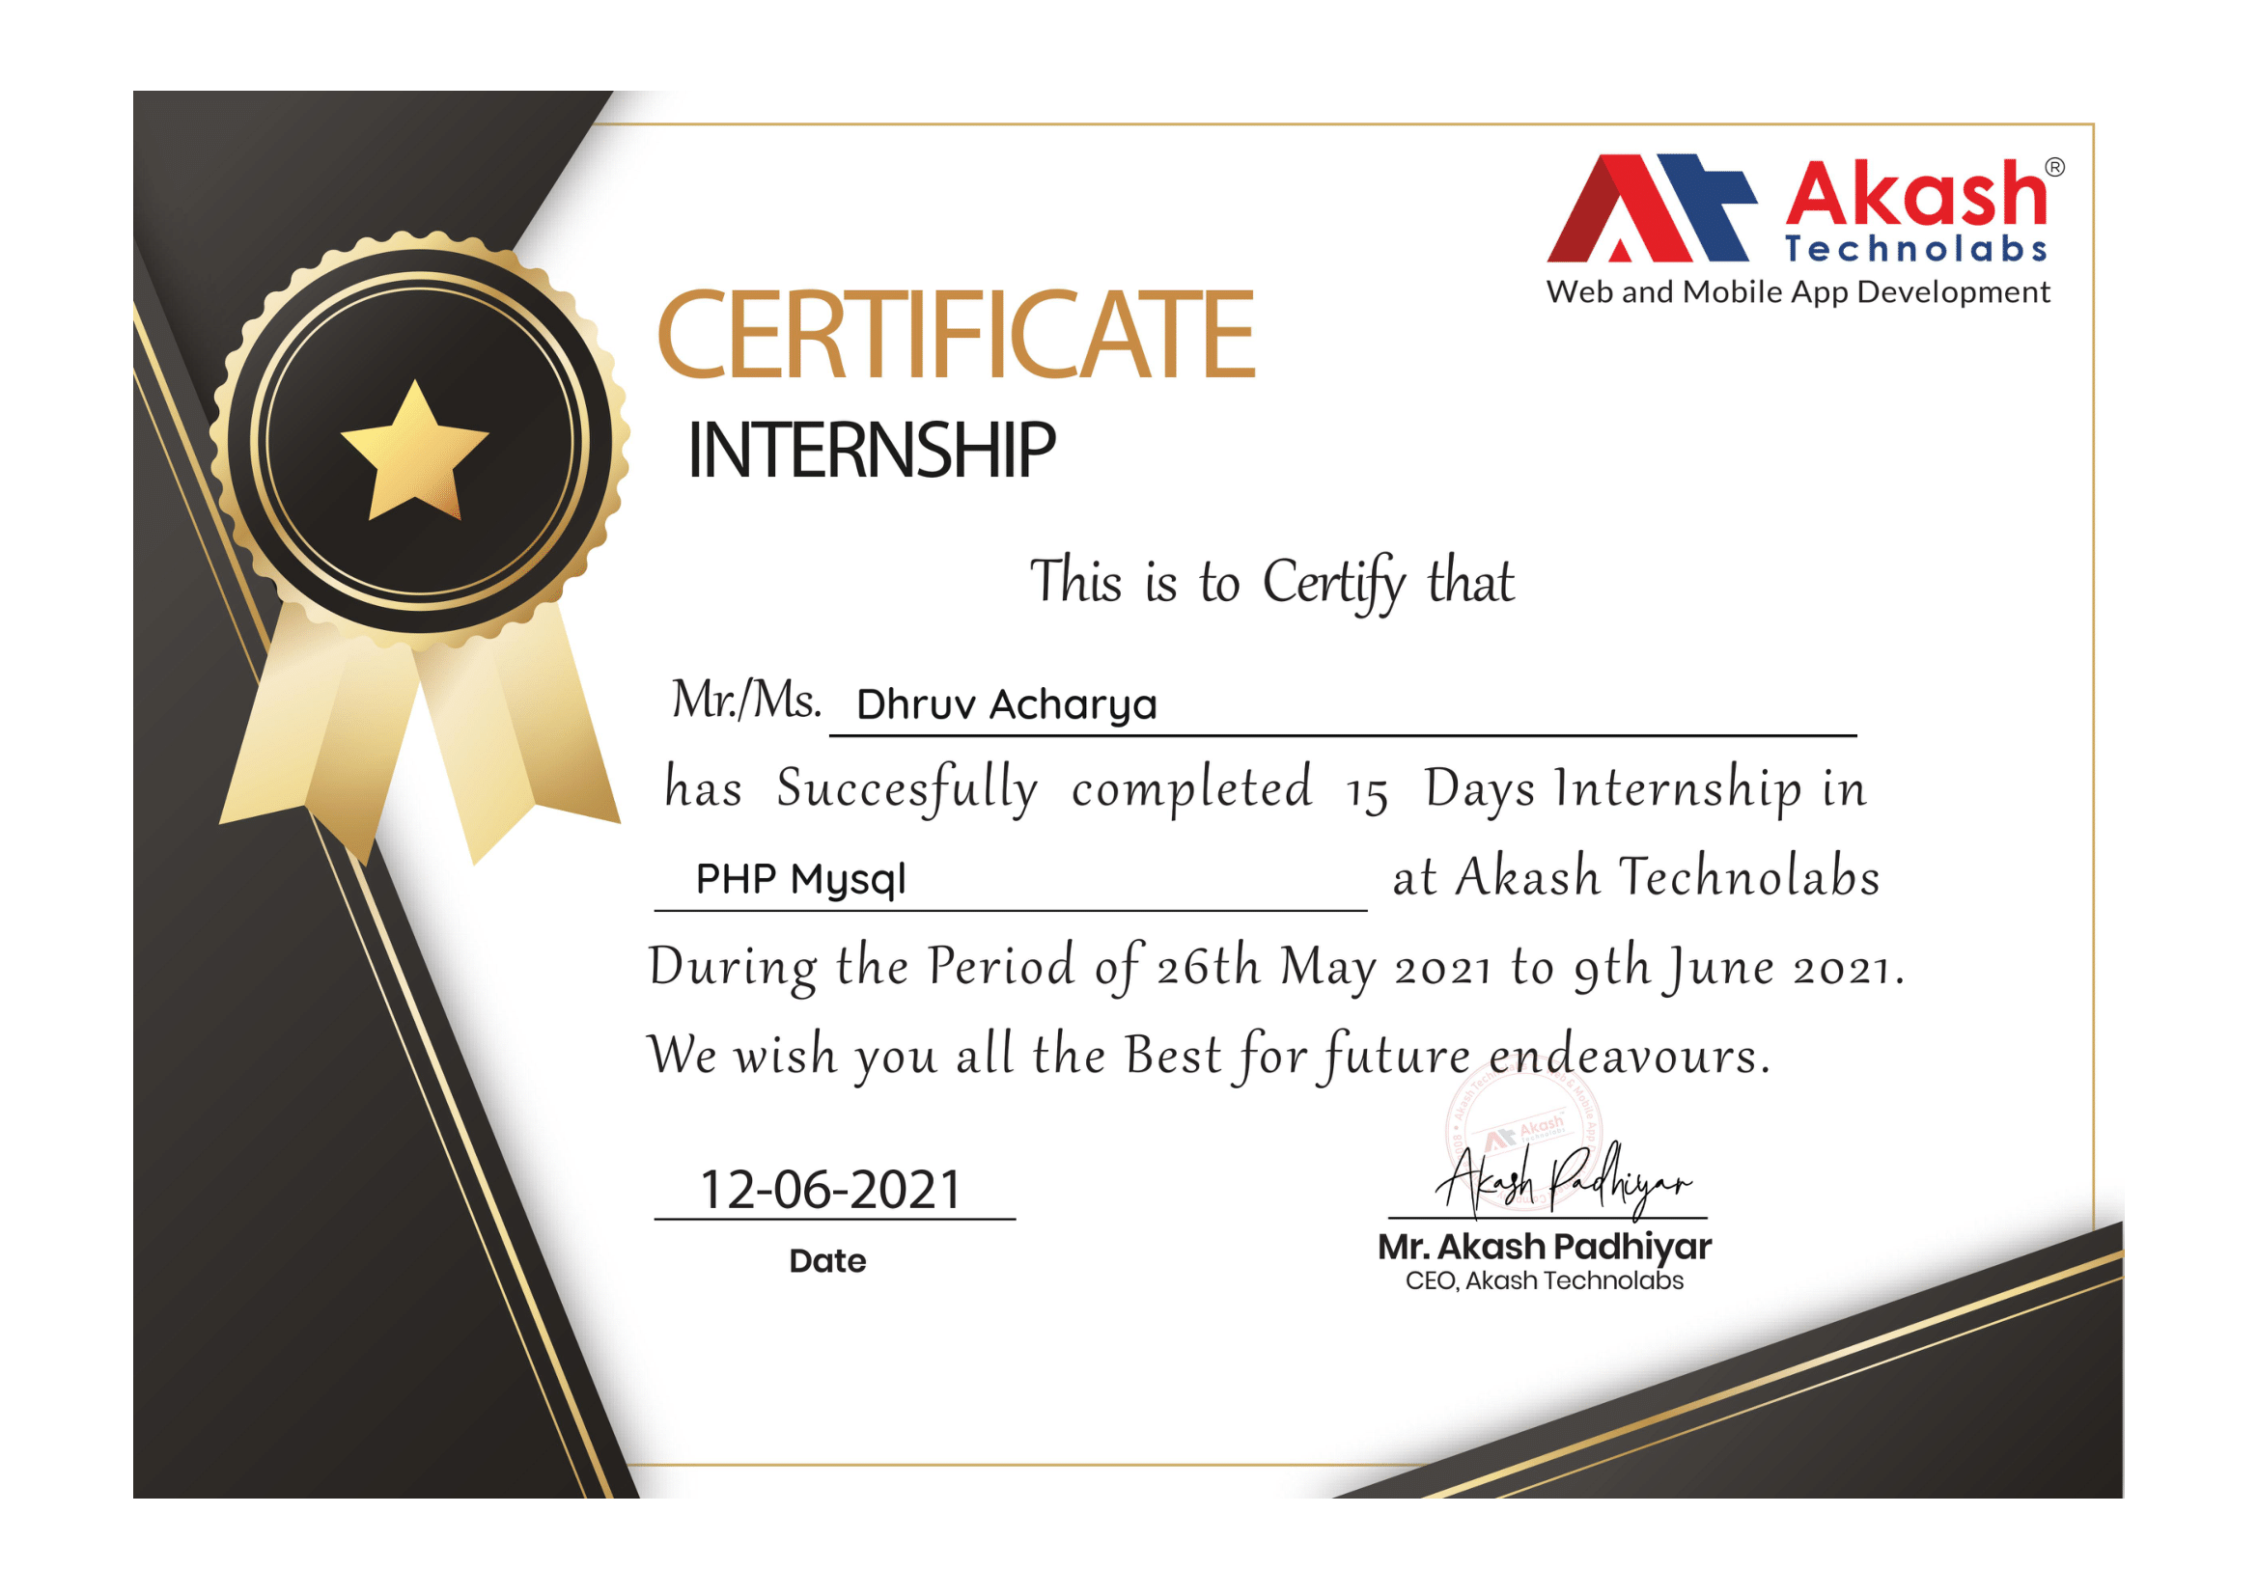

**[Akash Technolabs]**

Date: 12-06-21

This is to certify **Dhruv Acharya(190163107001), COMPUTER ENGINEERING** from Government Engineering College, Modasa has successfully completed the Summer Internship at our company/organization during **26th May 2021** to **9th June 2021.**

Project /Work done: **Task implementation provided by the company and Module development.**

Tools/Technology used/learnt:  **HTML, CSS, JS, PHP, WORDPRESS.**

The organization has found him hardworking and sincere during this period.



**Abstract**

Nowadays, many offline retail stores are struggling in front of online giant retail shops like Amazon and Flipkart. In the recent past, the online shop has become extensively popular just by utilizing online platforms.

In order to stand up with the online market, The local shops also need to be present virtually. Unfortunately, many small local shops don’t consider creating their own website or digital platform to advertise or sell their product as their business isn’t that widespread. However, That doesn’t mean small shops can’t benefit from online support.

This project will help small shops to make their presence online and help them to enhance their reach and capability.

**Index**

|  |  |  |
| --- | --- | --- |
| **Sr.No** | **Content** | **Page.No** |
| **1** | **Introduction** |  |
| **2** | **Problem Statement/Definition** |  |
| **3** | **Tools/Technologies** |  |
| **4** | **Timeline Chart** |  |
| **5** | **Module Development/Implementation** |  |
| **6** | **Conclusion** |  |
| **7** | **References** |  |

**CHAPTER-1**

**INTRODUCTION**

The ‘make your shop online’ website is a web-based project with the purpose to empower small-scale businesses by helping them with advertising and selling their product on our online platform. Our platform will provide full support for accelerating their reach to the extensive and appropriate user-based market.

This project consists of the Registration with email verification, Login with Forgot Password, View, and Edit Profile Modules.

This project is developed during the internship at Akash Technolabs, in which, they help me to understand the concept of backend technology and to work with the database, in addition, they also provided the tasks to perform on the related topic.

**CHAPTER-2**

**Problem Statement/Task Definitions**

**Tasks:**

* CRUD Operation on PHP.
* Personal website/Resume.

**Project :**

Create a web-based project for the small retail shops and their consumers. There are two kinds of user use this website one shopkeeper who wants to make its shop online and second customer whos gonna visit the shop.

On one hand, the shopkeeper first has to create its account on site then it can create a shop in it, and can display their shop products also all the details of the product. On other hand, the customer can see all the available shops near his current location with the shop’s all products and details of it, in addition, he can also contact the shopkeeper.

**CHAPTER-3**

**Tools and Technologies**

**TOOLS**: VS CODE, Chrome Browser, WAMP Server

In web development, tools required mostly are editor and browser. Here, in this project, I have used VSCode as an editor and Chrome browser for output, testing, and debugging. WAMP is a webserver to run PHP code and also PHPMyAdmin for MySQL database handling.

**TECHNOLOGIES** : PHP, HTML, CSS, JS

To develop a basic website or page we need HTML, CSS, and JS. To make the website dynamic we require backend technology to work with the database. Here we have used PHP as backend technology.

**CHAPTER-4**

**Timeline Chart**

**CHAPTER-5**

**Module Development/Implementation**

**CHAPTER-6**

**Conclusion**

**CHAPTER-7**

**References**