**Practical 1**

AIM:Study of WWW, HTTP Request and response, List good features of a user-Friendly website.

* WWW:
* It stands for World Wide Web also known as Web.
* English scientist [Tim Berners-Lee](https://en.wikipedia.org/wiki/Tim_Berners-Lee) invented the World Wide Web in 1989.
* It is a collection of resources, documents, or web pages, can be located using a URL.
* Each page may also be interlinked by hypertext and accessible over the internet.
* The resources of the web are transferred via HTTP(hypertext Transfer Protocol).
* Users can access the websites or web pages using the web browser.
* Multiple web page or web resources with the common theme and a common domain name makes up a website.
* Websites are stored in the webserver.
* HTTP Request and Response:
  + HTTP message: HTTP messages are how data is exchanged between server and client.
  + There are two types of message:
    - HTTP Request
    - HTTP Response
  + Request sent by a client to trigger an action on the server, and server responses, the answer of request.
  + HTTP request and response use a generic message format of RFC 822 for transferring the required data.
  + This generic message format consists of the following four items:
    - A Start-line.
    - Zero or more header fields followed by CRLF.
    - An empty line, which indicates the end of header fields.
    - 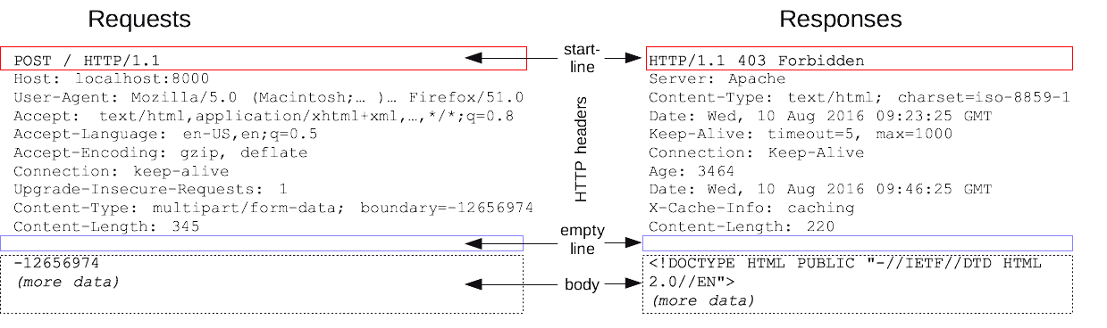(Optionally) A message body.