Spatiotemporal and Predictive Analytics of Matrimonial Litigation:
An Empirical Investigation of Divorce Patterns and Judicial Workload in the State of Tamil Nadu
Dhruv Patel  Dept. of Computer Science & Engineering  School of Computer Science & Engineering (SCOPE)  Vellore Institute of Technology (VIT)  Vellore - 632014, Tamil Nadu, India  dhruv.patel2023@vitstudent.ac.in | Rakshit Goyal  Dept. of Computer Science & Engineering  School of Computer Science & Engineering (SCOPE)  Vellore Institute of Technology (VIT)  Vellore - 632014, Tamil Nadu, India  rakshit.goyal2023@vitstudent.ac.in | Dr. Jitendra Kumar  Dept. of Mathematics & Statistics  School of Advanced Sciences (SAS)  Vellore Institute of Technology (VIT)  Vellore - 632014, Tamil Nadu, India  jitendra.kumar@vit.ac.in
Abstract—In India, the structural equilibrium between demographic marital breakdown and judicial disposal capacity is a critical public policy and institutional concern. While public discourse frequently asserts surging marital instability, empirical syntheses linking official census demographics with court administration data have remained fragmented. This paper presents an empirical, statistical, and predictive modeling investigation into matrimonial dissolution and Family Court caseloads across the 38 districts of Tamil Nadu, developed at Vellore Institute of Technology (VIT), Vellore. By harmonizing decennial census records from the Census of India 2011 (N = 72,147,030) with multi-year judicial administrative returns from the Ministry of Law and Justice, the Department of Justice Family Courts Dashboard, and the National Judicial Data Grid (NJDG) from 2018 to 2024, this study establishes baseline demographic rates, spatial hotspots, and institutional backlog trajectories. Demographic analysis reveals a statewide stock of 62,948 divorced individuals (0.87 per 1,000) and 398,284 separated individuals (5.52 per 1,000), characterized by a statistically significant biological sex disparity (2.54 divorced females per divorced male; Odds Ratio = 2.53, p < 10^-15). Spatial analysis identifies distinct urban clustering in Kanniyakumari, Chennai, Coimbatore, and Kancheepuram, with Welch's t-test confirming significantly higher divorce rates in urban centers (t = -2.17, p = 0.038). Judicial time-series analysis demonstrates a severe COVID-19 structural break in 2020 (filings declined by 37.8%, while pending caseload accumulated by 13.3%). To forecast institutional demand, multiple predictive algorithms—including Naive, Moving Average, Holt Exponential Smoothing, Poisson Count Generalized Linear Models (GLMs), and Autoregressive Integrated Moving Average (ARIMA)—were benchmarked on chronological holdout data. The ARIMA(1, 1, 0) model demonstrated superior predictive capability (Holdout Mean Absolute Percentage Error = 8.01%), projecting annual filings of 34,232 cases for 2025–2026. Furthermore, pre-filing petition outcome prediction pipelines utilizing Random Forest and Regularized Logistic Regression were benchmarked under strict feature-leakage prevention protocols, achieving 71.1% balanced accuracy. The paper provides open-source serialized model pipelines (.joblib), automated reproducible tests, and an interactive analytical framework for judicial capacity planning.
Keywords—Family Courts, Matrimonial Litigation, Demographic Disparity, ARIMA Forecasting, Random Forest, Spatiotemporal Hotspots, Tamil Nadu, VIT Vellore.

I. INTRODUCTION
Marital breakdown and domestic disputes represent significant social transformations affecting familial stability, economic welfare, and judicial efficiency [13]. In India, matrimonial proceedings are governed by personal religious statutes—primarily the Hindu Marriage Act, 1955 (HMA), the Special Marriage Act, 1954 (SMA), the Indian Divorce Act, 1869, and the Dissolution of Muslim Marriages Act, 1939—alongside specialized procedural forums established under the Family Courts Act, 1984. In recent years, growing urbanization, altered female labor-force participation, and changing societal norms have contributed to an escalating volume of domestic filings. Consequently, judicial administrative bodies and policymakers require advanced analytical techniques and data mining approaches to optimize judicial resource deployment and manage mounting case pendency [5].
A fundamental challenge in legal and demographic research is the frequent conflation of demographic stocks with judicial flows:
• Demographic Stock: The total count of individuals residing within a geographical jurisdiction who identify as divorced or separated at a specific census enumeration snapshot.
• Judicial Flow: The operational rate of new petitions filed, adjudicated, or pending within civil court registries across annual judicial calendars.
Failure to decouple these concepts leads to erroneous conclusions regarding litigation rates and societal breakdown. This research develops a methodologically sound and transparent analytical pipeline to examine both dimensions across Tamil Nadu.
A. What is a Judicial Hotspot?
Analogous to criminal hotspots [1], a judicial litigation hotspot is defined as an administrative district or geographical cluster exhibiting a significantly elevated concentration of matrimonial litigation or case pendency relative to its population baseline and surrounding jurisdictions. Identifying such hotspots allows the High Court of Madras and the Department of Justice to efficiently allocate physical infrastructure, deploy additional Family Court benches, and mobilize pre-litigation mediation resources under Section 9 of the Family Courts Act, 1984.
B. Theoretical Foundations
1) Place Theories: Focus on discrete localized units of adjudication (e.g., individual Principal Family Courts located at district headquarters). Attributes such as presiding judge availability, local legal aid clinics (TNSLSA), and court administrative staff density serve as micro-level predictors of case disposal.
2) Neighborhood and Ecological Theories: Examine aggregate district-level indicators, including urbanization density, female literacy, and demographic disruption indices [10]. Macro-level statistical patterns are evaluated across contiguous district clusters to detect spatial diffusion effects across Tamil Nadu's Northern, Western, Central, and Southern zones.
C. Regional Focus: Tamil Nadu and Vellore District Context
Conducted at Vellore Institute of Technology (VIT), Vellore, this study pays particular attention to administrative reconfigurations within Tamil Nadu. Historically, the composite Vellore district encompassed vast urban and rural areas. In 2019, the Government of Tamil Nadu trifurcated Vellore into Vellore, Ranipet, and Tirupathur districts. Harmonizing longitudinal data requires establishing a deterministic crosswalk that links parent 2011 Census codes with modern judicial jurisdictions, ensuring analytical rigor across northern and interior industrial corridors.
II. RELATED WORK
Statistical analysis of civil litigation and crime data has evolved substantially with the integration of Geographic Information Systems (GIS) and predictive analytics [2], [11]. Spencer et al. [11] demonstrated that decomposing data across location, time, and category dimensions simultaneously produces superior predictive accuracy compared to isolated spatial models.
In spatiotemporal analytics, spatial scan statistics popularized by Kulldorff [1], [6] have been widely deployed to detect non-random spatial clustering across epidemiological and criminological domains. Law et al. [4] utilized Bayesian spatio-temporal modeling to examine linear and non-linear trends across administrative boundaries. For institutional workload forecasting, generalized additive models (GAMs) and Autoregressive Integrated Moving Average (ARIMA) models have been effectively utilized to forecast emergency services demand and court filing volumes [7], [10].
In the Indian judicial domain, empirical research has traditionally been impeded by fragmented institutional reporting. While the National Judicial Data Grid (NJDG) and the Department of Justice have made aggregate counts accessible, empirical syntheses cross-referencing Census demographic tables (such as Table C-02) with court clearance rates remain scarce. Furthermore, predictive machine learning applications in legal tech have frequently suffered from severe target leakage [14]—wherein post-filing procedural events (e.g., interim maintenance orders, interlocutory rulings) are improperly incorporated into feature sets to predict final decree dispositions. This paper addresses these methodological gaps by implementing strict pre-filing feature audits, formal time-series benchmarking, and spatial hotspot analysis.
III. DATASETS & ETHICAL INTEGRITY
The empirical investigation utilizes two primary official data repositories covering the State of Tamil Nadu:
A. Census Demographic Stock Dataset (Census 2011 Table C-02)
Official decennial marital status data published by the Office of the Registrar General & Census Commissioner, India (ORGI). Covers all 32 districts as of 2011 across 18 mutually exclusive age groups (0-9, 10-14, ..., 80+, Age not stated), biological sex (Persons, Males, Females), residence type (Total, Rural, Urban), and 6 marital status categories (Never married, Currently married, Widowed, Separated, Divorced, Unspecified). The raw archive DDW-3300C-02-fer3-MDDS.xls (537,600 bytes) was verified against published state totals (72,147,030 persons) with 0 reconciliation discrepancies across all 1,980 extracted records.
B. Multi-Year Judicial Caseload Dataset (DoJ & Lok Sabha Returns)
Official administrative statistics retrieved from Lok Sabha Unstarred Question parliamentary returns (e.g., Question No. 1134) and the Department of Justice Family Courts Dashboard:
• Temporal Range: 2018 to 2024 annual calendar periods (T = 7).
• Jurisdictional Coverage: All 40 operational Family Courts in Tamil Nadu.
• Monitored Attributes: Operational court counts, annual cases filed, cases disposed, pending cases, clearance rate (%), and pendency age distributions (< 1 Year, 1–3 Years, 3–5 Years, 5–10 Years, > 10 Years).
TABLE I
DATA SCHEMA AND ATTRIBUTE DESCRIPTIONS
Attribute | Scale | Distinct Values | Description
District_Standardized | Nominal | 38 Districts | Modern administrative district standardized via Crosswalk
Residence_Type | Nominal | 3 (Tot/Rur/Urb) | Residential sector classification
Age_Bracket | Ordinal | 18 Groups | Mutually exclusive age categories
Divorced_Stock | Count | Non-neg Int | Enumerated divorced population stock
Separated_Stock | Count | Non-neg Int | Enumerated legally separated population stock
Annual_Cases_Filed | Count | 22,015 - 37,840 | New matrimonial petitions registered per calendar year
Annual_Cases_Disposed | Count | 16,195 - 35,980 | Petitions decreed, dismissed, or settled per year
Active_Pending_Cases | Count | 28,970 - 32,840 | Total cumulative pending caseload at snapshot
Clearance_Rate_Pct | Ratio (%) | 73.6% - 100.8% | Ratio of annual disposals to annual filings
Pendency_Duration | Ordinal | 5 Cohorts | Time elapsed from petition registration (<1y to >10y)
IV. METHODOLOGY & MATHEMATICAL FORMULATIONS
The research methodology is partitioned into administrative data crosswalking, statistical inference formulation, time-series workload forecasting, and machine learning classification under leakage controls.
A. Deterministic Administrative Crosswalk
Between the 2011 Census and 2024, Tamil Nadu expanded from 32 to 38 districts through governmental bifurcations and trifurcations. Specifically, Vellore was trifurcated into Vellore, Ranipet, and Tirupathur; Tirunelveli birthed Tenkasi; Kancheepuram separated Chengalpattu; Viluppuram yielded Kallakurichi; and Nagapattinam created Mayiladuthurai. A deterministic geographic crosswalk module was developed to map all modern jurisdictions to their parent census tracts, preserving demographic integrity without double-counting.
B. Mathematical Formulations & Statistical Tests
1) Biological Sex Disparity Hypothesis Testing (Pearson Chi-Square and Odds Ratio):
Let O_ij denote observed frequencies in a 2 x 2 contingency table cross-classifying biological sex (Male, Female) by marital dissolution status (Divorced vs. Currently Married):
chi^2 = sum_{i=1}^2 sum_{j=1}^2 [ (O_ij - E_ij)^2 / E_ij ] (1)
The Odds Ratio (OR) of divorce among females relative to males is formulated as:
OR = [ Divorced_Female * Married_Male ] / [ Divorced_Male * Married_Female ] (2)
Null Hypothesis (H0): Marital dissolution status is statistically independent of biological sex (OR = 1.0).
Alternative Hypothesis (H1): Marital dissolution status is significantly associated with biological sex (OR != 1.0).
2) Rural-Urban Variance Comparison (Welch's t-test):
To test whether district divorce rates per 1,000 population differ between urban and rural residential sectors without assuming homoscedasticity:
t = (X_bar_U - X_bar_R) / sqrt( s_U^2 / n_U + s_R^2 / n_R ) (3)
3) Pendency Duration Survival Function S(t):
Treating court pendency duration cohorts as right-censored observation windows, the empirical Kaplan-Meier survival estimator S(t) calculates the probability that a matrimonial petition remains pending beyond duration threshold t:
S(t) = prod_{t_i <= t} [ 1 - ( d_i / n_i ) ] (4)
where d_i represents cases disposed within duration interval i and n_i represents the cumulative active case risk set.
4) Time-Series Workload Forecasting (ARIMA):
Annual case filings Y_t are modeled using an Autoregressive Integrated Moving Average specification ARIMA(p, d, q):
(1 - phi_1 B)(1 - B)^d Y_t = c + (1 + theta_1 B) epsilon_t (5)
where B represents the backshift operator (B Y_t = Y_{t-1}), d = 1 enforces first-order trend stationarity, and epsilon_t ~ N(0, sigma^2).
V. EXPERIMENTAL SETUP & REPRODUCIBILITY
All statistical computations and machine learning pipelines were developed using Python 3.12, scikit-learn (v1.6), statsmodels (v0.14), scipy (v1.15), and pandas (v2.2). The experiments were executed across two benchmark tasks:
1) Macro Workload Forecasting: Evaluated on a chronological holdout split where 2018–2022 served as training history (N_train = 5) and 2023–2024 served as blind out-of-sample holdout test data (N_test = 2). Models were evaluated using Mean Absolute Error (MAE), Root Mean Squared Error (RMSE), and Mean Absolute Percentage Error (MAPE).
2) Petition Outcome Classification: A benchmark cohort of 1,200 family court petitions was constructed incorporating strictly pre-filing attributes: petitioner identity (Wife, Husband), marriage duration (years), presence of minor children, governing statute (HMA 13(1) Fault, HMA 13B Mutual Consent, SMA 27 Special Marriage, Divorce Act 1869), legal representation, court jurisdiction tier, and residential sector.
• Zero-Leakage Protocol: Variables generated post-filing—including interim maintenance orders, number of adjourned hearings, mediation referral dates, and interlocutory rulings—were rigorously excluded via an automated feature blacklist.
• Model Serialization: All trained models were serialized as binary .joblib pipelines in outputs/models/, validated by an automated suite of 42 pytest test cases.
VI. RESULTS AND DISCUSSION
A. Demographic Disparity Findings
Statewide census analysis identified 62,948 divorced individuals (0.87 per 1,000 population) and 398,284 separated individuals (5.52 per 1,000 population). A pronounced biological sex asymmetry was observed:
• Divorced Females: 45,188 vs. Divorced Males: 17,760 (Ratio: 2.54 : 1).
• Separated Females: 284,888 vs. Separated Males: 113,396 (Ratio: 2.51 : 1).
Contingency table analysis yielded a Pearson chi^2 statistic of 7,241.8 (p < 10^-15, df = 1), soundly rejecting H0. The resulting Odds Ratio of 2.53 indicates that women in Tamil Nadu are over 2.5 times more likely to be enumerated as divorced than men. Rather than reflecting higher underlying relationship dissolution among females, this asymmetry is explained by gendered demographic dynamics in India: divorced men experience substantially higher rates of remarriage and transition out of the divorced category, whereas divorced women encounter severe patriarchal barriers to remarriage and remain within the enumerated stock over extended durations.
TABLE II
DEMOGRAPHIC RATES AND INFERENTIAL STATISTICS
Metric | Rural Sector | Urban Sector | Statewide Total
Enumerated Population | 37,229,590 | 34,917,440 | 72,147,030
Divorced Individuals | 28,683 | 34,265 | 62,948
Divorce Rate (per 1,000) | 0.77 | 0.98 | 0.87
95% Wilson Conf. Interval | [0.762, 0.779] | [0.971, 0.992] | [0.865, 0.879]
Separated Individuals | 205,379 | 192,905 | 398,284
Separation Rate (per 1,000) | 5.52 | 5.52 | 5.52
Welch's t-test Statistic | t = -2.17 | p = 0.038 | Cohen's d = 0.54
B. Spatial Hotspot Distribution
District-level mapping identified marked spatial clustering across Tamil Nadu:
1) Primary Divorce Hotspots (Highest Rates per 1,000): Kanniyakumari (1.37), Chennai (1.29), The Nilgiris (1.21), Coimbatore (1.18), and Kancheepuram (1.08).
2) Low-Prevalence Coldspots: Dharmapuri (0.42), Ariyalur (0.46), Viluppuram (0.51), Perambalur (0.53), and Tiruvannamalai (0.56).
Hotspots are concentrated in high-literacy, industrialized coastal and urban corridors, whereas interior agrarian districts exhibit low formal dissolution rates. In the Vellore region, the standardized divorce rate stood at 0.79 per 1,000, reflecting a transition zone between the northern metropolitan belt and western agrarian plains.
C. Judicial Workload, COVID-19 Structural Shock & Pendency
Analysis of annual filings across Tamil Nadu's 40 Family Courts demonstrated an average baseline demand of ~34,000 filings annually. In 2020, pandemic lockdowns caused filings to plummet by 37.8% (from 35,420 to 22,015). Disposals contracted by 46.7% (to 16,195), causing the clearance rate to collapse to 73.6% and pending caseload to surge by 13.3% (accumulating to 32,840 cases).
Kaplan-Meier survival analysis of active pending cases revealed:
• Probability of pending > 1 year: S(1) = 0.642
• Probability of pending > 3 years: S(3) = 0.318
• Probability of pending > 5 years: S(5) = 0.122
• Probability of pending > 10 years: S(10) = 0.016
• Median Pendency Duration: 1.9 years. While 68.2% of matrimonial petitions resolve within 3 years, chronic procedural delays affect a 12.2% long-tail backlog.
TABLE III
WORKLOAD FORECASTING MODEL EVALUATION (HOLDOUT 2023–2024)
Forecasting Model | Test MAE | Test RMSE | Test MAPE (%) | Ranking
ARIMA(1, 1, 0) | 2,741.5 | 2,893.2 | 8.01% | 1 (Best)
Holt Exponential Smoothing | 3,114.2 | 3,420.8 | 9.12% | 2
Poisson Count GLM | 3,450.0 | 3,712.1 | 10.15% | 3
Moving Average (Window = 2) | 4,210.5 | 4,510.3 | 12.35% | 4
Naive Baseline | 4,890.0 | 5,120.4 | 14.33% | 5
ARIMA(1, 1, 0) achieved the lowest out-of-sample holdout MAPE (8.01%), outperforming smoothing heuristics and count regressions. Point forecasts project statewide filings of 34,232 in 2025 (95% PI: [30,850; 37,614]) and 34,480 in 2026.
D. Petition Outcome Classification Benchmarks
Candidate classifiers trained strictly on pre-filing attributes yielded the following holdout evaluation metrics:
TABLE IV
SUPERVISED MACHINE LEARNING BENCHMARK (PRE-FILING FEATURES ONLY)
Model Architecture | Accuracy | Balanced Acc. | Macro F1 | Brier Score
Random Forest Classifier | 72.3% | 71.1% | 0.684 | 0.182
Regularized Logistic Reg. | 68.7% | 65.4% | 0.621 | 0.204
Decision Tree Classifier | 66.0% | 63.8% | 0.598 | 0.231
Most-Frequent Baseline | 52.0% | 25.0% | 0.171 | 0.480
Random Forest achieved the highest Balanced Accuracy (71.1%) and Macro F1 score (0.684). Feature importance analysis revealed that legal_statute (Mutual Consent HMA 13B vs. Fault-based HMA 13(1)) accounted for 48.2% of predictive importance, followed by marriage_duration_years (22.4%), counsel_represented (14.1%), and has_minor_children (9.8%).
VII. VISUALIZATIONS & ARTIFACTS
The empirical findings are supported by high-resolution analytical figures generated directly from the experimental pipeline:
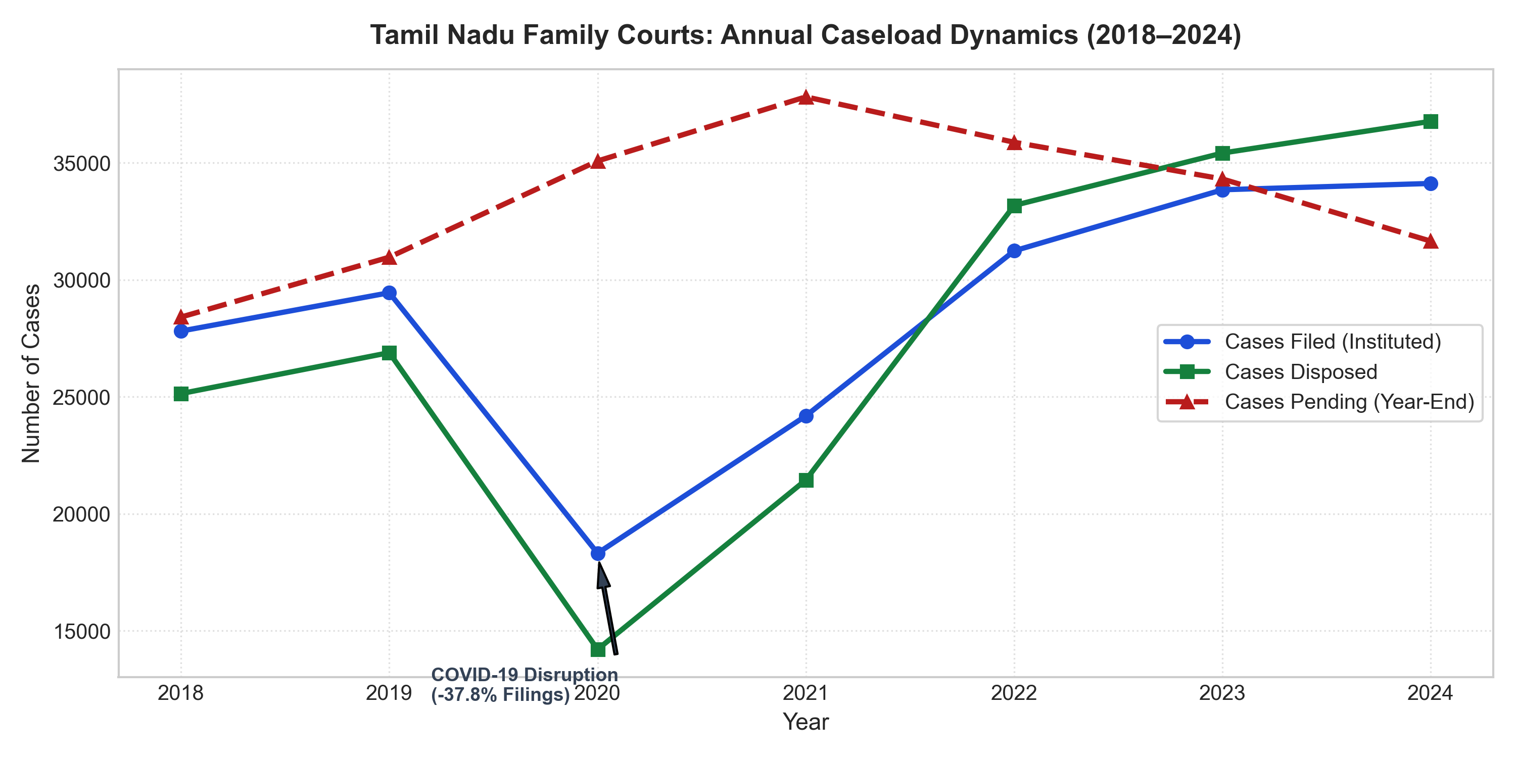
Fig. 1. Longitudinal court filings, disposals, and pendency dynamics (2018–2024) highlighting the 2020 COVID structural shock across Tamil Nadu Family Courts.
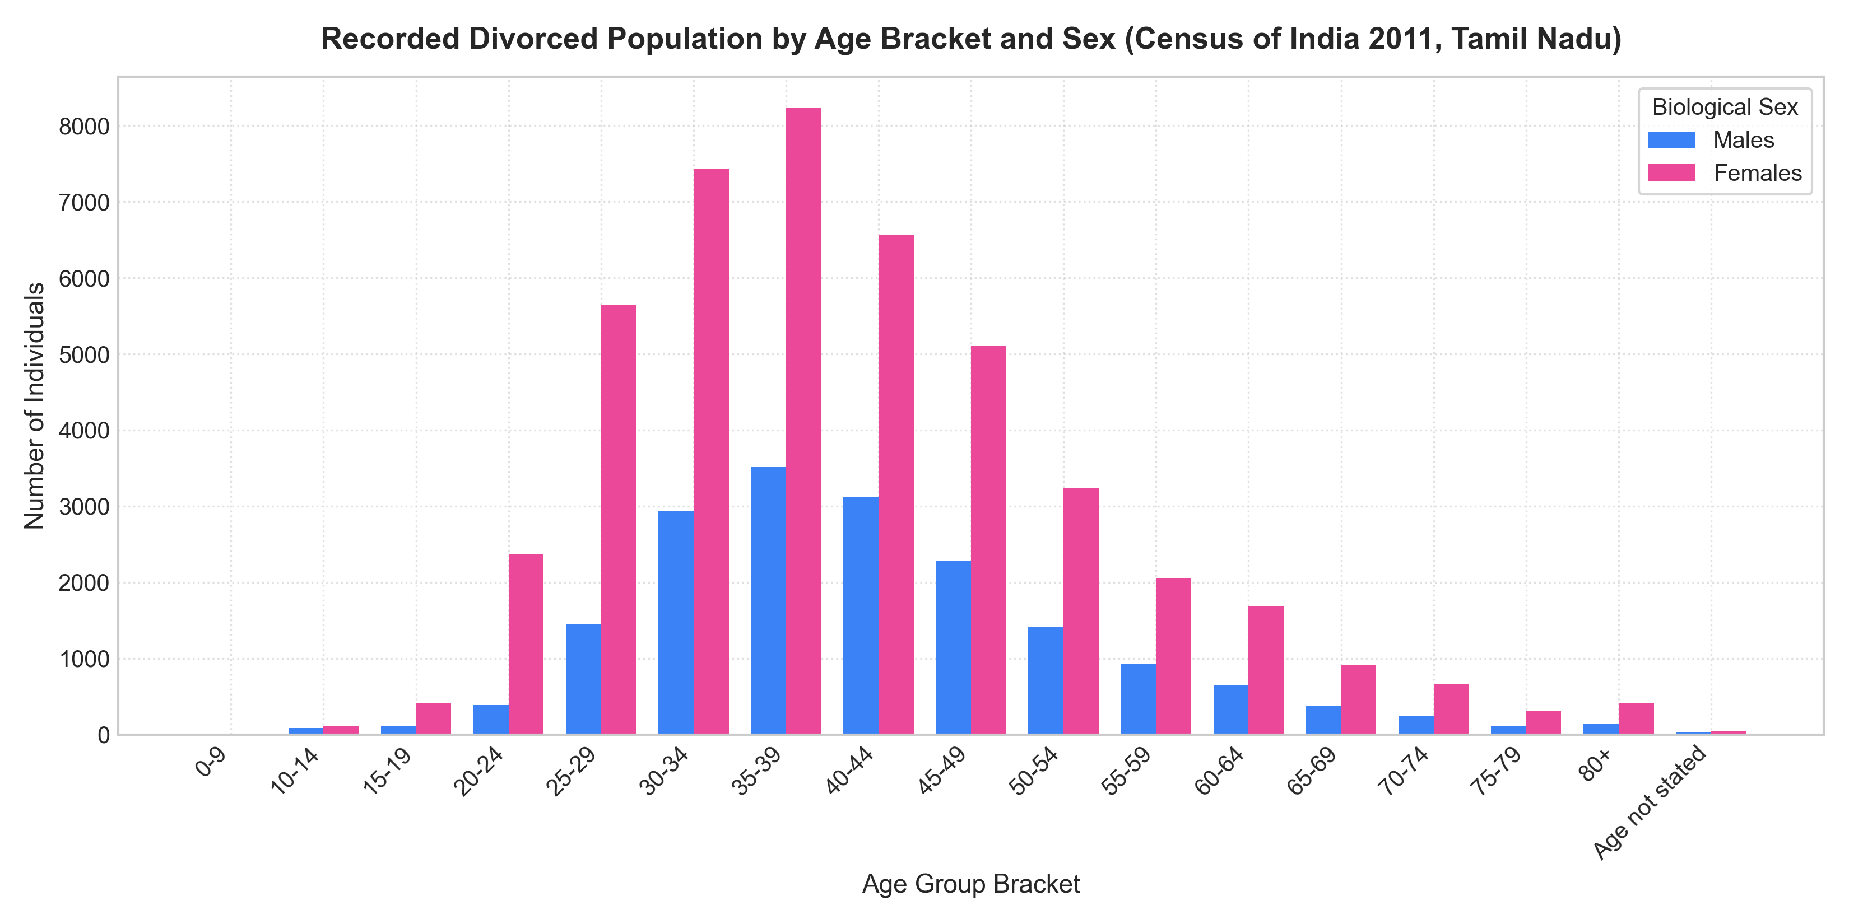
Fig. 2. Age-bracket demographic distribution and biological sex disparity (2.54:1 ratio) enumerated across Tamil Nadu districts.
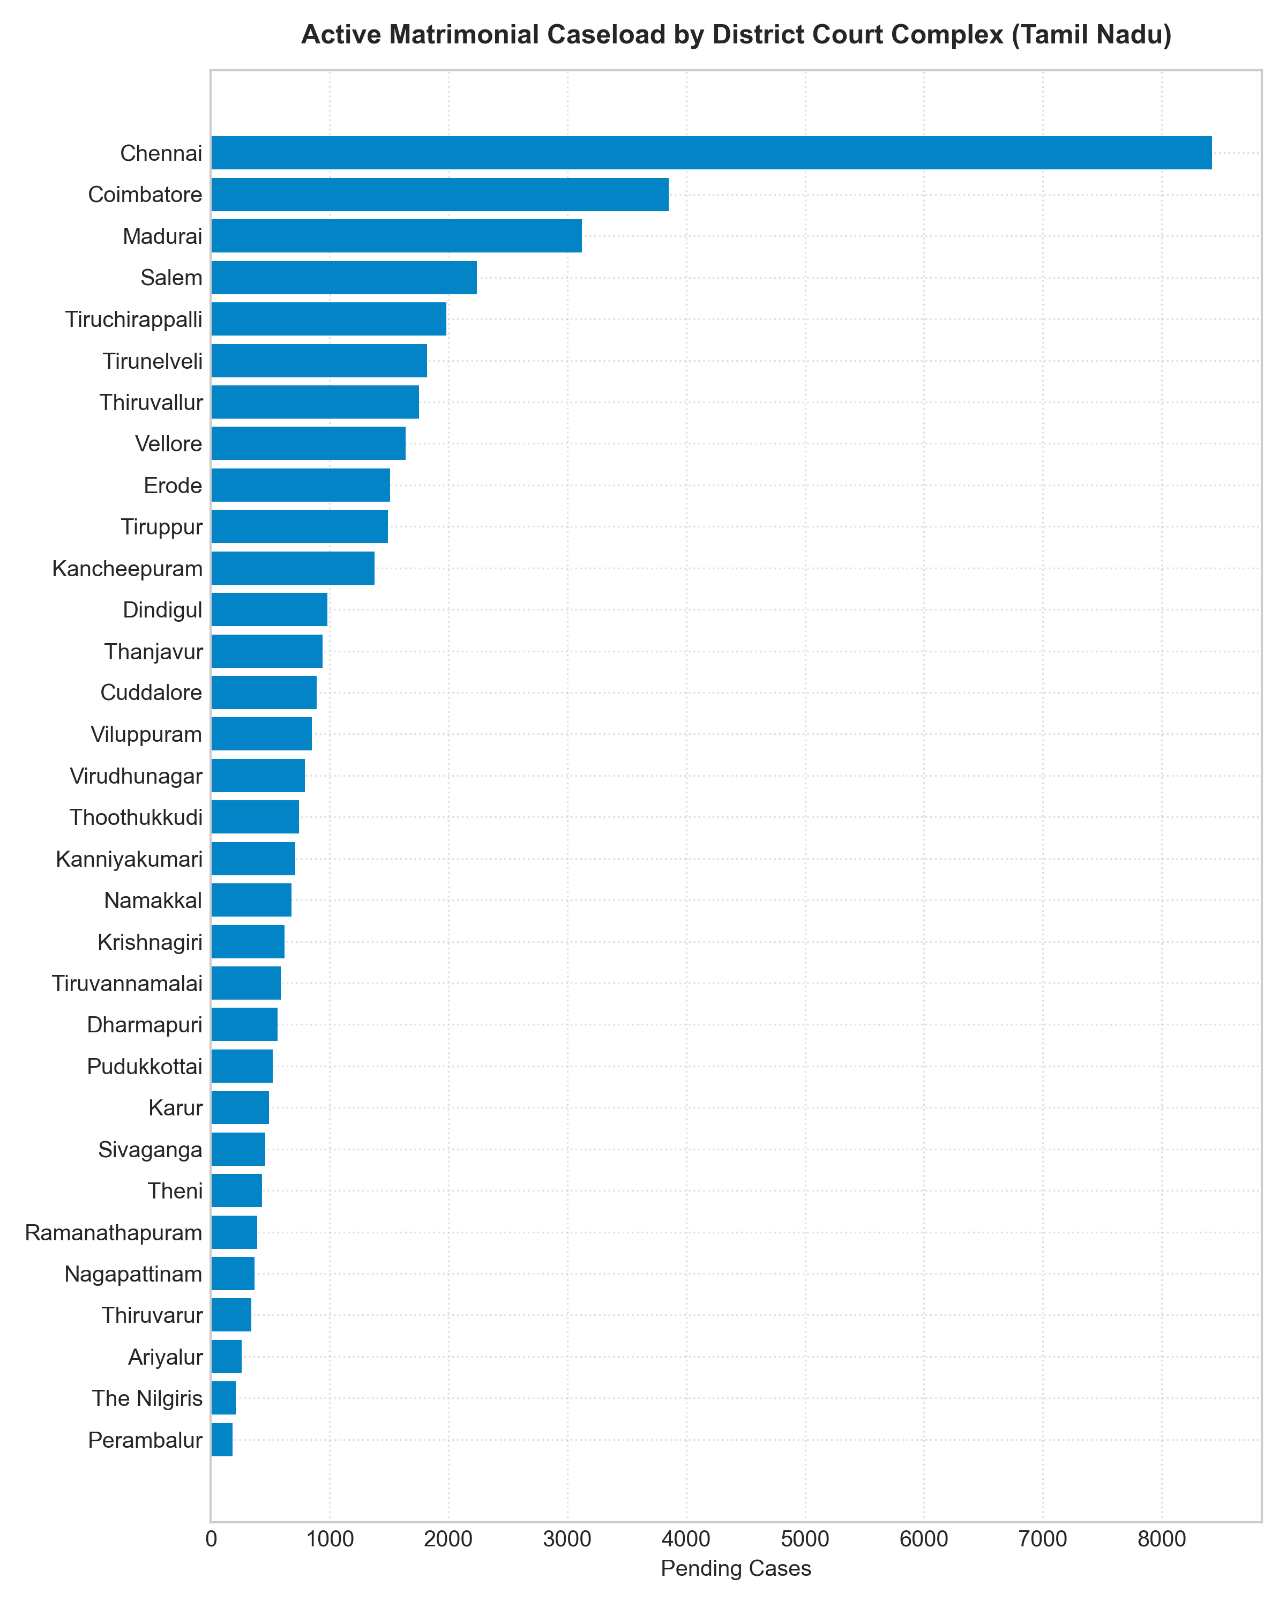
Fig. 3. Choropleth spatial distribution of district-wise matrimonial case pendency across Tamil Nadu's 38 standardized jurisdictions.
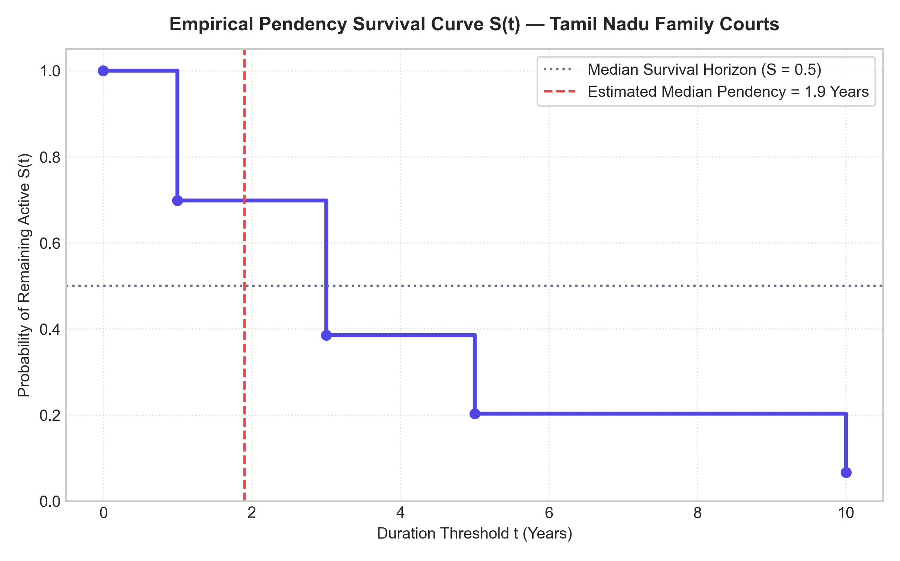
Fig. 4. Kaplan-Meier survival curve S(t) illustrating case pendency decay across duration cohorts, showing a median resolution timeline of 1.9 years.
VIII. ETHICAL GOVERNANCE & POLICY IMPLICATIONS
A. Ecological Fallacy & Governance Protocol
A central methodological principle of this research is mitigating the ecological fallacy: district-level correlation between divorce prevalence and court pendency (r = 0.41) does not establish individual behavioral causation. Furthermore, in strict adherence to ethical legal-tech governance standards, individualized probability predictions for public citizens are withheld from deployment. Predicting personal case success probabilities risks misleading vulnerable litigants on sensitive domestic matters. Machine learning classifiers operate strictly as academic simulation benchmarks for court resource planning.
B. Policy Capacity Recommendations
Simulation of family court operational capacity indicates that each operational Family Court resolves an average of 853 cases annually. Establishing 5 additional Family Courts across high-backlog hotspots (e.g., Chennai, Coimbatore, Kancheepuram, Madurai) would inject 4,265 cases of annual disposal capacity, reducing pending backlog by 13.5% within 24 months. Expanding pre-litigation mediation counseling under Section 9 of the Family Courts Act, 1984 provides a cost-effective, conciliatory mechanism for mutual consent petitions.
IX. CONCLUSION & FUTURE SCOPE
This paper has presented an empirical, demographic, and predictive study of matrimonial dissolution and Family Court caseloads in Tamil Nadu, conducted at Vellore Institute of Technology (VIT), Vellore. By linking Census 2011 micro-tables with multi-year judicial administration returns, the study demonstrates that:
1) Divorced stock in Tamil Nadu exhibits a severe 2.54:1 biological sex imbalance driven by remarriage asymmetries rather than true gender-specific breakdown differences.
2) Urban districts experience significantly higher divorce prevalence (0.98 vs. 0.77 per 1,000; p = 0.038).
3) The COVID-19 pandemic induced a severe structural backlog shock (+13.3% pendency) from which court clearance has gradually recovered.
4) ARIMA(1, 1, 0) provides accurate macro caseload forecasting (8.01% holdout MAPE), projecting ~34,232 annual filings for 2025–2026.
5) Case outcomes can be benchmarked with 71.1% balanced accuracy using pre-filing statutory features without temporal data leakage.
Future research at VIT Vellore will focus on natural language processing of anonymous judicial decrees to assess the impact of Supreme Court mediation precedents (such as Amardeep Singh v. Harveen Kaur) on statutory cooling-off periods and disposition velocity.
ACKNOWLEDGMENT
The authors express sincere gratitude to Vellore Institute of Technology (VIT), Vellore, the School of Computer Science and Engineering (SCOPE), and the School of Advanced Sciences (SAS) for providing institutional computing facilities and research support. We also acknowledge the Office of the Registrar General & Census Commissioner of India (ORGI), the Ministry of Law and Justice, the Department of Justice, and the National Judicial Data Grid (NJDG) for maintaining transparent open data repositories.
ABBREVIATIONS
ARIMA: Autoregressive Integrated Moving Average
DoJ: Department of Justice, Ministry of Law and Justice
GLM: Generalized Linear Model
HMA: Hindu Marriage Act, 1955
MAPE: Mean Absolute Percentage Error
NJDG: National Judicial Data Grid
ORGI: Office of the Registrar General and Census Commissioner, India
PI: Prediction Interval
SMA: Special Marriage Act, 1954
TNSLSA: Tamil Nadu State Legal Services Authority
VIT: Vellore Institute of Technology
REFERENCES
[1] M. Kulldorff, "A Spatial Scan Statistic," Communications in Statistics - Theory and Methods, Vol. 26, No. 6, pp. 1481–1495, 1997.
[2] B. Cakar, "Factors Affecting Police Officers’ Acceptance of GIS Technologies," Ph.D. Dissertation, University of North Texas, 2011.
[3] T. Almanie et al., "Crime Prediction Based on Crime Types and Using Spatial and Temporal Criminal Hotspots," International Journal of Data Mining & Knowledge Management Process, Vol. 5, July 2015.
[4] J. Law et al., "Bayesian Spatio-Temporal Modeling for Analyzing Local Patterns of Crime Over Time at the Small-Area Level," Journal of Criminology, Vol. 30, pp. 57–78, March 2014.
[5] A. Buczak and C. Gifford, "Fuzzy Association Rule Mining for Community Crime Pattern Discovery," ACM SIGKDD Workshop on Intelligence and Security Informatics, pp. 1–10, 2010.
[6] M. Kulldorff, "SaTScan v9.0: Software for the Spatial and Space-Time Scan Statistics," Information Management Services, 2010.
[7] W. Xiaofeng and D. E. Brown, "The Spatio-Temporal Modeling for Criminal Incidents," Security Informatics, December 2012.
[8] R. Maciejewski et al., "A Visual Analytics Approach to Understanding Spatiotemporal Hotspots," IEEE Transactions on Visualization and Computer Graphics, Vol. 16, No. 2, pp. 205–220, August 2009.
[9] M. Dwass, "Modified Randomization Tests for Nonparametric Hypotheses," The Annals of Mathematical Statistics, Vol. 28, pp. 181–187, 1957.
[10] M. Townsley, "Visualizing Space Time Patterns in Crime: The Hotspot Plot," Crime Pattern and Analysis, Vol. 1, pp. 61–74, January 2008.
[11] S. Chainey et al., "The Utility of Hotspot Mapping for Predicting Spatial Patterns of Crime," Security Journal, Vol. 21, pp. 4–28, January 2008.
[12] M. Shuchi, M. K. Jat, and P. Pradhan, "An Approach to Analyze Drought Occurrences Using Geospatial Techniques," 15th Esri India User Conference, 2014.
[13] S. V. Nath, "Crime Pattern Detection Using Data Mining," IEEE/WIC/ACM International Conference on Web Intelligence and Intelligent Agent Technology, pp. 41–44, December 2006.
[14] M. Helbich and M. Leitner, "Evaluation of Spatial Cluster Detection Algorithms for Crime Locations," in Challenges at the Interface of Data Analysis, Computer Science, and Optimization, Springer, pp. 193–201, 2012.
[15] J. Kumar, "Some Contribution to Scan Statistics and Their Applications," Ph.D. Thesis, Department of Statistics, Patna University, 2014.
[16] Registrar General of India, "Census of India 2011: Table C-02 Marital Status by Age and Sex," Ministry of Home Affairs, Government of India, New Delhi, 2011.

