

CSE 3243 Web Programming Lab

Mini Project Report on

ProcastiTrack:
DIGITAL PROCASTINATION ANALYZER

SUBMITTED BY

Dhruv Saraogi 42 230962250

Keshav Shivhare 51 230962302

Suraj Inamdar 48 230962290

Section C- AIML – Batch 2

Under the Guidance of:

Dr. Suma D

School of Computer Engineering

Manipal Institute of Technology, Manipal, Karnataka – 576104

2025-26

Abstract
ProcrastiTrack is a full-stack web application built with Django that helps students track and overcome procrastination through data-driven behavioral insights. Users can log study sessions, record distractions, build habits, and manage tasks all within a single integrated platform. A rule-based engine with 15 behavioral rules analyzes the user's data and generates personalized productivity suggestions. Interactive dashboards powered by Chart.js visualize 7-day and 30-day trends in focus scores, distraction patterns, and productivity. The system successfully implements all 24 functional requirements, covering user authentication, behavioral analytics, automated alerting, and pattern detection across 8 interconnected database models.

Table of Contents
1. Introduction
2. Literature Review
3. Methodology
4. System Architecture
5. Implementation Details
6. User Experience & Interface Design
7. Testing & Validation
8. Results and Discussion
9. Future Work
10. Conclusion
References

1. Introduction
1.1 Background and Context
Students in today's digital environment face constant distractions that make sustained, focused study increasingly difficult. While awareness of procrastination is widespread, very few tools exist that allow students to quantitatively track their own behavior, understand its triggers, and receive targeted, data-driven guidance. Existing productivity apps focus on task management and timers but do not capture the richer behavioral data — focus quality, distraction duration, habit consistency needed to genuinely address procrastination.
ProcrastiTrack fills this gap by providing a web application that combines multi-dimensional data collection with automated behavioral analysis and personalized recommendations, all specifically designed for students.
1.2 Problem Statement
Students often lack objective data about their study behavior. They may study for long hours yet remain unproductive due to frequent interruptions, poor focus, and broken habits. Without a structured system to log, measure, and analyze their behavior, identifying specific problems and making targeted improvements is extremely difficult.
1.3 Research Objectives
- Monitor and analyze user study behavior and productivity patterns over time.
- Track and categorize distractions to identify behavioral triggers causing procrastination.
- Maintain historical records of study sessions, habits, and tasks for long-term trend analysis.
- Generate intelligent, personalized suggestions using a 15-rule behavioral engine.
- Compute a composite daily productivity score and track improvement trends over time.
- Visualize user productivity through interactive graphical dashboards.
1.4 Thesis Statement
By capturing multi-dimensional behavioral data and analyzing it through a structured rule-based engine, a web application can effectively detect procrastination patterns and provide students with actionable, personalized suggestions that lead to measurable improvement in productivity.

2. Literature Review
2.1 Existing Tools and Gaps
Several existing productivity tools were analyzed during the planning phase of this project:
Tool | Key Features | Limitation
Forest App | Pomodoro timer, gamified focus sessions | No behavioral data analysis or suggestions
Toggl Track | Time tracking across projects | Not student-focused; no distraction logging
Habitica | Gamified habit tracking | No study-specific analytics or procrastination detection
RescueTime | Automatic screen time tracking | No manual session logging or academic context
Microsoft To Do | Task management | No behavioral analytics or AI suggestions
2.2 Gaps Addressed by This Project
- No free tool integrates session tracking, distraction logging, habit management, task management, and behavioral analytics in one student-focused platform.
- No existing tool provides suggestions derived from the user's own historical behavioral data.
- No open-source student productivity tool tracks a composite productivity score factoring in focus quality, study duration, distraction penalty, and task completion simultaneously.

3. Methodology
3.1 Development Approach
The project followed an iterative Agile methodology. Development was broken into functional modules — authentication, session tracking, distraction logging, habit tracking, task management, suggestion engine, and analytics — each designed, implemented, and tested independently before integration.
3.2 Technology Stack
Layer | Technology | Version | Purpose
Language | Python | 3.10+ | Core backend language
Framework | Django | 5.2.3 | MTV web framework
Database | SQLite3 | Built-in | Development database
Frontend | Bootstrap | 5.3.3 | Responsive UI components
Charts | Chart.js | 4.4.6 | Interactive data visualizations
AJAX | jQuery | 3.7.1 | Asynchronous UI interactions
WSGI Server | Gunicorn | 22.0+ | Production HTTP server
Static Files | WhiteNoise | 6.7+ | Compressed static file serving
Django was chosen for its built-in authentication, powerful ORM, admin interface, and strong security defaults. Chart.js was preferred for its simple API and smooth animations. Bootstrap reduced frontend development time with pre-built responsive components.

4. System Architecture
4.1 MTV Pattern
The application follows Django's MTV (Model–Template–View) pattern. The Model layer (models.py) handles data storage via Django's ORM. The View layer (views.py) contains all business logic, querying models and invoking the suggestion engine. The Template layer (11 HTML files) renders data into HTML pages. URL routing (urls.py) dispatches all 17 URL patterns to the correct view.
4.2 Database Models
Eight models, all linked to Django's built-in User via ForeignKey, enforce strict per-user data isolation:
Model | Key Fields | Purpose
StudySession | subject, start_time, end_time, focus_score (1–10), notes | Records each study session; computes duration automatically
DistractionLog | distraction_type (10 choices), duration_minutes, context, session (FK, optional) | Logs distraction events with type and duration
Habit | name, frequency, current_streak, longest_streak, stability_score (0–100) | Tracks recurring habits with streak and consistency analytics
Task | title, priority (4 levels), status, deadline, completed_at | Manages tasks with deadline and overdue auto-detection
ProductivityMetrics | date, avg_focus, total_study_min, distraction_ratio, productivity_score (0–100) | One computed daily summary row per user per day
SuggestionHistory | suggestion_text, category (6 types), is_helpful (nullable) | Stores AI suggestions and thumbs up/down user feedback
BehaviorPattern | pattern_type, description, confidence (0–1), data_points | Stores detected behavioral patterns with confidence scores
Alert | alert_type (8 types), severity (4 levels), title, message, is_read, is_dismissed | Stores milestone, risk, and overdue alerts

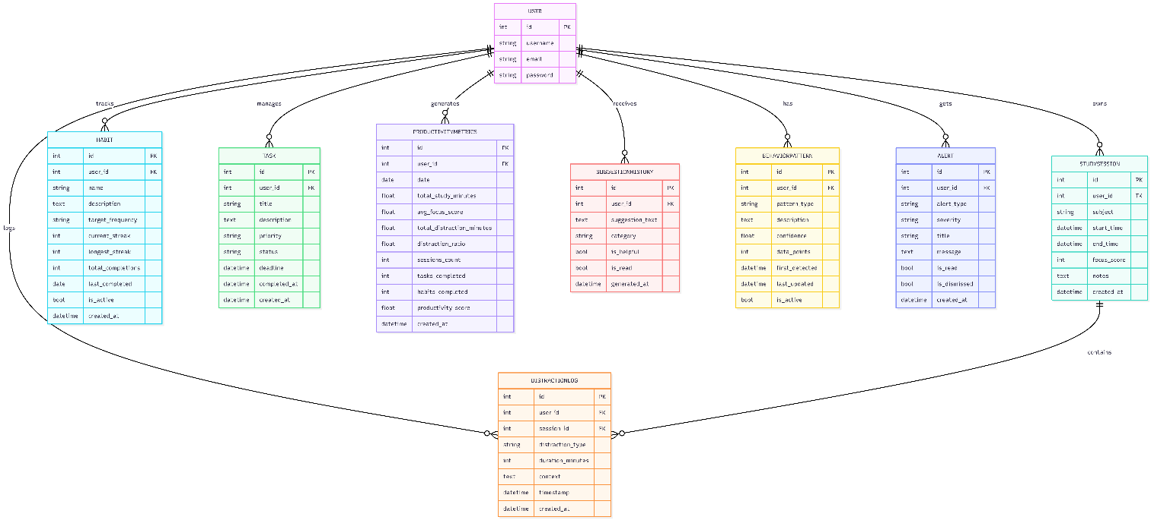
Fig: ER Diagram — All 8 Models and Their Relationships

4.3 Security Architecture
- @login_required on all 14 protected views; session-based authentication with PBKDF2 password hashing.
- All queries filter by user=request.user; get_object_or_404 validates ownership.
- CSRF tokens on all forms; Django ORM prevents SQL injection; template auto-escaping prevents XSS.
- SECRET_KEY, DEBUG, DATABASE_URL, and ALLOWED_HOSTS read from environment variables in production.
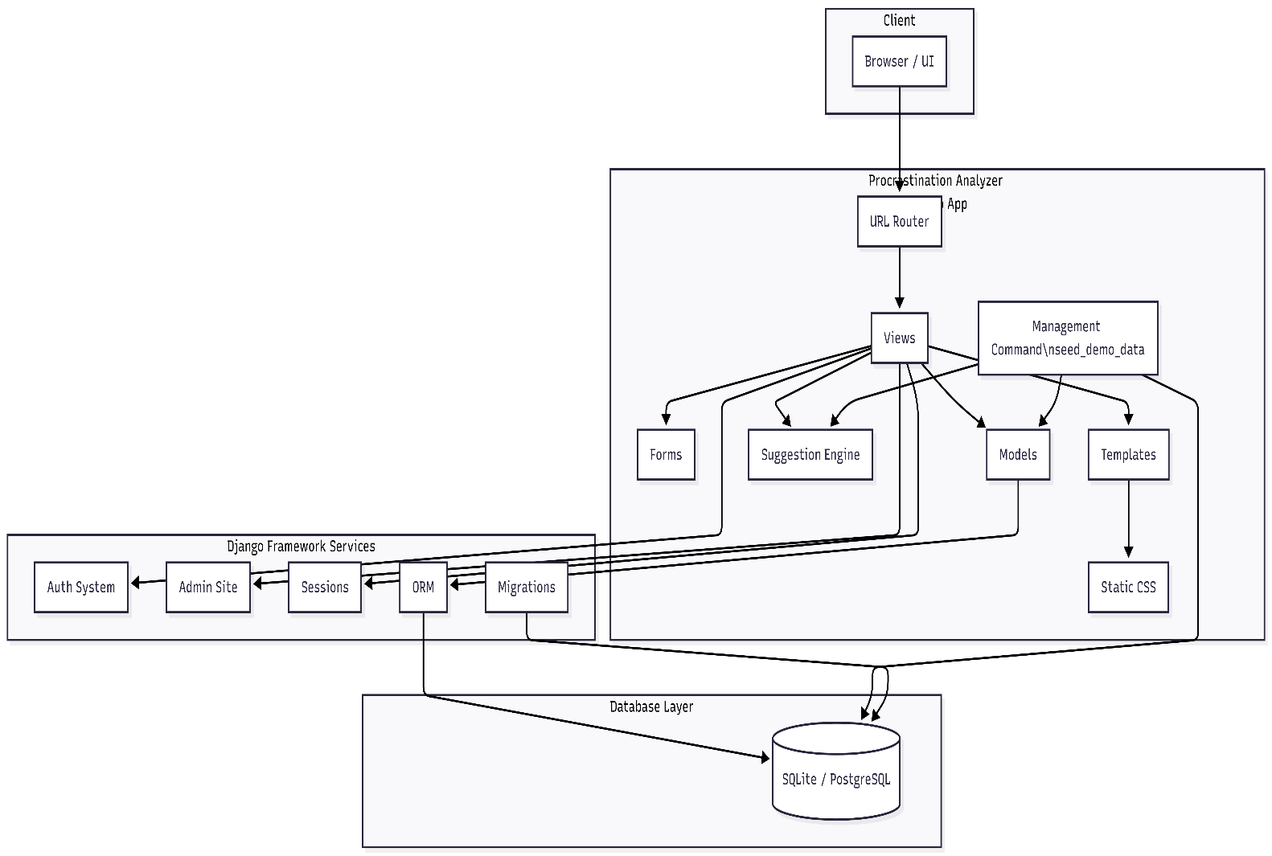

Fig: Architecture Diagram

5. Implementation Details
5.1 Core Feature Implementations
Study Session Tracking
Sessions are logged via a Django ModelForm capturing subject, start/end time, focus score (1–10), and optional notes. Duration is computed as a model property. On save, the compute_daily_metrics() function is triggered to update that day's ProductivityMetrics record. The view displays the 20 most recent sessions in a sortable table.
Distraction Logging
Users log distractions across 10 predefined categories (Social Media, Phone Notifications, Entertainment, Daydreaming, etc.) with duration in minutes and an optional link to a study session. This granular categorization allows the engine to identify the user's dominant distraction type and provide type-specific advice (9 unique strategy tips).
Habit Tracker - Streak & Stability Logic
When a user marks a habit complete, the system checks the last_completed date: if yesterday, streak increments; if any earlier date, streak resets to 1; if today, no change. The stability score (0–100) combines a consistency ratio (total completions vs. expected completions based on frequency) with a streak bonus of up to 30 points for a 30-day streak.
Rule-Based AI Suggestion Engine (suggestion_engine.py, 406 lines)
The engine's main function, analyze_and_suggest(user), applies 15 behavioral rules against 7-day and 30-day data windows and returns categorized suggestions. Key rules include:
Rule # | Condition | Category | Suggestion
1 | No sessions this week | Focus | Start with Pomodoro technique
2 | Avg focus < 4 / < 6 / ≥ 8 | Focus | Tiered feedback: improve, sustain, or celebrate
3 | > 15 distractions this week | Distraction | Distraction notepad technique
4 | Top distraction type by minutes | Distraction | One of 9 type-specific strategy tips
5 | Distraction ratio > 30% | Distraction | Pomodoro recommendation
6–8 | Broken streaks / low stability / no habits | Habit | Habit stacking, what-the-hell effect warning
9–11 | Overdue tasks / 10+ pending / no tasks | Task | Eisenhower Matrix, break into smaller steps
12–13 | Sessions < 20 min / peak time analysis | Schedule | Schedule optimization, depth over frequency
14 | > 35 study hours/week | Wellness | Burnout prevention — schedule rest
15 | 15%+ productivity improvement WoW | Focus | Positive reinforcement
Productivity Score Formula
Daily productivity score = max(0, (avg_focus/10)×40 + min(study_min/240,1)×30 − min(distraction_ratio,1)×20 + min(tasks_done/3,1)×10).
This gives a 0–100 composite score balancing focus quality (max 40 pts), study depth (max 30 pts), distraction penalty (max −20 pts), and task completion (max 10 pts).

5.2 AJAX Endpoints and Real-Time Features
Endpoint | Trigger | Response
/habits/complete/<pk>/ | Mark habit done | JSON: new streak, total, stability_score
/tasks/complete/<pk>/ | Mark task done | JSON: success + slide-out CSS animation
/alerts/dismiss/<pk>/ | Dismiss alert | JSON: success
/suggestions/rate/<pk>/ | Thumbs up/down | JSON: success
/api/unread-count/ | Polls every 30s | JSON: {count: N} — updates navbar badge

6. User Experience and Interface Design
6.1 Design Philosophy
The UI follows a premium dark glassmorphism aesthetic using 884 lines of custom CSS with CSS custom properties for theming. Design goals were clarity (data readable at a glance), responsiveness (Bootstrap 5 grid, sidebar collapses at < 992px), and interactivity (AJAX for all completion and dismiss actions). Typography uses Google Fonts Inter at weights 300–800.
6.2 Key Screens
Dashboard: 4 summary cards (weekly study hours, avg focus, distractions, tasks done), dual-axis Chart.js line chart (study hours + focus trend), doughnut chart (distraction distribution), animated SVG productivity score ring, top 5 habit streaks with stability bars, and recent alerts preview.
Analytics: 30-day deep-dive with 5 interactive charts: productivity trend, study hours bar chart, focus score line, distraction ratio area chart, and habit stability. Detected behavioral patterns are shown with confidence progress bars.

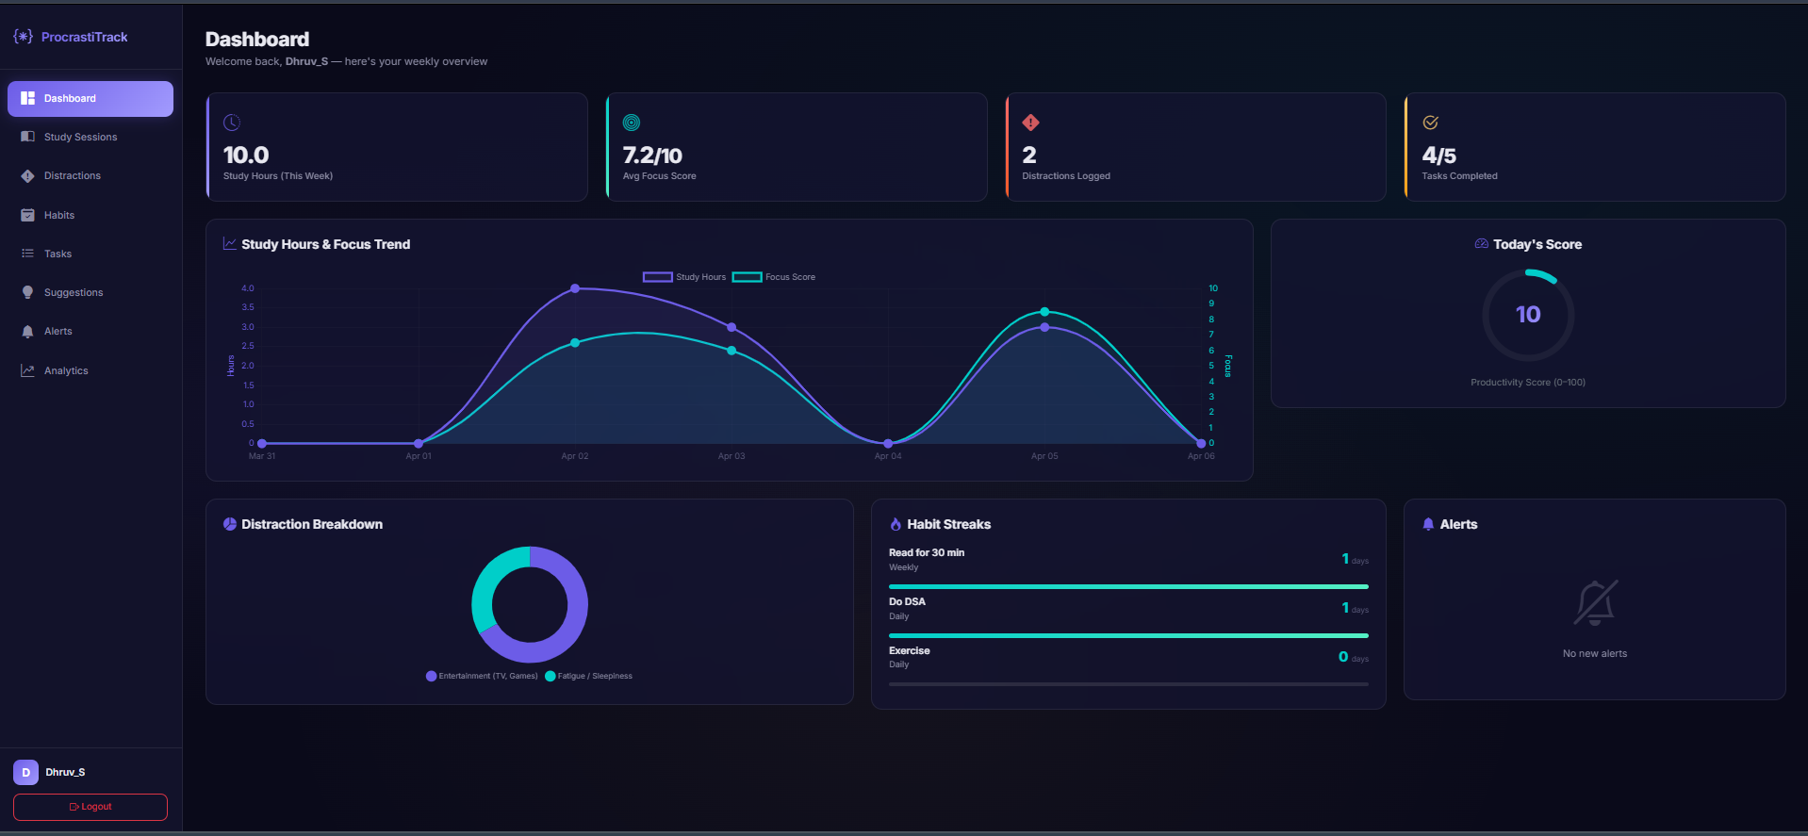
Fig: Main Dashboard — Weekly Summary Cards, Charts, and Productivity Ring

7. Testing and Validation
7.1 Testing Approach
All 24 functional requirements were tested manually. Form validation was tested with both valid inputs and edge cases (e.g., end_time before start_time, focus score outside 1–10). AJAX endpoints were inspected via browser developer tools. Security was tested by accessing protected URLs without login (should redirect) and attempting cross-user data access (should 404).
7.2 Functional Requirements - Verification Summary
FR ID | Requirement | Status
FR-01/02 | User registration and login/logout | Pass
FR-03/04 | Log, view, and delete study sessions | Pass
FR-05/06 | Log distractions; link to session | Pass
FR-07–10 | Create habits; AJAX completion; streak tracking; archive | Pass
FR-11–13 | Create tasks; AJAX completion; overdue auto-detection | Pass
FR-14/15 | Generate 15-rule suggestions; rate as helpful/unhelpful | Pass
FR-16/17 | Compute daily metrics; detect behavioral patterns | Pass
FR-18/19 | Generate alerts; dismiss via AJAX | Pass
FR-20/21 | 7-day dashboard and 30-day analytics with charts | Pass
FR-22–24 | Real-time alert badge; seed demo data; admin panel | Pass

8. Results and Discussion
8.1 Project Outcomes
All 24 functional requirements and all 7 project objectives stated in the synopsis were fully achieved. The completed system comprises 3,200+ lines of application code across ~120 KB, 8 database models, 17 view functions, 17 URL patterns, a 15-rule behavioral suggestion engine, 7 interactive Chart.js charts, 5 AJAX endpoints, and 10 distinct security measures.
8.2 Strengths
- Comprehensive integration: Session tracking, distraction logging, habit management, task management, AI suggestions, pattern detection, and alerting in one platform.
- Production-ready architecture: PostgreSQL support, WhiteNoise, Gunicorn, and environment-variable configuration from the start.
- Security-first design: 10 security layers including per-query data isolation, CSRF protection, and PBKDF2 hashing.
- Effective rule-based engine: 15 rules cover a wide range of scenarios from severe procrastination to early burnout signs.
8.3 Limitations
- Rule-based rather than ML: The engine uses manually written rules, limiting adaptive personalization beyond predefined conditions.
- No email or push notifications: Alerts are only visible inside the app; no out-of-app reminders exist.
- No data export: Users cannot download their data as CSV or PDF for offline review.

9. Future Work and Recommendations
9.1 Planned Enhancements
- Pomodoro Timer: Built-in timer that auto-starts and logs study sessions on completion.
- PDF/CSV Export: Downloadable productivity reports for academic record-keeping.
- Email Notifications: Daily/weekly summaries and overdue task reminders via transactional email.
- Automated Test Suite: Django unit tests for all model methods, view functions, and engine rules.
- Machine Learning Engine: Replace the rule-based engine with a classifier trained on user feedback (helpful/unhelpful ratings) for adaptive, personalized suggestions.
- Mobile App: Companion mobile app using the existing AJAX endpoints as a REST API foundation.
- Collaborative Features: Group study rooms, peer accountability, and shared habit challenges.
- Caching and Async Tasks: Redis caching and Celery task queue for background metric computation at scale.

10. Conclusion
ProcrastiTrack successfully demonstrates that a full-stack web application can make behavioral productivity analytics accessible to students. By combining study session tracking, distraction logging, habit management, task management, a rule-based AI suggestion engine, pattern detection, and interactive dashboards into a single platform, the system addresses a genuine and widespread problem in student life.
The most significant technical contributions are the composite productivity score formula — which unifies focus quality, study depth, distraction penalty, and task completion into a single 0–100 metric — and the 15-rule suggestion engine that translates raw behavioral data into context-specific, actionable advice. All 24 functional requirements were fully implemented and verified, and the application is architected for production deployment on cloud platforms.
With planned future enhancements including a machine learning suggestion engine, email notifications, and a mobile companion app, ProcrastiTrack has the potential to evolve into a comprehensive, real-world EdTech platform that meaningfully supports students in building productive academic habits.

References
[1] Django Software Foundation. (2024). Django Documentation — Version 5.0. https://docs.djangoproject.com/en/5.0/
[2] Bootstrap Team. (2024). Bootstrap 5.3 Documentation. https://getbootstrap.com/docs/5.3/
[3] Chart.js Contributors. (2024). Chart.js Documentation — Version 4.4. https://www.chartjs.org/docs/latest/
[4] jQuery Foundation. (2024). jQuery API Documentation — Version 3.7. https://api.jquery.com/
[5] WhiteNoise Authors. (2024). WhiteNoise Documentation. https://whitenoise.readthedocs.io/
[6] Steel, P. (2007). The Nature of Procrastination: A Meta-Analytic and Theoretical Review. Psychological Bulletin, 133(1), 65–94.
[7] Mozilla Developer Network. (2024). Web APIs Reference. https://developer.mozilla.org/en-US/
[8] Gunicorn Authors. (2024). Gunicorn Documentation. https://docs.gunicorn.org/

