Design Feedback Report
Generated on: 7/12/2025, 4:04:18 pm

Deck: hindi-concurrency

Feedback #1 - Slide 2
Timestamp | 7/12/2025, 3:58:41 pm
Instruction | please add some more text here in the container

Slide Code (HindiIntro.jsx):
import { motion } from 'framer-motion';

const HindiIntro = () => {
return (
<div className="h-full flex flex-col justify-center max-w-6xl mx-auto">
<h2 className="text-5xl font-bold mb-12 text-blue-400">1. Introduction to Concurrency</h2>

<div className="grid grid-cols-2 gap-12">
<div className="space-y-8">
<motion.div
initial={{ x: -50, opacity: 0 }}
animate={{ x: 0, opacity: 1 }}
transition={{ delay: 0.2 }}
className="bg-white/5 p-6 rounded-xl border border-white/10"
>
<h3 className="text-2xl font-bold mb-4 text-purple-400">Concurrency क्या है?</h3>
<p className="text-xl text-gray-300 leading-relaxed">
Concurrency का मतलब है एक साथ कई कार्यों (tasks) को <strong>manage</strong> करना। यह ज़रूरी नहीं कि वे एक ही समय पर execute हो रहे हों।
</p>
</motion.div>

<motion.div
initial={{ x: -50, opacity: 0 }}
animate={{ x: 0, opacity: 1 }}
transition={{ delay: 0.4 }}
className="bg-white/5 p-6 rounded-xl border border-white/10"
>
<h3 className="text-2xl font-bold mb-4 text-green-400">Concurrency बनाम Parallelism</h3>
<ul className="list-disc pl-6 space-y-2 text-gray-300">
<li><strong>Concurrency:</strong> एक साथ कई चीजों से निपटना। (Structure)</li>
<li><strong>Parallelism:</strong> एक साथ कई चीजें करना। (Execution)</li>
</ul>
</motion.div>
</div>

<motion.div
initial={{ x: 50, opacity: 0 }}
animate={{ x: 0, opacity: 1 }}
transition={{ delay: 0.6 }}
className="bg-white/5 p-6 rounded-xl border border-white/10"
>
<h3 className="text-2xl font-bold mb-4 text-orange-400">Go क्यों बेहतर है?</h3>
<ul className="list-disc pl-6 space-y-4 text-gray-300 text-lg">
<li><strong>Lightweight Threads:</strong> Goroutines OS threads से बहुत हल्की होती हैं (सिर्फ 2KB stack)।</li>
<li><strong>Smart Scheduler:</strong> Go का runtime scheduler (GMP) goroutines को कुशलतापूर्वक manage करता है।</li>
<li><strong>Channels:</strong> Communication के लिए सुरक्षित और सरल तरीका।</li>
</ul>
</motion.div>
</div>
</div>
);
};

export default HindiIntro;

Screenshots:
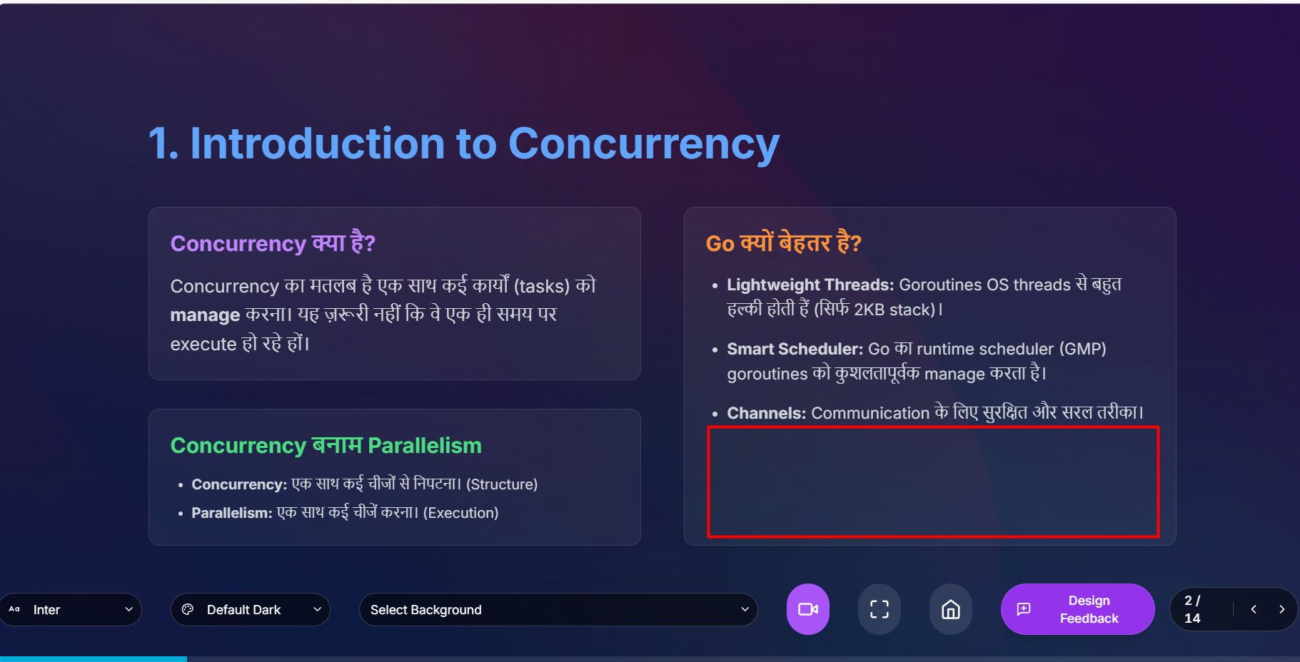
Feedback #1765103321206
____________________________________________________________

Feedback #1 - Slide 4
Timestamp | 7/12/2025, 3:08:01 pm
Instruction | please add some animation and motion graphics here

Slide Code (HindiGMP.jsx):
import { motion } from 'framer-motion';

const HindiGMP = () => {
return (
<div className="h-full flex flex-col justify-center max-w-6xl mx-auto">
<h2 className="text-5xl font-bold mb-12 text-blue-400">3. Go Scheduler (GMP Model)</h2>

<div className="grid grid-cols-2 gap-12">
<div className="space-y-8">
{/* GMP Components */}
<motion.div
initial={{ opacity: 0, x: -20 }}
animate={{ opacity: 1, x: 0 }}
whileHover={{ scale: 1.02, boxShadow: "0 0 20px rgba(59,130,246,0.3)" }}
className="bg-white/5 p-6 rounded-xl border border-white/10 cursor-pointer transition-all"
>
<h3 className="text-2xl font-bold mb-4 text-purple-400">GMP Components</h3>
<ul className="space-y-4 text-gray-300 text-lg">
<motion.li
initial={{ opacity: 0, x: -10 }}
animate={{ opacity: 1, x: 0 }}
transition={{ delay: 0.1 }}
>
<strong className="text-blue-300">G (Goroutine):</strong> Code जो execute हो रहा है।
</motion.li>
<motion.li
initial={{ opacity: 0, x: -10 }}
animate={{ opacity: 1, x: 0 }}
transition={{ delay: 0.2 }}
>
<strong className="text-green-300">M (Machine):</strong> OS Thread जो code run करता है।
</motion.li>
<motion.li
initial={{ opacity: 0, x: -10 }}
animate={{ opacity: 1, x: 0 }}
transition={{ delay: 0.3 }}
>
<strong className="text-orange-300">P (Processor):</strong> Logical processor जो Gs को M पर schedule करता है।
</motion.li>
</ul>
</motion.div>

{/* Work Stealing */}
<motion.div
initial={{ opacity: 0, x: -20 }}
animate={{ opacity: 1, x: 0 }}
transition={{ delay: 0.2 }}
whileHover={{ scale: 1.02, boxShadow: "0 0 20px rgba(59,130,246,0.3)" }}
className="bg-white/5 p-6 rounded-xl border border-white/10 cursor-pointer transition-all"
>
<h3 className="text-2xl font-bold mb-4 text-yellow-400">Work Stealing</h3>
<p className="text-lg text-gray-300">
जब एक Processor (P) के पास काम खत्म हो जाता है, तो वह दूसरे P की queue से आधा काम "चुरा" लेता है (steals)। इससे CPU cores का efficient use होता है।
</p>
</motion.div>
</div>

{/* Right side - GMP Visual Representation with animations */}
<motion.div
initial={{ opacity: 0, scale: 0.9 }}
animate={{ opacity: 1, scale: 1 }}
transition={{ delay: 0.4 }}
className="flex items-center justify-center bg-white/5 rounded-xl border border-white/10 p-8"
>
<div className="flex flex-col items-center gap-4">
{/* Goroutines (G) with staggered animation */}
<div className="flex gap-4">
{['G', 'G', 'G'].map((label, index) => (
<motion.div
key={index}
initial={{ opacity: 0, y: 20 }}
animate={{ opacity: 1, y: 0 }}
transition={{ delay: 0.5 + index * 0.15 }}
whileHover={{ scale: 1.15 }}
className="w-16 h-16 rounded-full bg-blue-500 flex items-center justify-center text-white font-bold text-xl cursor-pointer hover:shadow-lg hover:shadow-blue-500/50 transition-all"
style={{ boxShadow: "0 0 15px rgba(59,130,246,0.4)" }}
>
{label}
</motion.div>
))}
</div>

{/* Divider line with fade-in animation */}
<motion.div
initial={{ opacity: 0, height: 0 }}
animate={{ opacity: 1, height: 32 }}
transition={{ delay: 0.65 }}
className="h-8 w-1 bg-gradient-to-b from-gray-500 to-orange-500"
/>

{/* Processor (P) - scales from center */}
<motion.div
initial={{ opacity: 0, x: -20, rotate: -10 }}
animate={{ opacity: 1, x: 0, rotate: 0 }}
transition={{ delay: 0.8 }}
whileHover={{ scale: 1.1, rotate: 5 }}
className="w-32 h-32 rounded-lg bg-orange-500 flex items-center justify-center text-white font-bold text-2xl cursor-pointer hover:shadow-lg hover:shadow-orange-500/50 transition-all"
style={{ boxShadow: "0 0 20px rgba(249,115,22,0.5)" }}
>
P
</motion.div>

{/* Divider line */}
<motion.div
initial={{ opacity: 0, height: 0 }}
animate={{ opacity: 1, height: 32 }}
transition={{ delay: 0.9 }}
className="h-8 w-1 bg-gradient-to-b from-orange-500 to-green-600"
/>

{/* Machine/Thread (M) - enters from right */}
<motion.div
initial={{ opacity: 0, x: 20, rotate: 10 }}
animate={{ opacity: 1, x: 0, rotate: 0 }}
transition={{ delay: 1.0 }}
whileHover={{ scale: 1.1, rotate: -5 }}
className="w-40 h-20 rounded-lg bg-green-600 flex items-center justify-center text-white font-bold text-2xl cursor-pointer hover:shadow-lg hover:shadow-green-600/50 transition-all"
style={{ boxShadow: "0 0 20px rgba(22,163,74,0.5)" }}
>
M (Thread)
</motion.div>

{/* Flow direction indicator */}
<motion.div
initial={{ opacity: 0 }}
animate={{ opacity: 0.6 }}
transition={{ delay: 1.2 }}
className="text-center mt-4 text-gray-400 text-sm"
>
↓ Schedule Flow ↓
</motion.div>
</div>
</motion.div>
</div>
</div>
);
};

export default HindiGMP;

Screenshots:
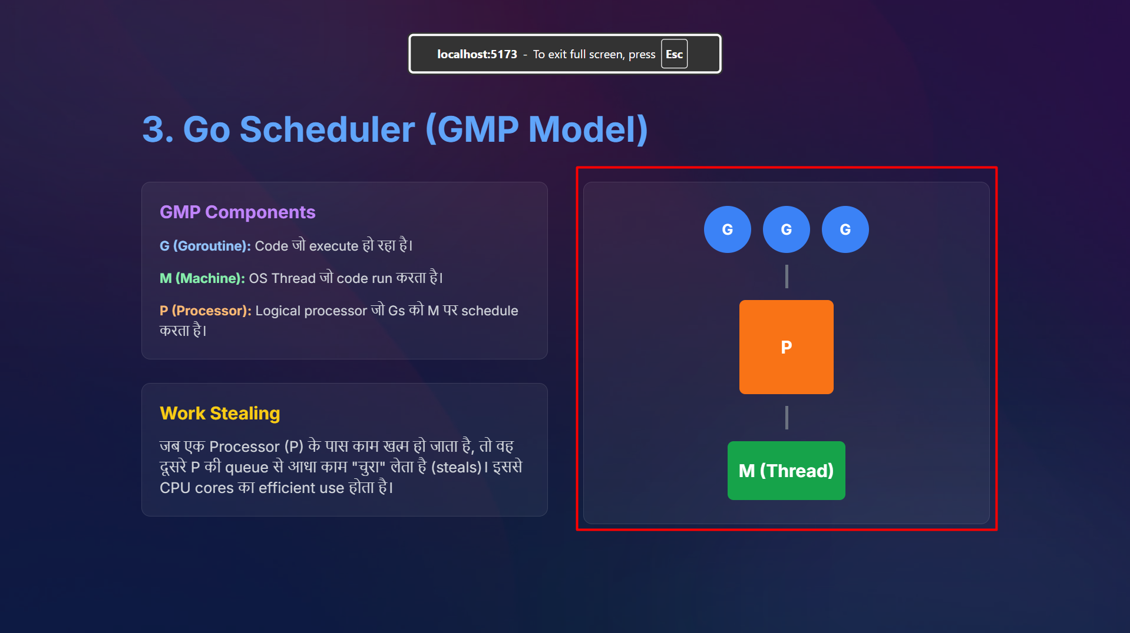
Feedback #1765100281316
____________________________________________________________

