MongoDB Task

- Connecting mongoDB cluster using the connection string:
connection string for shell:
mongosh "mongodb+srv://mongodb-assignment.uoynp.mongodb.net/" --apiVersion 1 --username dhruvnpatel
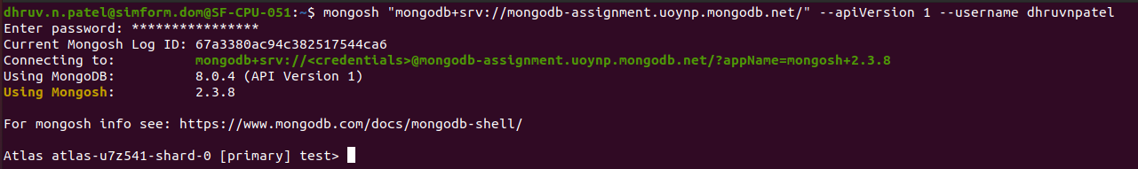
- Current database in mongoDB:
show dbs

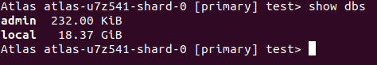
- create database name : mongoDB_task
use mongoDB_task

1) Batch Create with minimum 100 records in MongoDb (create batch).

const cities = ["New York", "Los Angeles", "Chicago", "Houston", "San Francisco"];
const statuses = ["active", "deactivated"];
const records = [];

for (let i = 1; i <= 200; i++) {
const duplicateFlag = Math.round(Math.random()); // Randomly 0 or 1
const record = {
name: `User${i}`,
age: Math.floor(Math.random() * 51) + 20, // Random age between 20-70
email: `user${i}@example.com`,
city: cities[Math.floor(Math.random() * cities.length)], // Random city
status: statuses[Math.floor(Math.random() * statuses.length)], // Random status
};

records.push(record); // Insert normally

if (duplicateFlag === 1) {
records.push({ ...record }); // Insert duplicate
}
}

db.users.insertMany(records)

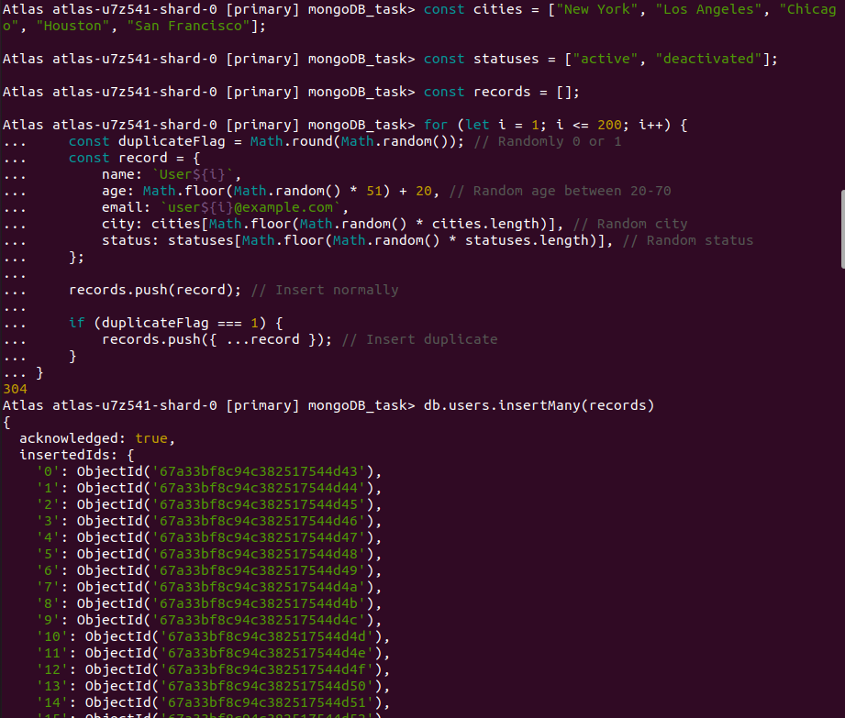

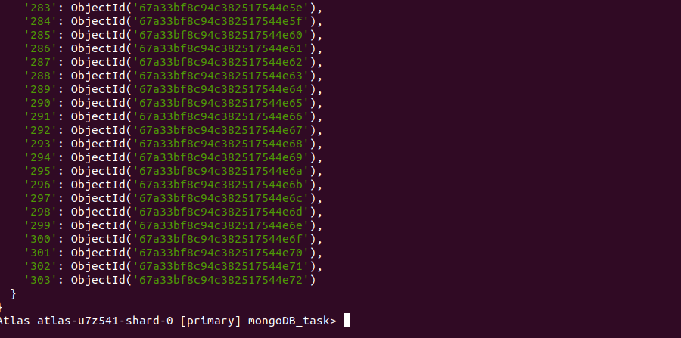

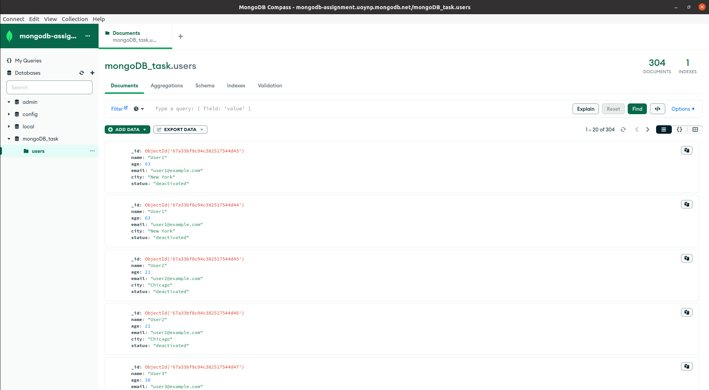

2) Batch Update with minimum 100 records in MongoDB (update batch).

db.users.updateMany(
{"status":"active"},
{$inc:{age:1}}
)
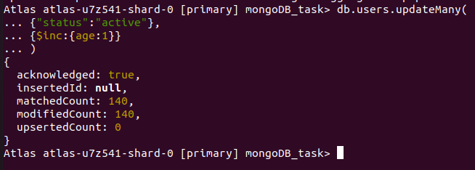

3) Perform indexing on particular 3 fields in MongoDB.

Before indexing :

db.users.explain().find({"city": "Chicago", "status": "active", "age": { $gt: 40 ,$lt:60} })

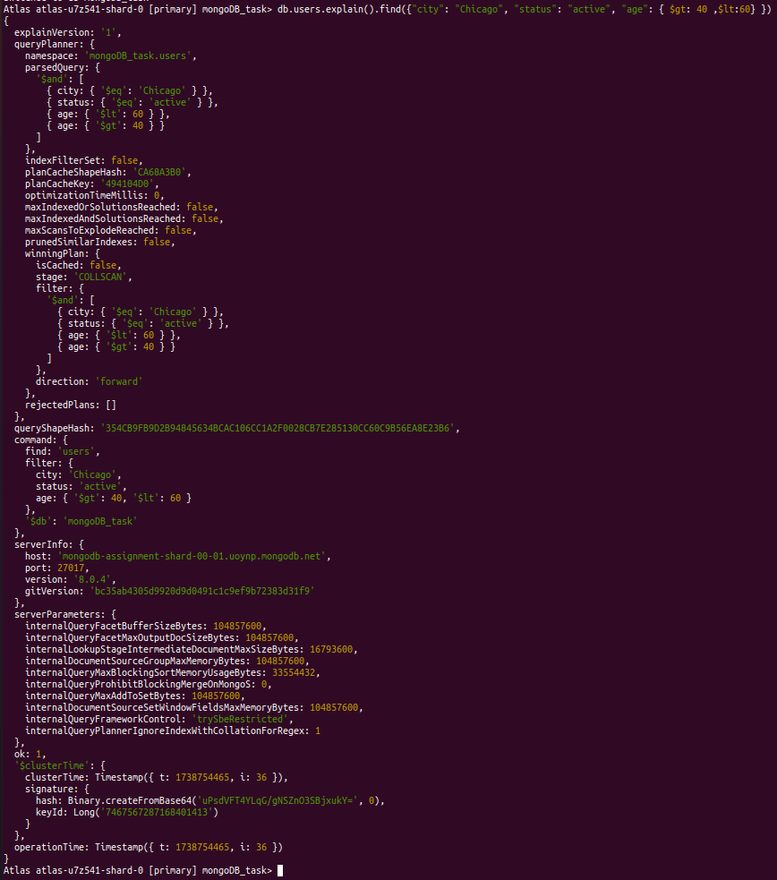

indexing :

db.users.explain().find({"city": "Chicago", "status": "active", "age": { $gt: 40 ,$lt:60} })
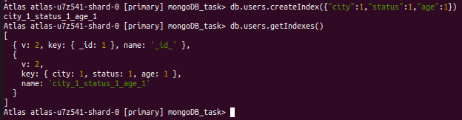
after Indexing :

db.users.explain().find({"city": "Chicago", "status": "active", "age": { $gt: 40 ,$lt:60} })

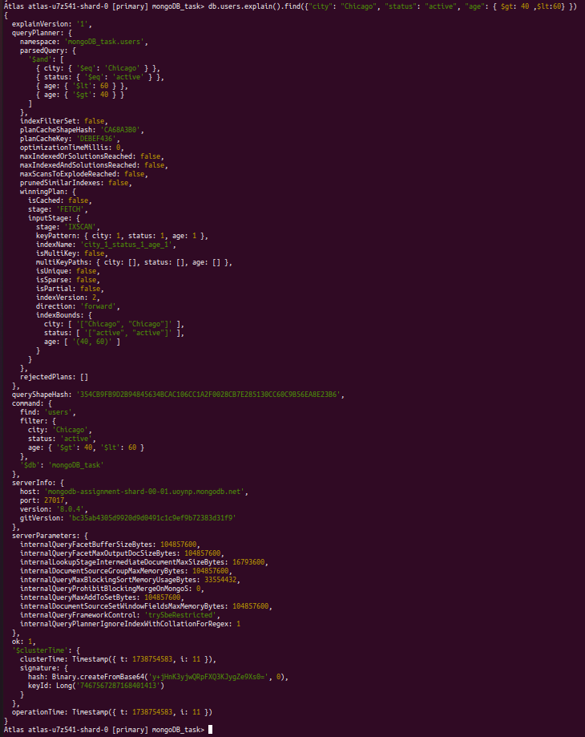
4) Find duplicates using aggregation in MongoDB

db.users.aggregate([
{
$group: {
_id: {
name: "$name",
age: "$age",
email: "$email",
city: "$city",
status: "$status"
},
count: { $sum: 1 }
}
},
{
$match: {
count: { $gt: 1 }
}
},
{
$project: {
_id: 0,
name: "$_id.name",
age: "$_id.age",
email: "$_id.email",
city: "$_id.city",
status: "$_id.status",
count: 1
}
}
]);

