ISTE 330 Database Connectivity and Access
Esports Tournament Management System
Milestone 1: Specification, Design and Project Plan
Group 1
Member | RIT ID | Role
Dhruva Ravindran | dsr1378 | Project Lead and Documentation
Abdullojon Ziyaev | za9369 | Database Architect
Faizahnadir Nathershah | fn6379 | Database Logic and Sample Data
Abdullah Naseem | afn5363 | Java Back-End (JDBC)
Swati Poojary | sp6056 | Java Front-End, Reports and Testing
Submitted: Friday, October 30, 2026

Contents
1. Problem Specification 3
2. Feature List 5
3. Database Design 6
4. Entity Relationship Diagram 9
5. UML Diagrams 10
6. Gantt Chart 13
7. Data Dictionary 14
8. Team Responsibilities 18
9. Risk Assessment 19

1. Problem Specification

1.1 The Problem
An esports organization needs software to manage its tournaments: the teams, coaches and players taking part, team registrations, match schedules, match results, standings and reports. Keeping this information in separate files makes it hard to keep accurate, and hard to answer simple questions such as who is leading a tournament or which players are on a team right now.
We will build a Java application that connects to a MySQL database through JDBC and keeps all of this information in one place. Each person logs in with their own account and can only use the functions that fit their role: Tournament Director, Coach or Player.

1.2 Who Uses the System
User type | Who they are | What they need to do
Tournament Director | Staff member who organizes and runs tournaments | Create and manage tournaments, schedule matches, record results, register teams, create accounts, see every report
Coach | Person responsible for one or more teams | Manage their team rosters, add or remove players, sign their teams up for tournaments, follow schedules and standings
Player | Competitor who belongs to one or more teams | See their own profile, teams, upcoming matches, results and personal statistics; update their own contact details

1.3 What the System Will Do
Functional requirements (FR):
- FR1 Log in: every user logs in with a username and password. The password is checked against a salted hash stored in the database; plain-text passwords are never stored.
- FR2 Role-based access: after login the user can only use the functions of the role stored on their account (Director, Coach or Player).
- FR3 Tournaments: a director can create, view, search, edit and delete tournaments (name, game, dates, location, prize pool, maximum teams, status).
- FR4 Teams and rosters: teams belong to one game and one coach. Players join and leave teams over time, and the history is kept.
- FR5 Registrations: a team can register for a tournament only if the tournament is open, the team plays the same game, it is not already registered, and the tournament is not full.
- FR6 Matches: a director schedules matches between two teams registered in the same tournament, then records the final score. Draws are not allowed.
- FR7 Player statistics: kills, deaths and assists are kept for each player in each completed match.
- FR8 Reports: at least five reports - tournament standings, match schedule, tournament registrations, team rosters and player statistics.
- FR9 Search: a director can search tournaments, teams and players by name.

1.4 Quality Requirements
- Zero-confusion deployment: the instructor runs one SQL script and one obvious Java entry point, then logs in with the test accounts. No searching through folders, code or configuration, and no extra data entry.
- Security: passwords are never stored as plain text; they are stored as salted hashes and checked against the database at login.
- Safe SQL: PreparedStatements for login, inserts, updates, deletes and searches; CallableStatements for stored procedures.
- Data integrity: primary keys, foreign keys and constraints enforce the business rules in the database itself.
- Error handling: database errors are caught and shown as clear messages instead of crashing the program.
- Clean submission: the final submission contains only the files that are required to run and evaluate the system.

1.5 Technical Requirements Covered
Course requirement | How we will meet it
Minimum 8 tables, PKs, FKs, normalization | 11 tables in 3NF, every table has a primary key, 17 foreign key columns
At least two many-to-many relationships | Three: Player-Team (TeamMembership), Team-Tournament (TournamentRegistration), Player-Match (PlayerMatchStat)
Hashed passwords, login from database | UserAccount.password_hash + password_salt; Java hashes the typed password and compares
JDBC connections, ResultSets, CRUD, exceptions | DAO classes, one DatabaseConnection class, try-with-resources
PreparedStatements for login, insert, update, delete, search | All user-input SQL in the DAO layer uses PreparedStatement
Three stored procedures + CallableStatement | sp_RegisterTeamForTournament, sp_AddPlayerToTeam, sp_RecordMatchResult
Five meaningful reports | Standings, schedule, registrations, rosters, player statistics (built on SQL views)
One SQL script, test accounts, startup guide | One script (esports_tms_setup.sql) builds everything; Director, Coach and Player test accounts; one-page startup guide at Milestone 3

1.6 Deliverables and Deadlines
Milestone | Due | What we hand in
1 | Fri 30 Oct 2026 | This document: specification, feature list, ERD, UML, data dictionary, Gantt chart, team responsibilities, risk assessment
2 | Wed 18 Nov 2026 | Working demo: database and sample data, login with hashing, CRUD with PreparedStatements, one stored procedure through CallableStatement, two reports, updated UML
3 | Wed 2 Dec 2026 | Complete system, one SQL script, startup guide, README, test credentials, all reports and functions

1.7 Design Notes
These are the only business rules we have fixed so far. Anything else will be decided and documented as the project develops.
- A team plays one game, and a tournament is for one game. A coach can manage more than one team.
- The match winner is calculated from the scores rather than stored. Draws are not allowed.
- The matches table is named TournamentMatch because MATCH is a reserved word in MySQL.
- The database script has been tested on MySQL 8.0. Required software versions will be listed in the README.

2. Feature List
Planned features, who uses them, which milestone delivers them, and the JDBC technique each one demonstrates.
ID | Feature | Users | Milestone | Technique shown
F01 | Log in / log out | All | M2 | PreparedStatement, SHA-256 hash check
F02 | Role-based access (Director, Coach, Player) | All | M2 | Role from UserAccount
F03 | Create user account (hashed password) | Director | M2 | PreparedStatement INSERT
F04 | Create / edit / delete tournament | Director | M2 | PreparedStatement INSERT, UPDATE, DELETE
F05 | Search tournaments, teams, players | Director | M2 | PreparedStatement with LIKE
F06 | Register team for tournament | Director, Coach | M2 | CallableStatement: sp_RegisterTeamForTournament
F07 | Tournament standings report | All | M2 | View vw_TournamentStandings, ResultSet
F08 | Match schedule report | All | M2 | View vw_MatchSchedule, ResultSet
F09 | Schedule / edit / cancel match | Director | M3 | PreparedStatement INSERT, UPDATE
F10 | Record match result | Director | M3 | CallableStatement: sp_RecordMatchResult
F11 | Add player to team | Coach | M3 | CallableStatement: sp_AddPlayerToTeam
F12 | Remove player from team (keeps history) | Coach | M3 | PreparedStatement UPDATE leave_date
F13 | Edit team details | Coach | M3 | PreparedStatement UPDATE
F14 | Team roster report | Director, Coach | M3 | View vw_TeamRoster
F15 | Tournament registrations report | Director | M3 | View vw_TournamentRegistrations
F16 | Player statistics report | All | M3 | View vw_PlayerStatistics
F17 | View / update my profile | Player | M3 | PreparedStatement SELECT, UPDATE
F18 | View my teams, schedule and stats | Player | M3 | PreparedStatement with player_id
F19 | Clear error messages for database errors | All | M2-M3 | SQLException handling

3. Database Design

3.1 Tables
The database esports_tms has 11 tables. The full ERD is in Section 4 and every column is listed in the data dictionary in Section 7.
Table | Purpose
UserAccount | One login account per person. Holds the role and the salted password hash used for authentication.
Director | Profile of a Tournament Director (1:1 with a DIRECTOR user account).
Coach | Profile of a Coach (1:1 with a COACH user account). A coach manages one or more teams.
Player | Profile of a Player (1:1 with a PLAYER user account).
Game | Video game titles that teams play and tournaments are held in.
Team | A competitive team for one game, managed by one coach.
TeamMembership | Junction table for the Player <-> Team many-to-many relationship, with membership history.
Tournament | A tournament for one game, run by one director.
TournamentRegistration | Junction table for the Team <-> Tournament many-to-many relationship.
TournamentMatch | A scheduled match between two registered teams in a tournament, with its result.
PlayerMatchStat | Junction table for the Player <-> TournamentMatch many-to-many relationship (per-match player statistics).

3.2 Many-to-Many Relationships
Each many-to-many relationship is implemented with its own junction table. No field ever holds a list of values.
Relationship | Junction table | Primary key | Foreign keys | Business meaning
Player <-> Team | TeamMembership | (team_id, player_id, join_date) | team_id -> Team  player_id -> Player | A player can be on many teams over time; a team has many players. join_date in the key lets a player leave and later rejoin.
Team <-> Tournament | TournamentRegistration | (tournament_id, team_id) | tournament_id -> Tournament  team_id -> Team | A team enters many tournaments; a tournament has many teams. A team can register only once per tournament.
Player <-> TournamentMatch | PlayerMatchStat | (match_id, player_id) | match_id -> TournamentMatch  player_id -> Player | A player plays in many matches; a match has many players. Holds kills, deaths and assists.

Extra integrity rule: TournamentMatch uses composite foreign keys (tournament_id, home_team_id) and (tournament_id, away_team_id) that point to TournamentRegistration. The database itself therefore refuses a match between teams that are not registered in that tournament. A check constraint also stops a team from playing itself.

3.3 Normalization
Normal form | Rule | How our design meets it
1NF | Atomic values, no repeating groups | Every column holds one value. Team rosters, registrations and match stats are rows in junction tables, never comma-separated lists.
2NF | No partial dependency on part of a composite key | In the junction tables, every non-key column (e.g. team_role, seed_number, kills) depends on the whole key. Player names live in Player, not in TeamMembership.
3NF | No transitive dependency | Coach and game details are stored once and referenced by ID. The match winner and standings are calculated in views instead of being stored, so they can never disagree with the scores.

Login design: UserAccount holds only login data (username, hash, salt, role). Profile details are in Director, Coach or Player, linked one-to-one through a unique user_id. This keeps security data separate and avoids empty columns.

3.4 Stored Procedures (called with CallableStatement)
Procedure | Parameters | Checks before changing data
sp_RegisterTeamForTournament | IN tournament_id, IN team_id  OUT success, OUT message | Tournament exists and is UPCOMING; team exists; team plays the tournament's game; not already registered; tournament not full
sp_AddPlayerToTeam | IN team_id, IN player_id, IN team_role  OUT success, OUT message | Team and player exist; player not already a current member; roster below players_per_team + 2 substitutes
sp_RecordMatchResult | IN match_id, IN home_score, IN away_score  OUT success, OUT message | Match exists and is SCHEDULED; scores 0-99; no draw. Sets status to COMPLETED

Every procedure returns a success flag and a plain-English message, so the Java program can show the user exactly why something was rejected. All three were tested on MySQL 8.0 with both valid and invalid inputs.

3.5 Reports
# | Report | Source | Shows
1 | Tournament standings | vw_TournamentStandings | Played, wins, losses, score difference and points (3 per win) per team
2 | Match schedule | vw_MatchSchedule | Date, round, venue, teams, score, winner and status for each match
3 | Tournament registrations | vw_TournamentRegistrations | Teams entered in each tournament with coach, date, seed and status
4 | Team rosters | vw_TeamRoster | Current players of each team with role and join date
5 | Player statistics | vw_PlayerStatistics | Matches played, total kills, deaths, assists and K/D ratio

3.6 Password Security
- Each account has its own random 32-character salt.
- Stored value = SHA-256( salt + password ), saved as 64 hex characters.
- At login, Java reads the salt for the username, hashes the typed password the same way and compares. The plain password is never saved or printed.
- The SQL script creates the sample hashes with MySQL's SHA2() function. We confirmed that Java's MessageDigest produces exactly the same hash for the test accounts.

3.7 Sample Data Plan
Data | Amount | Why
Tournaments | 4 (1 completed, 1 ongoing, 2 upcoming) | Shows every status and lets the instructor test registration
Games | 3 | Shows that registration is limited to the matching game
Teams / coaches | 8 teams / 4 coaches | Each coach manages two teams
Players | 45 | 40 starters, 2 substitutes, 3 free agents to test Add Player
Matches | 14 (10 completed, 4 scheduled) | Standings, schedule and Record Result can all be demonstrated
Player statistics | 100 rows | Meaningful statistics report
Team history | 2 players with past teams | Demonstrates the many-to-many relationship over time

4. Entity Relationship Diagram
Crow's foot notation. Two bars = exactly one. Circle + crow's foot = zero or many. Circle + bar = zero or one. Orange tables are junction tables. (U) = unique column.
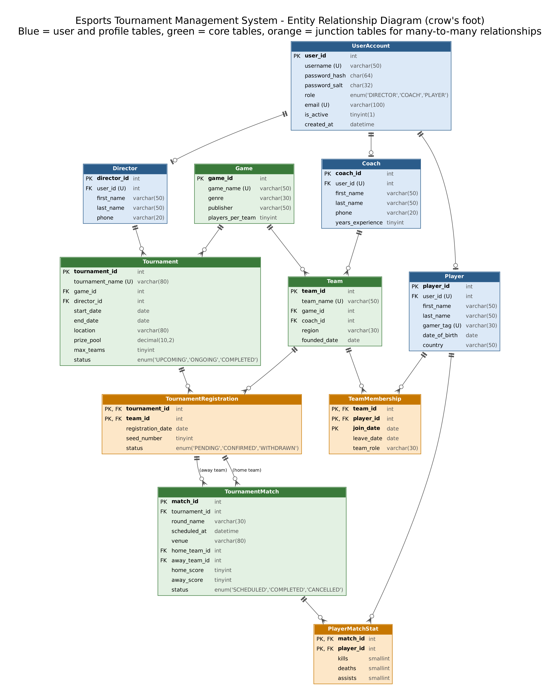
Figure 1. Entity Relationship Diagram (generated from the tested database schema)

5. UML Diagrams

5.1 Use Case Diagram
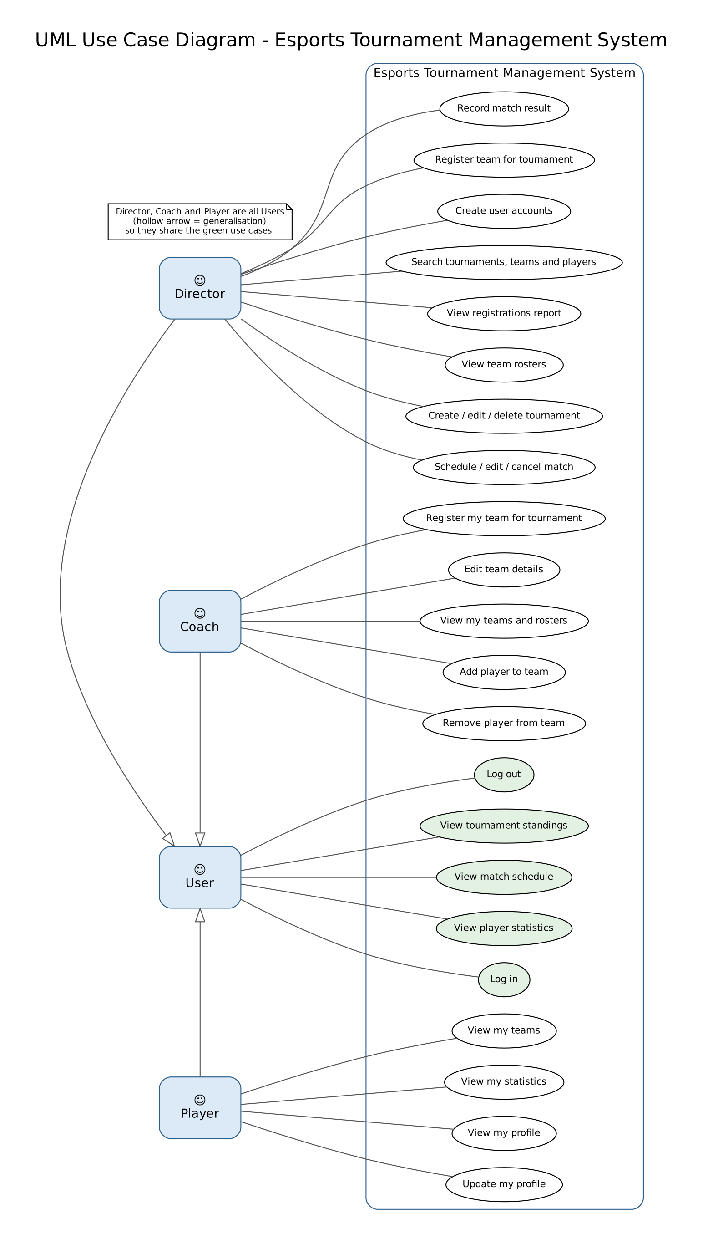
Figure 2. Use cases by user type

5.2 Class Diagram - Domain Model
One Java class per table in package model. Junction classes carry the extra data of each many-to-many relationship.
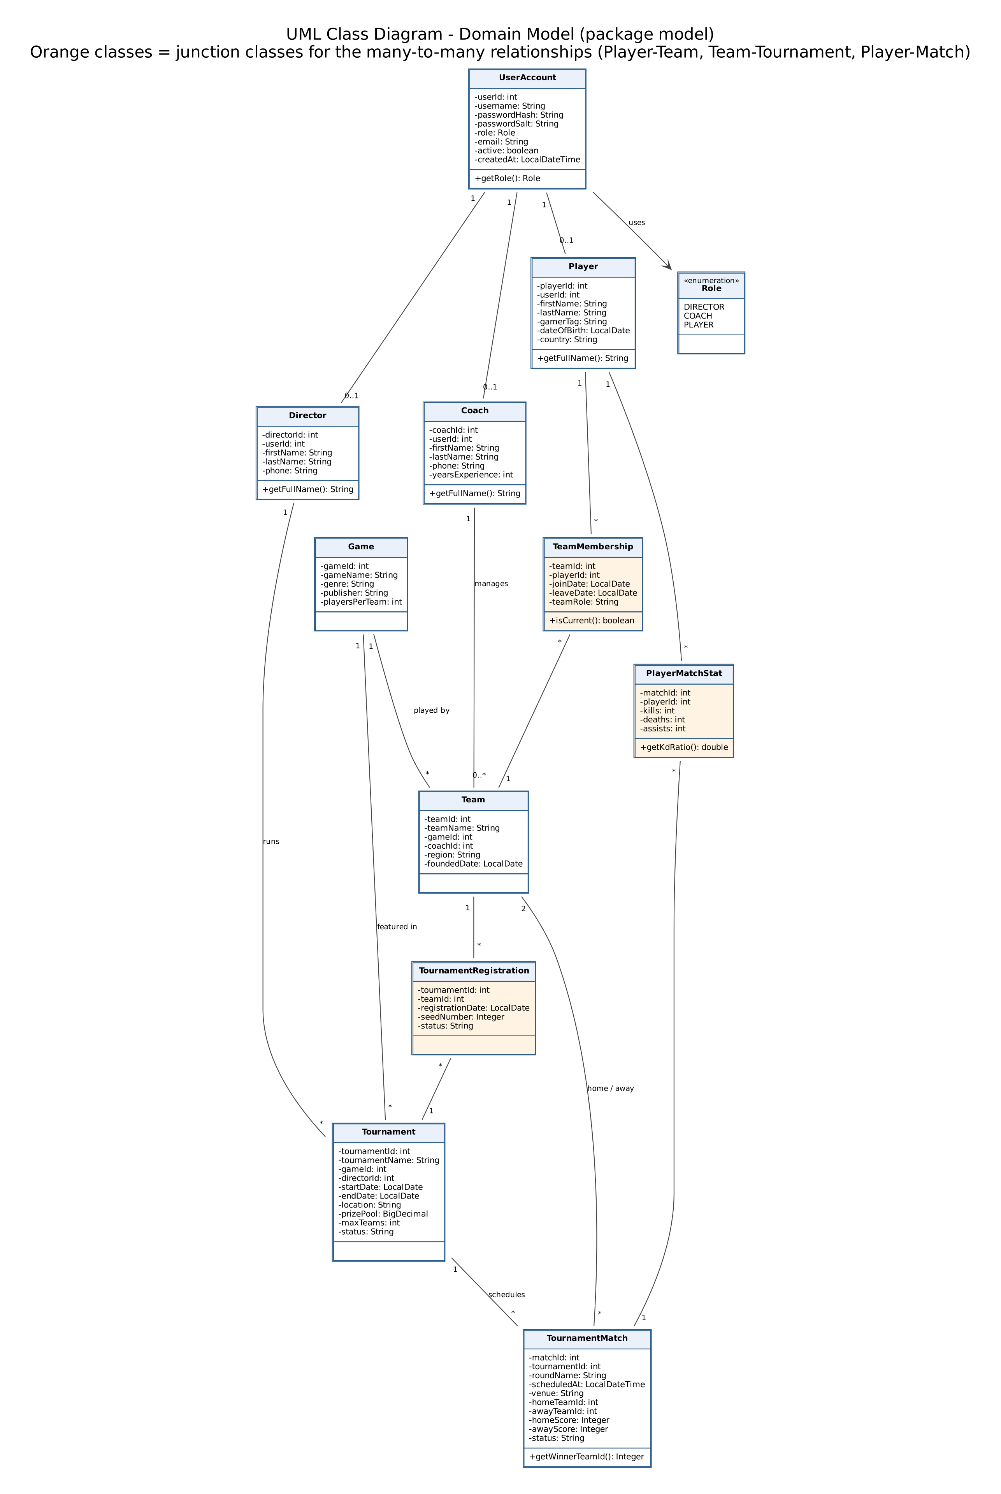
Figure 3. Domain model classes and multiplicities

5.3 Class Diagram - Application Structure
Initial design, to be updated at Milestone 2 as the spec requires. The UI never writes SQL. Menus call DAO classes; DAO classes are the only classes that use JDBC; all of them get connections from one DatabaseConnection class. Dashed arrows show dependencies.
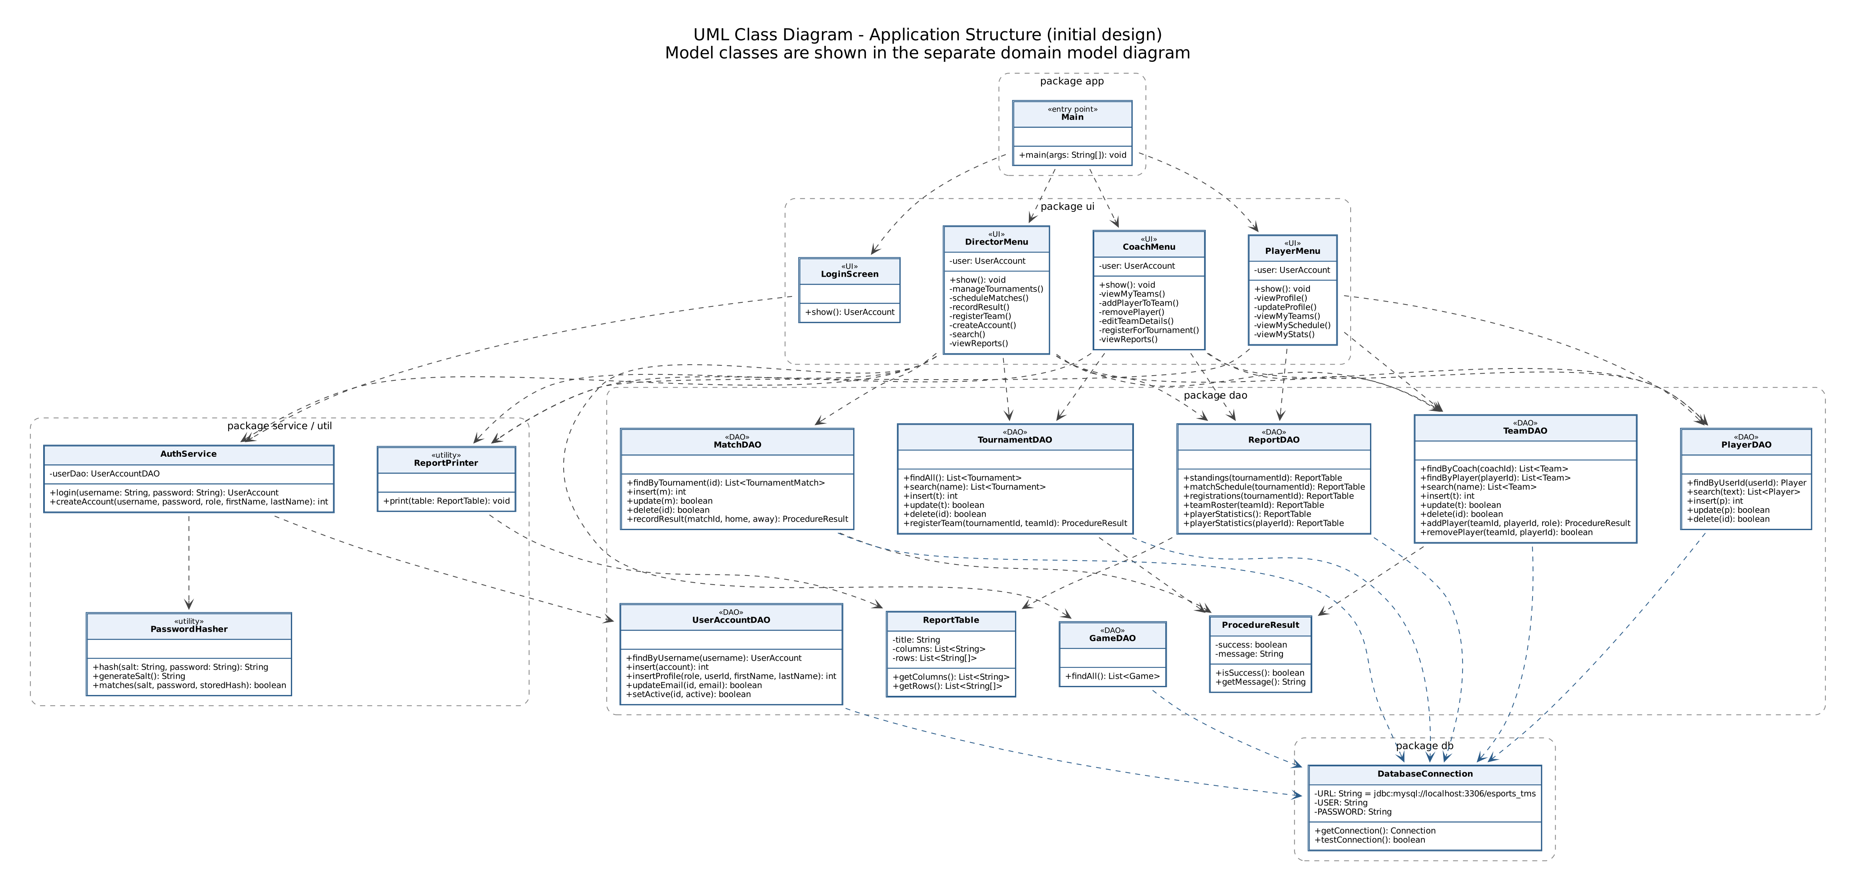
Figure 4. Initial Java package and class design

6. Gantt Chart
Built from our task plan. The editable GanttProject file is docs/milestone1/source/Project_Schedule.gan (open with ganttproject.biz). Each deadline has 1-2 days of buffer for clean-machine testing.
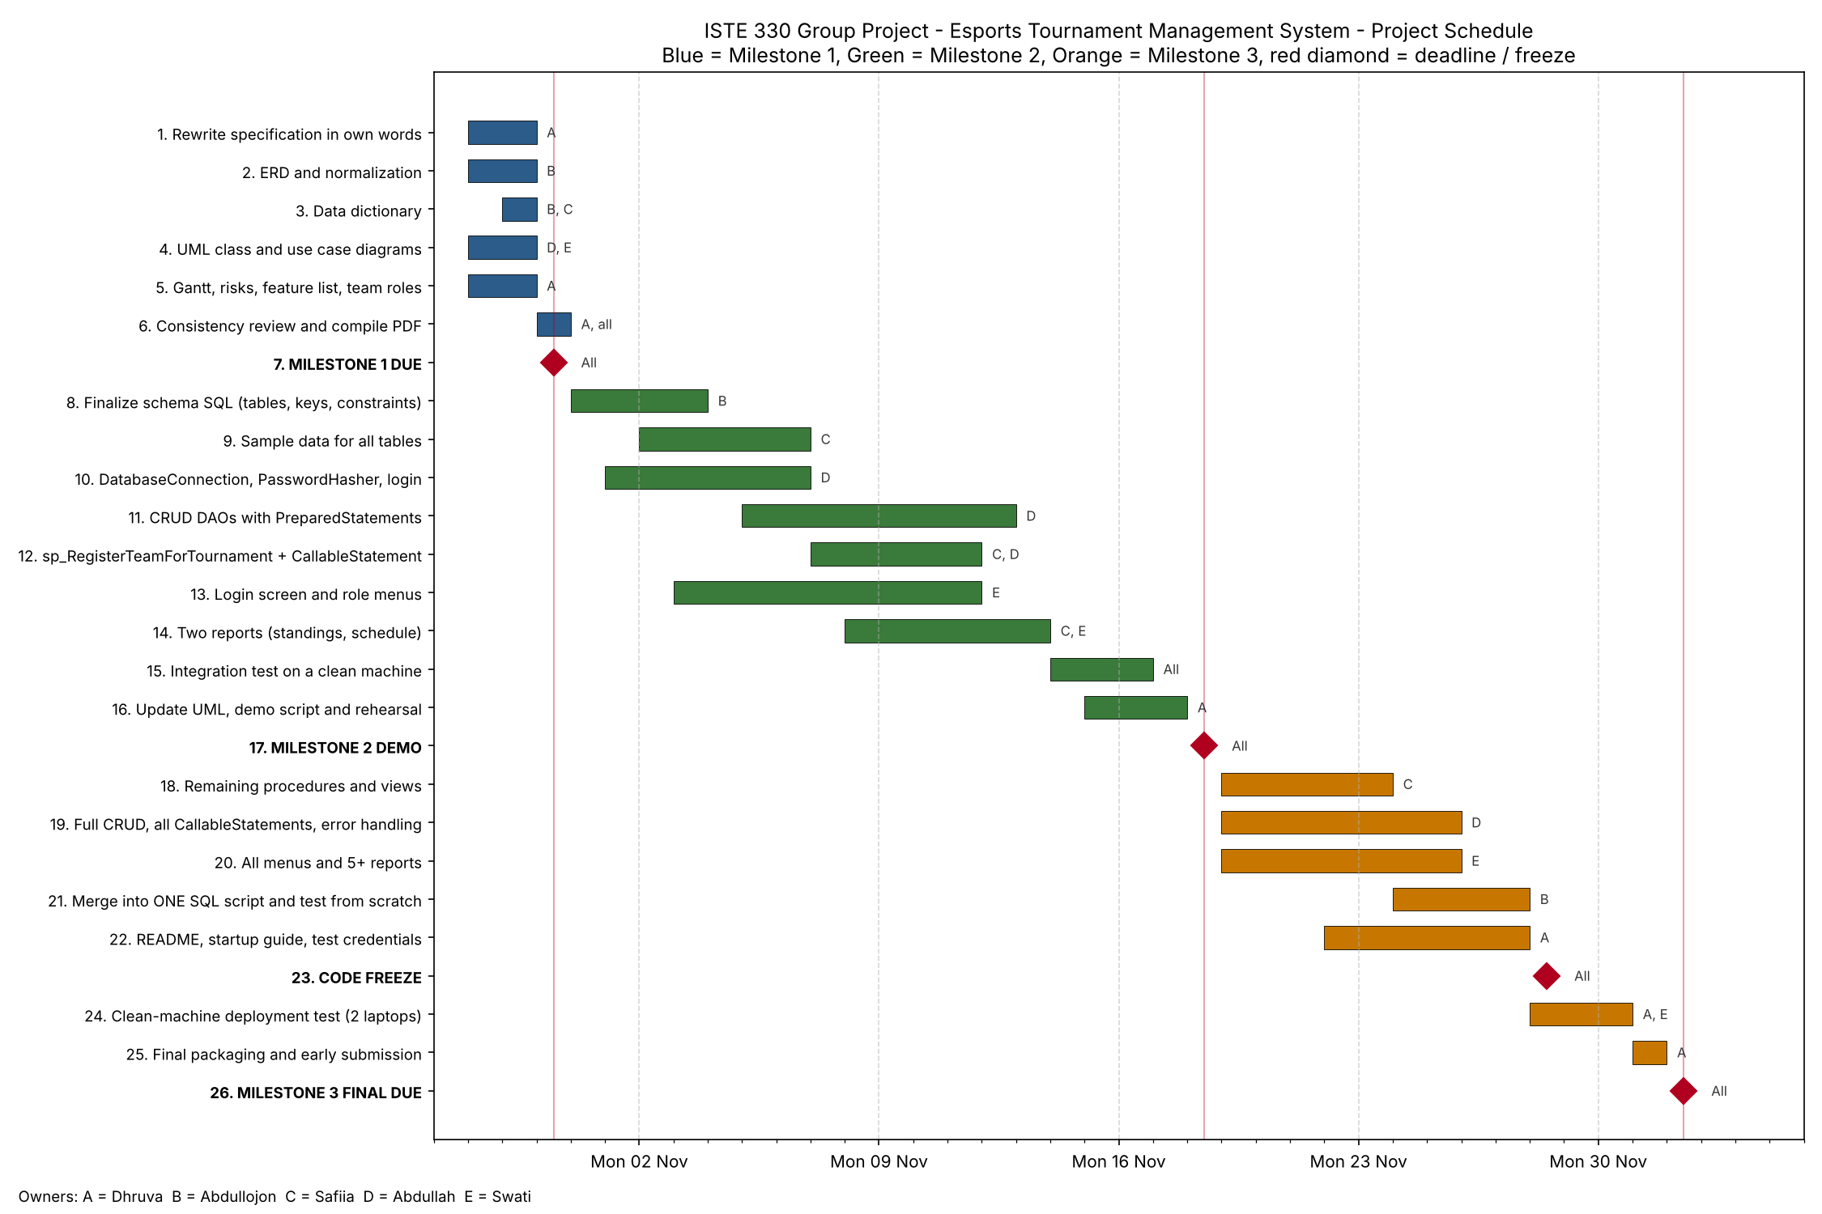
Figure 5. Project schedule, 28 Oct - 2 Dec 2026

7. Data Dictionary
Generated directly from the tested database, so names and types match the SQL script exactly. Key: PK = primary key, FK = foreign key, UQ = unique.

7.1 UserAccount
One login account per person. Holds the role and the salted password hash used for authentication.
Column | Data type | Null | Key | References | Description
user_id | int  AUTO_INCREMENT | No | PK |  | Unique account number (auto-generated).
username | varchar(50) | No | UQ |  | Login name; must be unique.
password_hash | char(64) | No |  |  | SHA-256 hash of salt + password, 64 hex characters. Plain passwords are never stored.
password_salt | char(32) | No |  |  | Random 32-character salt unique to this account.
role | enum('DIRECTOR','COACH','PLAYER') | No |  |  | User type: DIRECTOR, COACH or PLAYER. Controls the menu shown after login.
email | varchar(100) | No | UQ |  | Contact email; must be unique.
is_active | tinyint(1)  default 1 | No |  |  | 1 = can log in, 0 = account disabled.
created_at | datetime  default CURRENT_TIMESTAMP | No |  |  | Date and time the account was created.

7.2 Director
Profile of a Tournament Director (1:1 with a DIRECTOR user account).
Column | Data type | Null | Key | References | Description
director_id | int  AUTO_INCREMENT | No | PK |  | Unique director number (auto-generated).
user_id | int | No | FK, UQ | UserAccount.user_id | Login account of this director (one account per director).
first_name | varchar(50) | No |  |  | Director's first name.
last_name | varchar(50) | No |  |  | Director's last name.
phone | varchar(20) | Yes |  |  | Contact phone number (optional).

7.3 Coach
Profile of a Coach (1:1 with a COACH user account). A coach manages one or more teams.
Column | Data type | Null | Key | References | Description
coach_id | int  AUTO_INCREMENT | No | PK |  | Unique coach number (auto-generated).
user_id | int | No | FK, UQ | UserAccount.user_id | Login account of this coach (one account per coach).
first_name | varchar(50) | No |  |  | Coach's first name.
last_name | varchar(50) | No |  |  | Coach's last name.
phone | varchar(20) | Yes |  |  | Contact phone number (optional).
years_experience | tinyint  default 0 | No |  |  | Years of coaching experience (0 or more).

7.4 Player
Profile of a Player (1:1 with a PLAYER user account).
Column | Data type | Null | Key | References | Description
player_id | int  AUTO_INCREMENT | No | PK |  | Unique player number (auto-generated).
user_id | int | No | FK, UQ | UserAccount.user_id | Login account of this player (one account per player).
first_name | varchar(50) | No |  |  | Player's first name.
last_name | varchar(50) | No |  |  | Player's last name.
gamer_tag | varchar(30) | No | UQ |  | In-game name; must be unique.
date_of_birth | date | No |  |  | Player's date of birth.
country | varchar(50) | No |  |  | Country the player represents.

7.5 Game
Video game titles that teams play and tournaments are held in.
Column | Data type | Null | Key | References | Description
game_id | int  AUTO_INCREMENT | No | PK |  | Unique game number (auto-generated).
game_name | varchar(50) | No | UQ |  | Title of the game; must be unique.
genre | varchar(30) | No |  |  | Game genre, e.g. Tactical Shooter, MOBA.
publisher | varchar(50) | No |  |  | Company that publishes the game.
players_per_team | tinyint | No |  |  | Starting players per team (1-10). Roster limit = this + 2 substitutes.

7.6 Team
A competitive team for one game, managed by one coach.
Column | Data type | Null | Key | References | Description
team_id | int  AUTO_INCREMENT | No | PK |  | Unique team number (auto-generated).
team_name | varchar(50) | No | UQ |  | Team name; must be unique.
game_id | int | No | FK | Game.game_id | Game this team competes in.
coach_id | int | No | FK | Coach.coach_id | Coach who manages this team.
region | varchar(30) | No |  |  | Home region of the team.
founded_date | date | No |  |  | Date the team was founded.

7.7 TeamMembership
Junction table for the Player <-> Team many-to-many relationship, with membership history.
Column | Data type | Null | Key | References | Description
team_id | int | No | PK, FK | Team.team_id | Team the player belongs to.
player_id | int | No | PK, FK | Player.player_id | Player on the team.
join_date | date | No | PK |  | Date the player joined. Part of the key so a player can rejoin later.
leave_date | date | Yes |  |  | Date the player left; NULL = currently on the team.
team_role | varchar(30)  default Member | No |  |  | Role in the team, e.g. Captain, Member, Substitute.

7.8 Tournament
A tournament for one game, run by one director.
Column | Data type | Null | Key | References | Description
tournament_id | int  AUTO_INCREMENT | No | PK |  | Unique tournament number (auto-generated).
tournament_name | varchar(80) | No | UQ |  | Tournament name; must be unique.
game_id | int | No | FK | Game.game_id | Game played in this tournament.
director_id | int | No | FK | Director.director_id | Director responsible for this tournament.
start_date | date | No |  |  | First day of the tournament.
end_date | date | No |  |  | Last day; must be on or after start_date.
location | varchar(80) | No |  |  | Venue or online server.
prize_pool | decimal(10,2)  default 0.00 | No |  |  | Total prize money (0 or more).
max_teams | tinyint | No |  |  | Maximum number of registered teams (2 or more).
status | enum('UPCOMING','ONGOING','COMPLETED')  default UPCOMING | No |  |  | UPCOMING (open for registration), ONGOING or COMPLETED.

7.9 TournamentRegistration
Junction table for the Team <-> Tournament many-to-many relationship.
Column | Data type | Null | Key | References | Description
tournament_id | int | No | PK, FK | Tournament.tournament_id | Tournament the team entered.
team_id | int | No | PK, FK | Team.team_id | Team that registered.
registration_date | date | No |  |  | Date the team registered.
seed_number | tinyint | Yes |  |  | Seeding position (optional; set by the director).
status | enum('PENDING','CONFIRMED','WITHDRAWN')  default CONFIRMED | No |  |  | PENDING, CONFIRMED or WITHDRAWN.

7.10 TournamentMatch
A scheduled match between two registered teams in a tournament, with its result.
Column | Data type | Null | Key | References | Description
match_id | int  AUTO_INCREMENT | No | PK |  | Unique match number (auto-generated).
tournament_id | int | No | FK | TournamentRegistration.tournament_id, TournamentRegistration.tournament_id | Tournament this match belongs to.
round_name | varchar(30) | No |  |  | Stage of the tournament, e.g. Group Stage R1, Semi Final.
scheduled_at | datetime | No |  |  | Date and time the match is scheduled.
venue | varchar(80) | No |  |  | Where the match is played.
home_team_id | int | No | FK | TournamentRegistration.team_id | First team; must be registered in the same tournament.
away_team_id | int | No | FK | TournamentRegistration.team_id | Second team; must be registered in the same tournament and differ from home team.
home_score | tinyint | Yes |  |  | Final score of home team; NULL until completed.
away_score | tinyint | Yes |  |  | Final score of away team; NULL until completed. Draws not allowed.
status | enum('SCHEDULED','COMPLETED','CANCELLED')  default SCHEDULED | No |  |  | SCHEDULED, COMPLETED or CANCELLED. Winner is calculated from scores, not stored.

7.11 PlayerMatchStat
Junction table for the Player <-> TournamentMatch many-to-many relationship (per-match player statistics).
Column | Data type | Null | Key | References | Description
match_id | int | No | PK, FK | TournamentMatch.match_id | Match the statistics are for.
player_id | int | No | PK, FK | Player.player_id | Player the statistics are for.
kills | smallint  default 0 | No |  |  | Eliminations by the player in the match (0 or more).
deaths | smallint  default 0 | No |  |  | Times the player was eliminated (0 or more).
assists | smallint  default 0 | No |  |  | Assists by the player in the match (0 or more).

8. Team Responsibilities
Each member owns one area from design to final submission, so there is always one clear person responsible for each part.
Member | RIT ID | Role | Owns
Dhruva Ravindran | dsr1378 | Project Lead and Documentation | Specification, Gantt, risk register, feature list, README, startup guide, final packaging and submission
Abdullojon Ziyaev | za9369 | Database Architect | ERD, normalization, data dictionary, tables and keys, owner of the single SQL setup script
Faizahnadir Natharshah | fn6379 | Database Logic and Sample Data | Stored procedures, views, report queries, realistic sample data
Abdullah Naseem | afn5363 | Java Back-End (JDBC) | DatabaseConnection, DAO classes, PreparedStatements, CallableStatements, password hashing, login, exception handling
Swati Poojary | sp6056 | Java Front-End, Reports and Testing | Main entry point, login screen, Director/Coach/Player menus, report screens, end-to-end testing

8.1 Work by Milestone
Member | Milestone 1 | Milestone 2 | Milestone 3
Dhruva | Specification, feature list, Gantt, risks, compile document | Updated UML, demo script, rehearsal | README, startup guide, clean-machine test, final ZIP
Abdullojon | ERD, normalization, data dictionary | Final schema SQL with all keys and constraints | Merge everything into ONE SQL script and test it from scratch
Faizahnadir | Data dictionary descriptions, procedure and report design | Sample data, first stored procedure, two report queries | Remaining procedures, views, all report queries
Abdullah | Application class diagram | Connection, password hashing, login, CRUD, first CallableStatement | All DAOs, all CallableStatements, exception handling
Swati | Use case diagram, consistency review | Login screen, role menus, two report screens | All menus and reports, end-to-end testing

8.2 How We Work
- All work is kept in one shared GitHub repository, with a branch for each milestone.
- The Database Architect owns the SQL script, so there is only ever one version of the database.
- Changes to tables or columns are agreed by the group first, because they affect the Java code.
- Regular check-ins; anyone who falls behind tells the group early.
- A feature counts as done only when it runs on a second member's computer.

9. Risk Assessment
# | Risk | Likelihood | Impact | Mitigation | Owner
1 | Program does not start on the instructor's computer (automatic F for Milestone 3) | Medium | Very high | One SQL script and one obvious Java entry point; full test on a computer that did not build the code before every submission | Dhruva, Swati
2 | Wrong MySQL user/password stops the connection | High | High | Connection settings kept in one place and explained in the README and startup guide | Abdullah
3 | Java and SQL hash passwords differently, so nobody can log in | Medium | High | Agreed SHA-256(salt + password); already verified Java matches MySQL SHA2() for all test accounts | Abdullah, Faizah
4 | Schema changes late and breaks Java code | Medium | High | Schema agreed early in Milestone 2; later changes agreed by the group; data dictionary kept in line with the real database | Abdullojon
5 | Merge conflicts or lost work in Git | Medium | Medium | Small commits, pull before push, one owner per file area, one owner for the SQL script | All
6 | A member falls behind or drops the course | Medium | High | Regular check-ins; every area has a backup member; all work is in the shared repository | Dhruva
7 | MySQL or Java version differences between team computers and the instructor's | Low | Medium | Agree versions at the start, list them in the README, test the script on a fresh database | Abdullojon
8 | Submission contains extra or missing files | Medium | High | Checklist of required files; unzip and run the final submission before uploading | Dhruva
9 | Sample data too thin to show features | Low | Medium | Data plan in Section 3.7 covers every status, report and procedure path | Faizah

