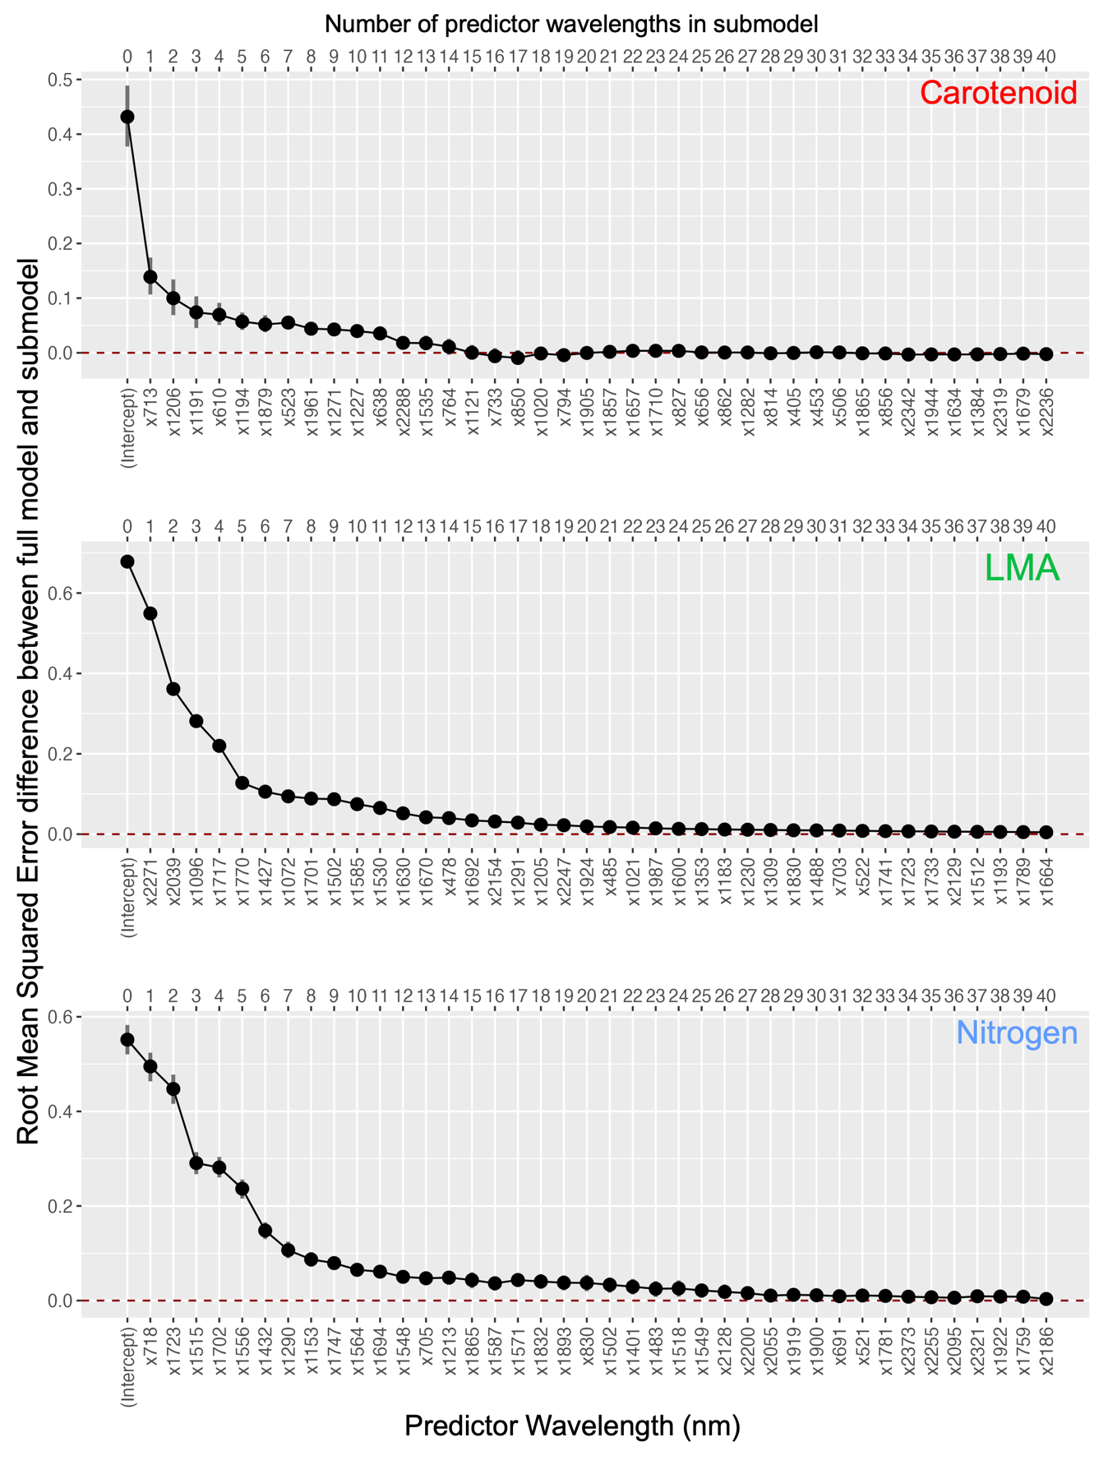
Figure S1. Decrease in the root mean squared error between the full model and the reduced model (on the standardized scale) as we add more wavelengths to the full model using step-wise forward selection. The horizontal line at 0 represents the step where adding more wavelengths results in similar predictive accuracy between the full model and submodel according to the cross-validation root mean squared error. The vertical bars represents one standard deviation in cross validation rmse. The number of wavelengths are chosen when the one standard deviation bar intersects the horizontal line.

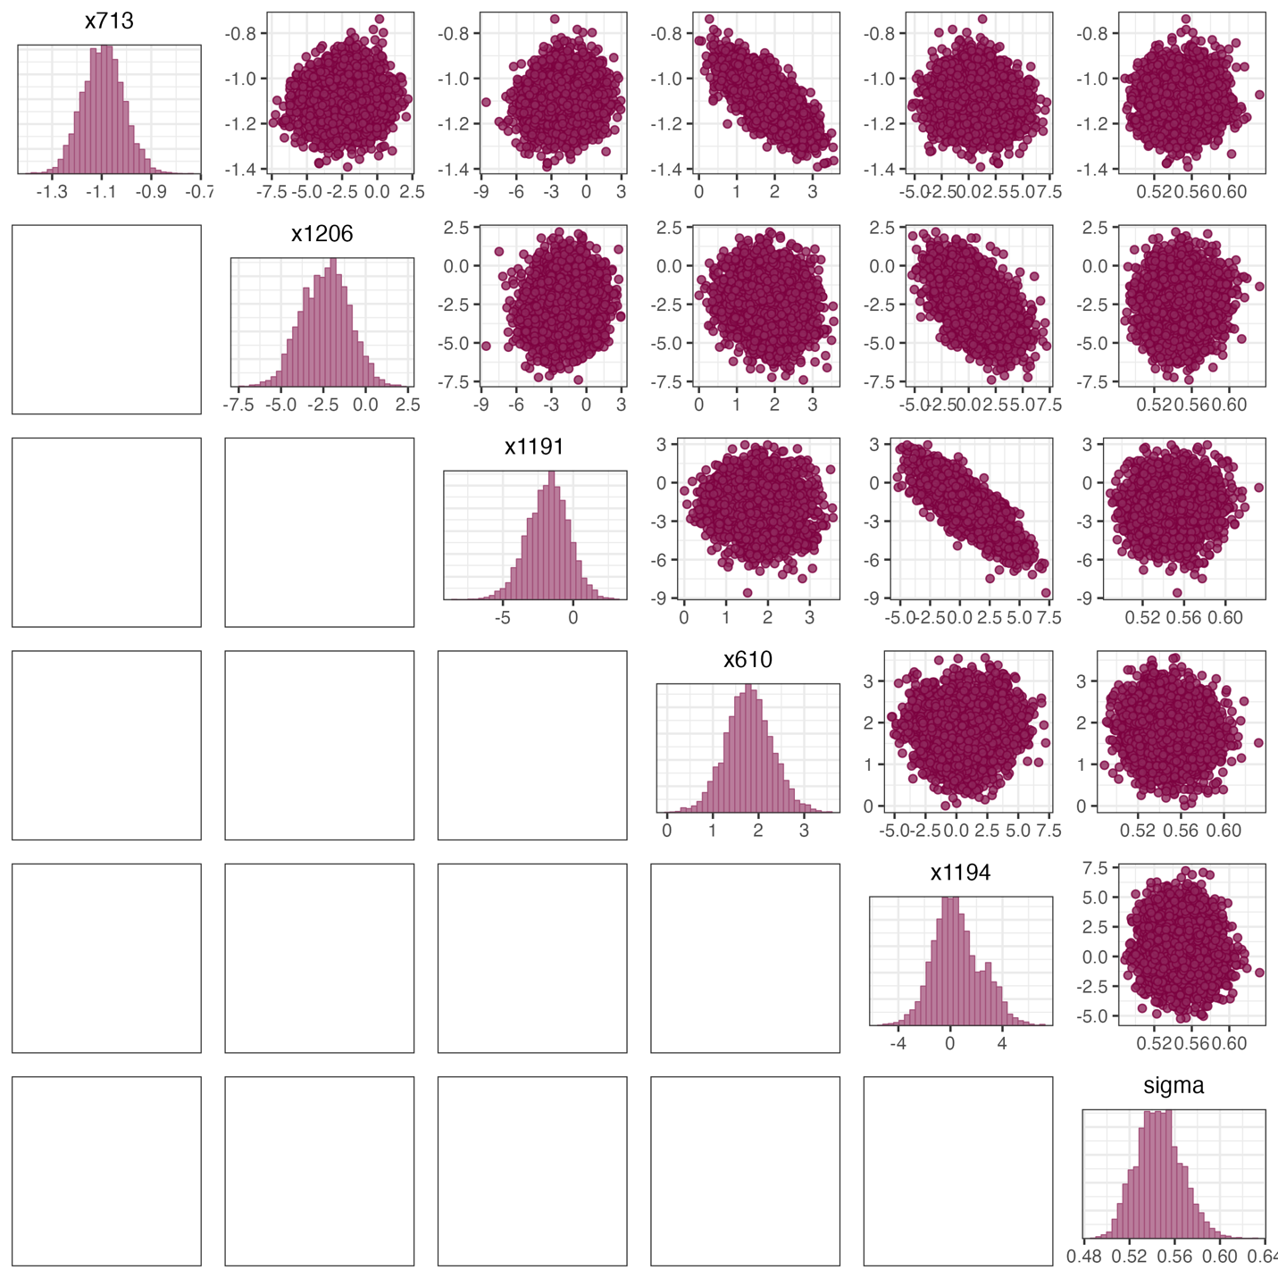
Figure S2. Posterior distribution for five projected regression parameters and the projected sigma parameter of the reduced model for carotenoid. The regression parameters for wavelengths 1191 nm and 1194 nm are correlated with each other resulting in long univariate posterior parameter intervals of these parameters (Figure 7, Main text)
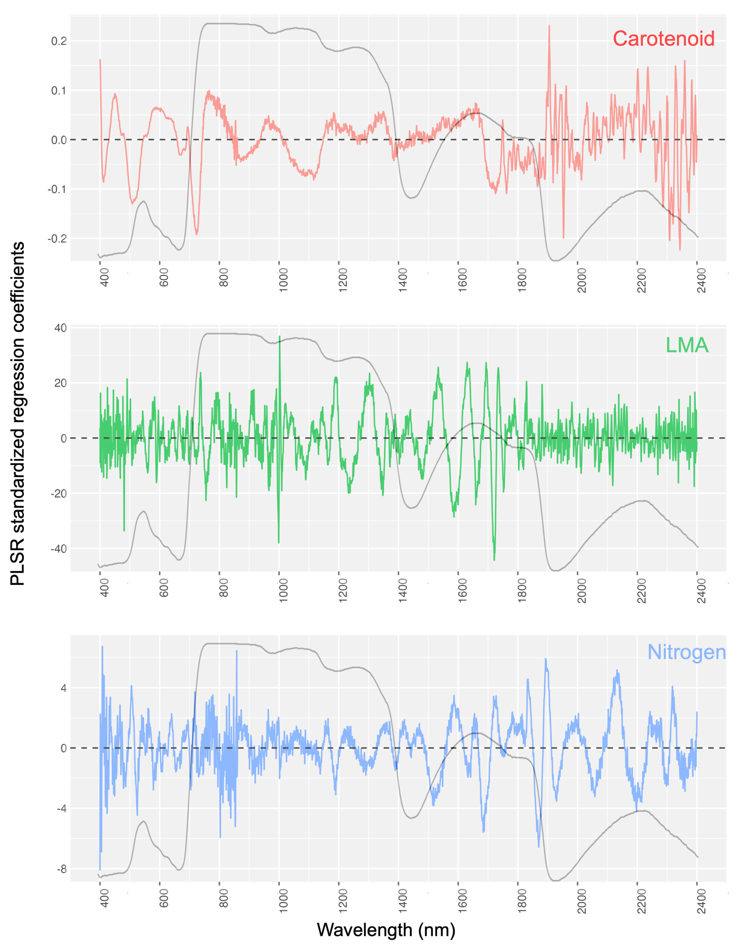
Figure S3. The Partial Least Squares Regression (PLSR) coefficients for the three traits.
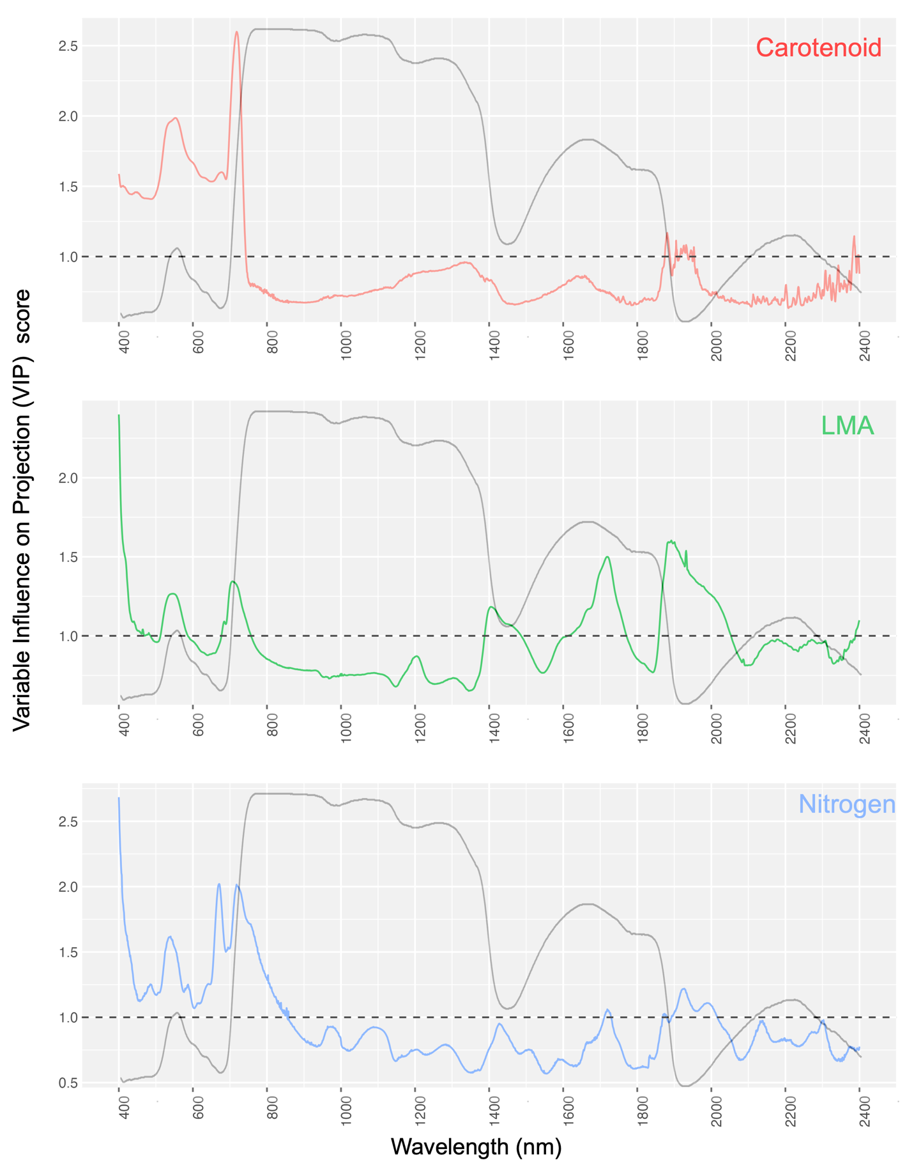
Figure S4. Variable Influence on Projection (VIP) scores for each wavelength on the individual traits. Wavelengths with VIP values above 1 are generally considered to contribute significantly to trait prediction (Mehmood et al., 2012).

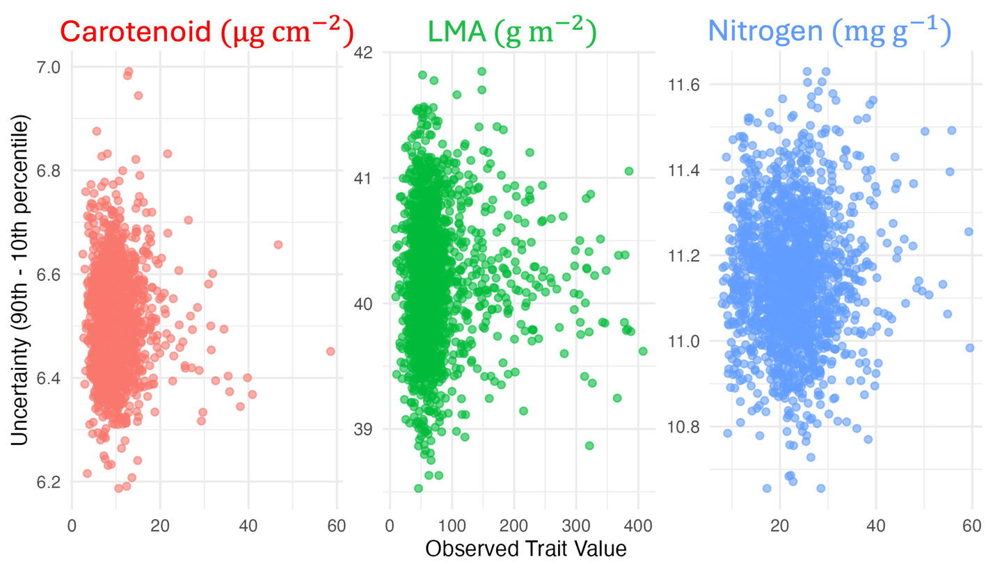
Figure S5. Variation of uncertainty (denoted by the difference of 90th and 10th percentile) and the observed trait values. The uncertainty is driven by the measurement error as well as the uncertainty in the parameters of the Bayesian model.

References
Mehmood, T., Liland, K. H., Snipen, L., & Sæbø, S. (2012). A review of variable selection methods in Partial Least Squares Regression. Chemometrics and Intelligent Laboratory Systems, 118, 62–69. https://doi.org/10.1016/j.chemolab.2012.07.010

