**ESE 650 project 1: Color Segmentation**

Dhruva Kumar

Overview

Object detection is done via color segmentation to detect instances of a red barrel in an image. There are 4 color classes chosen and training is done both manually and by using an unsupervised color segmentation scheme (kmeans). The training model is created using a Gaussian mixture model for each color class. For a new test image, this GMM model returns a mask for the red barrel pixels. Shape heuristics are used to identify the centroid, bounding box and depth of the red barrel in the image.

1. Training: Labeling images

Labeling the images by defining the pixels associated with each color class was done both manually and via an unsupervised color segmentation scheme.

The color classes chosen were:

1. red (barrel)

2. grey (floor. ceiling. wall. everything else)

3. yellow (some walls, some weird structures)

4. other_red (everything else that looks like red apart from the barrel.

jacket. seat. floor. brick red wall.)

The red barrel pixels were manually segmented out.

The rest were segmented out using kmeans (k = 4) on the ‘ab’ space of the LAB color space.

1. Training: GMM Model

Once the color classes have been defined, a GMM model is created for each color class.

Parameters:

Number of clusters (k) = 3

Full covariance matrix used.

On observation of the data, the ‘ab’ space of LAB and ‘CbCr’ space of YCbCr turned out to be good candidates to cluster the data into different classes.

The following plots show the data points of each class plotted in these color spaces. The 3 cross hairs shown represent the mean of each cluster in each color class.

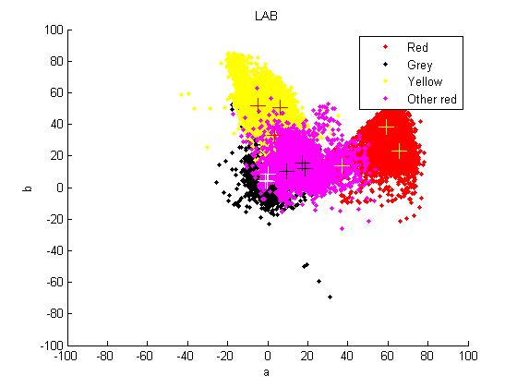

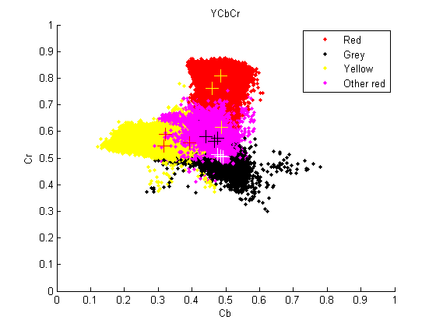

‘ab’ space of LAB was chosen to fit the GMM model to the data.

1. Testing

Once the GMM model is created for each color class, for a new test image, a mask is created for the red barrel pixels which are highly likely to occur – MAP.

Uniform prior is chosen.

Shape heuristics are then used to segment out the red barrel with the details: centroid, bounding box, depth.

Metrics used for shape detection - A weighted average of the following normalized parameters:

* Area
* Extent (number of red pixels in bounding box / total number of pixels)
* The norm of the difference of the ratio of minor axis length to major axis length to the ratio of the actual barrel dimensions.

Instruction to run the scripts:

Run main.m.  
 Specifiy the directory which contains the test images. (Replace ‘data/…’ with the directory name, say ‘test/…’)  
There’s an option to save all the images in a desired location (which has been currently commented out)