Kokoro: Emotional Trajectory Memory for AI Companions via World Model State Representations
Dhruva Myakeri

Abstract
We introduce Kokoro, an open-source library that gives AI companions persistent emotional trajectory memory by framing user emotional state as a world model problem. Unlike existing memory systems that store discrete emotional facts, Kokoro maintains a continuously evolving state vector trained to capture the dynamics of how emotional states change across sessions. The transition model ,a 591k-parameter MLP trained on 10,000 synthetic multi-session trajectories derived from EmpatheticDialogues ,learns emotionally meaningful state representations without fine-tuning any LLM. Validation on held-out trajectories shows a 197% improvement in arc separation over a last-session embedding baseline, with a shuffled-label control confirming genuine learned structure (68.5% collapse). A linear probe achieves Pearson r=0.765 for valence and r=0.631 for arousal, confirming the state vector encodes the primary dimensions of Russell's circumplex. Out-of-distribution validation on the Multi-Session Chat dataset ,4,000 real multi-session conversations never seen in training ,confirms generalization beyond synthetic data. Emotional retrieval surfaces different memories than semantic-only retrieval in 55% of evaluated scenarios, demonstrating that emotional state tracking changes what context reaches the LLM. Kokoro ships as a drop-in Python library requiring two lines of integration code.

1 Introduction
AI companions are becoming a significant part of how people process their lives. Yet every companion system today resets emotionally at the start of each conversation. A companion may remember that you mentioned your sister, that you work in finance, or that you own a dog. It does not know that you have been declining for three weeks, that last Tuesday felt like a turning point, or that your message today ,"still here lol" ,carries more weight than it looks like.
We argue this is not a retrieval problem. It is a world model problem.
Existing memory systems ,Mem0, Zep, LangMem, MemGPT ,store discrete facts extracted from conversations and retrieve them when semantically relevant. This works for factual continuity. It cannot work for emotional trajectory. Trajectory is not a stored fact. It is a pattern that emerges from the sequence of emotional states across sessions. No retrieval system can compute it because it was never stored. The difference is precise: a fact-retrieval system knows you were anxious on April 18. A world model knows you have been in a high-arousal negative state for three weeks and the trajectory suggests you are slowly moving toward lower arousal ,which is either recovery or depression depending on valence. That is not stored anywhere. It emerges from the learned dynamics.
In reinforcement learning, a world model is a learned transition function that takes the current state of an environment and a new observation and predicts the next state ,enabling an agent to reason about where things are heading without explicit rules (Ha & Schmidhuber, 2018). We apply this framing directly to user affect. The companion is an agent. The user's emotional state is the environment. Each conversation session is an observation. The transition model learns the dynamics of how that environment evolves.
This framing connects naturally to the emotion dynamics literature. Kuppens & Verduyn (2017) formalized emotional inertia ,the autocorrelation of emotional trajectory over time ,and the DynAffect model describing how emotional states move around an attractor. Kokoro's transition model is a learned autoregressive affect-dynamics model instantiated in embedding space. The synthetic training data encodes the arc structures that emotion dynamics research has identified. The model learns to navigate them.
The challenge is data. Existing longitudinal emotional dialogue datasets focus primarily on static fact retrieval and information extraction tasks (Chen et al., 2026) or require continuous physiological annotation. No publicly available dataset provides psychology-grounded multi-session emotional arc data suitable for training a transition model over emotional trajectory shapes. We address this with a synthetic trajectory construction method: using arc templates grounded in Russell's circumplex model of affect (Russell, 1980), we construct 10,000 multi-session training trajectories by sampling sessions from EmpatheticDialogues (Rashkin et al., 2019) according to their circumplex coordinates. The transition model is trained on these synthetic trajectories with a cosine prediction objective and evaluated on real multi-session conversations it has never seen.
At inference time the state vector serves a second purpose: as an emotionally-aware retrieval signal. Standard RAG retrieves memories that are topically similar to the current message. Kokoro retrieves memories that are both topically similar and emotionally resonant with the user's current state. For the message "hey" from someone who has been isolated for weeks, semantic retrieval has no signal. Emotional retrieval does.
We introduce Kokoro (心, Japanese for heart/mind), an open-source Python library implementing this approach as a drop-in memory layer for any AI companion stack. Our contributions are:
- The world model framing for user emotional state. We are the first to apply the world model framework to user affect in AI companions ,treating the user's emotional state as an environment with learnable dynamics rather than a collection of retrievable facts.
- A synthetic trajectory construction method. Multi-session emotional arc training data constructed from single-session datasets using psychology-grounded arc templates. Specifically targets the gap in arc-shaped trajectory data for transition model training.
- A validated transition model. 591k parameters. Trained entirely on synthetic data. Generalizes to real out-of-distribution multi-session conversations. 197% improvement in arc separation over baseline. r=0.765 valence decodability confirmed by linear probe.
- Emotionally-aware hybrid RAG. The state vector as a second retrieval axis alongside semantic similarity. Surfaces emotionally relevant memories that semantic retrieval cannot find.
- Kokoro. An open-source drop-in Python library. Two lines of integration code. No LLM fine-tuning. No GPU required. Works with any companion stack.

2 Background

2.1 Russell's Circumplex Model of Affect
Russell (1980) proposed that all human emotional experience can be represented in a continuous two-dimensional space defined by valence (the positive-to-negative dimension of feeling) and arousal (the activated-to-deactivated dimension of energy). The model has been empirically validated across cultures and languages (Russell & Barrett, 1999) and remains the dominant framework in affective computing (Picard, 1997).
Every emotion maps to a point in this space. Anxious occupies negative valence, high arousal. Content occupies positive valence, low arousal. Devastated occupies negative valence, low arousal. Excited occupies positive valence, high arousal. The model is continuous ,emotional states are not discrete categories but positions in a 2D manifold, enabling gradient-based learning and smooth trajectory modeling.
The primary finding of the circumplex literature most relevant to Kokoro: valence is the dominant axis of human affect. This prediction is confirmed by our results ,PC1 of Kokoro's state space explains 82.6% of variance and correlates with valence polarity at r=0.75. Emotion-to-coordinate mappings used in this work are derived from Russell (1980) and Warriner et al. (2013) VAD norms.

2.2 Emotion Dynamics
Emotions are not static labels ,they evolve over time according to characteristic patterns. Kuppens et al. (2010) introduced emotional inertia: the autocorrelation of emotional state over time, measuring how much the current state predicts the next. High inertia ,characteristic of depression and certain anxiety disorders ,means states are persistent and resistant to change.
Kuppens & Verduyn (2017) extended this with the DynAffect model, characterizing trajectories in terms of an affective home base, variability, and attractor strength. Kokoro's transition model is, in effect, a learned autoregressive affect-dynamics model. It learns from data what the attractor structure of emotional trajectories looks like. The DynAffect model describes this analytically; Kokoro learns it empirically from synthetic trajectory data.

2.3 World Models
Ha & Schmidhuber (2018) formalized the world model framework for reinforcement learning agents: a representation model encodes observations into a compact latent state, and a transition model predicts how that state evolves given an action. The prediction-quality-as-learning-signal principle is the foundation of Kokoro's training objective.
One important disanalogy: in Ha & Schmidhuber (2018) both the encoder and transition model are learned jointly. In Kokoro the encoder is a frozen pre-trained sentence transformer. Only the transition model is learned. This simplifies training and enables CPU deployment, but means the encoder's representational capacity is fixed ,the transition model must learn emotional structure on top of a general-purpose semantic space.

3 Related Work

3.1 Memory Systems for LLM Agents
The dominant paradigm for long-term LLM memory is fact extraction and retrieval. Mem0 (Packer et al., 2023) extracts semantic facts and stores them in a vector database. Zep maintains a temporal knowledge graph. LangMem provides a LangChain-native fact store. MemGPT (Packer et al., 2023) introduces an OS-analogy with hierarchical memory tiers. These systems are effective for factual continuity and share a common limitation: memory is a collection of discrete facts, and the retrieval problem is finding which facts match the current context. Trajectory is invisible to any single retrieval operation.

3.2 Cross-Session Emotional State Modeling
CTEM (Zheng et al., CHI 2026) introduces Cross-Temporal Emotion Modeling for an AI companion named Auri, maintaining an evolving emotional state validated in a 21-day in-the-wild study with 96 participants. The critical difference from Kokoro: CTEM models the companion agent's emotional state. Kokoro models the user's emotional state.
TheraMind (WWW 2026) is a dual-loop therapy system with Intra-Session and Cross-Session loops for longitudinal therapeutic planning. The critical difference: TheraMind requires clinical conversation structure and is not transferable to general companion applications.
CEmoFlow (2026) proposes a continuous-time Neural-ODE framework for modeling latent affective state. CEmoFlow is the closest methodological relative to Kokoro. CEmoFlow constructs its training data from anonymized chitchat with continuously interpolated emotion soft-labels and timestamps using Physics-Informed Neural Networks to simulate emotional dynamics. Kokoro differs in using psychology-grounded arc templates derived from Russell's circumplex, enabling explicit control over trajectory shape during training, and in targeting the retrieval task for AI companion memory rather than latent space steering.
EASM (Kotecha et al., 2026) is an industry system introducing emotion-attended stateful memory reporting a 95% user retention improvement. This result is directionally consistent with Kokoro's motivation but comes from a proprietary system with no published architecture.

3.3 Multi-Session Dialogue and Longitudinal Benchmarks
Xu, Szlam & Weston (2022) introduced the Multi-Session Chat (MSC) dataset ,conversations between user pairs across five sessions. We use MSC as our out-of-distribution validation dataset. The model was never trained on MSC data; it is used purely to test generalization.
Chen et al. (2026) introduced EvoEmo and ES-MemEval, a benchmark evaluating five core long-term memory capabilities ,information extraction, temporal reasoning, conflict detection, abstention, and user modeling ,in personalized long-term emotional support dialogues. ES-MemEval focuses on discrete memory capabilities over extended conversations, a complementary but distinct task from Kokoro's focus on continuous emotional trajectory modeling for retrieval. The EvoEmo dataset and ES-MemEval benchmark are publicly available.

3.4 Positioning Summary

System | User-Side | Domain-Agnostic | Synthetic Training | Open Library
Mem0 / Zep / LangMem | No (facts) | Yes | N/A | Yes
CTEM | No (agent-side) | Yes | No | No
TheraMind | Yes | No (therapy) | No | No
CEmoFlow | Yes | Yes | Interpolated chitchat | No
ES-MemEval / EvoEmo | Yes | Yes | Synthetic profiles | Yes (benchmark)
Kokoro (ours) | Yes | Yes | Arc-template synthetic | Yes
Table 1: Kokoro vs. related systems. CEmoFlow and EvoEmo use synthetic/interpolated data; Kokoro uses psychology-grounded arc templates explicitly designed for trajectory shape control.

4 Method
Figure 1 shows the complete Kokoro pipeline. At update time, a new conversation session is encoded into a session embedding, the transition model updates the user state vector, and both are persisted. At inference time, the state vector and a query embedding jointly drive hybrid retrieval, and the retrieved context is injected into the LLM system prompt.
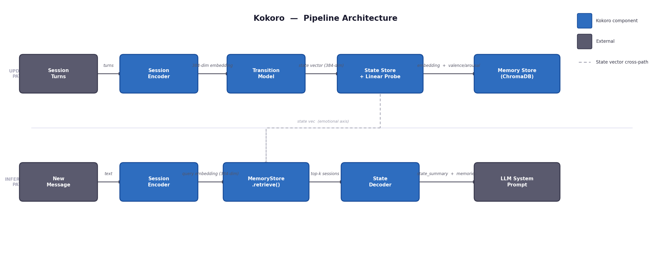Figure 1: Kokoro pipeline. Update path (top): session turns are encoded, transition model updates state vector, persisted to SQLite and ChromaDB. Inference path (bottom): hybrid retrieval combines semantic query similarity and emotional state similarity.

4.1 Synthetic Trajectory Construction
The transition model requires multi-session training data ,sequences of conversations across weeks labeled with emotional coordinates at each session. Existing longitudinal datasets focus on memory capability benchmarking (Chen et al., 2026) or require physiological annotation; none provide the arc-shaped trajectory sequences needed for transition model training. We construct this data synthetically.
Arc templates. We define 11 emotional arc templates grounded in the psychological literature (Lazarus, 1991; Bonanno, 2004; Tedeschi & Calhoun, 1996) as narrative approximations of common emotional trajectory shapes. Each template is a sequence of CircumplexZone objects specifying acceptable (valence, arousal) regions and week offsets. Templates include gradual_decline, slow_recovery, grief_arc, chronic_low_grade_anxiety, post_traumatic_growth, relapse_dip, and five others. All 11 are listed with their psychological basis and explicit caveats in the Appendix.
Session pool. EmpatheticDialogues (Rashkin et al., 2019) provides 17,780 training conversations each labeled with one of 32 emotion labels. We map each label to circumplex coordinates using Russell (1980) and Warriner et al. (2013) VAD norms, creating a pool of sessions indexed by emotional position.
Trajectory assembly. For each of 10,000 synthetic trajectories: sample an arc template, then for each session slot find all pool sessions whose circumplex coordinates fall within the zone tolerance, sample one uniformly at random, assign a week offset with jitter. No session appears twice in the same trajectory. Each session is used at most 8 times across all trajectories.
Limitation. Synthetic trajectories chain sessions from different people about different topics ,the only connection between sessions is their emotional coordinates, not narrative continuity. This is appropriate for learning emotional dynamics but means the training distribution does not reflect the natural coherence of real user trajectories. Out-of-distribution validation on MSC (Section 5.5) tests whether the model generalizes despite this.

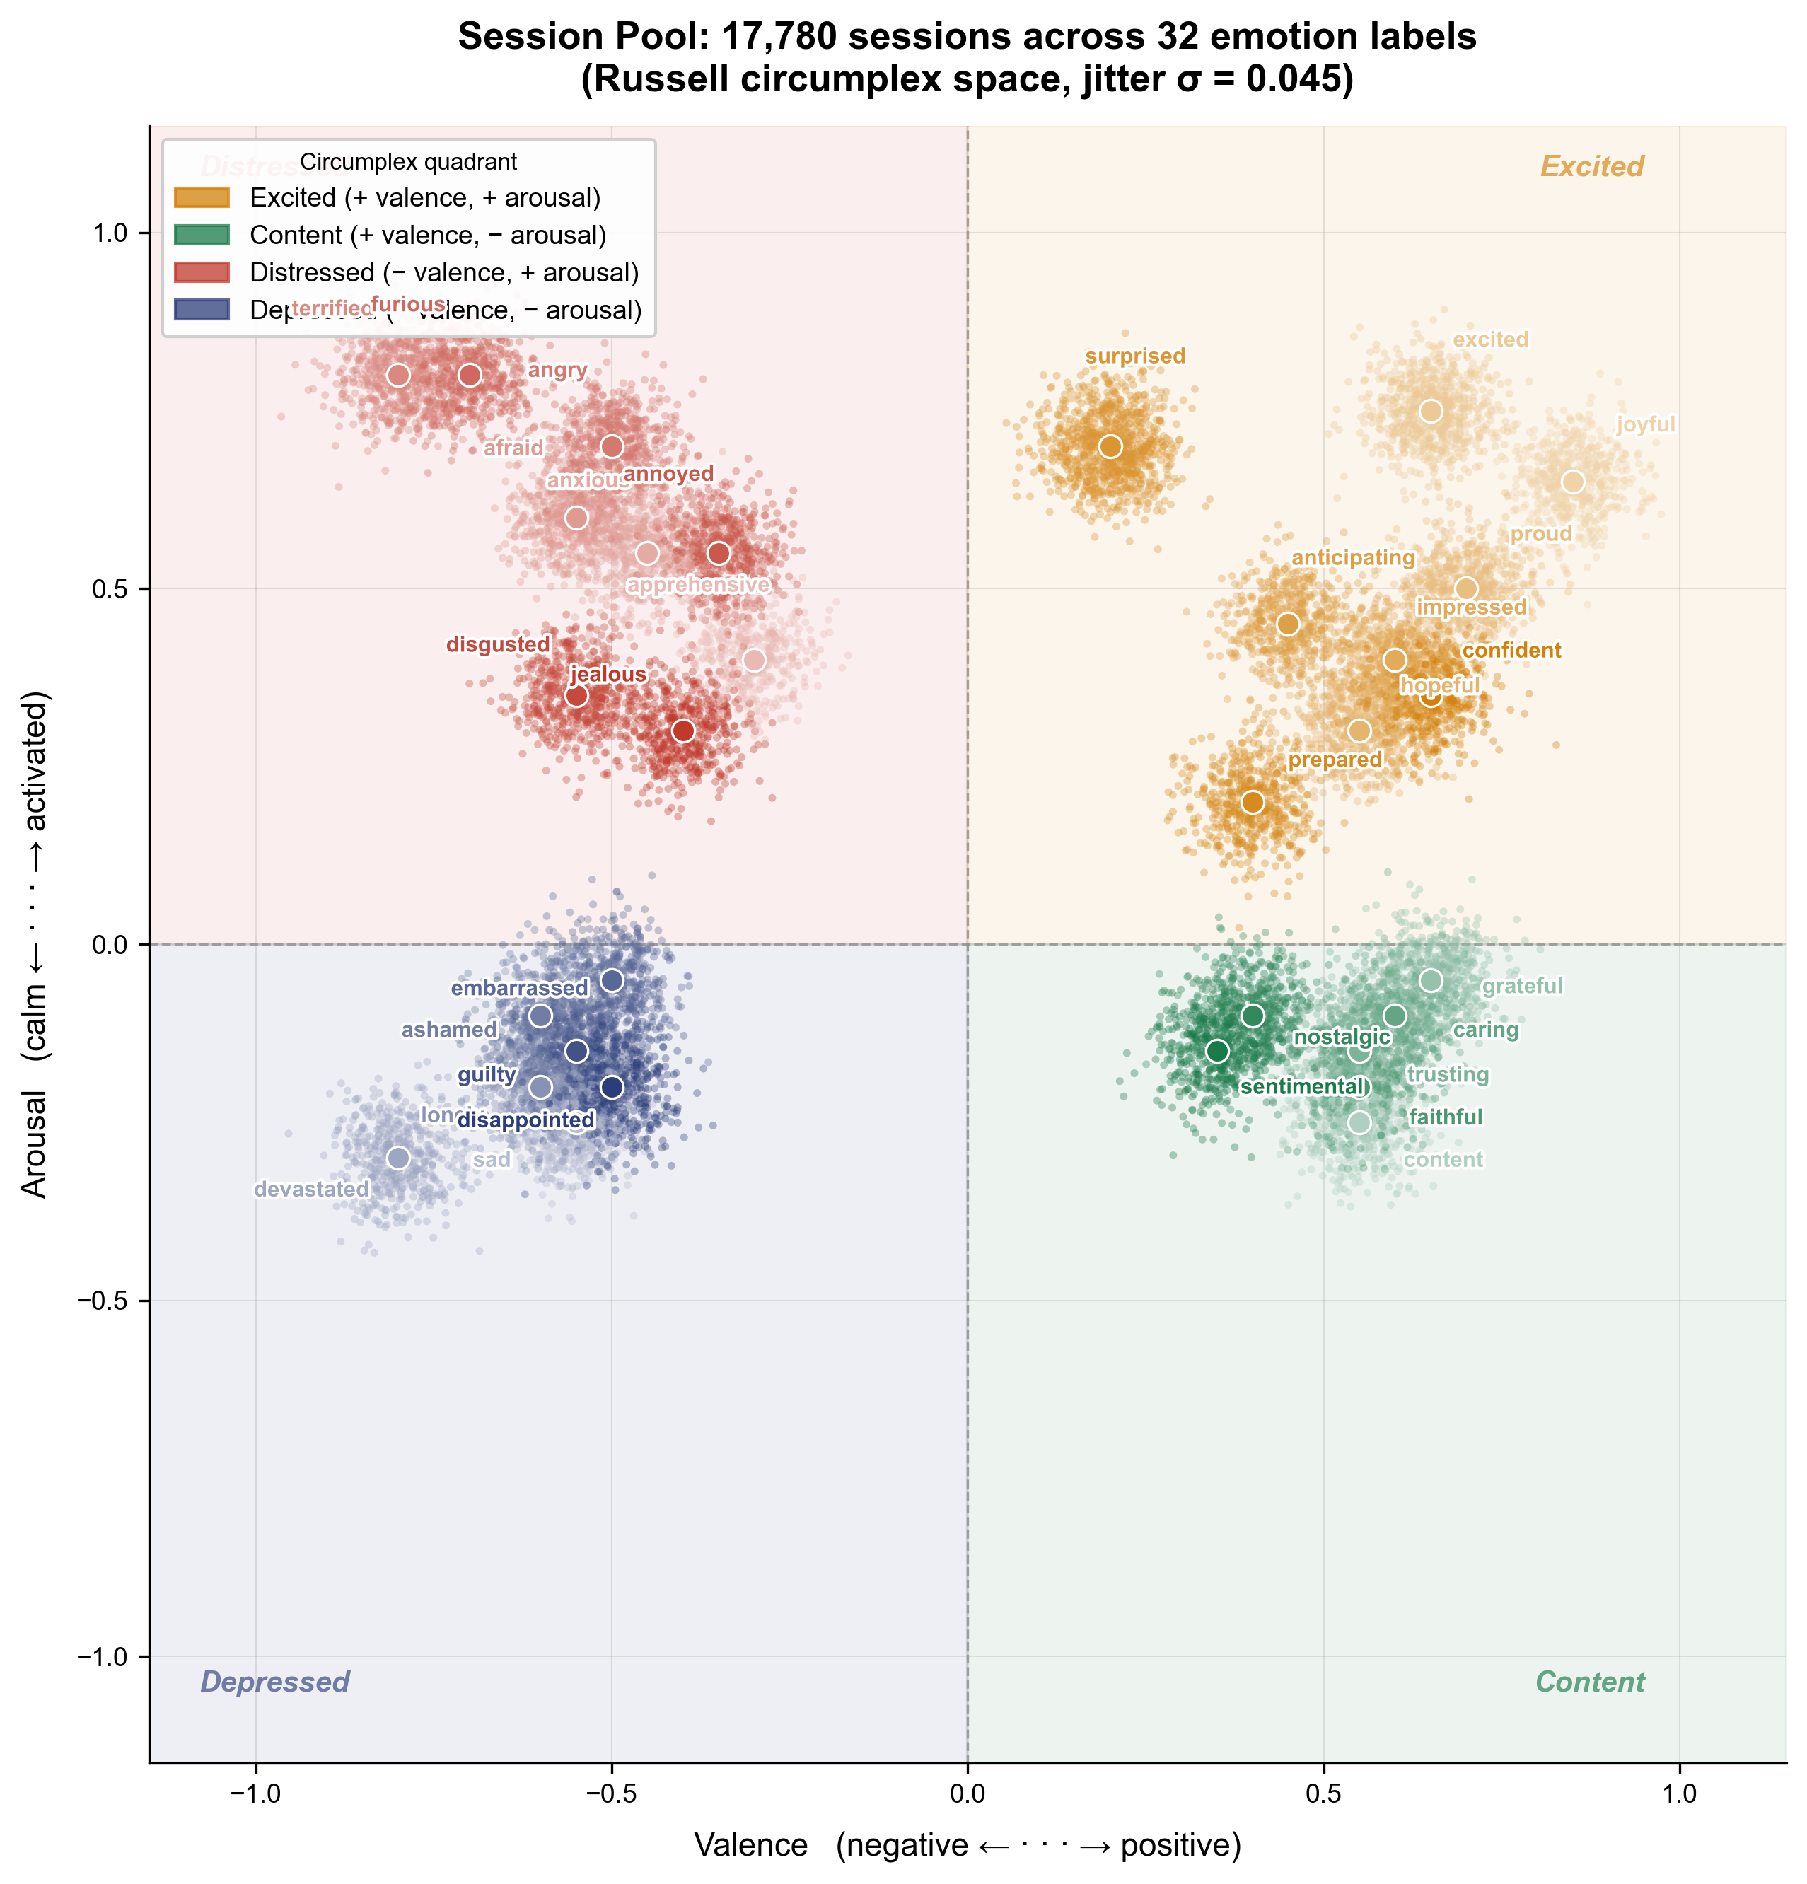
Figure 2: 17,780 EmpatheticDialogues sessions plotted in valence-arousal space. Four-quadrant structure consistent with Russell (1980).

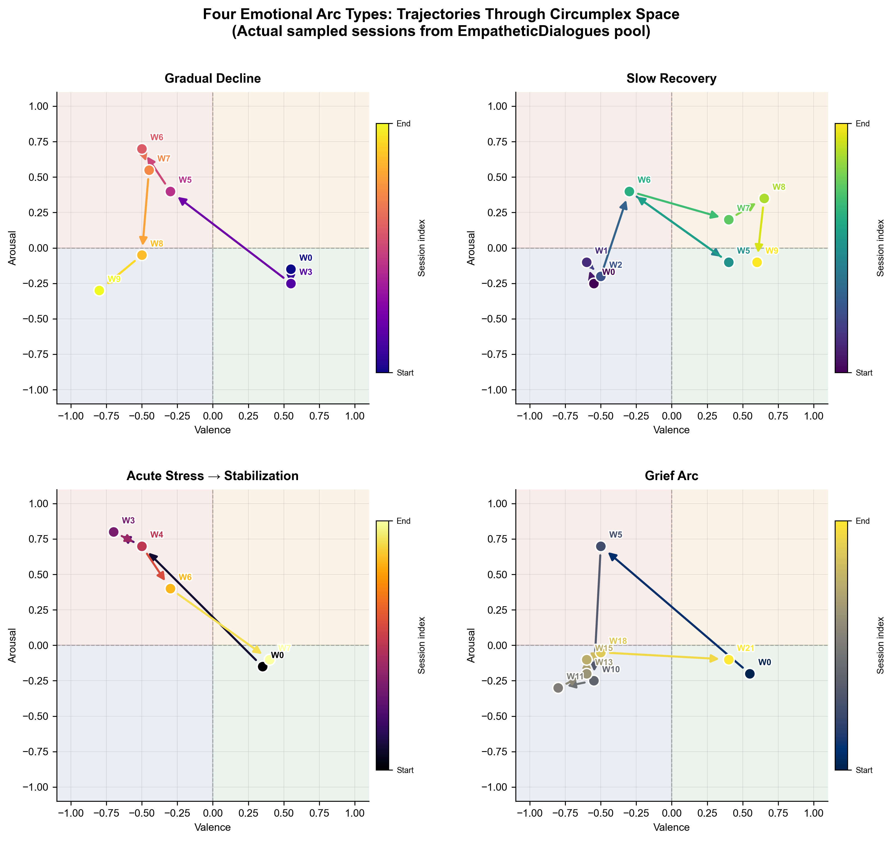
Figure 3: Four arc templates as paths through circumplex space. Grief arc shows characteristic acute-distress-then-low-energy pattern.

4.2 Session Encoder
Each conversation session is encoded into a 384-dimensional embedding using all-MiniLM-L6-v2 (Reimers & Gurevych, 2019), a 22M-parameter sentence transformer pretrained on large-scale text. Before encoding, ParlAI tokenization artifacts in EmpatheticDialogues are decoded (e.g., _comma_ → ,). User turns are weighted 2× over assistant turns in weighted mean pooling, biasing the representation toward the user's expressed content. The encoder is frozen throughout training and inference.

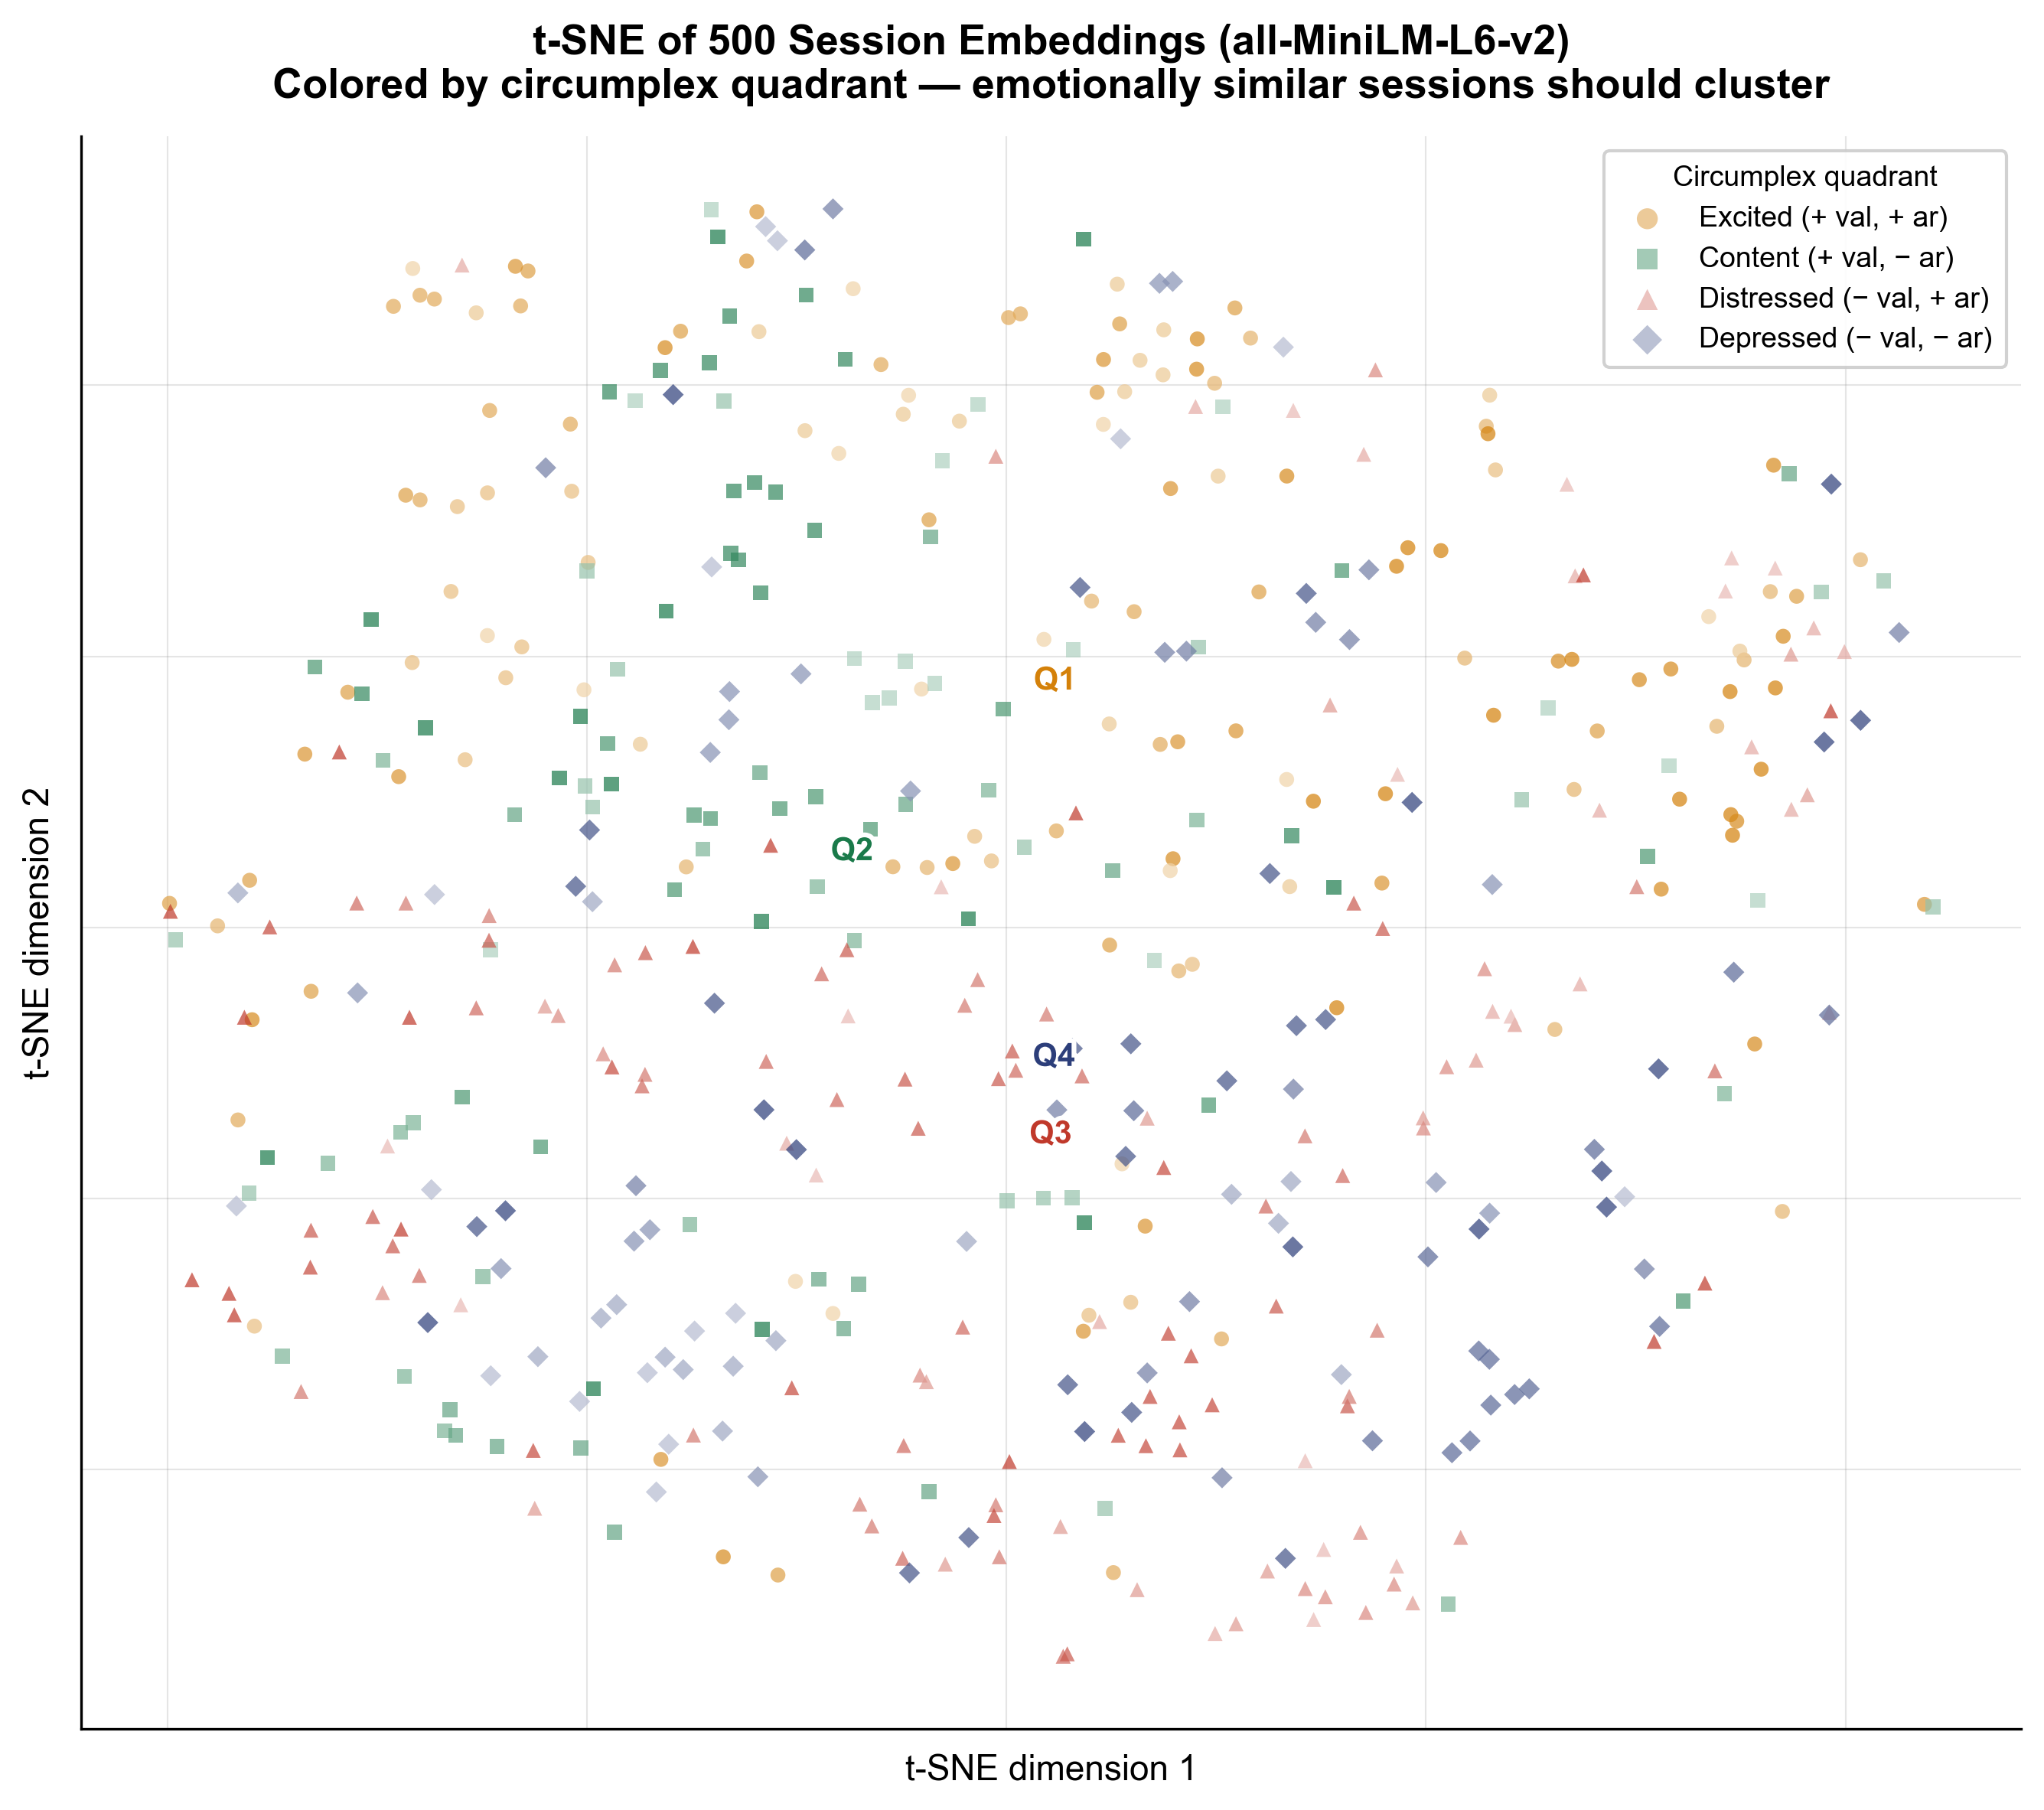
Figure 4: t-SNE of 500 session embeddings. Limited emotional clustering confirms the encoder alone is insufficient and motivates the transition model.

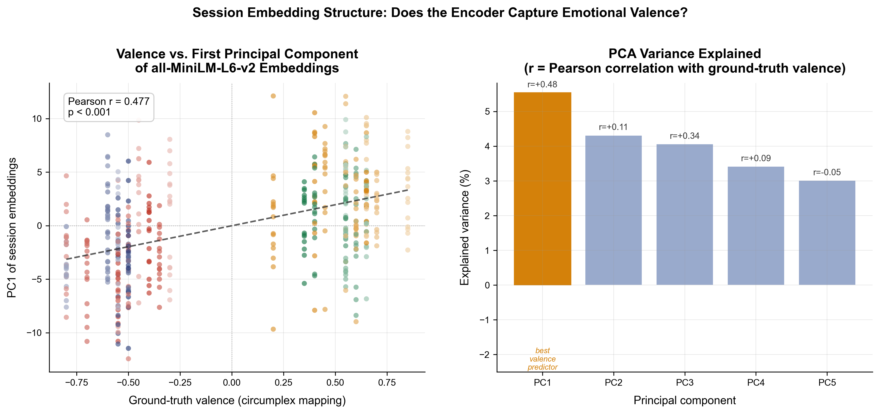Figure 5: Pearson r=0.477 between ground-truth valence and PC1 of session embeddings (p<0.001). Encoder captures moderate valence signal.

4.3 Transition Model
The transition model is a 4-layer MLP taking the concatenation of current state vector s_t ∈ ℝ^384 and new session embedding e_t ∈ ℝ^384:
s_{t+1} = normalize( W₂ · ReLU( LayerNorm( W₁ · [s_t ; e_t] ) ) )
Architecture: Linear(768→512) → LayerNorm → ReLU → Dropout(0.1) → Linear(512→384) → L2-normalize. Total parameters: 591,744. L2 normalization constrains all state vectors to the unit hypersphere, preventing magnitude drift.
Training objective. Given state s_t at session t and embedding e_{t+1} of the next session:
L = 1 - cosine_similarity( f(s_t, e_t), normalize(e_{t+1}) )
The model is trained to predict where emotional content is heading. This is a proxy objective ,the model optimizes prediction accuracy; emotionally meaningful state representations emerge as a side effect. Loss range: 0.0 (perfect) to 2.0 (worst). Random baseline: ~1.0. Trained model validation: 0.503. Known limitation: the cosine prediction objective without variance-preserving regularization is susceptible to dimensional collapse; future work should explore VICReg (Bardes et al., 2022) or contrastive objectives.
Cold start. New users initialize with a zero state vector. The warm-up period (session_count < 3) prevents emotional context injection until the state has accumulated sufficient history.
Training details. AdamW optimizer, learning rate 3×10^{-4}, cosine annealing schedule, batch size 32, 100 epochs. Embeddings precomputed before training (~50× speed improvement). Best validation loss at epoch 4.

4.4 Linear Probe
To verify that the state vector encodes the primary dimensions of Russell's circumplex, we train a linear probe ,Linear(384→2), no hidden layers ,to predict (valence, arousal) from state vectors. The probe is trained separately after the transition model is frozen, using the same synthetic trajectory data with ground-truth circumplex coordinates. The probe serves two purposes: (1) a validation experiment confirming circumplex alignment; (2) a production component extracting continuous valence and arousal scores for state decoding. The probe ships with the Kokoro library alongside the transition model checkpoint. Important caveat: the probe was validated on synthetic in-distribution data; Section 5.5 and Section 7 discuss its failure to generalize to naturalistic text.

4.5 Hybrid Emotionally-Aware RAG
Standard RAG retrieves memories by semantic similarity to the current query. Kokoro adds emotional similarity to the current user state as a second retrieval axis. For a query embedding q ∈ ℝ^384 and current state s ∈ ℝ^384, the combined retrieval score for stored session embedding e_i is:
score_i = α · cosine(q, e_i) + (1 - α) · cosine(s, e_i)
where α ∈ [0,1] controls the semantic-emotional tradeoff (default α=0.6). The emotional axis is most valuable for emotionally ambiguous messages with no semantic anchor ,messages like "hey" or "still here lol" where cosine(q, e_i) provides no useful signal but cosine(s, e_i) retrieves sessions from similar emotional states.

4.6 WorldMemory API
The complete pipeline is exposed through a single public class:
from kokoro import WorldMemory
memory = WorldMemory(user_id="alice")
memory.update(session_turns) # after each session
context = memory.get_context(message) # before each reply
update() encodes the session, runs the transition model, saves state to SQLite, and indexes the session in ChromaDB. get_context() loads the state, decodes it via the linear probe, retrieves hybrid memories, and returns state_summary, relevant_memories, valence, arousal, trend, and ready. Developers can replace the built-in ChromaDB retrieval via a retrieval_fn parameter.

5 Experiments
We evaluate Kokoro along four dimensions: arc separation quality, circumplex alignment, out-of-distribution generalization, and downstream retrieval behavior. All experiments use the transition model trained on 10,000 synthetic trajectories unless stated otherwise.

5.1 Training: Data Quantity Resolves Overfitting
Figure 6 shows training and validation loss curves for 300 vs 10,000 trajectories. With 300 trajectories the model reaches train loss 0.202 but validation loss 0.640 ,a gap of 0.44 indicating severe overfitting. With 10,000 trajectories the gap narrows to 0.10 (train 0.437, val 0.540). Same model. Same architecture. Same objective. The gap difference is attributable to data quantity, motivating the synthetic trajectory construction method.

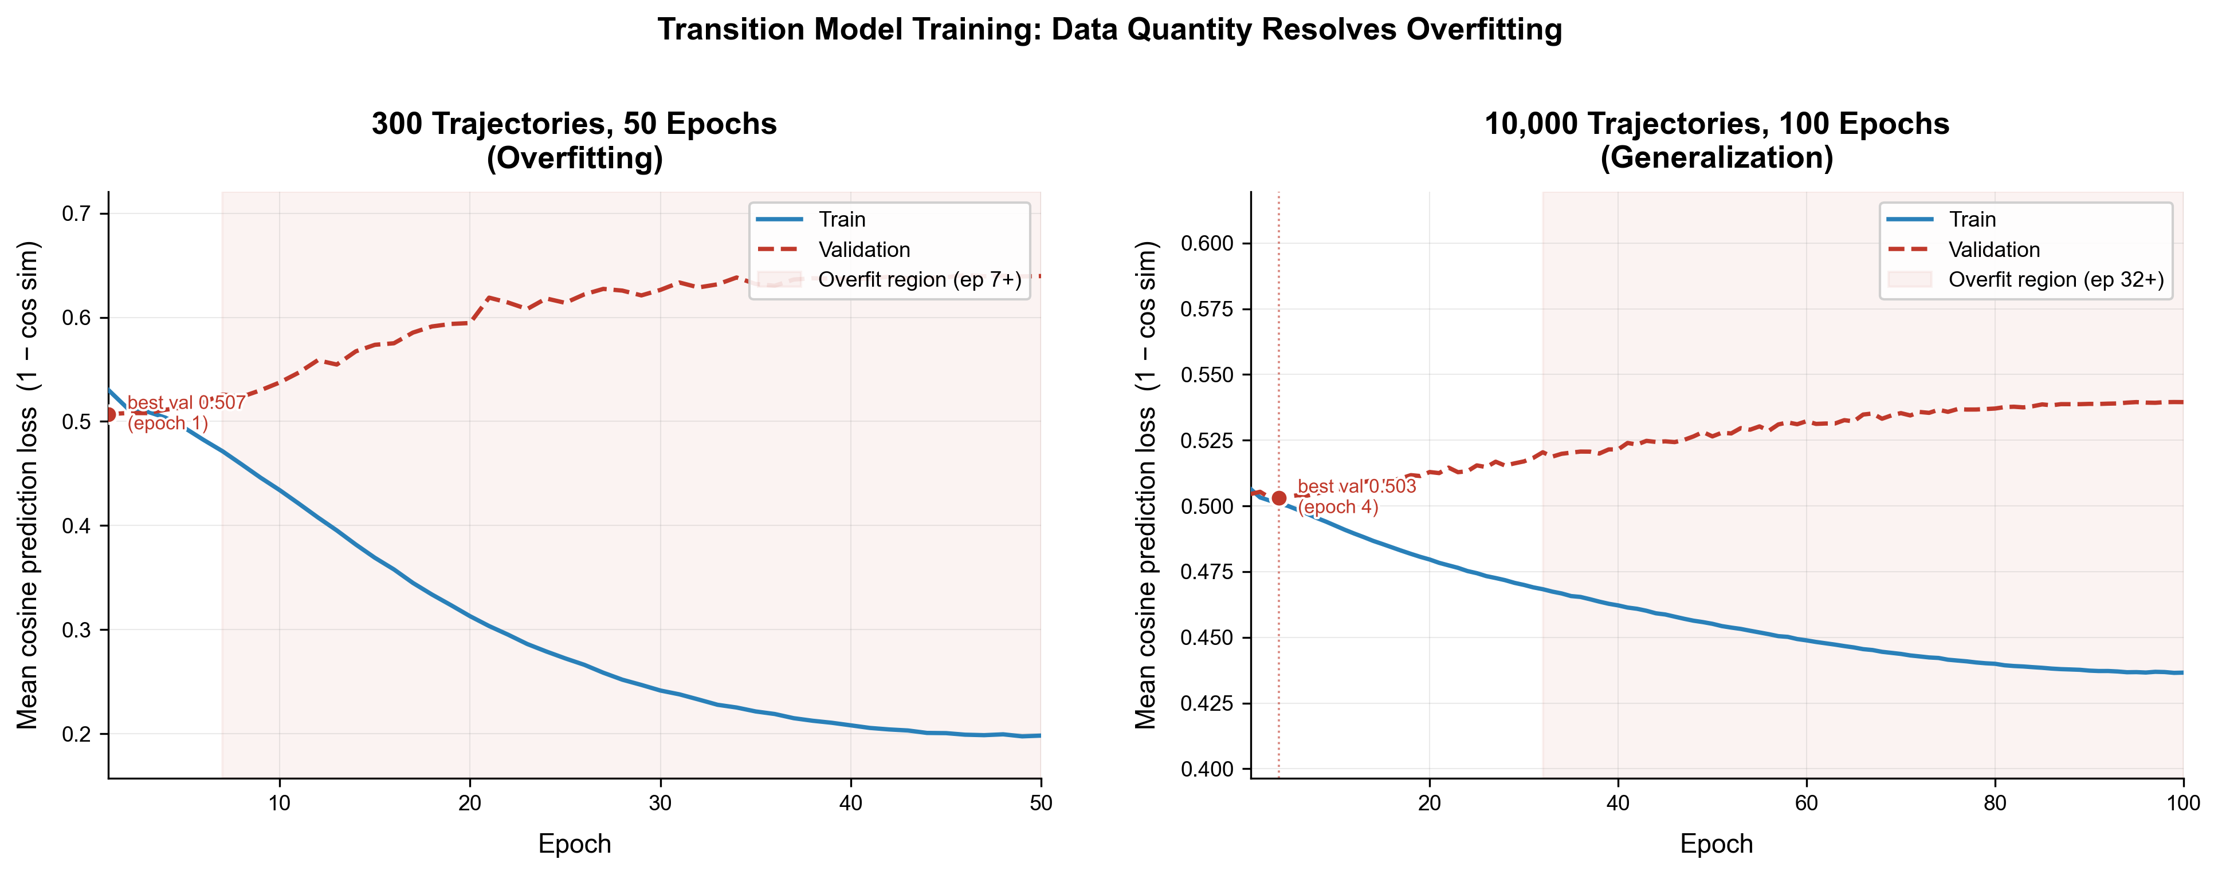Figure 6: Training and validation loss curves for 300 vs 10,000 trajectories. Same model, same objective. Data quantity alone narrows the gap from 0.44 to 0.10.

5.2 Arc Separation
We evaluate whether state vectors from trajectories of the same arc type cluster together more than state vectors from different arc types using the separation ratio: mean between-arc cosine distance / mean within-arc cosine distance. A ratio of 1.0 means arc type has no effect on state position.
Note on metric interpretation: the separation ratio measures group-level separation in the learned state space. Given the dimensional collapse documented in Section 5.4, this metric should be interpreted as evidence of directional structure along the primary valence axis rather than rich multi-dimensional clustering. We report it alongside silhouette scores for completeness.

Condition | Within-Arc Dist | Between-Arc Dist | Sep. Ratio | Silhouette | PC1/Valence r
Identity (floor) | 1.0000 | 1.0000 | 1.0000 | undef. | —
Last-session emb (baseline) | 0.7243 | 0.7584 | 1.0471 | -0.0174 | 0.4018
EWMA α=0.3 (no params) | 0.2989 | 0.3257 | 1.0898 | -0.0296 | —
Trained model (ours) | 0.0105 | 0.0328 | 3.1111 | -0.1340 | 0.7493*
Table 2: Arc separation results. *p<0.001, 95% CI [0.73, 0.77]. All silhouette scores are negative, indicating individual cluster overlap; the separation ratio captures group-level directional structure. Improvement over last-session baseline: 197%.
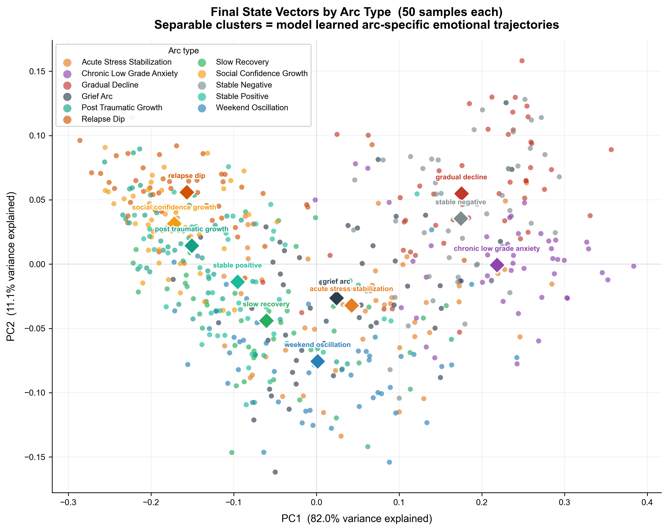
Figure 7: Final state vectors of 50 trajectories per arc type in PCA space. Recovering arcs cluster toward one end of PC1 (valence axis). Declining arcs cluster toward the other.

5.3 Shuffled-Label Control
We test whether separation reflects genuine learned structure by randomly permuting arc type labels while leaving state vectors unchanged.

Condition | Separation Ratio | Relative to True Labels
True labels | 3.1111 | —
Shuffled labels (control) | 0.9807 | -68.5%
Table 3: Shuffled-label control. A 68.5% collapse after label permutation confirms learned arc-specific structure.

5.4 Effective Dimensionality
We measure dimensionality using the participation ratio PR = (Σλ_i)² / Σ(λ_i²). PR=1.0 means all variance in one dimension; PR=384 means maximally distributed.

Metric | Value | Interpretation
Participation ratio | 1.4 / 384 (0.4%) | Strong dimensional collapse
PC1 variance explained | 82.6% | Primary axis = valence (r=0.75, p<0.001)
PC2 variance explained | 10.3% | Secondary axis
Cumulative PC1-PC5 | 98.5% | 5 dims explain almost everything
Table 4: Effective dimensionality. The state space collapses onto the valence axis ,the psychologically primary dimension of affect (Russell, 1980). This is a genuine limitation discussed in Section 6.1.
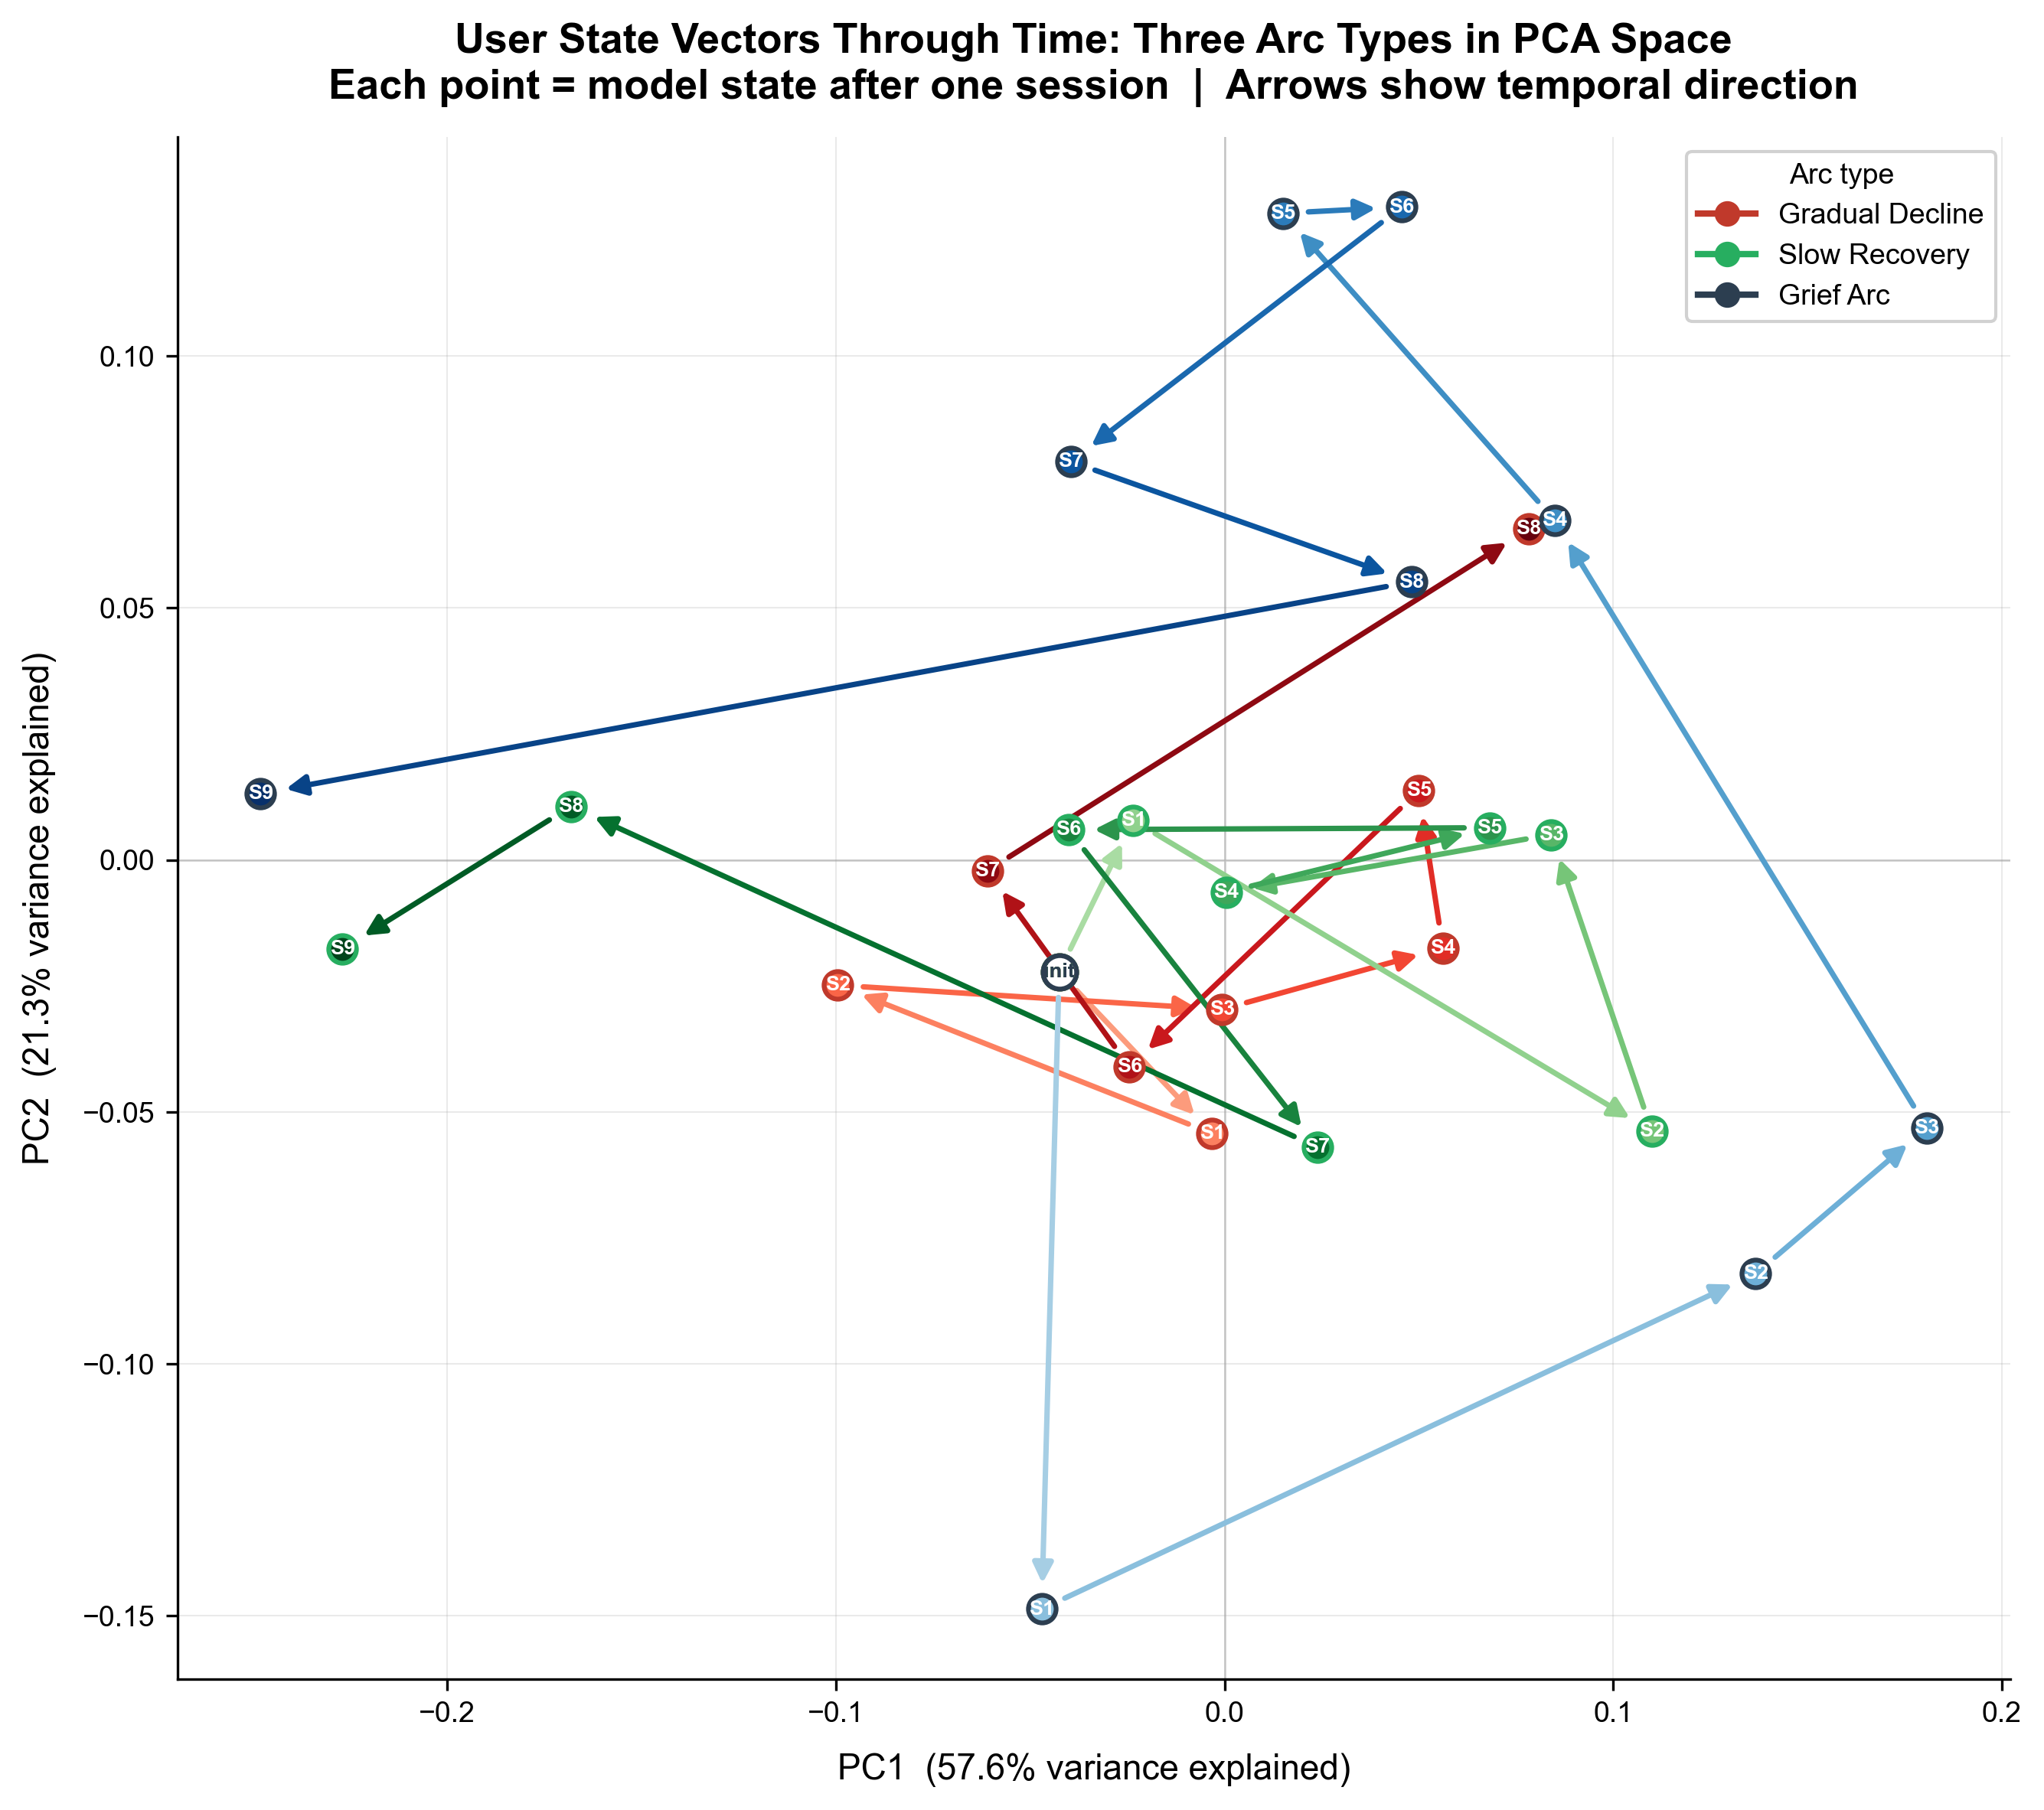
Figure 8: Three arc trajectories as paths through PCA of state vectors. Grief arc shows characteristic initial sharp movement followed by slow drift.

5.5 Linear Probe: Circumplex Alignment
We train a linear probe ,Linear(384→2), no hidden layers ,to predict (valence, arousal) from state vectors on held-out validation trajectories.

Metric | Valence | Arousal
Pearson r | 0.765 | 0.631
MSE | 0.107 | 0.071
MAE | 0.250 | 0.217
Table 5: Linear probe results on synthetic validation data. Sanity check: stable_positive pred_val=+0.354 vs stable_negative pred_val=-0.616, gap=0.97 (3.9× MAE). NOTE: these results hold only within the EmpatheticDialogues distribution.
Important limitation. The probe achieves r=0.765 on synthetic in-distribution text. On naturalistic companion conversation text (20 diverse evaluation scenarios) the probe outputs nearly identical values regardless of emotional content (valence range -0.144 to -0.110 across all scenarios). This is a distribution shift failure discussed in Section 7.

5.6 Out-of-Distribution Validation: Multi-Session Chat
We run the trained model on the Multi-Session Chat dataset (Xu et al., 2022) ,4,000 real multi-session conversation sequences, never seen during training, no arc labels, completely different conversational structure from EmpatheticDialogues.

Metric | Value | Interpretation
Sequences evaluated | 4,000 | Real user pairs, 2+ sessions each
State collapse check | PASS (0.0203) | Distinct states for distinct conversations
MSC within-seq movement | 0.0179 | State changes across real sessions
Synthetic within-seq movement | 0.0149 | Training data comparison
Ratio MSC/Synthetic | 1.20x | Real data moves state 20% more than synthetic
PC1 on MSC | 71.4% | Less collapsed on varied real input (cf. 82.6% synthetic)
Table 6: OOD validation on MSC. State vectors remain non-collapsed and move meaningfully on real multi-session conversations never seen during training.
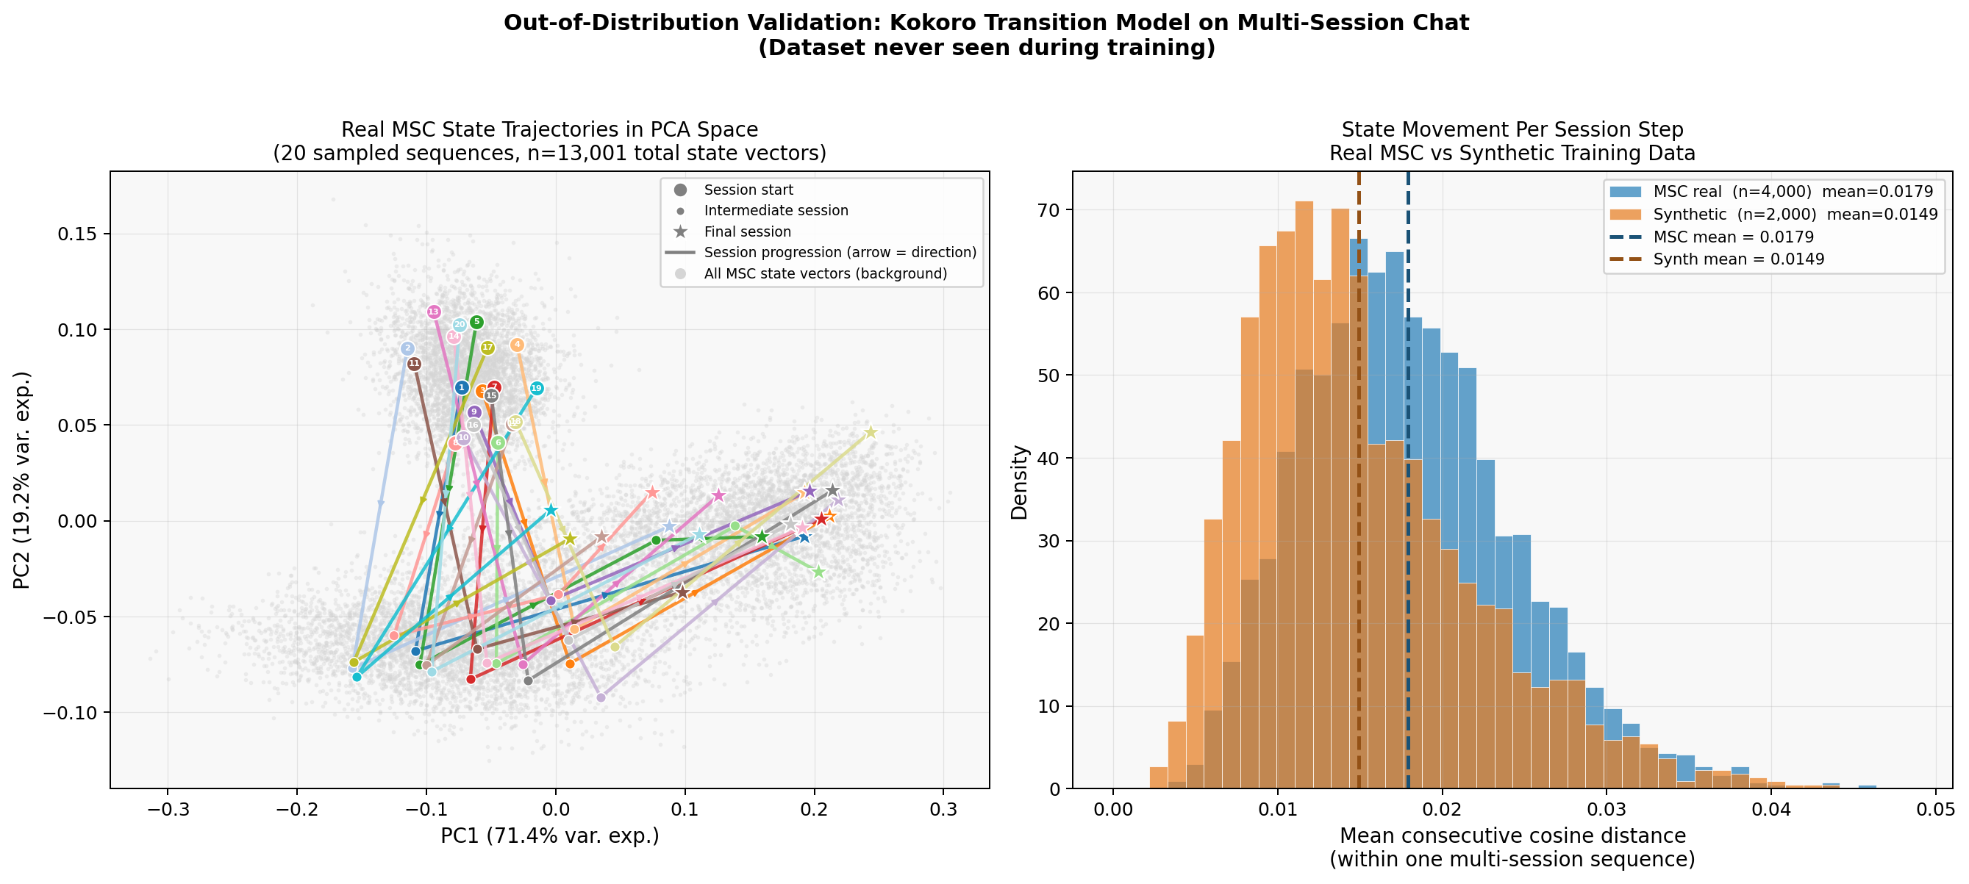Figure 9: OOD validation on MSC. Left: 20 real MSC sequences as paths through PCA state space. Right: per-session movement distribution for MSC (blue) vs synthetic (orange).
Cold-start bias. All sampled paths fan in a consistent direction in PCA space due to zero-vector initialization. This confirms the necessity of the session_count < 3 warm-up guard.

5.7 Downstream Retrieval Evaluation
We evaluate whether emotional retrieval surfaces meaningfully different memories than semantic-only retrieval and whether those memories produce better companion responses.
Setup. 20 multi-session conversation scenarios covering 8 arc types. Each scenario contains 4-6 sessions followed by an ambiguous new message. Two conditions: Condition A (α=1.0): semantic-only. Condition B (α=0.6): Kokoro hybrid. Neither condition injects a state summary ,retrieval method is the single variable. Same LLM (llama-3.1-70b-versatile) and base system prompt for both. Separate judge LLM evaluates responses blind to condition.

Condition | Wins | Win Rate | Notes
A: Semantic only | 12 | 60% | Specific factual details rewarded by judge
B: Kokoro hybrid | 8 | 40% | Different memories surfaced in 55% of scenarios
TIE | 0 | 0% | —
Table 7: Downstream retrieval evaluation. Semantic-only preferred in single-turn blind comparison. Discussion of what this result does and does not measure in Section 6.2.

6 Analysis

6.1 What Dimensional Collapse Tells Us
The participation ratio of 1.4/384 is a genuine limitation. We do not minimize it. The model uses less than 1% of its available state space, primarily tracking valence. The cosine prediction objective without variance-preserving regularization is known to be susceptible to this form of collapse ,the network minimizes loss by projecting representations onto the axis of maximum variance in the training data, which in EmpatheticDialogues is valence polarity.
What partially mitigates this: the axis the model collapsed onto is not arbitrary. PC1 correlates with valence polarity at r=0.75 ,the psychologically primary dimension of affect according to Russell (1980). The model learned the most important dimension. The limitation is that it learned only that dimension. Future work with VICReg (Bardes et al., 2022) or contrastive objectives should force the model to use more dimensions, potentially recovering arousal and finer emotional distinctions.

6.2 What the Downstream Results Actually Mean
The 40% Kokoro win rate in single-turn blind evaluation requires careful interpretation. Semantic-only retrieval excels at surfacing memories with specific topical details that the LLM uses verbatim. The judge rewards that specificity in a single-turn comparison. Kokoro surfaces emotionally resonant memories regardless of topic, which is most valuable when the current message has no semantic anchor.
Kokoro's contribution is multi-session emotional continuity ,the companion's ability to maintain an appropriate emotional register across weeks. Single-turn blind comparison does not capture this. The appropriate evaluation is a longitudinal user study with real companion deployments, measuring whether users feel the companion understands their emotional situation over time. We identify this as the primary direction for future work.

6.3 Why the World Model Framing Is the Right One
The counterfactual makes the advantage explicit: what if instead of learning a transition model, we stored emotional labels per session and retrieved matching sessions? This lookup approach cannot answer: has the user been anxious for three weeks, or is this an acute episode? Is the anxiety increasing or stabilizing? These questions require trajectory ,the sequence of states and the dynamics connecting them.
The transition model encodes exactly this information. The state vector after five sessions of gradual decline carries different information from a state vector after five sessions of stable anxiety even when the most recent session is identical. History is compressed into state. This is what makes it a world model: the current state is a sufficient statistic for predicting the future, conditioned on the learned dynamics.

7 Limitations
Dimensional collapse. The transition model exhibits strong dimensional collapse (PR=1.4/384). The cosine prediction objective without variance-preserving constraints defaults to tracking the axis of maximum variance. The model is primarily a valence tracker. Future work should explore VICReg (Bardes et al., 2022) or InfoNCE contrastive objectives.
Proxy training objective. The model optimizes next-session prediction, not state representation quality directly. These are correlated but not identical. The validation results suggest the approximation is good in practice.
Probe generalization failure. The linear probe achieves r=0.765 on synthetic EmpatheticDialogues-style text but outputs nearly identical values on naturalistic companion conversation text (range -0.144 to -0.110 across 20 diverse scenarios). This is a distribution shift failure. The state_summary feature is unreliable outside the training distribution. The state vector itself generalizes; the probe that decodes it does not. Fixing this requires fine-tuning the probe on naturalistic emotional text.
Synthetic training distribution. Synthetic trajectories chain sessions from different people about different topics. Real user trajectories have narrative coherence. The 1.20x real-to-synthetic movement ratio suggests some sensitivity to this mismatch.
Session-level data leakage. The train/validation split is at the trajectory level. Because sessions appear in up to 8 trajectories, the same session text may appear in both splits. A session-disjoint split would provide a stronger guarantee. The MSC OOD validation provides a leakage-free generalization test.
Cold start warm-up period. New users initialize with a zero state vector. Kokoro provides no emotional value for users with fewer than three recorded sessions.
Single-turn downstream evaluation. As discussed in Section 6.2, the downstream evaluation tests single-turn response quality. A longitudinal user study is required to properly evaluate Kokoro's intended contribution.

8 Conclusion
We introduced Kokoro, an open-source library that gives AI companions persistent emotional trajectory memory by treating user emotional state as a world model problem. The central argument is that emotional continuity in AI companions is not a retrieval problem ,it is a dynamics problem. Storing and retrieving emotional facts cannot produce trajectory awareness. A learned transition model that captures how emotional states evolve across sessions can.
The transition model, trained on 10,000 synthetic multi-session trajectories constructed from EmpatheticDialogues without any real longitudinal data, produces state representations that separate emotional arc types with 197% improvement over a last-session embedding baseline. A shuffled-label control confirms this separation reflects genuine learned structure. Out-of-distribution validation on MSC confirms generalization to real multi-session conversations never seen during training. A linear probe confirms both primary circumplex dimensions are linearly decodable from state vectors within the training distribution (r=0.765 valence, r=0.631 arousal).
The honest limitations are significant. The state space is strongly collapsed onto the valence axis due to an unregularized cosine prediction objective. The linear probe fails to generalize to naturalistic conversation text outside the training distribution. The downstream evaluation tests single-turn response quality rather than long-term emotional continuity.
What Kokoro establishes is the correctness of the framing and the feasibility of the approach. The world model framework applied to user emotional state produces representations with real structure, trained from synthetic data alone, generalizing to real conversations. The path from proof of concept to a system that demonstrably improves companion experience requires: a longitudinal user study with real deployments, a variance-preserving training objective (VICReg or contrastive), and a probe that generalizes across conversation styles.
Kokoro is open source, ships as a drop-in Python library with two lines of integration code, and requires no GPU and no LLM fine-tuning. We hope the world model framing ,and the synthetic trajectory construction method that makes it trainable without longitudinal data ,proves useful to researchers and practitioners building the next generation of emotionally aware AI companions.

References
Bardes, A., Ponce, J., & LeCun, Y. (2022). VICReg: Variance-invariance-covariance regularization for self-supervised learning. ICLR 2022.
Bonanno, G. A. (2004). Loss, trauma, and human resilience. American Psychologist, 59(1), 20–28. [Note: Bonanno demonstrates resilience is the modal response to trauma; arc template uses this as a narrative approximation not a literal trajectory model.]
CEmoFlow (2026). Time-continuous modeling for temporal affective pattern recognition in LLMs. arXiv:2601.12341.
Chen, T., Lu, J., Shen, Y., & Zhang, L. (2026). ES-MemEval: Benchmarking conversational agents on personalized long-term emotional support. WWW 2026. DOI: 10.1145/3774904.3792143. Dataset: https://doi.org/10.5281/zenodo.18338564
Devlin, J., Chang, M. W., Lee, K., & Toutanova, K. (2019). BERT: Pre-training of deep bidirectional transformers for language understanding. NAACL-HLT 2019.
Ha, D., & Schmidhuber, J. (2018). World models. arXiv:1803.10122.
Kotecha, R., et al. (2026). Emotion-attended stateful memory (EASM). [Verify full citation before submission]
Kuppens, P., Allen, N. B., & Sheeber, L. B. (2010). Emotional inertia and psychological maladjustment. Psychological Science, 21(7), 984–991.
Kuppens, P., & Verduyn, P. (2017). Emotion dynamics. Current Opinion in Psychology, 17, 22–26.
Lazarus, R. S. (1991). Emotion and Adaptation. Oxford University Press.
Mohammad, S. M. (2018). Obtaining reliable human ratings of valence, arousal, and dominance for 20,000 English words. ACL 2018.
Packer, C., et al. (2023). MemGPT: Towards LLMs as operating systems. arXiv:2310.08560.
Picard, R. W. (1997). Affective Computing. MIT Press.
Rashkin, H., Smith, E. M., Li, M., & Boureau, Y. L. (2019). Towards empathetic open-domain conversation models. ACL 2019, 5370–5381.
Reimers, N., & Gurevych, I. (2019). Sentence-BERT: Sentence embeddings using Siamese BERT-networks. EMNLP 2019.
Russell, J. A. (1980). A circumplex model of affect. Journal of Personality and Social Psychology, 39(6), 1161–1178.
Russell, J. A., & Barrett, L. F. (1999). Core affect, prototypical emotional episodes, and other things called emotion. Journal of Personality and Social Psychology, 76(5), 805–819.
Tedeschi, R. G., & Calhoun, L. G. (1996). The posttraumatic growth inventory. Journal of Traumatic Stress, 9(3), 455–471. [Note: PTGI is a measurement instrument; arc template uses post-traumatic growth as a narrative approximation, not a literal trajectory model.]
TheraMind (2026). Multi-session therapy system with cross-session emotional memory. [Verify: arXiv:2510.25758, WWW 2026]
Warriner, A. B., Kuperman, V., & Brysbaert, M. (2013). Norms of valence, arousal, and dominance for 13,915 English lemmas. Behavior Research Methods, 45(4), 1191–1207.
Xi, Y., & Wang, W. (2025). Livia: An emotion-aware AR companion. arXiv:2509.05298.
Xu, J., Szlam, A., & Weston, J. (2022). Beyond goldfish memory: Long-term open-domain conversation. ACL 2022, 5180–5197.
Zheng, Q., et al. (2026). Toward natural and companionable virtual agents via cross-temporal emotional modeling. CHI 2026. DOI: 10.1145/3772318.3790917. arXiv:2605.15812.

Appendix: Arc Templates
All 11 emotional arc templates with psychological grounding and explicit caveats on the nature of the psychological citations.

Arc Type | Sessions | Direction | Psychology Basis / Caveat
gradual_decline | 8 | Declining | Lazarus (1991) stress accumulation. NOTE: Lazarus posits subjective appraisal mediates stress; arc is a narrative approximation of accumulated stress, not a deterministic model.
slow_recovery | 9 | Improving | Bonanno (2004). NOTE: Bonanno shows resilience is the modal response; this arc represents a recovery trajectory, not the most common outcome.
acute_stress_stabilization | 7 | Stress then stable | Lazarus & Folkman (1984) coping.
chronic_low_grade_anxiety | 8 | Stable negative | Clinical anxiety literature.
weekend_oscillation | 8 | Oscillating | Circadian mood variation.
grief_arc | 9 | Decline then slow recovery | Bonanno (2004). NOTE: Kubler-Ross stages are empirically contested and anecdotal; this arc is a narrative template only, not evidence-based.
post_traumatic_growth | 9 | Decline then growth | Tedeschi & Calhoun (1996). NOTE: PTGI is a measurement instrument, not a trajectory model; PTG is also contested as sometimes illusory. Arc is a narrative approximation.
social_confidence_growth | 7 | Improving | Social anxiety intervention literature.
relapse_dip | 9 | Mixed | Recovery/relapse models.
stable_positive | 6 | Stable positive | Positive psychology baselines.
stable_negative | 6 | Stable negative | Depression persistence literature.
Table A1: All 11 arc templates with explicit caveats. Psychology citations are used as narrative inspiration for trajectory shapes, not as claims that these are universal or deterministic emotional trajectories.

