Analysis Report

Generated with the reporter() Function of the metafor Package

04 June, 2022

## Methods

A random-effects model was fitted to the data. The amount of heterogeneity (i.e., $τ^{2}$), was estimated using the restricted maximum-likelihood estimator (Viechtbauer, 2005). In addition to the estimate of $τ^{2}$, the $Q$-test for heterogeneity (Cochran, 1954) and the $I^{2}$ statistic (Higgins & Thompson, 2002) are reported. In case any amount of heterogeneity is detected (i.e., ${\hat{τ}}^{2}>0$, regardless of the results of the $Q$-test), a prediction interval for the true outcomes is also provided (Riley et al., 2011). Studentized residuals and Cook’s distances are used to examine whether studies may be outliers and/or influential in the context of the model (Viechtbauer & Cheung, 2010). Studies with a studentized residual larger than the $100×\left(1-0.05/\left(2×k\right)\right)$ th percentile of a standard normal distribution are considered potential outliers (i.e., using a Bonferroni correction with two-sided $α=0.05$ for $k$ studies included in the meta-analysis). Studies with a Cook’s distance larger than the median plus six times the interquartile range of the Cook’s distances are considered to be influential. The rank correlation test (Begg & Mazumdar, 1994) and the regression test (Sterne & Egger, 2005), using the standard error of the observed outcomes as predictor, are used to check for funnel plot asymmetry. The analysis was carried out using R (version 4.1.2) (R Core Team, 2020) and the **metafor** package (version 3.0.2) (Viechtbauer, 2010).

## Results

A total of $k=5$ studies were included in the analysis. The observed outcomes ranged from $0.0296$ to $1.0647$, with the majority of estimates being positive (100%). The estimated average outcome based on the random-effects model was $\hat{μ}=0.3466$ (95% CI: $-0.0263$ to $0.7195$). Therefore, the average outcome did not differ significantly from zero ($z=1.8217$, $p=0.0685$). A forest plot showing the observed outcomes and the estimate based on the random-effects model is shown in Figure 1.

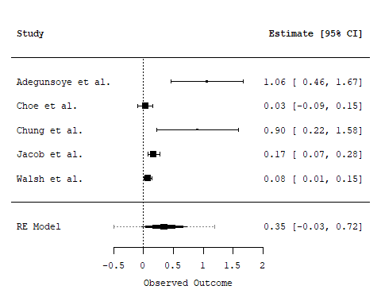

Figure 1: Forest plot showing the observed outcomes and the estimate of the random-effects model

According to the $Q$-test, the true outcomes appear to be heterogeneous ($Q\left(4\right)=18.8557$, $p=0.0008$, ${\hat{τ}}^{2}=0.1488$, $I^{2}=96.9941$%). A 95% prediction interval for the true outcomes is given by $-0.4965$ to $1.1897$. Hence, although the average outcome is estimated to be positive, in some studies the true outcome may in fact be negative.

An examination of the studentized residuals revealed that one study (Adegunsoye et al.) had a value larger than $±2.5758$ and may be a potential outlier in the context of this model. According to the Cook’s distances, one study (Adegunsoye et al.) could be considered to be overly influential.

A funnel plot of the estimates is shown in Figure 2. The regression test indicated funnel plot asymmetry ($p=0.0003$) but not the rank correlation test ($p=0.4833$).

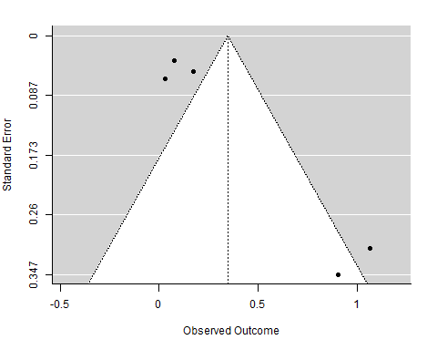

Figure 2: Funnel plot

## Notes

This analysis report was dynamically generated for model object ‘res’ with the reporter() function of the **metafor** package. The model call that was used to fit the model was ‘rma(yi = lnor, vi = var, data = dat, slab = paste(Authors))’. This report provides an illustration of how the results of the model can be reported, but is not a substitute for a careful examination of the results.

## References

Begg, C. B., & Mazumdar, M. (1994). Operating characteristics of a rank correlation test for publication bias. *Biometrics*, *50*(4), 1088–1101. <https://doi.org/10.2307/2533446>

Cochran, W. G. (1954). The combination of estimates from different experiments. *Biometrics*, *10*(1), 101–129. <https://doi.org/10.2307/3001666>

Higgins, J. P. T., & Thompson, S. G. (2002). Quantifying heterogeneity in a meta-analysis. *Statistics in Medicine*, *21*(11), 1539–1558. <https://doi.org/10.1002/sim.1186>

R Core Team. (2020). *R: A language and environment for statistical computing*. R Foundation for Statistical Computing. <https://www.R-project.org/>

Riley, R. D., Higgins, J. P. T., & Deeks, J. J. (2011). Interpretation of random effects meta-analyses. *British Medical Journal*, *342*, d549. <https://doi.org/10.1136/bmj.d549>

Sterne, J. A. C., & Egger, M. (2005). Regression methods to detect publication and other bias in meta-analysis. In H. R. Rothstein, A. J. Sutton, & M. Borenstein (Eds.), *Publication bias in meta-analysis: Prevention, assessment and adjustment* (pp. 99–110). Wiley.

Viechtbauer, W. (2005). Bias and efficiency of meta-analytic variance estimators in the random-effects model. *Journal of Educational and Behavioral Statistics*, *30*(3), 261–293. <https://doi.org/10.3102/10769986030003261>

Viechtbauer, W. (2010). Conducting meta-analyses in R with the metafor package. *Journal of Statistical Software*, *36*(3), 1–48. <https://doi.org/10.18637/jss.v036.i03>

Viechtbauer, W., & Cheung, M. W.-L. (2010). Outlier and influence diagnostics for meta-analysis. *Research Synthesis Methods*, *1*(2), 112–125. <https://doi.org/10.1002/jrsm.11>