A Study on “Monomolecular Layers and Light” by Karl H. Drexhage
Scientific American, 1970

By Grace Shih
Fall 2005
OPTI 310

Abstract: The study of the physics behind electromagnetic waves is fairly young, and only until about 40 years ago were we able to easily and accurately quantify the generation and propagation of light. A technique developed by Karl Drexhage and his colleagues at the University of Marburg in Germany uses a multilayer system of fluorescent dye and long-chain fatty acid molecules to probe the structure of light waves, specifically standing light waves in front of a mirror and the boundary wave associated with total internal reflection, known as evanescent waves.

The wavelength of visible light is quite small compared to other recognized and heavily used/seen light waves such as radio, microwaves, and infrared, thus they are difficult to accurately quantify. In comparison to the size of the fatty-acid C₂₀H₄₀O₂ molecules the wavelength of electromagnetic waves is orders of magnitude larger. The main objective for using monomolecular dye and fatty-acid layers is to utilize stable and fluorescent nanometer-sized particles for viewing standing waves and boundary waves with exceptional resolution [2].
To begin, a short explanation of standing waves is necessary in appreciating the potential application of this process of observation. The concept of standing waves can be seen in everyday situations. The most logical description is that of a rope of a certain length, L, with one end tied to an anchor (Figure 1). When one moves the free end up and down quickly, a wave propagates down the string and deflects off the fixed end, coming back to form another half wavelength. The number of half wavelengths, n, produced depends on the energy applied; this is the same idea for electromagnetic standing waves. The number of half wavelengths that can exist on the string must be an integer number, n [7] (Equation 1).
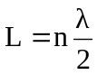 Equation 1
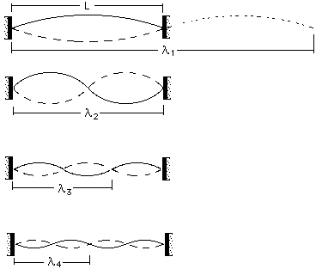
Figure 1
The number of half wavelengths within a fixed length depends on the energy of oscillation.

A similar system can be achieved in terms of monomolecular fatty-acid layers. A thin, rigid and highly reflective metal film is coated with the fatty-acid in a staircase-like fashion, where the thickness of the resulting layers increases down the metal film, then the fluorescent dye is layered on top of the stacks (Figure 2).
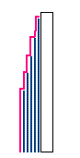
Figure 2
Figure 2 shows the fatty-acid layers in a staircase-like configuration (blue lines) with fluorescent dye over the entire surface (pink).

When light is sent directly perpendicular to the layered surface through the fluorescent dye and layers, it is reflected off the metal and propagates back on the same axis in the opposite direction. This reflected light then interferes with the original incoming light (the same case as the rope tied to an anchor) to form a standing wave within the fatty-acid layers. It is most important to note that the dye molecules absorb an amount of light proportional to the square of the amplitude of the electric field it experiences from the light waves (I E²), therefore the intensity of its fluorescence is proportional to the same quantity [2]. This intensity is measurable and therefore can be quantified. These forms of standing waves in front of a mirror are important in the display and measurement of the width of picosecond laser pulses [5].
An interesting phenomenon that accompanies the behavior of light in the process of total internal reflection is the boundary wave. Also known as the evanescent wave (meaning “passing away quickly”), this intriguing behavior between electrons in relation to electromagnetic waves was extremely difficult to quantify [2]. Essentially, it is the result of the electromagnetic waves tunneling into the bounding media at angles larger than the critical angle of total internal reflection (Figure 3).
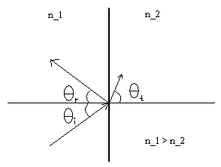
Figure 3
The light is incident at an angle greater than the critical angle for total internal reflection, thus reflection occurs, but the evanescent wave (shown here as the “transmitted” wave) still appears on the other side of the boundary.

Early in its mathematical discovery it was believed to be a purely theoretical concept, but as the monomolecular layer technique will show, it is very real and measurable.
The derivation for the mathematical form of the evanescent wave is quite tedious, but Hecht gives a very good description of it through the use of these equations [3]:
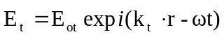 Equation 2
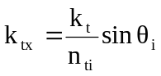 Equation 3
Equation 4
Equation 2 is the general wave function for the transmitted electric field (the evanescent wave we are interested in) where k is the propagation vector for the electric field and ω is the angular frequency. Equation 3 is the condition that arises when sinθ_{i} > n_{ti} by which our evanescent wave exists. Lastly, Equation 4 is the mathematical equation for the evanescent wave that shows the amplitude of the electric field, E_{0t}, decreasing exponentially as a function of the distance through the interface it travels. This shows that an evanescent wave only exists a few wavelengths of light into the surface [4]. It is very obvious that this quantity is extremely small for normal mechanical instruments to measure, thus the method with fluorescent dyes is an excellent way to at least observe the physical existence of these boundary waves [1].
Consider a thin glass plate covered with a layer of dye molecules and then covered with a varying number of CdC₂₀ molecule layers (Cadmium-strengthened fatty-acid molecules). The CdC₂₀ layers is a refractive index matching substance that is essentially the same index of refraction as the glass plate, so the interface between the dye and the glass is invisible to the light waves. The slide is then covered with a liquid of higher refractive index. Since the CdC₂₀ has a lower refractive index, this set-up is ideal for a total internal reflection process. When light is sent through at an angle greater than the critical angle, the boundary wave existing in the layers is detected by the dye molecules, which emit yellow fluorescence with an intensity proportional to the square of the amplitude of the localized electric field [2]. From the intensity apparent in the dye molecules, a verification of the exponential decay of the evanescent wave was found with a large amount of precision [5]. More importantly, the dependence of this exponential decay length into the medium on the angle of incidence (at angles greater than the critical angle) has been quantified [1].
Although the details of aligning each monomolecular layer have been omitted, the process is fairly simple and requires a small amount of organic substances. The concept behind the usefulness of fluorescent dyes within a monomolecular layer will be the same with any substance once chooses. The idea of using such small sized particles in the experiment was the main concept for this technique, and the process of stabilizing and layering the molecules is not difficult and does not require precision instruments. This, of course, greatly increased the ability to simply and effectively observe electromagnetic behavior not seen before. This inherently alludes to a great number of other innovations in the future of nanotechnology and the study of electrons in nanometer-scale structures [5], including the verification of several other theories within physical optics and quantum physics.

Bibliography
[1] Agarwal, V.K., “Present Status and Future Potential of Monomolecular and Multimolecular Built-Up Films,” Thin Solid Films 10, 3-12 (1978).
[2] Drexhage, K.H., “Monomolecular Layers and Light,” Sci. Am. 222, 108-118 (1970).
[3] Hecht, E., Optics, 4th Ed. (Addison Wesley, San Francisco, 2002).
[4] Lyuboshitz, V.L., “Dissipation of the energy of excited atoms located near an absorptive medium surface,” Phys. Lett. 3, 407-409 (1977).
[5] Nejo, H., Nanoelectrodynamics (Springer, Germany, 2003).
[6] Prieve, D.C., “Evanescent Waves and Total Internal Reflection,” http://www.andrew.cmu.edu/user/dcprieve/Evanescent%20waves.htm (2005).
[7] Wolfe, J., “Strings, standing waves, and harmonics,” http://www.phys.unsw.edu.au/~jw/strings.html (2005).

