No-Code Dataset Preparation Platform
A No Code approach towards data cleaning and preprocessing
Mentor: Asmita Ingale
Mentee: Dhruva Tikhe

Project Goal
The goal of the project is to create a no-code webapp for cleaning and preprocessing datasets for Machine Learning specific applications. The pipeline in the project seamlessly handles the processing of the dataset without the users needing to write any form of code
Importance
High-quality datasets are essential for reliable Machine Learning and AI applications. This project simplifies the often, time-consuming preprocessing stage by providing a no-code solution that automates data cleaning and preparation, reducing manual effort, improving consistency, and saving development time. While the initial focus is on ML-specific preprocessing, the platform is designed to evolve with AI-assisted recommendations, explanations, and workflow optimisation, making dataset preparation faster and more accessible.
The platform ensures preprocessing is consistent and reproducible across datasets, reducing manual errors and improving model reliability.
Note: Traditional Machine Learning algorithms generally require categorical or textual data to be converted into numerical representations through encoding.
Target Audience
Machine Learning engineers, data scientists, software developers, ML Ops etc. are the target audience who want a no-code solution to data cleaning and preprocessing
Existing Solutions
Platform | Description | Issues
KNIME | Visual data editor with data cleaning and preprocessing features. | - Complicated to use  - Desktop application only.
Orange | Widget-based application for data imputation, normalization, and machine learning workflows. | - Not modern  - Slow for large datasets.
Dataiku | Enterprise-grade MLOps platform for data preparation, analytics, and machine learning. | - Complicated to use  - Practical usage requires the paid version.
Power Query | No-code data transformation and cleaning tool integrated into Microsoft Excel and Power BI. | - Limited ML-specific preprocessing capabilities  - Primarily designed for ETL and business intelligence workflows.

Flow of the Project
- Input: Input consists of the raw/unclean dataset which is mostly in the form of .csv or .xlsx file
- Output: Output will be a clean and preprocessed dataset file in form of .csv or .xlsx, which will be fit for further implementation of Machine Learning models.
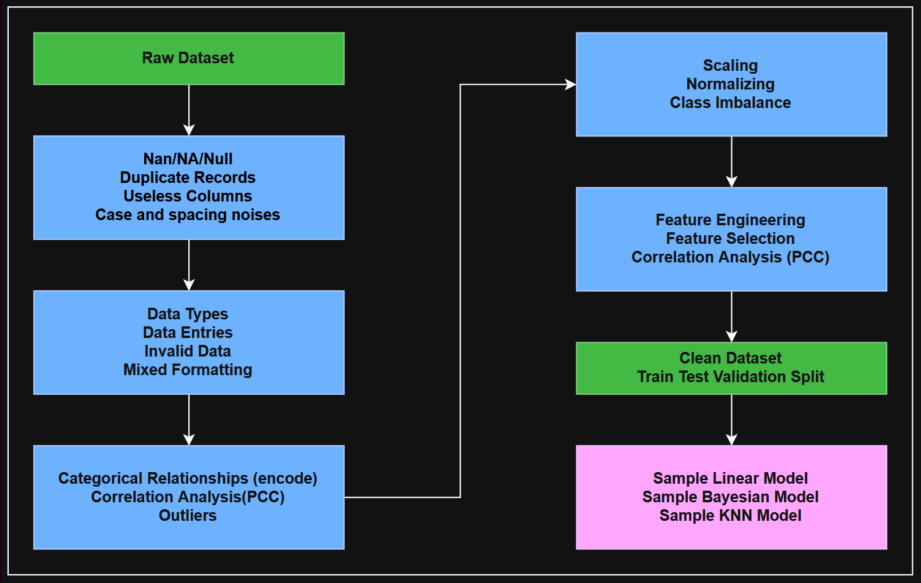
- Features: The data will flow through the several features and settings of the project which will transform it to be usable for ML applications.

Showcasing some common issues in real world data
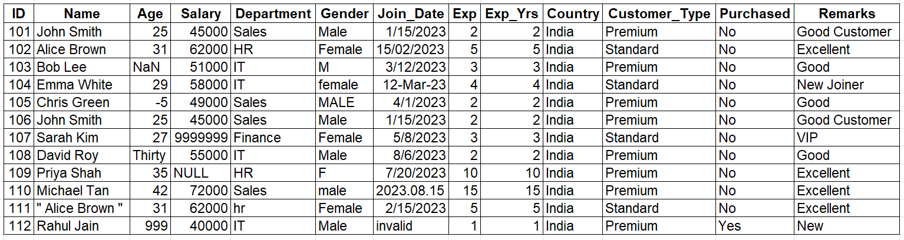
Sample Input:

Explaining the issues:
Issue | Example | Solution
Missing values | Age = NaN, Salary = NULL | Replace with Average of Age and Salary respectively
Duplicate rows | Rows 101 and 106 | Remove one of the rows since duplicated
Inconsistent categories | Male, male, MALE, M, Female, F, hr, HR | Replace with Male, and Female respectively
Outliers | Salary = 9999999, Age = 999 | Remove rows or replace by Average of Salary and Age
Invalid entries | Age = Thirty, Age = -5, Join_Date = invalid | Remove rows or convert to numerical/date
Highly correlated features | Exp and Exp_Yrs | Highly correlated so remove one of the columns
Constant columns | Country = India for every row | Remove the column since it doesn’t provide any value
Categorical features | Department, Gender, Country, Customer_Type | Convert textual data into numerical data using Encoding
Imbalanced classes | Purchased = 11 × No, 1 × Yes | Create new data for “Yes” samples since its very imbalanced (SMOTE)
Mixed formatting | Dates in multiple formats (2023-01-15, 15/02/2023, 12-Mar-2023, 2023/03/12, 2023.08.15) | Convert all dates to a single format for easier understanding
Textual noise | " Alice Brown " (leading/trailing spaces), mixed case in Gender and Department | Convert to Lowercase and remove the extra spaces
Useless columns | ID and Name are not relevant to the dataset for training | Drop the columns since they don’t provide any value

Similarly, for ML applications, there is even more processing to do (e.g. Converting text to numbers, balancing the classes, removing useless columns etc.) which will also be implemented as a part of the project.
For all the actions, for each data, only 1 iteration is needed to clean it and preprocess it respectively. This allows for a faster workflow.
Success is achieved when the output dataset is a clean and preprocessed dataset which can be used for ML model training.
Scope of Features
Feature | Explanation | Example
Missing data | Data is just not present (NA/NULL) | [1, 2, 4, NA, NULL, 7]
Duplicate data | Entire row is repeated | [1,2,3,4,5]  [1,2,3,4,5]
Useless columns | Columns like ID, or Sr.No are not useful. Or have repeated data | Sr.no = [1,2,3,4,5,6]  Country = [India, India, India]
Case and Spacing issues | Alphabet casing and spacing after words | “Hello”, “hello”, “ HEllo ”
Incorrect data types | Same data expressed in different types | Age = 20, Twenty, 20
Inconsistent data entries | Inconsistent representation of data | Male, male, M, man, m  Female, female, F, woman, f
Invalid data | Data which doesn’t make sense in real world | Age = -5  Salary = -10 INR
Textual data | Textual data in categories or strings | Diabetes = [Yes, No, Yes, Yes, No]
Highly Correlated Columns | Columns which denote similar contents | Height (cm) and Height (inch)
Outliers | Unexpectedly high or low values | Blood Pressure = [120, -4, 2, 120]

We will be solving all these issues in data (and maybe even more) to create a fully clean and ready-to-use dataset for Machine Learning applications.
AI Contents
Not in primary scope as of now, but in the future iterations, we plan to implement the following AI features with help of LLM support
- Smart preprocessing suggestions: Recommend appropriate methods and techniques based on characteristics of the dataset.
- Natural-language explanations: Explain why a particular preprocessing step is recommended in simple terms.
- Pipeline optimisation: Suggest the order of preprocessing operations to minimise errors.
- Automated Dataset Summary: Create a summary of the dataset which helps to tell us more about the data and its overall purpose.

How the solution stands out
Existing Tools | Proposed Solution
General-purpose data preparation tools | Specifically designed for ML dataset preprocessing.
Require knowledge of workflows and many settings | One-click guided pipeline with beginner-friendly UI.
Focus on ETL/BI as much as ML | Focuses only on preparing data for ML training.
Don't explain decisions | Explains every preprocessing step in plain English.
User manually decides many preprocessing methods | Recommends suitable preprocessing automatically. (LLM capability)
Enterprise/desktop oriented (OS based) | Lightweight web application that anyone can access.

The project is not trying to replace KNIME or Dataiku. It targets students, researchers, and developers who simply want to upload a dataset and receive an ML-ready dataset without learning complex workflow tools.
The novelty of this project lies in combining deterministic ML preprocessing with AI-assisted explanations and recommendations in a beginner-friendly no-code web platform.
Business Value
The proposed solution provides business value in the following ways:
- Reduces data preparation time from hours to minutes.
- Enables non-technical users to build ML-ready datasets.
- Standardizes preprocessing across multiple teams.
- Reduces human errors and biases during data cleaning.
- Can be integrated into existing ML pipelines.
- Lowers onboarding time for new ML engineers since no complicated workflows are present.
- Makes preprocessing reproducible and consistent across many projects and teams.

Future Scope
Future versions of the project can be extended to converting it into a VS Code extension/plugin, Jupyter Notebook Plugin and Google Colab Extension.
AI features mentioned above will also be a part of the future scope. They will help to make the interface more user friendly and explainable.
Why not directly use LLMs (broadly understood as AI)?
Current LLMs (ChatGPT, Gemini, Claude etc.) can recommend steps, explaining them and generating summaries for the data. But the preprocessing for each dataset is deterministic and needs to be reproducible. Those operations are better performed using traditional data-processing libraries because they are accurate, reproducible, and computationally efficient.
Also relying only on LLMs for preprocessing the datasets can lead to several issues such as, inaccurate data (since generative ai models may not be perfect), company’s private data getting leaked to online endpoints (security risk), improper prompting and model biasing can totally change the outcome for the dataset, commercially available datasets are at times huge in size (beyond GBs in size) which is not possible to be processed with LLMs for cleaning and preprocessing. Hence the traditional approach of using libraries is better, but by adding AI assistance to the tool, we make it simpler for people to understand, generate summaries and recommendations.

