No-Code Dataset Preparation Platform
A No Code approach towards data cleaning and preprocessing
Mentor: Asmita Ingale
Mentee: Dhruva Tikhe

High Level Architecture
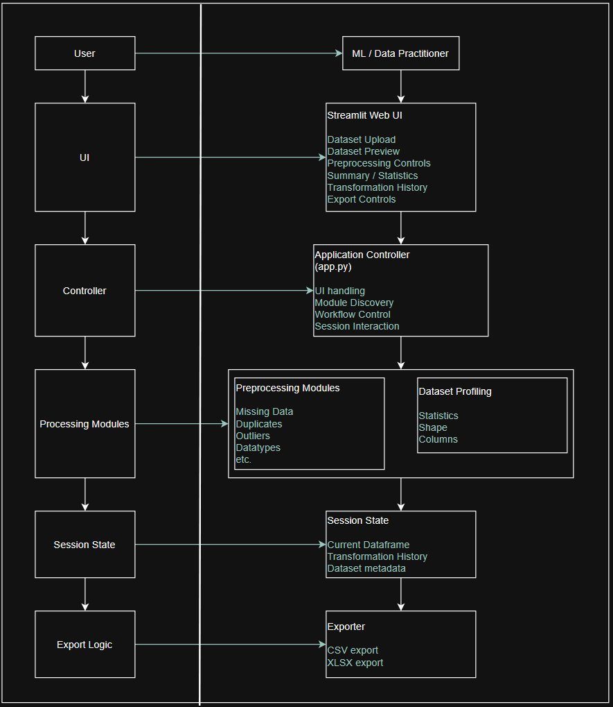
The architecture proposed for the project is shown in the diagram below. This is high-level architecture i.e. made from an abstraction point of view. The text points in green show the actions and/or individual modules under the main heading of that specific section
Functional Acceptance Criteria for Current Modules
ID | Requirement | Acceptance Criterion
1 | Dataset Upload | System shall successfully accept supported CSV/XLSX datasets
2 | Invalid File | System shall reject unsupported or unreadable files with a meaningful error
3 | Dataset Preview | System shall display a preview of the uploaded dataset
4 | Missing Values | User shall be able to select columns and apply supported missing-value strategies
5 | Duplicates | System shall be able to identify and remove duplicate records
6 | Data Types | User shall be able to detect and convert supported incorrect data types
7 | Outliers | User shall be able to detect and handle supported outlier cases
8 | Transformation | System shall update the current dataset after successful preprocessing
9 | Export | User shall be able to export the processed dataset
10 | Export Integrity | Exported dataset shall contain the transformations performed during the session

Non-Functional Acceptance Criteria for Current Modules
For the MVP, the application should successfully process datasets within the defined development/test dataset limits without crashing and/or freezing.
Reliability
- Invalid files should not crash the application.
- Invalid preprocessing configurations should be rejected.
- Failed transformations should not silently overwrite the dataset.
- The application should provide meaningful error messages.

Usability
- A user without programming knowledge should be able to perform basic preprocessing through the UI.
- Every preprocessing operation should clearly state which columns it applies to.
- The UI should prevent incompatible operations from being applied to inappropriate column types.

Maintainability
- Each preprocessing operation should be implemented as an independent module.
- Modules should follow a consistent interface.
- Adding a new preprocessing operation should not require major changes to app.py.
- Modification to the module file and the registry file should be sufficient to implement the module (with minimal changes to app.py).

SDLC Approach
Following table describes the plan to implement SDLC approach in the development and maintenance of the project. A detailed document going over each phase will be produced shortly after approval of the current methodology and scope of the project.

Sr. | SDLC Phase | Project Activity
1 | Requirement Analysis | Identify ML/data-preparation problems and user requirements
2 | System Design | Architecture, UML diagrams, module design, UI design
3 | Implementation | Develop Streamlit application and preprocessing modules
4 | Testing | Unit, integration, system and user acceptance testing
5 | Deployment | Deploy Streamlit application
6 | Maintenance | Fix bugs, improve preprocessing methods, support larger datasets

Target Users
The target users can be defined as ML / Data Science practitioners - people who received raw dataset and need to clean and preprocess it before using it for machine learning or data analysis without wanting to write preprocessing codes manually.

Actor | How they use the Application | Priority
ML Engineer | Performs initial dataset preparation before building ML pipelines | Primary
Data Scientist | Cleans and preprocesses datasets before model development | Primary
Data Analyst | Cleans messy datasets for analysis/visualization | Secondary
ML/DS Student / Researcher | Experiments with preprocessing techniques without writing extensive code | Secondary
System Administrator | Deploys/maintains the application | Supporting, if applicable

For future use cases and generalised explanations, the term “ML / Data Practitioner” will be the most appropriate as it includes all the above-mentioned roles. Alternatively, given the context, the term “User”, too can be used to indicate the above-mentioned roles.

