SCHOOL OF COMPUTER SCIENCE AND ARTIFICIAL INTELLIGENCE |  |  |  |  | DEPARTMENT OF COMPUTER SCIENCE ENGINEERING
Program Name: B. Tech |  |  |  | Assignment Type: Lab |  |  | Academic Year:2025-2026
Course Coordinator Name |  |  |  | Venkataramana Veeramsetty
Instructor(s) Name |  |  |  | Dr. V. Venkataramana (Co-Ordinator)  Dr. T. Sampath Kumar  Dr. Pramoda Patro  Dr. Brij Kishor Tiwari  Dr.J.Ravichander  Dr. Mohammand Ali Shaik  Dr. Anirodh Kumar  Mr. S.Naresh Kumar  Dr. RAJESH VELPULA  Mr. Kundhan Kumar  Ms. Ch.Rajitha  Mr. M Prakash  Mr. B.Raju  Intern 1 (Dharma teja)  Intern 2 (Sai Prasad)  Intern 3 (Sowmya)  NS_2 ( Mounika)
Course Code |  |  | 24CS002PC215 | Course Title |  | AI Assisted Coding
Year/Sem |  |  | II/I | Regulation |  | R24
Date and Day  of Assignment |  |  | Week2 - Monday | Time(s)
Duration |  |  | 2 Hours | Applicable to  Batches
Assignment Number:4.1(Present assignment number)/24(Total number of assignments)
 | Q.No. | Question |  |  |  |  |  | Expected Time  to complete
 | 1 | Lab 4: Advanced Prompt Engineering – Zero-shot, One-shot, and Few-shot Techniques  Lab Objectives:  - To explore and apply different levels of prompt examples in AI-assisted code generation.  - To understand how zero-shot, one-shot, and few-shot prompting affect AI output quality.  - To evaluate the impact of context richness and example quantity on AI performance.  - To build awareness of prompt strategy effectiveness for different problem types.  Lab Outcomes (LOs):  After completing this lab, students will be able to:  - Use zero-shot prompting to instruct AI with minimal context.  - Use one-shot prompting with a single example to guide AI code generation.  - Apply few-shot prompting using multiple examples to improve AI responses.  - Compare AI outputs across the three prompting strategies.  Task #1 – Zero-Shot Prompting with Conditional Validation  Objective  Use zero-shot prompting to instruct an AI tool to generate a function that validates an Indian mobile number.  Requirements  - The function must ensure the mobile number:  - Starts with 6, 7, 8, or 9  - Contains exactly 10 digits  Expected Output  - A valid Python function that performs all required validations without using any input-output examples in the prompt.  PROMPT: Write a python function that validates whether a given number is a valid Indian mobile number  CURSOR :  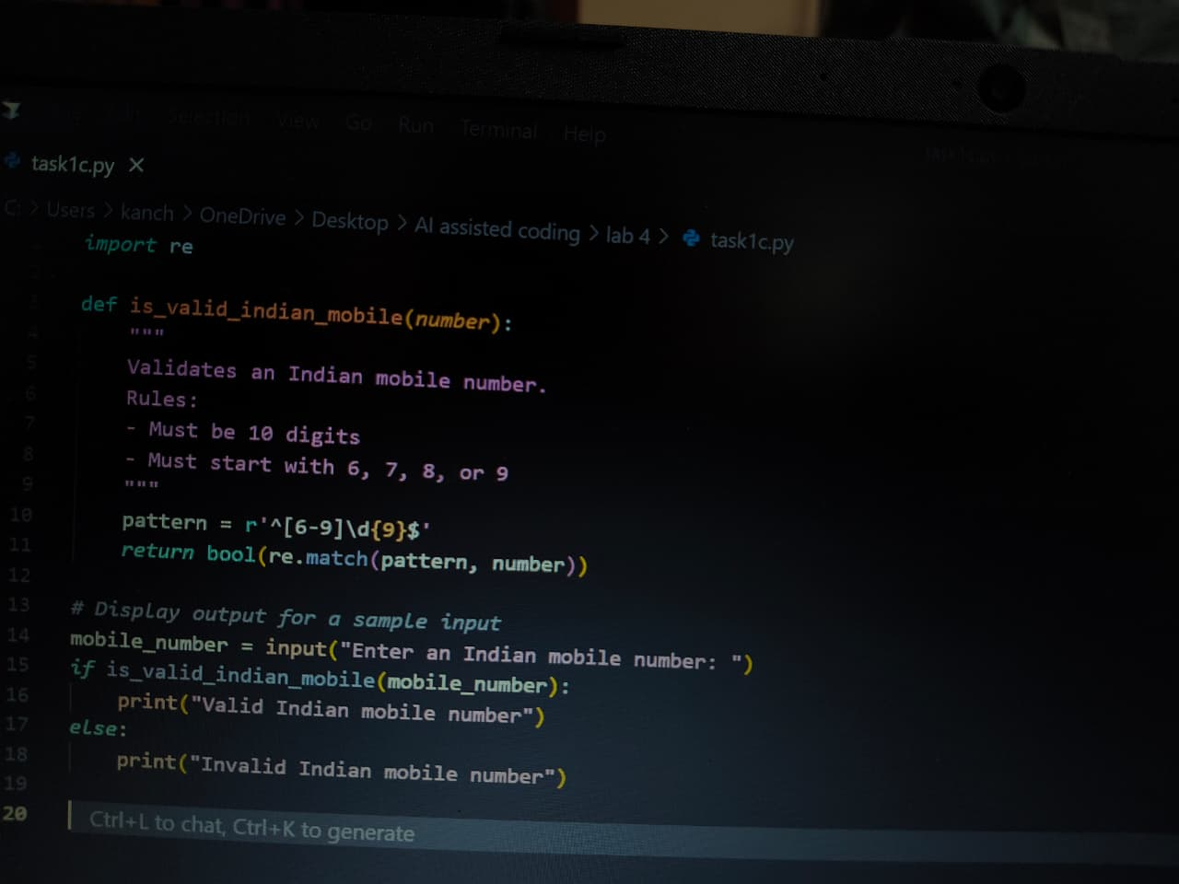  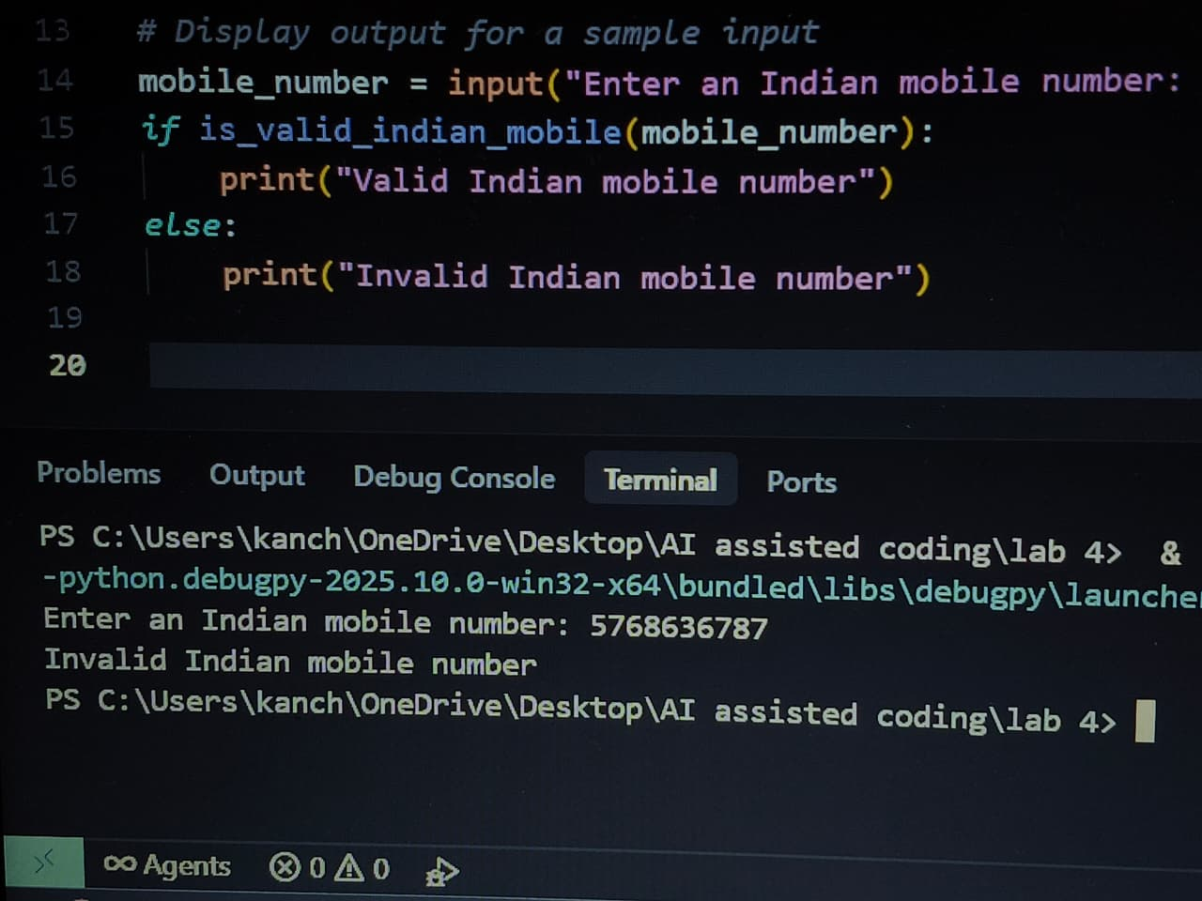  VS CODE:  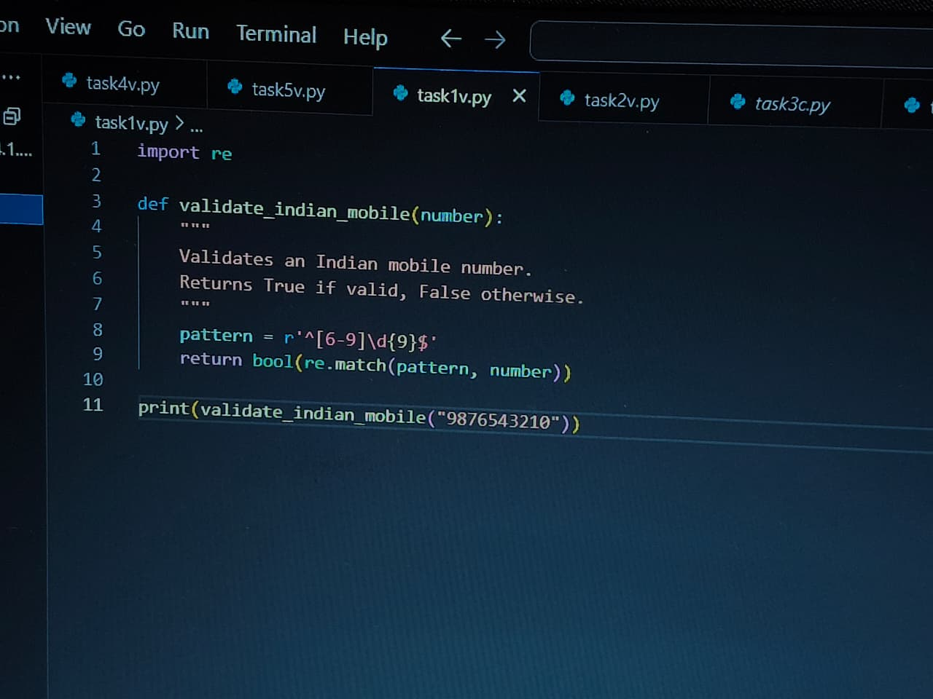  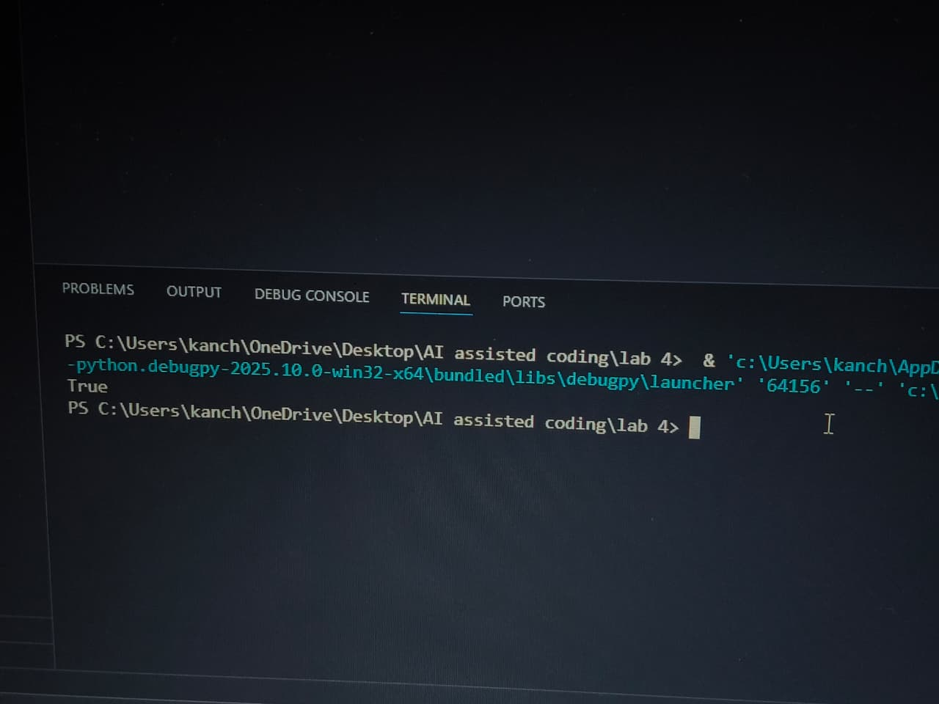  Task #2 – One-Shot Prompting with Edge Case Handling  Objective  Use one-shot prompting to generate a Python function that calculates the factorial of a number.  Requirements  - Provide one sample input-output pair in the prompt to guide the AI.  - The function should handle:  - 0! correctly  - Negative input by returning an appropriate message  Expected Output  - A Python function with correct factorial logic and edge case handling, generated from a single example.  PROMPT: Write a python function to generate factorial of a number using one-shot prompting  CURSOR:  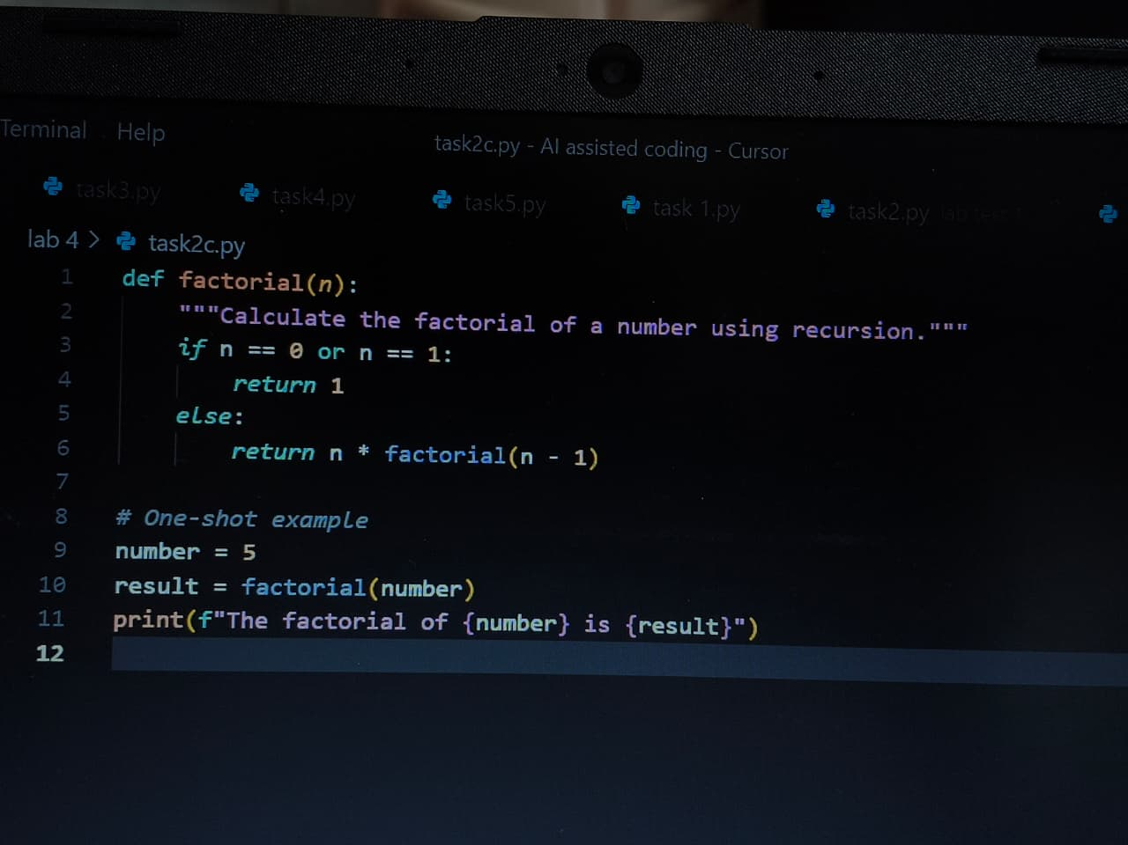  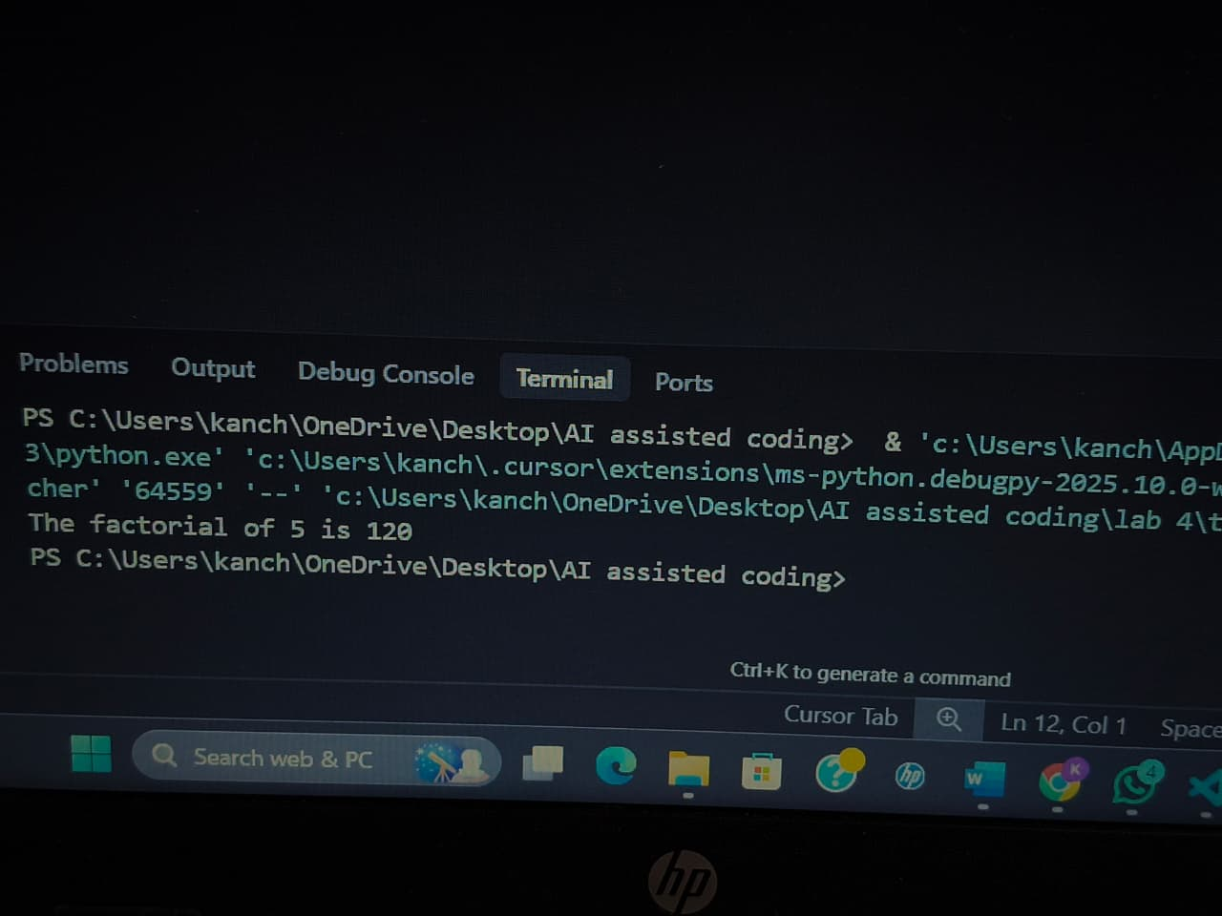  VS CODE:  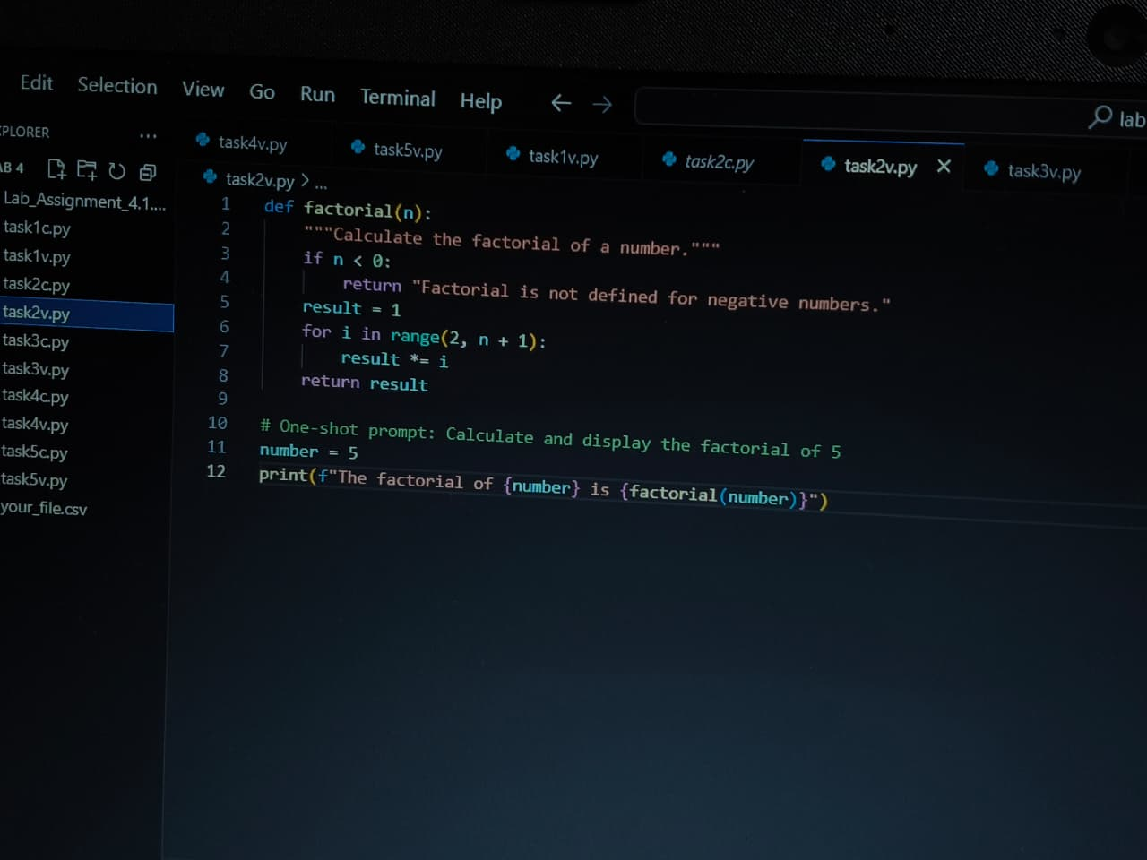  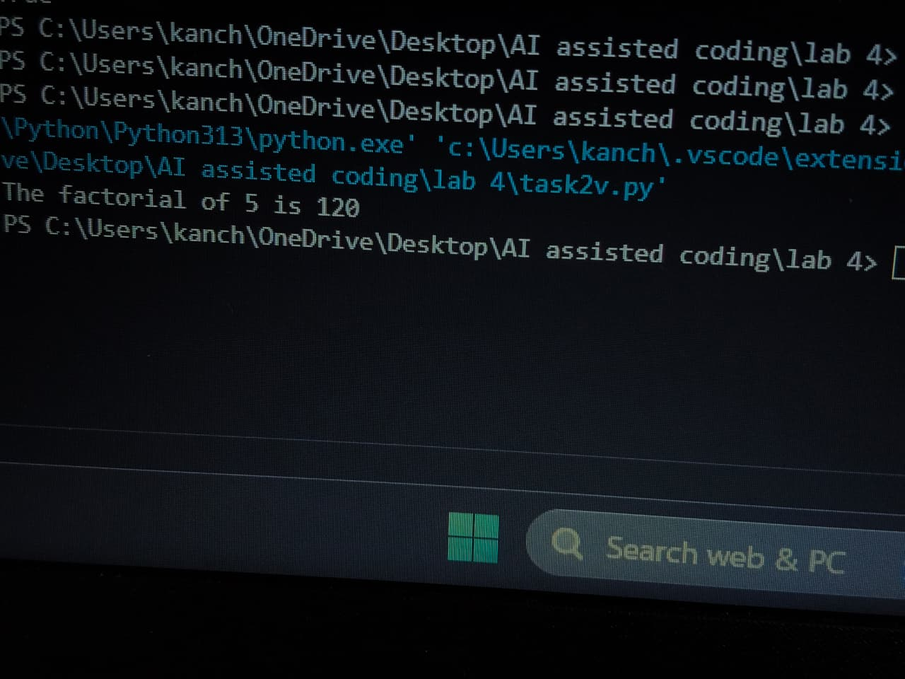  Task #3 – Few-Shot Prompting for Nested Dictionary Extraction  Objective  Use few-shot prompting (2–3 examples) to instruct the AI to create a function that parses a nested dictionary representing student information.  Requirements  - The function should extract and return:  - Full Name  - Branch  - SGPA  Expected Output  - A reusable Python function that correctly navigates and extracts values from nested dictionaries based on the provided examples.  PROMPT: Write a python code that takes a nested dictionary containing student information and display it using few-shot prompting  CURSOR:  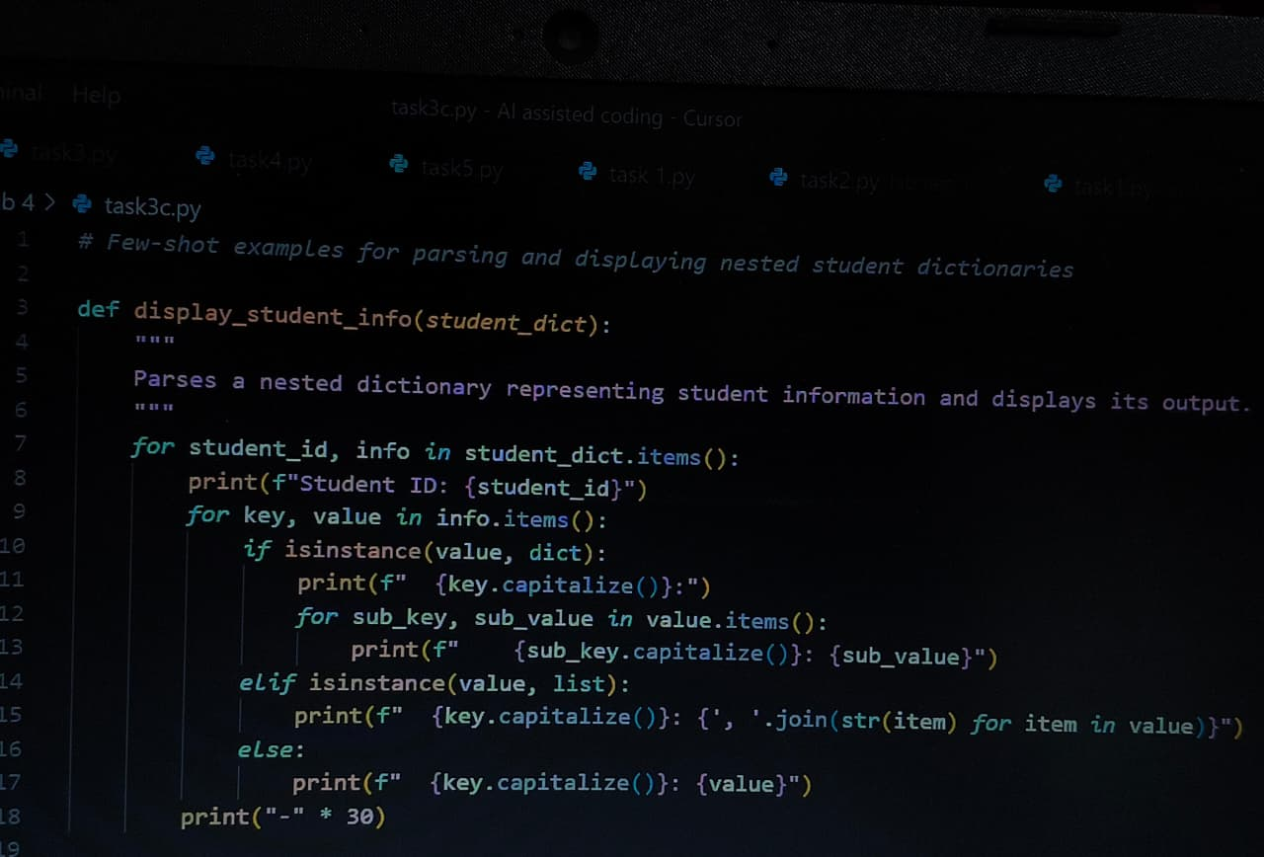  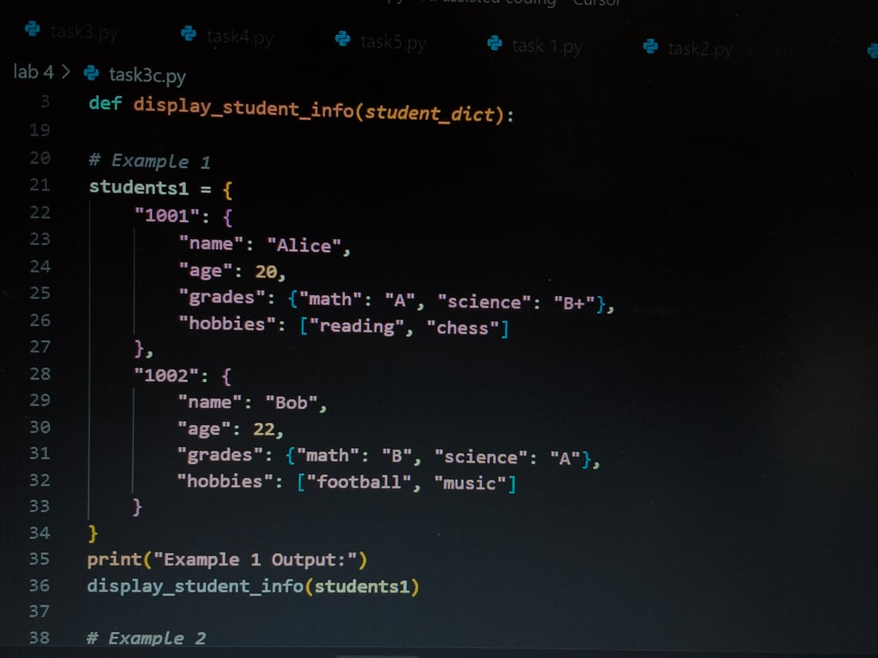  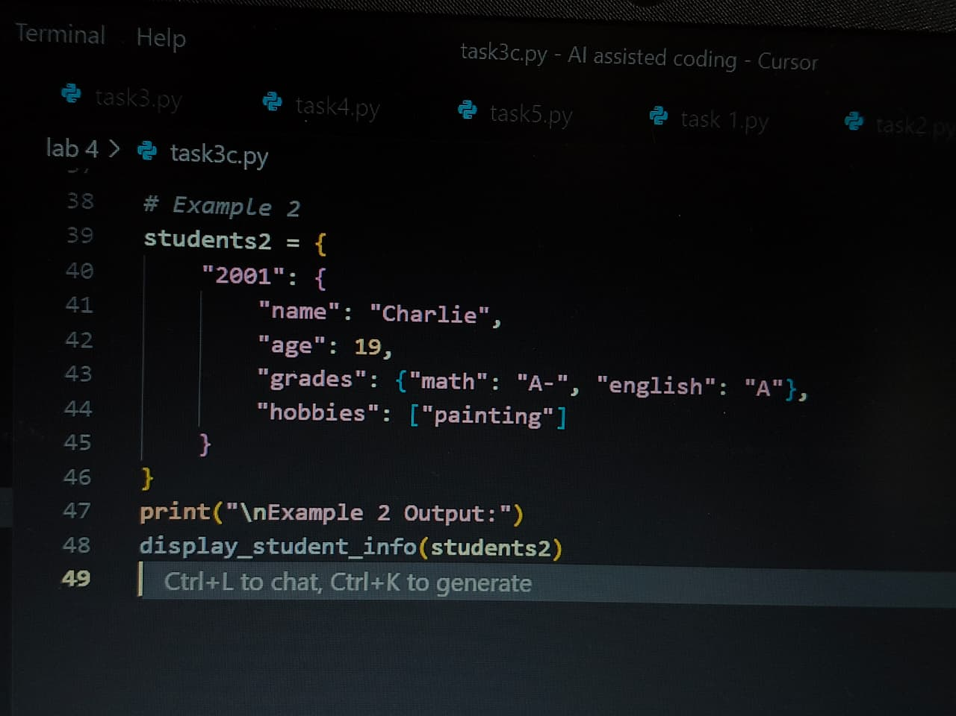  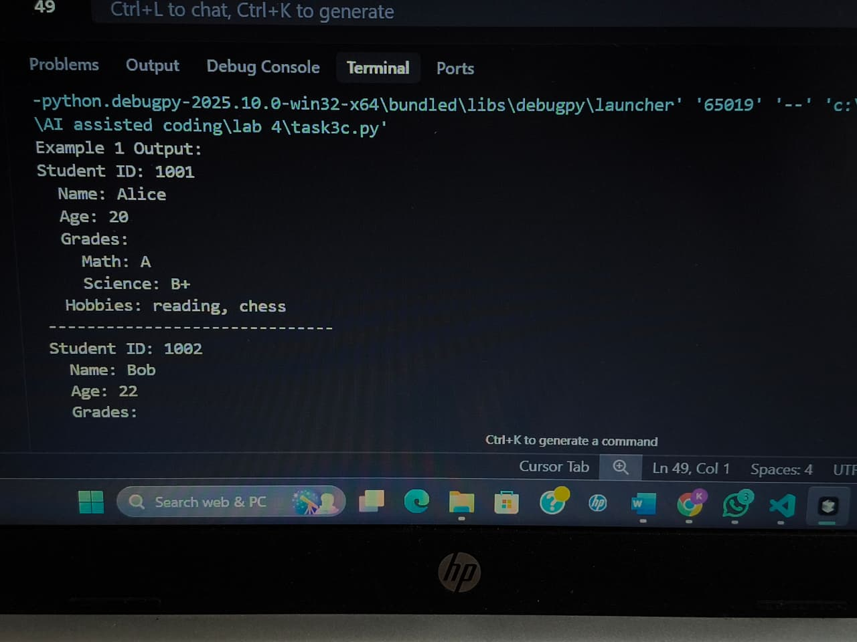  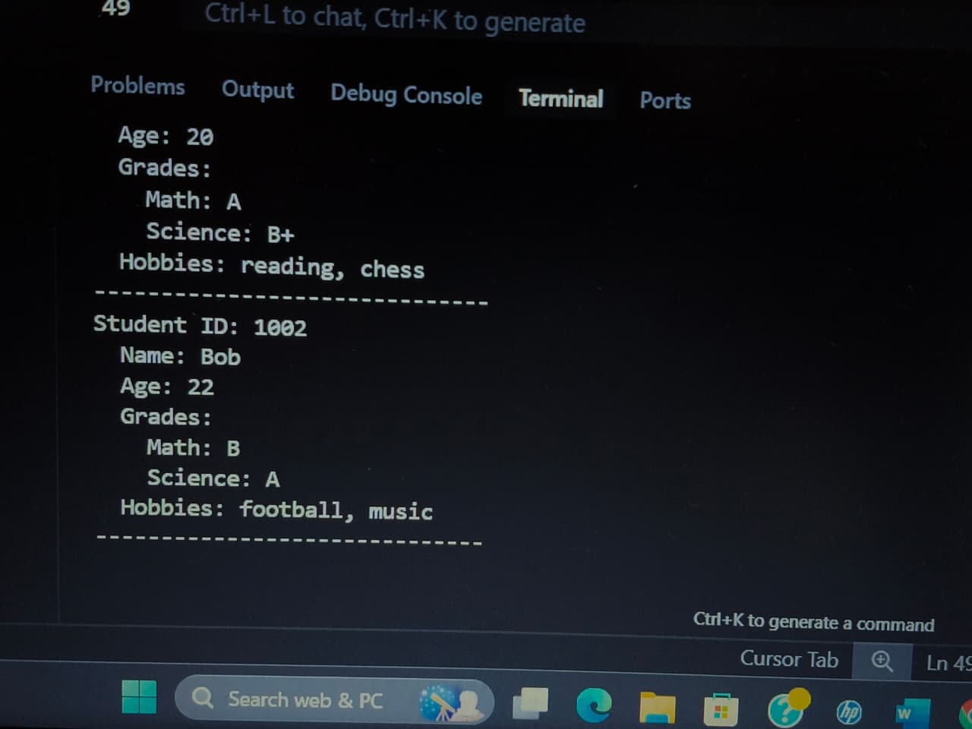  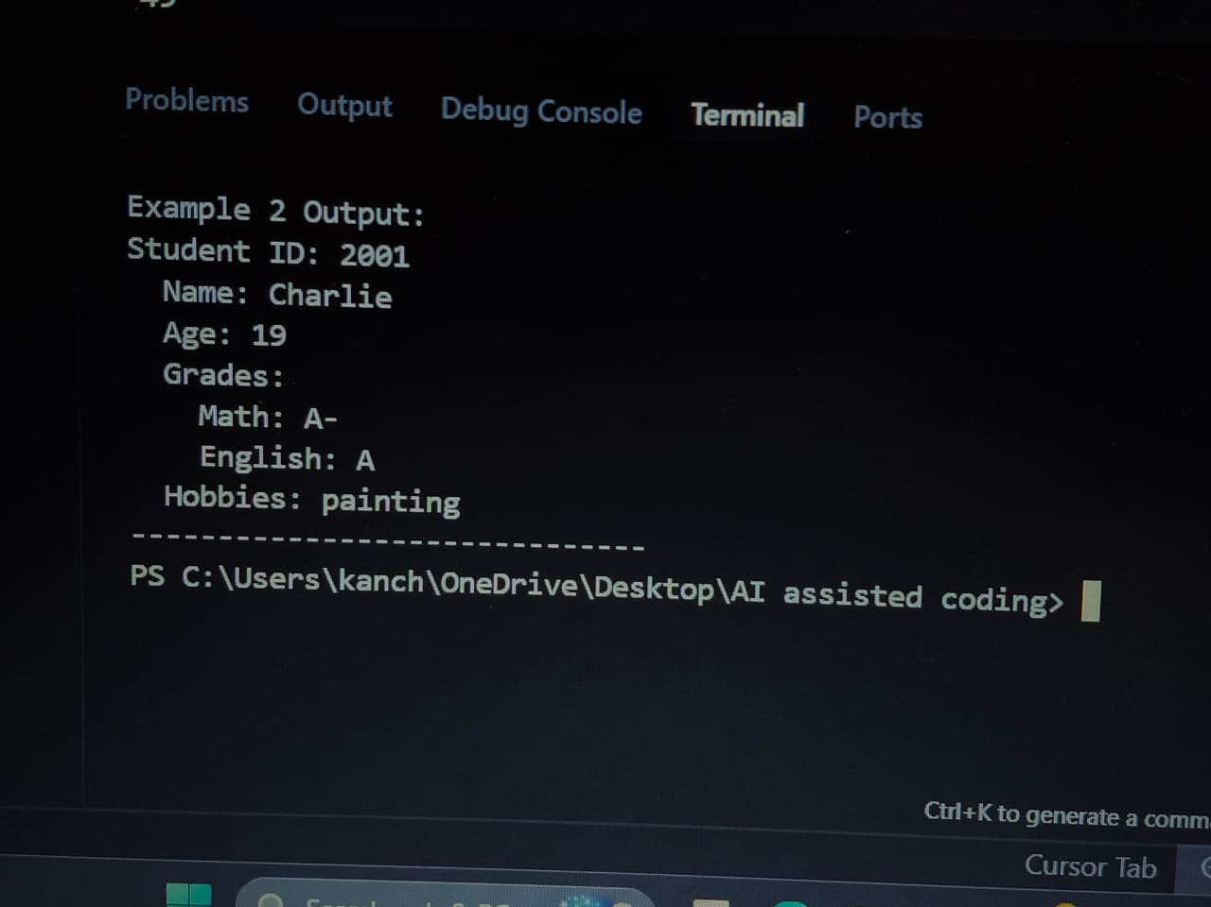  VS CODE:  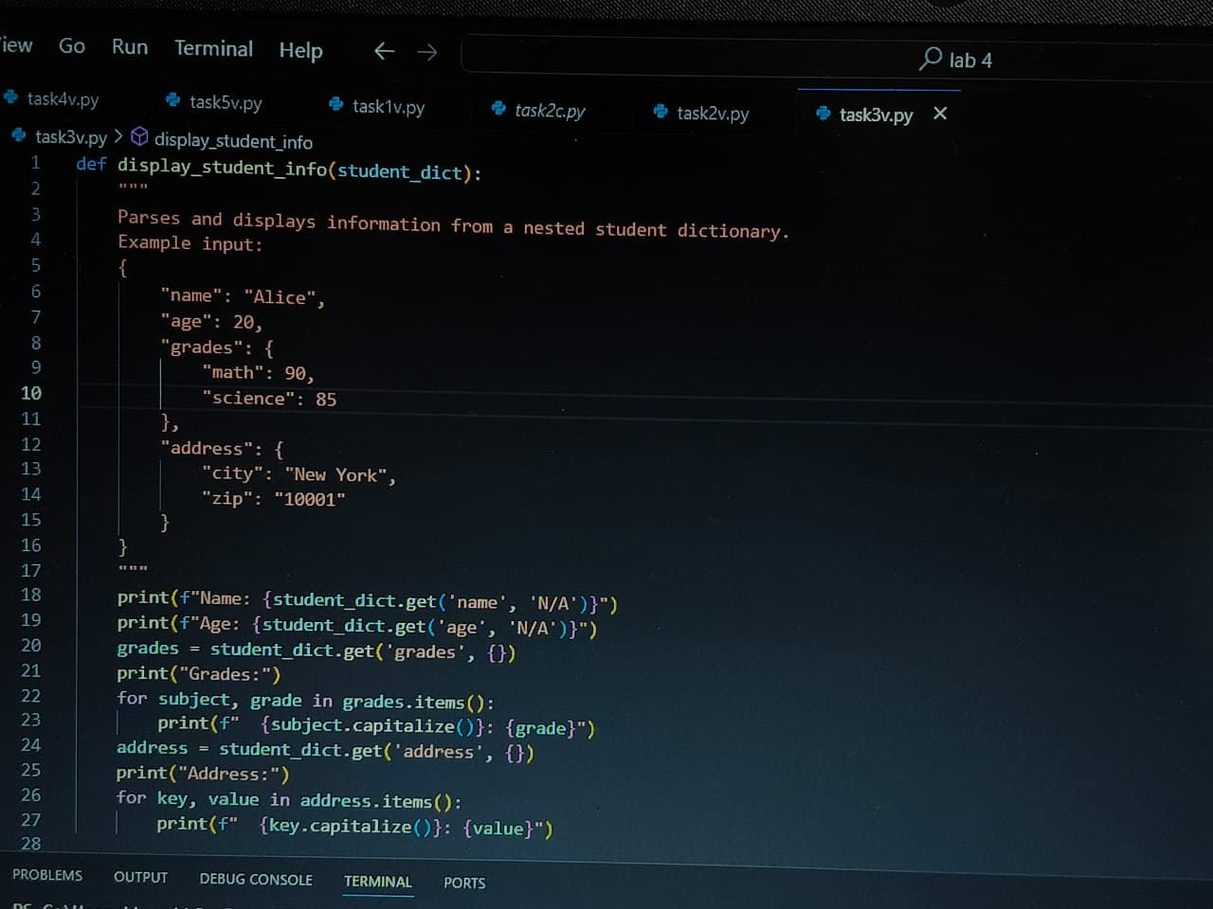  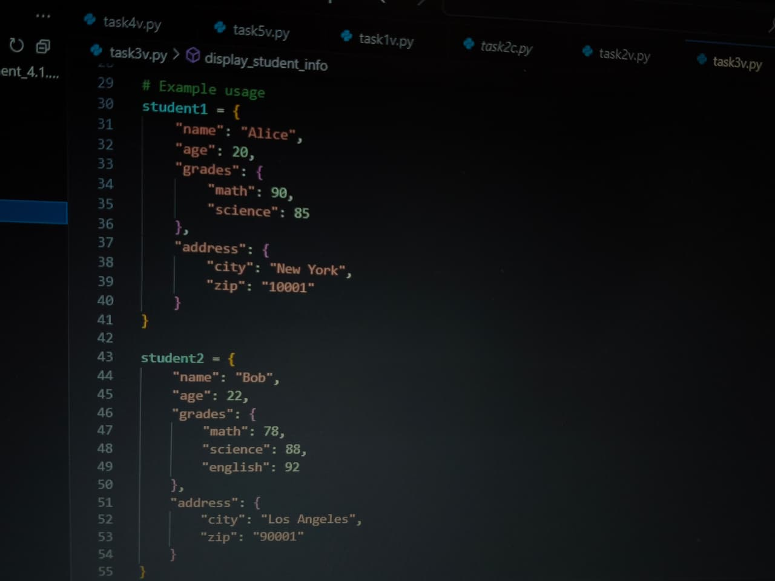  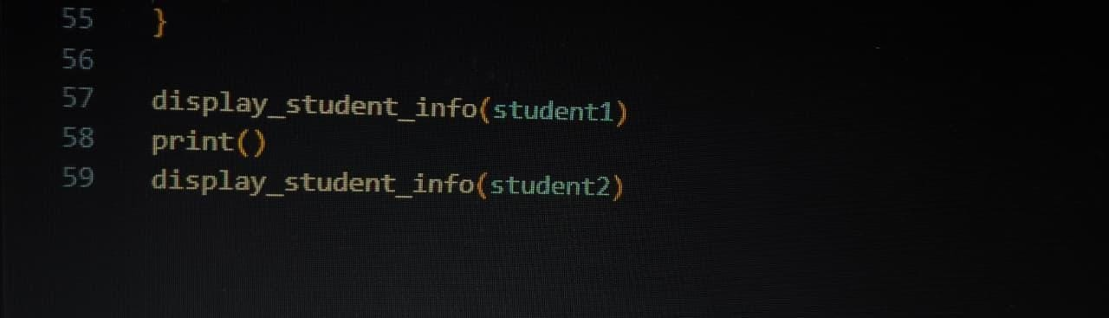  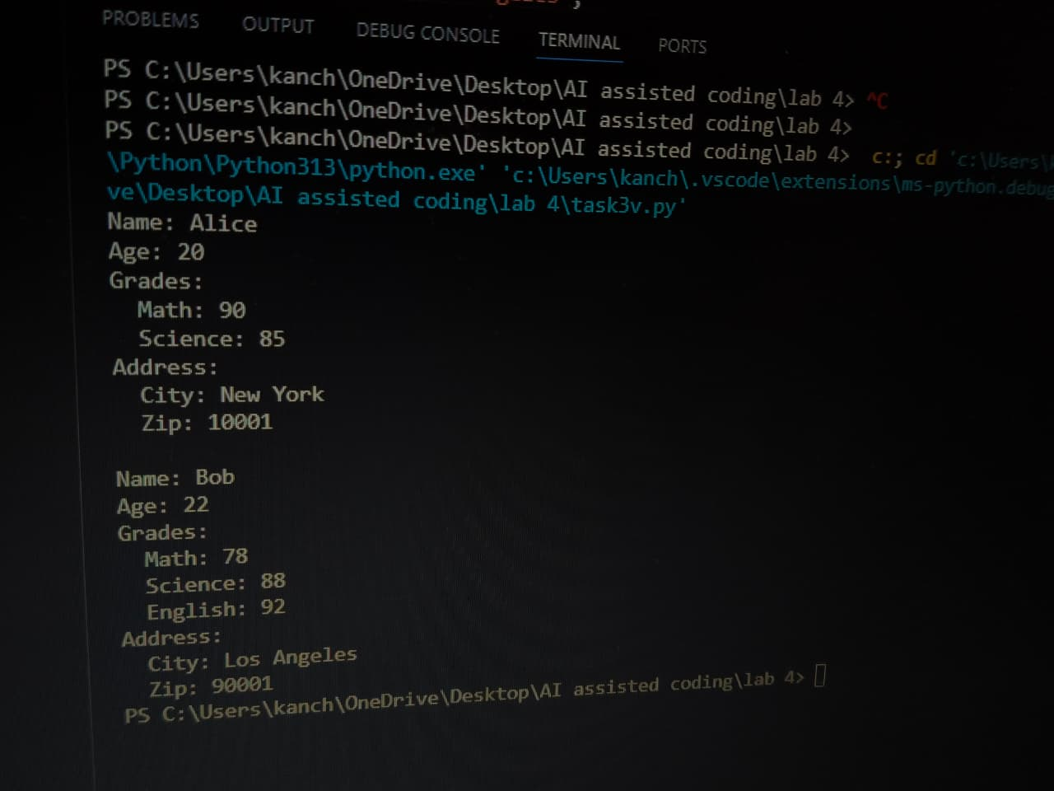  Task #4 – Comparing Prompting Styles for File Analysis  Objective  Experiment with zero-shot, one-shot, and few-shot prompting to generate functions for CSV file analysis.  Requirements  - Each generated function should:  - Read a .csv file  - Return the total number of rows  - Count the number of empty rows  - Count the number of words across the file  Expected Output  - Working Python functions for each prompting style, with a brief reflection comparing their accuracy, clarity, and efficiency.  PROMPT: Write a python function to analyze a csv file using zero- shot, one-shot and few-shot prompting and the function should count the number of empty rows and words  CURSOR:  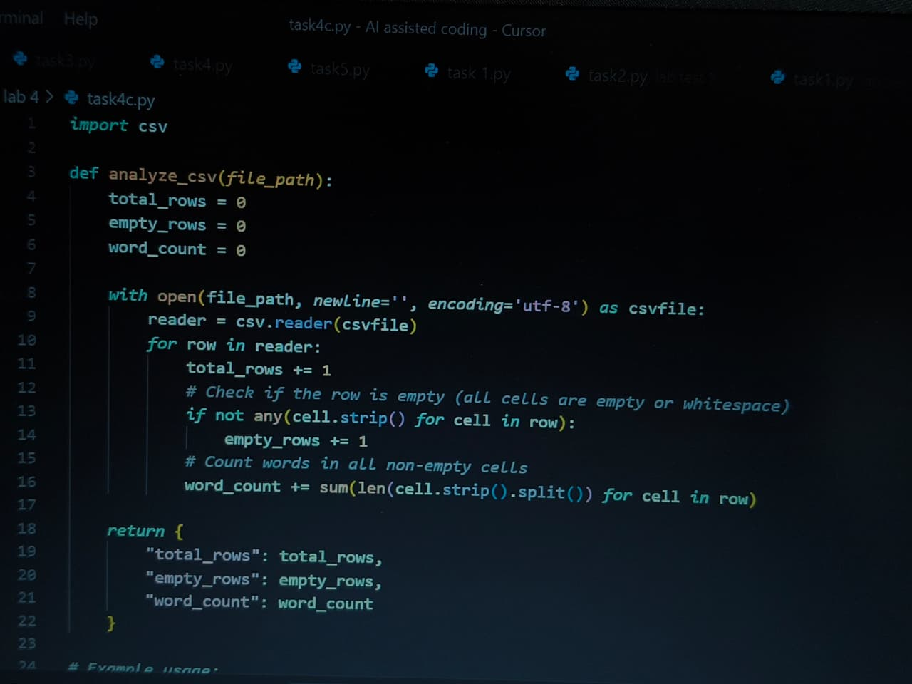  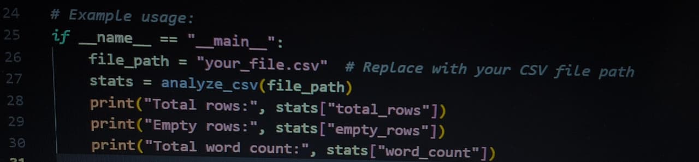  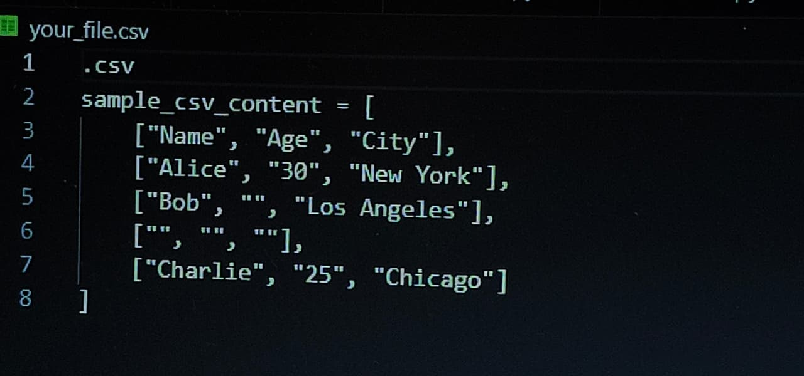  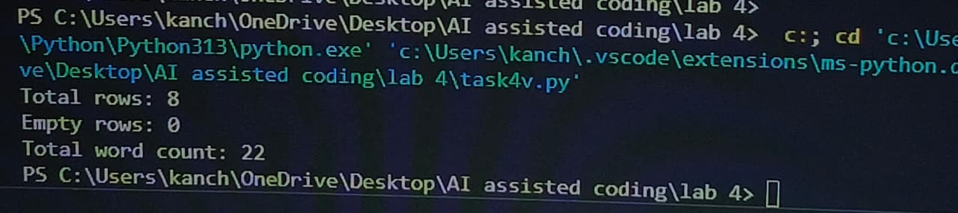  VS CODE:  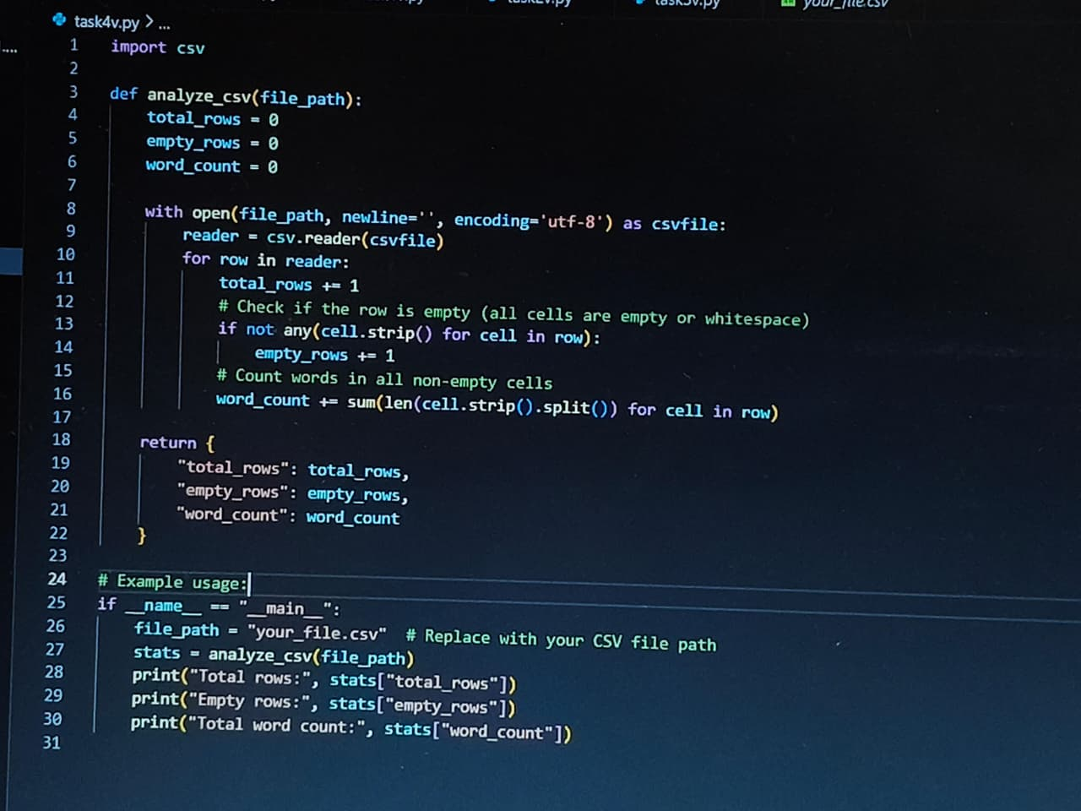      Task #5 – Few-Shot Prompting for Text Processing and Word Frequency  Objective  Use few-shot prompting (with at least 3 examples) to generate a Python function that processes text and analyzes word frequency.  Requirements  The function must:  - Accept a paragraph as input  - Convert all text to lowercase  - Remove punctuation  - Return the most frequently used word  Expected Output  - A functional Python script that performs text cleaning, tokenization, and returns the most common word using only the examples provided in the prompt  PROMPT:  Note: Report should be submitted a word document for all tasks in a single document with prompts, comments & code explanation, and output and if required, screenshots  Evaluation Criteria:  Criteria Max Marks  Zero Shot (Task #1) 0.5  One Shot (Task#2) 0.5  Few Shot (Task#3, Task#4 & Task #5) 1.5  Total 2.5 Marks |  |  |  |  |  | Week2 - Monday

