**Assessment of Heart Rate Variability Before and**

**After Exercise in Young Healthy Adults**

**Amitabh Dube*, Sweta Soni\*\***

*Professor of Physiology, ** Research Scholar, Government S.M.S. Medical College, Jaipur – 302004, India.

Government S.M.S. Medical College, Jaipur – 302004, India,

**Abstract**: **Background**: Analysis of rhythmic patterns embedded within beat to beat variations in heart rate (HRV) is a tool used to assess the balance of cardiac autonomic nervous activity and may be predictive for prognosis of some medical conditions, such as ischemic cardiac events in later life. The purpose of this study was to assess the effect of short term low intensity exercise in 30 young healthy adults. **Methods** : Heart rate (HR), Systolic blood pressure (SBP) and Diastolic blood pressure (DBP), Heart rate variability parameters (HRV) high frequency (HF) (0.15-0.4 Hz), low frequency (LF) (0.04-0.15 Hz) , very low frequency (VLF) (≤0.04 Hz), LF/HF ratio, LFnu (LF in normalized units), HFnu (HF in normalized units) were measured from baseline before exercise and after 1½ minutes exercise using Master’s two step test. **Results**: HR, SBP, DBP were significantly high (P < 0-05) after exercise and VLF, LF, LFnu, LF/HF ratio were increased after exercise. Significant difference could not be appreciated among the HRV parameters except for total power (TP) which was significantly decreased post-exercise. **Conclusion**: The present study reiterated the dynamical and autonomic response to low-intensity exercise. However, the response in form of a significant increase in DBP and a decrease in TP reflects a physiological response which is not commensurate with the demands of the stress to which the system was subject. It would indeed be worthwhile to explore further the issues so raised in the present study.

**Key word :** Autonomic Functions, Exercise, Heart Rate Variability

**Author for correspondence:** Amitabh Dube, Professor of Physiology, Government S.M.S. Medical College, Jaipur – 302004, India

**Introduction:** Physical exercise enhances or maintains [physical fitness](http://en.wikipedia.org/wiki/Physical_fitness) and overall [health](http://en.wikipedia.org/wiki/Health) and wellness. It is performed for various reasons including strengthening [muscles](http://en.wikipedia.org/wiki/Muscle) and the [cardiovascular system](http://en.wikipedia.org/wiki/Cardiovascular_system), honing [athletic](http://en.wikipedia.org/wiki/Sport) skills, [weight loss](http://en.wikipedia.org/wiki/Weight_loss) or maintenance, as well as for the purpose of enjoyment1. Frequent and regular physical exercise boosts the [immune system](http://en.wikipedia.org/wiki/Immune_system), and helps prevent the “[diseases of affluence](http://en.wikipedia.org/wiki/Diseases_of_affluence)” such as [heart disease](http://en.wikipedia.org/wiki/Heart_disease), [cardiovascular disease](http://en.wikipedia.org/wiki/Cardiovascular_disease), [Type 2 diabetes](http://en.wikipedia.org/wiki/Type_2_diabetes) and [obesity](http://en.wikipedia.org/wiki/Obesity) 2. Exercise, a common physiological condition, elicits normal physiological profile and latent potential cardiovascular abnormalities (if any, not present at rest), can be used as a sensitive and specific maker to determine the adequacy of cardiac function and the fine interplay between the cardiovascular (CVS) and the autonomic nervous system (ANS) activity thereof. The types of exercise, isometric (static) or isotonic (dynamic), may influence CVS physiology accordingly 3.Isometric (Static) exercise is defined as continuous muscular contraction without movement (e.g. handgrip) 3. Isotonic (Dynamic) exercise, muscular contraction resulting in movement, primarily subjects the left ventricle to volume load and the cardiovascular response is commensurate with the intensity and severity of the exercise 3.Stair climbing, an example of isotonic exercise, is a good physiological maneuver to evaluate the sensitivity and specificity of the CVS system to the exercise. Master’s two step test is a good simulator of isotonic stair climbing in laboratory condition and was used in the present study to evaluate the CVS response and the fine interplay between CVS & ANS via HRV analysis 4-5.

As per past studies, acute effects of a single exercise bout on HRV is manifested as an initial decrease in HRV and vagal related indices (e.g. SDNN, RMSSD, HF of HRV Spectral Power) after exercise 6-7. HRV measures can reach pre-exercise values within 5 minutes when the exercise intensity is low and duration is short 8-9.

On the other hand high intensity exercise induces prolonged vagal reactivation and HRV recovery with progressive increase of high and low frequency HRV power indices that still might not reach resting values after 10 minutes 10-11, 15 minutes 11-13, 30 minutes 7, or even one hour 6,9,13-14. The present study was so designed to evaluate the influence of short term low intensity isotonic exercise on the CVS profile (Heart Rate [HR] and Blood Pressure [BP]) and HRV.

**Material and Method:** The present study was carried out on 30 young healthy male medical students in the age range of 18 - 25 years in the Upgraded Department of Physiology, S.M.S. Medical College, after taking a detailed history and physical examination to rule out any acute or chronic ailment. A written informed consent was taken before inclusion of the subject in the proposed study. The study was approved by local institutional ethical committee. Subjects with any acute or chronic illness or taking any medication that modulate ANS physiology, smokers, alcoholics and those engaged in any organized physical activity for the last six months and those patients with medical histories of any cardiovascular disease were excluded from the present study. Recordings were taken before and after short term low intensity exercise schedule so prescribed to the sample population.

The study protocol was explained to subjects after obtaining informed written consent to participate in the study. A detailed history and clinical examination was done to exclude subjects satisfying exclusion criteria. Weight (64.9 ± 10.29 Kg) and age (19.3 ± 1.208 years) of subjects were recorded. The study was carried out between 9.00 A.M. to 12.00 P.M. after emptying bladder and consuming a light standard breakfast 1½ to 2 hours before arrival. Subjects were asked to abstain from the use of caffeine and other stimulants 12 hours before the study and strenuous exercise 24 hours before the study 15. Analysis of heart rate variability was done by using NIVOMON, L&T tasted on the principle of impedance plethysmography16. Data was presented as Mean + Standard Deviation. Mean and standard deviation of the observation for all the parameters were calculated and comparisons were done by applying student’s ‘t’ test (paired). Paired ‘t’ test was applied between baseline parameters, i.e., before exercise and post-exercise parameters. Statistical significance was assigned at P < 0.05.

**Results:** Measures of HR, SBP, DBP and HRV before (baseline) and after short term low intensity exercise are illustrated along with Mean ± SD. Table 1 depicts HR, SBP, DBP and frequency domain of HRV measures before and after exercise. After exercise significantly high values (P < 0.01) of HR, SBP and DBP were observed in the sample population. The mean values of VLF, LF, LFnu and LF/HF ratio post-exercise so observed were high as compared to the values observed before-exercise but were not statistically significant. On the other hand mean values of HF, HFnu and TP were found to be attenuated after exercise as compared to the values observed before exercise. However, only the mean values of Total Power post-exercise differed significantly from (P < 0.01) from the values obtained before exercise.

**Table1.**

|  |  |  |  |
| --- | --- | --- | --- |
|  | Before exercise | After exercise | ‘P’ value |
| Heart Rate, HR (bpm) | 69.53 ± 8.431 | 75.6 ± 9.194 | 0.00001 |
| Systolic Blood Pressure, SBP (mmHg) | 119.4 ± 5.487 | 128.4 ± 6.112 | 0.00001 |
| Diastolic Blood Pressure, DBP (mmHg) | 75.67 ± 5.384 | 76.4 ± 6.621 | 0.039 |
| Very Low Frequency, VLF (ms2) | 31.21 ± 17.94 | 33.23 ± 16.31 | 0.624 |
| Low Frequency, LF (ms2) | 29.00 ± 13.08 | 29.76 ± 15.47 | 0.832 |
| High Frequency, HF (ms2) | 29.8 ± 16.7 | 27.1 ± 17.25 | 0.339 |
| Low Frequency, Normalized Units, LFnu | 50.47 ± 20.46 | 54.45 ± 23.34 | 0.341 |
| High Frequency Normalized Units, HFnu | 49.53 ± 20.46 | 46.22 ± 22.82 | 0.407 |
| LF/HF | 1.483 ± 1.362 | 1.922 ± 1.789 | 0.217 |
| Total Power, TP (ms2) | 1200 ± 1262 | 735.9 ± 942.6 | 0.003 |

**Discussion:** Physical exercise is a form of physical activity that is planned and performed with the goal of achieving or preserving physical fitness17. The present study was conducted to evaluate the influence of short term low intensity isotonic exercise on the CVS profile (HR, BP, and HRV) to evaluate the risk of developing ischemic cardiac events in sample population. Heart rate of the sample population increased significantly (P < 0.001) after exercise (using Master’s two step test) 4,which is in contradiction to the result of Gavin et al (2005)18. The findings of Gavin et al of decrease in heart rate are in the back drop of chronic exercise regimen which basically induces an enhanced vagal output and the present study is documenting acute changes of heart rate after exercise. However, an increase in heart rate as documented in the present study is supported by the findings of Zhang (2007)19, Fariatti et al (2011)21, Sigin et al (2005)22, Miyai et al (2002)25. The increase in heart rate after physical exercise so observed is due to vagal withdrawal and an enhanced sympathetic drive26.The present sample population showed a significant increase both in SBP (P < 0.001) and DBP (P < 0.05) after exercise. However our results are not in accordance with Zhang (2007)19 who observed that the blood pressure did not change significantly after each exercise session in the control group. Our results, though are in accordance with those observed by Sigin et al (2005)22, Miyai et al (2002)25 .

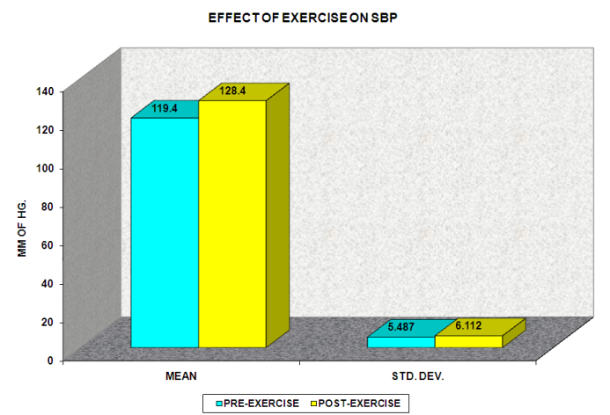

The increase SBP so observed in the present study is primarily due to an increase in HR. In mild to moderate exercise due to skeletal muscle vasodilatation there is either no change or a nominal decrease in total peripheral resistance (TPR) resulting in a no change or a nominal decrease in DBP. However, in the present study a significant increase in DBP was appreciated after low intensity exercise, which could be due to an inadequate and inappropriate physiological response and this deranged response could form one of the many risk factors contributing to the development of CVS dysfunction in later life events.

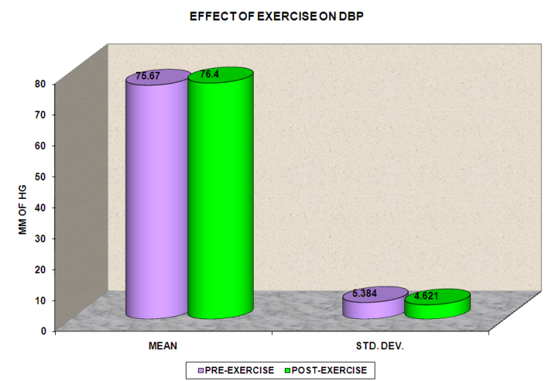

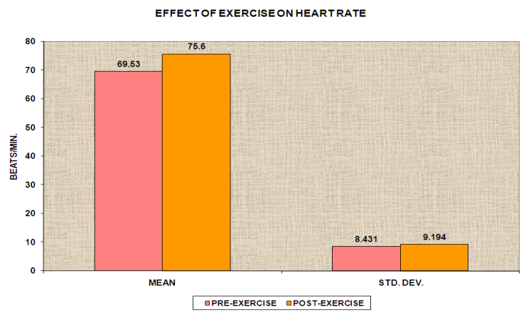

The autonomic functions so assessed via Heart Rate Variability (HRV) in the present study were evaluated through the Medical Analyzer Module of NIVOMON, L&T (based on the principles of impedance plethysmography17). The various parameters of HRV that were evaluated in the frequency domain were namely, Total Power, VLF, LF, HF, LFnu, HFnu, and LF/HF ratio. The present sample showed a significant (P < 0.01) decrease in Total Power (TP) after exercise which is in accordance to the findings of Zhang (2007)19. A decrease in total power could relate to the intricate interplay between the parasympathetic and the sympathetic divisions of the autonomic nervous system, wherein the normal neuro-economic physiological response could be contributing towards homeostasis of the internal milieu. The mean value of VLF (33.23 + 16.31) however increased after low intensity exercise, though the increase was not statistically significant which is not in accordance with Jovanov (2007)23 who observed a significant increase in VLF after exercise. The increase in VLF so observed after exercise is basically a reflection of the physiological axes of the thermo-regulatory and local renin-angiotensin systems, though it is difficult to comment on VLF in short-term HRV recordings (Jovanov, 2007)23.

An attenuated HF (27.1 + 17.25) and an increase in mean value of LF (29.76 + 15.47) after exercise, though not statistically significant, could be appreciated in the sample population under evaluation, which represents the normal physiological response of a vagal withdrawal and a stimulated sympathetic drive. Similar changes, which were not statistically significant, could be appreciated in other variables of the frequency domain of HRV, namely, an increase in LF/HF ratio (1.922 + 1.789) and LFnu (54.45 + 23.34) and a decrease in HFnu (46.22 + 22.82) post-exercise. Our results are in accordance with Jovanov (2007)23 and Goncalo et al (2010)20. Jovanov (2007)23 also observed a significant increase of LF/HF ratio.

The increased values of HR, SBP and DBP (statistically significant) so observed in the present study are primarily due to enhanced SNS activity and PNS withdrawal. Increased values (not statistically significant) of VLF, LF, LFnu, LF/HF ratio depict enhanced sympathetic activity and decreased HF and HFnu values indicate a reduced vagal tone after exercise. The interesting fact in the present study is to note that there was a significant decrease in the total power in the frequency domain of HRV parameters and a significant increase in diastolic blood pressure post-exercise. An increase in DBP and a decreased HRV in terms of LF/HF ratio and total power are not good indices of a healthy cardiovascular response.

The use of an exercise test in diagnosis and evaluation of cardiovascular disease is an effective mean to profile the physiological processes underline the disease stage. Previous studies have shown that exaggerated blood pressure and heart rate response to exercise is an important risk marker for developing hypertension and subsequent coronary artery disease. The present study depict an initial increase in Heart Rate, SBP, DBP and LF and decrease in HF Component of HRV which are normal physiological rhythm response as observed after exercise. The initial vagal withdrawal with subsequent sympathetic activation is the normal neurohumoral response of the activated autonomic axis to physical activity in form of exercise. The above phenomenon of increase HR and SBP replicates a normal physiological cardiac response to the activated autonomic drive in term of an enhanced LF and a depressed HF component of HRV (on PSD evolution).

**Conclusion:** In the present study HR, SBP and DBP increased significantly after exercise. There was a non-significant increase in the values of VLF, LF, LFnu, LF/HF ratio and a decrease in the values of TP, HF, HFnu after exercise. An enhanced sympathetic activity in the test group (after exercise) and vagal withdrawal from isotonic exercise in test group (after exercise) was observed. An increased DBP and a decreased HRV in terms of attenuated LF/HF ratio and total power post-exercise indicate towards an additional risk factor for developing subsequent hypertension and coronary artery disease. It would indeed be worthwhile to take up a large scale longitudinal study to look into the implications and issues so raised of the above cited response(s).

Limitation of the paper: Sample size is very small. There may be a comparison between boys and girls.

**Referencess**

1. Stampfer, M. J.; Hu, F. B.,et al (2000). "Primary Prevention of Coronary Heart Disease in Women through Diet and Lifestyle". New England Journal of Medicine 343 (1): 16–22.
2. Graham, C., et al. (2001). Diet, lifestyle, and the risk of type 2 diabetes mellitus in women. The New England Journal of Medicine, 345(11), 790–797.
3. American Heart Association Medical/Scientific Statement, Circulation 1990 : 82 : 2286 : 2322
4. American Heart Journal, St. Louis, 1935, 10 : 495-510.
5. American Journal of the Medical Sciences, Thorofare, N.J., 1929, 177 : 229-243.
6. James, D.V.B. Barnes A.J.,et al. (2002). Heart Rate Variability : response following a single bout of interval training. International Journal of Sports Medicine 23, 247-251.
7. Javorko, M., Zida., et al. (2002). Heart Rate recovery after exercise : ralations to heart rate variability and complexity. Brazilian Journal of Medical and Biological Research 35 (8), 991-1000.
8. Seiler, S., Haugen.,et al. (2007). Autonomic recovery after exercise in trained athletes : intensity and duration effects. Medicine and Sciences in Sports and exercise 39, 1366-1373.
9. Terziotti, P., Schena.,et al. (2001). Post exercise recovery of autonomic cardiovascular control : a study by spectrum and cross – spectrum analysis in humans. European Journal of Applied Physiology 84, 187-194.
10. Pober, D.M.,et al. (2004). Effects of a single bout of exercise on resting heart rate variability. Medicine and Science in Sports and Exercise 36, 1140-1148.
11. Takahashi, T., Okada, A.et al (2000) Differences in Human Cardiovascular response between upright and supine recovery from upright cycle exercise. European Journal of Applied Physiology 81, 233-239.
12. Gladwell, V.F., Sandercock, G.R.H, et al. (2010). Cardiac vagal activity following three intensities of exercise in humans. Clinical Physiology and Functional Imaging 30, 17-22.
13. Mourot, L., Bouhaddi, M.,et al. (2004). Short and long term effects of a single bout of exercise on heart rate variability : comparison between constant and interval training exercises. European Journal of Applied Physiology 92, 508-517.
14. Furlan, R., Piazza, S., et al. (1993). Early and Late effects of exercise and athletic training on neural mechanism controlling heart rate. Cardiovascular Research 27, 482-488.
15. Fletcher G, Balady GJ, Amsterdam EA, et al. (1992). Exercise standards for testing and training circulation, 86, 340-344
16. Electrical Impedance and Photo Plethysmography for medical application by G.D. Jindal et al. BARC/2004/E/025
17. Eric. H., Gary J., Balady. Exercise and Physical Activity. In: Eric J. Topal, editor, Textbook of Cardiovascular Medicine. 3rd ed. Philadelphia : Lippincott Williams and Wilkins. 2007: 3: 77.
18. Gavin R. H. Sandercock; el al. 2005. Effects of Exercise on Heart Rate Variability: Inferences from Meta-Analysis Medicine and Science in Sports and Exercise, 37(3), 433-439. American College of Sports Medicine.
19. John Zhang. 2007. Effects of exercise and custom-made orthotics on blood pressure and heart rate variability: a randomized controlled pilot study J Chiropr Med., Spring, 6(2), 56–65.
20. Goncalo V. Mendonca, el al. 2010. Sex differences in linear and nonlinear heart rate variability during early recovery from supramaximal exercise Applied Physiology, Nutrition, and Metabolism, 35 (S1), 439-446, 10.1139/H10-028
21. Fariatti et al. Evaluated the response that stretching had on Heart Rate Variability (HRV) in subjects with low flexibility. Journal of Strength and Conditioning Research 2011
22. Siqin et al. 2005. HEART RATE RECOVERY AFTER EXERCISE AND NEURALREGULATION OF HEART RATE VARIABILITY IN 30-40 YEAR OLD FEMALE MARATHON RUNNERS. Journal of Sports Science and Medicine, 4, 9-17
23. E. Jovanov. 2007. Heart rate variability has been related to respirations, baroreflexes, and On Spectral Analysis of Heart Rate Variability during Very Slow Yogic Breathing Am Heart J, 153, 28128
24. Gavin et al. 2005. Effects of Exercise on Heart Rate Variability: Inferences from Meta-Analysis Medicine and Science in Sports and Exercise, 37(3), 433-439. American College of Sports Medicine.
25. [Miyai](http://hyper.ahajournals.org/search?author1=Nobuyuki+Miyai&sortspec=date&submit=Submit), et al. 2002. Blood Pressure Response to Heart Rate During Exercise Test and Risk of Future Hypertension. Hypertension, 39, 761-766 doi: 10.1161/​hy0302.105777
26. Otto F. et al. 2010. Heart rate variability before and after cyclic exercise in relation to different body positions. Journal of Sports Science and Medicine, 9,176-182

**Disclosure:** No conflicts of interest, financial or otherwise are declared by the authors.