**Impact Of Smart phones On Digital Dexterity And Audiovisual Reaction Time In Teens.**

**Smita P.Ghate, Sunanda N.Kirtikar**

Dept. of Physiology, Seth GSMC & KEM Hospital, Parel, Mumbai – 12.

**Abstract:** **Background & Objectives:** Smartphone technology has changed the way people communicate with one another. Reaction time is one of the important methods used to study a person's central information processing speed and fast coordinated peripheral movement response. Aim was to measure and compare finger dexterity, auditory reaction time for low tone & high tone sound as well as visual reaction time for red & green light stimuli in frequent texters & rare texters. **Method:** The study was carried out on 100 medical students of age group 17-19 years. The study group consisted of 50 frequent mobile phone texters with QWERTY key pad since minimum of 4 years & control group consisted of 50 rare texters. Finger dexterity test and visual reaction time for red & green light stimuli also auditory reaction time for low & high tone sound was carried out on both groups. **Results:** Statistical analysis was carried using SPSS software. Finger dexterity test among frequent texters & nontexters was statistically nonsignificant. (p =0.1769). Visual & auditory reaction time between two groups was statistically significant for all four stimuli.(P=0.0000). **Interpretation &** **Conclusion:** Mobile phone texting showed non significant improvement in finger dexterity. However, it showed significant improvement in reaction time task.

**Keywords:** mobile texting, visual & auditory reaction time, finger dexterity.

Author for correspondence: Smita P.Ghate, Department of Physiology, Seth GS Medical College & KEMH, Parel, Mumbai, 12. Email id: drsmita.wagh2@gmail.com

**Introduction:** The use of cellular phones has skyrocketed in recent years, with more than 929.37 million subscribers in India as of May, 2012.1 The human body is able to perform numerous discrete actions. Many actions do not require visual attention and can be performed with ease.2 A skilled guitarist, for example, plays musical notes effortlessly due to honed muscle memory combined with tactile feedback from the guitar’s neck, strings, and frets. There are many ways to leverage the human ability to learn precise body movements and incorporate them into wearable computing.

Recent mobile trends show that users are as inclined to text each other as to call and talk.3 As the mobile technology moves closer to wearable computing, texting techniques will have to migrate as well. Fully 72% of all teens or 88% of teen cell phone users - are text massagers. That is a sharp rise from the 51% of teens who were texters in 2006. More than half of teens (54%) are texters.3

Among all teens, their frequency of use of texting has now overtaken the frequency of every other common form of interaction with their friends. One in three teens sends [more than 100 text messages a day](http://pewinternet.org/Reports/2010/Teens-and-Mobile-Phones/Chapter-2/Part-1.aspx?r=1), or 3000 texts a month.3

One-handed text input Smartphone technology has changed the way people communicate with one another. Reaction time is one of the important methods used to study a person's central information processing speed and fast coordinated peripheral movement response.

Reaction Time is independent of social-cultural influences and can purely indicate the efficiency or dysfunction of biological process in brain. For any response to occur the stimulus initially activates the sense organs and the impulse is then conducted to the brain and from the brain is sent back to execute the movement required to accomplish the task. Slowed performance is usually accompanied by prolonged simple Reaction Time.4,5

The purpose of this study is to compare the reaction time with frequent use of mobile phone for texting & those with rare mobile phone texters. In this study, students will be investigated whether text messaging has the unique effect of enhancing finger dexterity and to find out the impact of mobile phone texting on visual & auditory reaction time.6

**Material and Method:** The study was done on 100 volunteer undergraduate medical students, in the dept. of Physiology, tertiary health care centre of Municipal Corporation of Greater Mumbai in the age group of 17–21 years.

Informed consent was obtained from all the participants and ethical approval for the study was obtained from the institutional ethical committee.

Detailed medical history and physical examination of the subjects was done.

* The participants were divided in two groups of 50 each.
* The Study Group: 50 subjects using mobile phones with QWERTY keypad for more than 45 minutes per day since four months or more.
* The Control Group: 50 students of the same age group using mobile phone with QWERTY key pad for less than 20 minutes per day since four months or more.
* Prior to the testing, proper instructions were given and tests were properly explained and demonstrated.

The apparatus used in this study are:

- O’Connor dexterity test apparatus.

- Research Reaction Time Apparatus made by Anand agency, Pune-2.7

Each individual was explained about both tests and sufficient practice trials were given.

* All the participants were subjected to the tests in the quiet room.
* The O’Connor Dexterity Test equipment for Finger Dexterity Test consists of 310 cylindrical brass pins, one inch in length in a shallow metal tray; and a metal plate with 100 holes sunken in it. Participant had to pick up three pins at a time using only one hand (dominant) to fill each hole as fast as he could in a complete one minute. Results were drawn as number of holes completed in one minute.
* Before measuring the visual reaction time, each participant was asked to identify the flashing green and red light.
* Participant was instructed to press response button by Right index finger which was already on it to stop the clock as soon as he/she will see the red / green light.
* Before giving the sound signal, Participant was asked to concentrate to hear the sound. After hearing the sound signal, he/she should have been supposed to press immediately the response button from digital display & reaction time was then noted.

Three reading of each stimulus were taken and their respective average was calculated and comparison was then carried out.

**Outcome Measure:** Finger dexterity was measured by O’Connor dexterity test in both groups. Auditory and visual reaction time was measured by Research Reaction Time Apparatus in both groups.

Statistical Analysis: All data were analyzed by SPSS (Statistical Package for social sciences, Version 17, SPSS). Mean, standard deviation and student‘t’ test were used to investigate the results and a conclusion was drawn. p is level of significance. By Student‘t’ Test, p =0.1769, Non significant & P =0.001, Highly Significant, P =0.0276, Significant.

**Results:** On comparison of finger dexterity amongst mobile texters and mobile non texters it was found that their mean values are 15.58 and 13.14 respectively but difference between the groups was statistically non significant.

**Table 1: Comparison of Finger Dexterity between mobile texters and mobile non texters**

|  |  |
| --- | --- |
| Groups | Mean finger dexterity(± SD)  (no. of holes completed /minute) |
| Mobile texters (N=50) | 15.58 + 01.40 |
| Mobile non texters (N=50) | 13.14 + 12.61 |

p =0.1769, Non significant.

On Data analysis it was found that on comparison of visual reaction time for green light stimuli amongst mobile On On comparison of visual reaction time for green light stimuli amongst texters and mobile non texters difference between their mean values obtained was 0.02 which is statistically highly significant.(P =0.001)

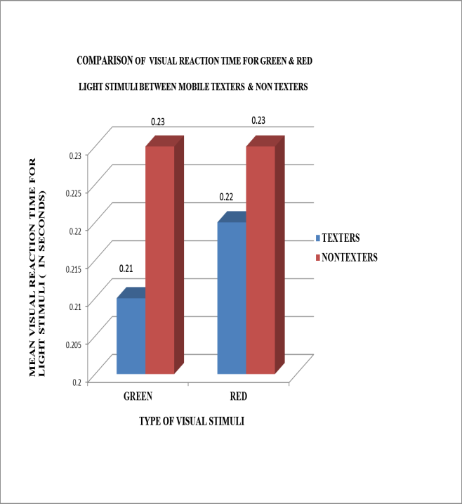

On comparison of visual reaction time for red light stimuli amongst mobile texters and mobile non texters data analysis showed that difference between their mean values obtained was 0.01 which was statistically significant.(P =0.0276)

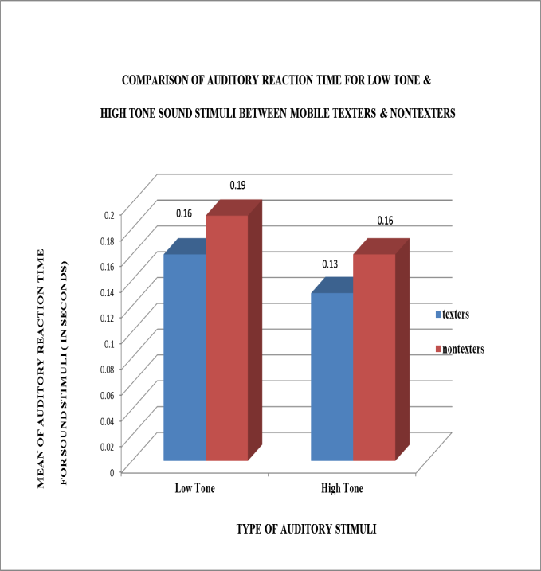

When the data obtained was studied, it was found that on comparison of auditory reaction time for low tone sound stimuli amongst mobile texters and mobile non texters, difference between their mean values obtained was 0.03 which is statistically significant.(P=0.001)

While on comparison of auditory reaction time for high tone sound stimuli amongst mobile texters and mobile non texters difference between their mean values obtained was 0.03 0.13 and 0.16 respectively and difference between the groups was statistically significant. .(P=0.001)

**Discussion:** Mobile phones have powerful influence over our lives, and Cell-phone texting has become the preferred channel of basic communication between teens and their friends, with cell calling a close second.4

The present study was conducted in 100 medical students of tertiary care hospital. Finger dexterity test and Auditory & Visual Reaction time were evaluated and compared in both the groups consisted of frequent texters & rare texters. The present study showed statistically nonsignificant increase in finger dexterity amongst study group as shown in the table as compared to control group. While it showed significant improvement in visual reaction time for both green & red light stimuli as well as auditory reaction time for low tone & high tone stimuli showed significant improvement.

This supports the hypothesis that, decreased reaction time because of increased cognitive function due to frequent, chronic texting. Texting requires a larger amount of mental processing than conversation. In the present study simultaneous texting was avoided while doing the reaction time procedure as it acts as a distractor & could have lead to increase in reaction time.11

Statistically nonsignificant result shown by the student t-Tests for finger dexterity comparing all teenagers doing frequent texting to their control group indicates that texting does not necessarily influence the digital dexterity significantly. Reason for this can be due to usage of a single digit, preferably the thumb while texting and to some extent lack of interest while performing the task.

Present study is corroborative with various previous studies.8-10 the studies showed that the mobile phone usage while driving causes distraction & increase in reaction time due to multi-tasking. The interference of making a telephone call while driving a vehicle is primarily visual as well as mechanical and has to do with seeing, locating, and punching the keys.11 Accidents often happen when a person is distracted.

**Conclusion:** The results of this study seem to conclude that cellular telephone usage for frequent texting does not have an effect on finger dexterity.

However, neurophysiological correlates of the effects of mobile phone texting significantly showed improvement in reaction time task.

Future work could be done by not only testing cognitive effects of texting but, also the mechanical effects that have to do with seeing, locating, conversation, and answering the phone. This may be done by using driving simulators.

There was some limitation to the experiment was the small sample size of 100 subjects. An increased sample size could decrease experimental error and uncertainty. In addition, the small age range of the participants (ages 17-21) could have affected the results, perhaps biasing the average of some physiological variables.

**Referencess**

1. Telecommunication statistics in India [Internet]. Available from : http://www.telecomindiaonline.com
2. Toni I, Krams M, Turner R, et al. The time course of changes during motor sequence learning: A whole-brain fMRI Study. NeuroImage : 1998; 8 : 50-61.
3. Lenhart A. Teens, cell phones and texting: Text messaging becomes centerpiece communication. Washington, DC: Pew Research Center, 2010.
4. Bruhn P, Parsons OA. Continuous reaction time in brain damage. Cortex : 1971; 7: 278-291
5. Biswas A, Debnath S. Reaction time with respect to sex and nature of stimulus. Meeting Abstract. hysical activity and successful aging. Köln: German Medical Science: 2006;6.<http://www.egms.de/en/meetings/pasa2006/06pasa017.shtml>
6. Education.com [Internet] .science fair : Doyle M. Does texting enhance finger dexterity? [Cited 12July].Available from : http://www.education.com/science-fair//texting-enhance-finger-dexterity
7. Malathi A, Parulkar V. Apparatus for the measurement of Reaction time. Indian Journal of Physiology and pharmacology: 1987;31(2);104-106
8. Shah C, Gokhale PA, Mehta HB,et al. Effect of Mobile use on Reaction Time. Al Ameen J Med Sci : 2010; 3(2) : 160-164
9. Consiglio W, Driscoll P. et al. Effect of cellular telephone conversations & other potential interference on reaction time in braking response. Accident Analysis & Prevention: Feb 2002.
10. Spencer, Paula. Driving to Distractions. Women’s Day: 2000 September; 105-108.
11. Anderson E, Bierman C,et al. The effects of audio & visual distractions on reaction time. University of Wisconsin – MadisonPhysiology 435: 2012 May; Lab 603, Group 14.

**Disclosure:** No conflicts of interest, financial or otherwise are declared by the authors.