Embedded system design Engineering

ESE_4009_1

Prof : Takis Zourntos

Date: 04/24/2018

By,

Dhruvangi Patel(c0688068)

Pruthvi Patel(c0687549)

|  |  |
| --- | --- |
| smart basket |  |

# 

# Abstract

A supermarket or a hypermarket is a form where wide variety of product items is available. These product items can be food, beverages or any household product. The main purpose of supermarkets is to provide availability of all the products and save the time of the customers but sometimes customer gets frustrated while waiting in the queue at billing counter and sometimes they get confused while comparing the total price of all the products with the budget in the pocket before billing. To overcome these problems, we have designed a smart trolley using a barcode scanner and beagle bone black. With this system, there is no need for customer to wait in the queue for the scanning for the product items and to know their total expense. Supermarkets or Hypermarkets provide this faculty to only those customers which having membership cards. When the customer inserts the membership card in the basket or trolley only then it will work as a smart trolley. Otherwise, it will work as a normal trolley. Supermarkets and hypermarkets use this technique as a strategy to increase the number of customers.

# Introduction

The purpose of this project is to implement an smart basket that provides great convenience and efficiency to customers which eliminates human’s effort and make easy shopping using latest technological equipment. Our goal includes to keep aware customer about their expense and provide detail information about their product. So they can estimate their budget and save their time. To achieve this goal we designed each module based on our choice microcontroller, Beagle bone Black since, it has a user friendly working platform and adequate processing speed that satisfied need of our project.

Smart Trolley has being designed to make the consumers more satisfaction and comfortable when shopping. By using this trolley consumers can easily know the price of the items and at the same time the shoppers will also know the total price of the items thus will make the shoppers know the estimation of their expenditure.

## Block diagram

BEAGLEBONE BLACK

HX711(load-cell Amplifier)

LOAD-CELL

BARCODE SCANNER

(Receiver)

HDMI DISPLAY

POWER SUPPLY

9

8

### Hardware introduction

* 1. Beagle bone Black -

The **BeagleBone** is a low-power [open-source](https://en.wikipedia.org/wiki/Open-source_hardware) [single-board computer](https://en.wikipedia.org/wiki/Single-board_computer) produced by [Texas Instruments](https://en.wikipedia.org/wiki/Texas_Instruments) . the BeagleBone is a [barebone](https://en.wikipedia.org/wiki/Barebone_computer) development board with a [Sitara](https://en.wikipedia.org/wiki/Sitara_ARM_Processor) ARM Cortex-A8 processor running at 720 MHz, 256 MB of RAM, two 46-pin expansion connectors, on-chip Ethernet, a microSD slot, and a USB host port and multipurpose device port which includes low-level serial control and JTAG hardware debug connections(no JTAG emulator is required),HDMI D type, Emmc, ADC, I2C, SPI, PWM and LCD. element14 BeagleBone Black is designed to satisfy the different requirements of various fields including game devices, home and industrial automation, consumer medical devices, printers, intelligent tolling systems, weighing systems of intelligent vending machine, educational terminals and high-end toys.

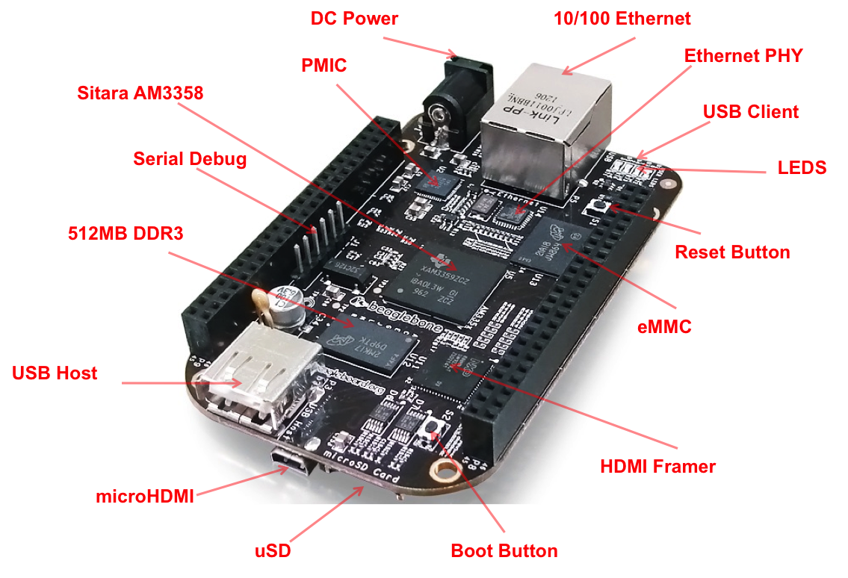

## 1.2 Barcode Scanner ( 1D CCD barcode reader Module with USB interface) - This 1D barcode scanner is small in size, light and low power module that can be easily integrated.  On the end is just a RS232, connect it serially with any computer (or microcomputer such as BeagleBone, Raspberry Pi, etc. When a barcode is scanned, the raw data is decoded, parity-checked and spit out as if they were typed on a keyboard.

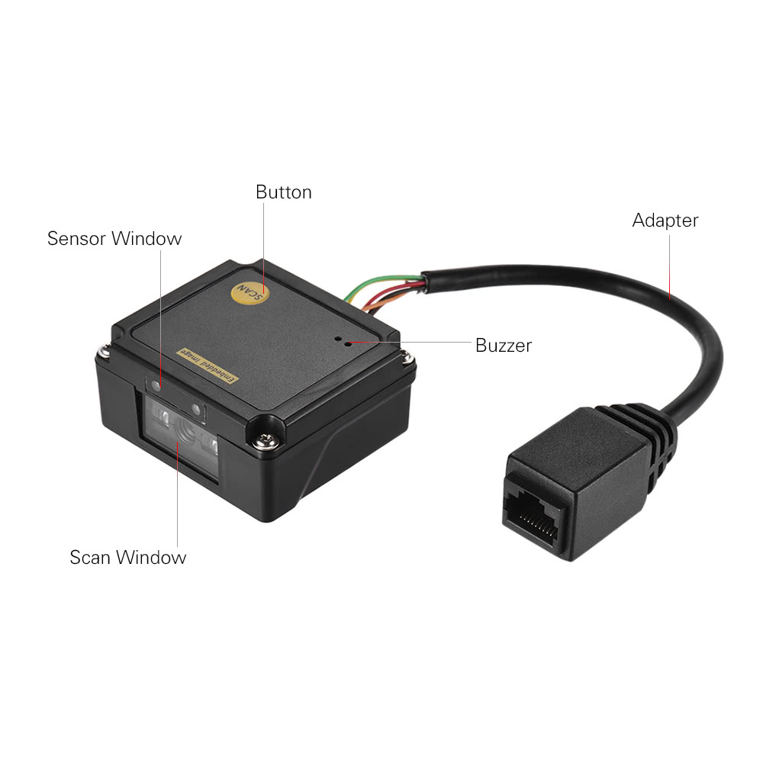

### 1.3 loadcell :- Load cell is a type of transducer which performs the functionality of converting force into an electric output which can be measured. You can find load cell at the heart of any weighing machine or electric scales. This type of transducer is highly accurate which provides user with required information that is difficult to obtain by other technology owing to certain commercial factors.

It is basically a device that measures strain and then converts force into electric energy which serves as measurement for scientists and workers. The strain measurement by load cells helps in maintaining integrity of the unit under pressure and protects people and equipment nearby.

The usage of this transducer is not limited to electronic scales. Apart from this, it is used in industrial scales, load-testing machines, flow-meters, etc.

##### HX711 loadcell Amplifier - This module uses 24 high-precision A / D converter. This chip is designed for high-precision electronic scale and design, has two analog input channels, programmable gain of 128 integrated amplifier. The input circuit can be configured to provide a bridge voltage electrical bridge (such as pressure, load) sensor model is an ideal high-precision, low-cost sampling front-end module.

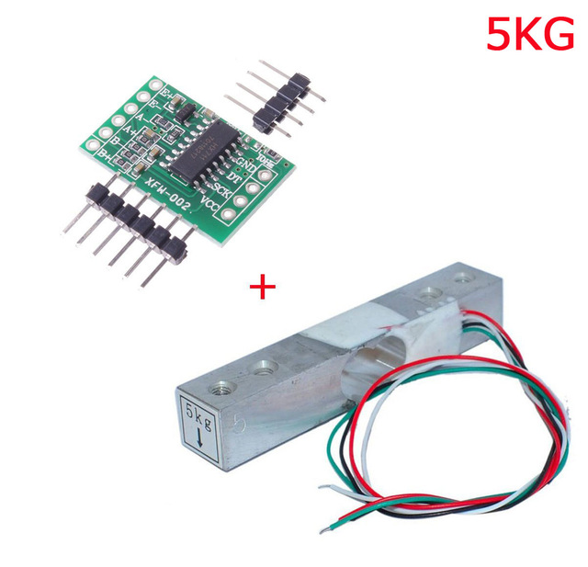

###### 1.6 HDMI Display –

 HDMI TFT Display Modules allow developers and makers to quickly add a TFT LCD display to their designs. Rather than using a FPC (Flexible Printed Circuit) ribbon cable, users can connect a standard HDMI cable from their desired board or computer right into the TFT module.

The HDMI TFT Display Modules without a touch panel have just two simple connections required to get the module up and running, DC power and the HDMI interface. The touch panel versions need just an additional USB connection to automatically load up their touch functionality via the USB-HID (USB Human Interface Device) interface.

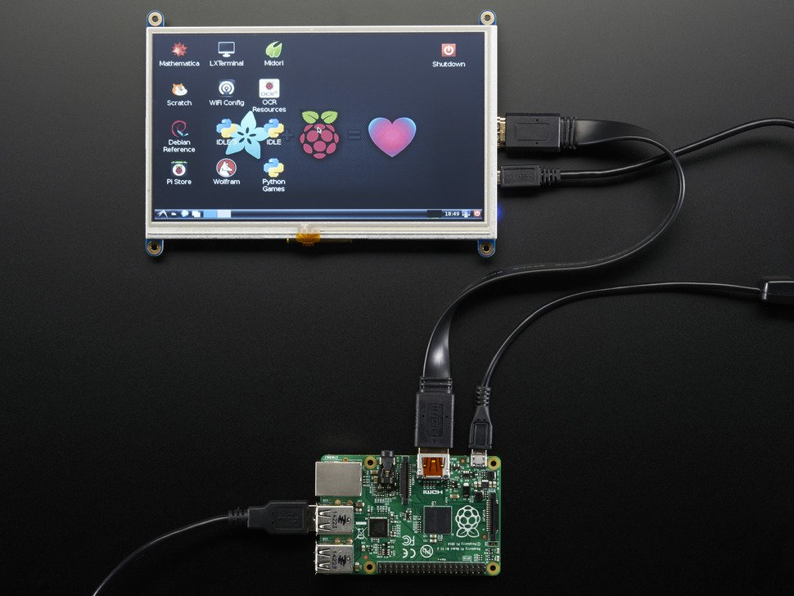

# 

# System Flow :-

YES

NO

GENERATE TOTAL

END

FINAL BILL

NO

YES

HSDH

SCANNING?

INTIALIZE BEAGLEBONE-BLACK, HDMI DISPLAY, BARCODE SCANNER

GENERATE BILL

DISPLAY ITEM’S DESCRIPTION

POWER

# System Description :-

First , power up beaglebone black with 5 V supply as well as provide 5v supply to barcode scanner.

Barcode scanner is connected with beaglebone black via RS232 cable through serial port UART.

As, we scan barcode RS232 send data to beaglebone black pin connection is given below

BBB P9_11 TX RX _3 RS232

P9_13 RX TX_2

Data receive in buffer and as per the coding it displays detail, price and total on HDMI display.

Here, load cell work as weight sensor but, it gives analog output so we need HX711 ADC amplifier to connect beaglebone black . changes occur in voltage that means that sense weight of object. 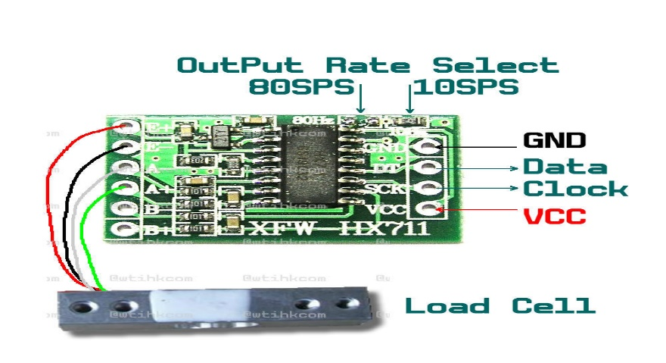

# Result and Conclusion :-

In Smart Trolley System, now there is no need for the customers to wait in the queue and wait for his/her turn for the scanning of the product items. Especially during weekends or festivals season, there is not time wastage in waiting in the queue. The customer has to do only billing at the billing counter and only those customers can use the smart trolley who are having membership card where specific system is inserted in it. So, supermarkets or hypermarkets use this concept as their business strategy to attract more number of customers.

# Future Scope

We have to update the details of the product items in the memory unit of trolley time to time. We take the help of Internet of Things and some software with the help of which all information will be updated regularly. Also, with the help of optical sensor, motors, and motor drivers, we will make trolley in such a way that it will follow the customer which purchasing items and it maintains the safe distance between customer and itself