

CSE523: Machine Learning

Faculty: Professor Mehul Raval

Group Name.: Code Rockers

Face Recognition & Attendance System

(Report File)

Sushan Bhojak – AU1940200

Priya Bhoraniya – AU1940173

Dhruvanshu Parmar – AU1940166

**Things we have done:**

Preprocess the data

calculating gradients:

calculate the magnitude and orientation for each pixel value

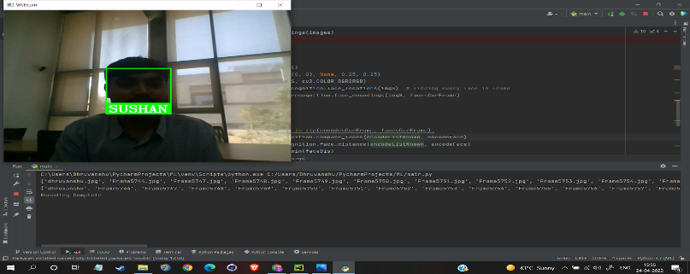

Now, we can detect face with HOG and recognize face through SVM classifier.

**Task to be performed next week:**

We will try multiple detection on same time.