**System is throwing "Available Id Exhausted" Error during COB**

**Available List IDs exhausted’ message will be displayed when the JOB.LIST reaches its tail and the number of running sessions are greater than the NUMBER.OF.IDS in the JOB.LIST to be processed. In this scenario, some agents will not get ID's to process. Such sessions will produce the message to inform that the job has reached the end. This is not a error message, but a message to tell the job is nearing completion**

**How to prevent INAU records from moving to IHLD during COB?**

If the NS module is not installed, contracts in INAU will be moved to IHLD during COB in the job UNAUTH.PROCESSING.  
There is an option in PGM.FILE which will prevent all contracts from moving to IHLD. To achieve this you need to set .NUH in ADDITIONAL.INFO of PGM.FILE record of Particular applications like PD, FT..,  If .NUH is set in PGM.FILE of the respective application, the system will not move the contracts from INAU to IHLD for that application.  
You can prevent contracts from moving to IHLD by setting .NUH but this cannot be done for specific contracts and this is applicable to all contracts of that application. For more details please refer to the help text of PGM.FILE.

Keywords - Prevent INAU records from moving to IHLD,COB,,,

**Reports not generated during COB**

Please be noted that from R22, the generation of reports has been moved to a separate service called "BNK/EB.EXTERNALISE.REPORT" . Only if this service is run, reports will be generated.  
The EB.EXTERNALISE.REPORT is designed to take the DATE values as per the BATCH Stage of the BATCH record to which the report is attached. Hence, even though it runs after COB TODAY is changed, the service will use internal TODAY values as per the BATCH Stage.

Please note that the purpose of the service BNK/EB.EXTERNALISE.REPORT is to generate/print all the COB reports that are not marked as ‘IMMEDIATE’ outside COB run in order to improve the operation efficiency of COB.**This service can’t be switched off if not needed, as it is part of cob performance improvement development.**

This service will print reports according to the BATCH.STAGE field that is given in the BATCH record of the report.

When the EB.PRINT job from the BATCH record is processed, it saves the BATCH.STAGE of the corresponding BATCH in an activation file. The TODAY variable is dependent on the BATCH.STAGE.

When the BNK/EB.EXTERNALISE.REPORT service is run, TODAY variable would get dynamically assigned as per the BATCH.STAGE in the activation file which was already stored during the processing of COB. This is the functionality of printing reports in R22.

You may refer to the following user guide link for a detailed explanation of EB.EXTERNALISE.REPORT.

[Configuring COB Using EXTERNALISE.REPORTS Attribute Type (temenos.com)](https://docs.temenos.com/docs/Solutions/T24_Transact/Infrastructure/EB/System_Core/COB/t_ExternaliseReports.htm)

For the current cob, run the service BNK/EB.EXTERNALISE.REPORT to generate reports.

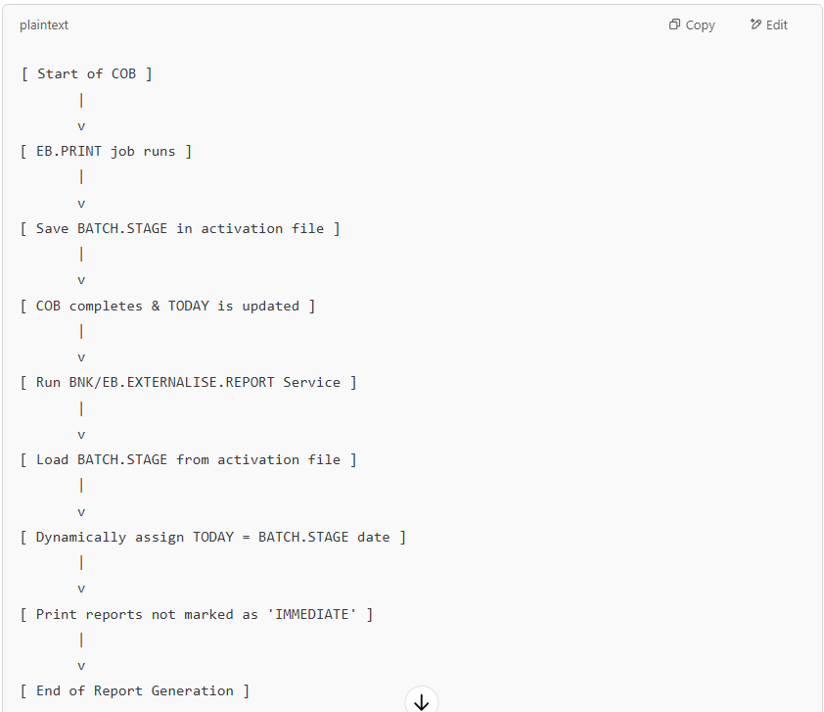

**What is the recommended way to run COB/service in TAFJ environment?**

In TAFJ T24 runtime environment, COB should always be executed from TAFJEE Execute Servlet rather than being executed from the classic prompt. Because only when COB is executed through Servlet mode, all the jar files, properties related to TAFJ, and respective application server will be properly loaded.

This method is always recommended to run the service/COB in Servlet mode in TAFJ.

Keywords - COB,TAFJ,TAFJEE,Servlet,

**How do we iden​​t​​ify and report critical COB errors to Temenos support team?**

**📘 EOD/COB Process: Error Handling in T24**

The **End of Day (EOD)** or **Close of Business (COB)** process in T24 is a critical batch process that runs a series of jobs. Each job may execute multiple programs and operating system-level commands.

**🔄 Overview of Execution Flow**

* The COB process involves **sequential and parallel jobs**.
* Each job may include:
  + T24 application-level programs
  + Shell scripts or OS commands
* During execution, **errors** may occur, which are broadly categorized into two types:

**❗ Types of Errors in EOD/COB**

**a. T24 Errors (Application-Level Errors)**

* These are **fatal or logical errors** detected by the T24 programs.
* They are handled internally by T24 and are:
  + Logged in the **EB.EOD.ERROR** application
  + Detailed records are stored in **EB.EOD.ERROR.DETAIL**
* **Effect on COB:**
  + Depending on severity, T24 may:
    - **Stop** the COB process (**fatal errors**)
    - **Allow it to continue** (**non-fatal warnings**)

📌 **How to Analyze T24 Errors:**

* Examine the **EB.EOD.ERROR** records for high-level error info.
* Use **EB.EOD.ERROR.DETAIL** for deep-dive troubleshooting.

**b. Non-T24 Errors (System-Level Errors)**

* These are errors **external** to the T24 application, often related to the database or operating system.
* Not handled by T24 logic directly.

📎 **Examples include:**

* ⚠️ **Deadlock** in a multi-threaded process
* 💾 **Disk space overrun**
* 🔐 **File permission issues**
* 🧩 Network or infrastructure issues
* 🔁 Shell script failures

**Identifying and Reporting EOD/COB Error**

When running EOD/COB, any application-related crash will be written into EB.EOD.ERROR with the information on the job name, the record, and the text of the crash. The underlying record from the .LIST file is removed and the updates done till then for the particular transaction will be rolled back. Wherever applicable the COB will be automatically restarted by the TSM (when running in phantom mode).

There will be some critical jobs that will crash and abort the COB due to business reasons as a further continuance of COB is not advocated. These jobs will be defined as .CRITICAL in the ADDITIONAL.INFO field of PGM.FILE. In such cases, the COB will not be automatically restarted by the TSM.

Similarly, whenever there is a system-related crash, the Temenos Service Manager will identify the non-responding agent and re-activate him. Identification is based on the time for which Agent does not provide any response. However, if it is a recurring system-related crash then the agents will keep on crashing.

The bank is advised not to ignore or resort to self remedy in any crash scenario. In any such instance of a T24 or system-related crash during EOD/COB the bank is expected to call the 24 by 7 Critical Support immediately.  
   
Ignoring the error messages in COB/EOD and continuing with the same (without advice from Help Desk) will lead to data integrity issues. In all such cases the bank may be advised to restore a previous good backup and re-key the transactions. Such a rollback can lead to business hours loss.  
   
Some of the common self remedies taken by the bank that lead to potential business hours loss are listed below. We recommend that the Help Desk 24 by 7 be consulted before making any such decision.

* Any deadlock situation or hang without any trace of error and hence releasing all locks
* Pressing I (ignore) to a I / R(etry) /Q(uit) message from the system
* Killing of processes from OS level
* Re-run of a crashed SYSTEM.WIDE or START.OF.DAY jobs and continue EOD/COB.
* Re run of any non multi-thread jobs.
* Re running of any job, this is not marked for re-run, based on the fact that the same action was done previously to continue EOD/COB under the advice of HD.
* Bypassing a core job
* Restoration and re-run of EOD/COB.
* Restarting the Server

The following information should be sent to the Helpdesk ([cshd@temenos.com](mailto:cshd@temenos.com)) during the initial phase of problem logging and any problem-specific information will be requested by the Helpdesk for proceeding further.

1. ​Full COMO of the crashed agent. In COB, this can be obtained from the file F.TSA.STATUS in the field COMO.NAME

        The COMO must be transferred using FTP from the server and mailed to us.

1. Screenshot of  F.TSA.STATUS of the crashed agent ( COB)

CURRENT.SERVICE. COB

NEXT.SERVICE.... STOP

LAST.MESSAGE.... _MTA/STARTUP_EB.PRINT_4_04 JUN 2005_12:37:30_Processing...1 C

COMO.NAME....... tSA_4_1367043998

JOB.PROGRESS.... 3

1. The respective EB.EOD.ERROR details.

jsh-> LIST F.EB.EOD.ERROR WITH @ID LIKE …<<date when the crash had occurred>>…

1. SHOW-ITEM-LOCKS

jsh-> SHOW-ITEM-LOCKS

1. WHERE output from JBASE

jsh->WHERE (V

1. If you are running R7 or Higher, please send the TecPack file from bnk.data. If on oracle, copy the contents to a j4 file, tar and mail it across.

Onl​ine Errors

Some of the most common online errors include:

* System freeze – Users are unable to login/ post any transaction
* Printing errors – Where no printouts are generated for the day
* Lock table overflow
* Disk space overrun

In all such instances, the users are advised to contact Help Desk 24/7. When doing so, send any system-related information that is deemed useful for analysis.​

**Monitoring the COB Progress via EB.COB.MONITOR.OUTPUT**

Steps to generate records in the EB.COB.MONITOR.OUTPUT application for monitoring COB progress.

The various stages of a COB can be monitored using the setup below, which generates records under the EB.COB.MONITOR.OUTPUT application. This setup provides details such as the COB run date, start and end time of each stage. Monitoring is conducted in a structured format, enabling third-party APIs to read or parse logged COB monitoring breach information. If the Relational Replication (RR) product is unavailable, Transact emits the data in DES.

**STEP 1:**In the SPF application, you must enable the DATA STREAM field.

Please find the below helptext for the DATA STREAM field:

DES Events will be emitted for a configured table, only if this field is set to YES. It works independent of the RR module.This field works in conjunction with the ES (Enterprise Streaming) module.  
If the ES module is not installed, then no new tables can be configured to emit the DES Events. However DES Events will be emitted for tables already configured.  
Read the RR.PARAM details for further information  
  
**STEP 2:**Create a record under EB.COB.MONITOR.PARAMETER application.

This application contains configuration information to Monitor COB and emit events stage wise and COB wise. Valid records are: COB, COB-NN, COB-COMPANYID(should be a valid TSA.SERVICE record).

Kindly find a sample record:

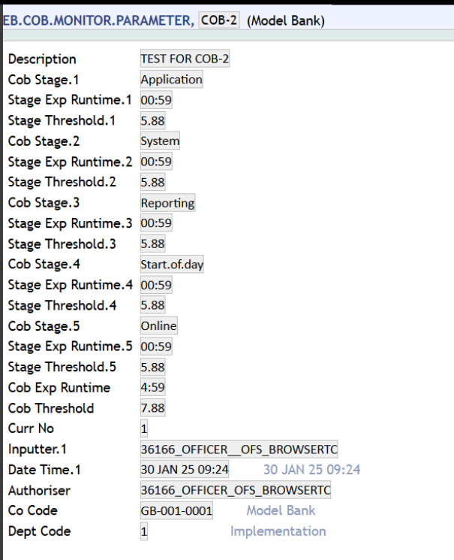

**STEP 3:** Once a record is created under EB.COB.MONITOR.PARAMETER application, we request you to kindly run the COB accordingly.

**STEP 4:** Once the COB process gets completed, we request you to kindly check if any records are generated under EB.COB.MONITOR.OUTPUT application.

Please find the sample records generated under under EB.COB.MONITOR.OUTPUT application after completion of the COB process.

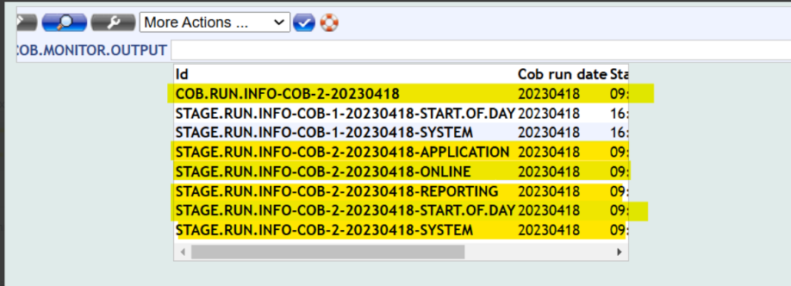

**Verifying Pre-COB Services**

The users have the option to pre-check whether the standalone services run independently and get completed in the business day before initiating the actual COB (Close of Business). The COB commences only when all the pre-check services are completed successfully on that business day. COB raises a fatal error if the service fails or if the service is not started during that business day.

Users enable the *Pre Cob Check* field in **TSA.SERVICE** for all standalone services (runs before COB) and execute the services successfully during the business day before the COB starts.

The pre-checks are not performed in the following services:

* COB
* Date change services
* Services that are part of COB, that is, the services that have a corresponding batch record that does not have the *Batch Stage* field.

The following are the sample scenarios for pre-COB checks.

[Configured service runs successfully and triggers a COB](https://docs.temenos.com/docs/Solutions/T24_Transact/Infrastructure/EB/System_Core/COB/Verify_Precob.htm)

**Service 1 : BNK/OFS.CLEANUP.UNIQUE.MSG.REF**

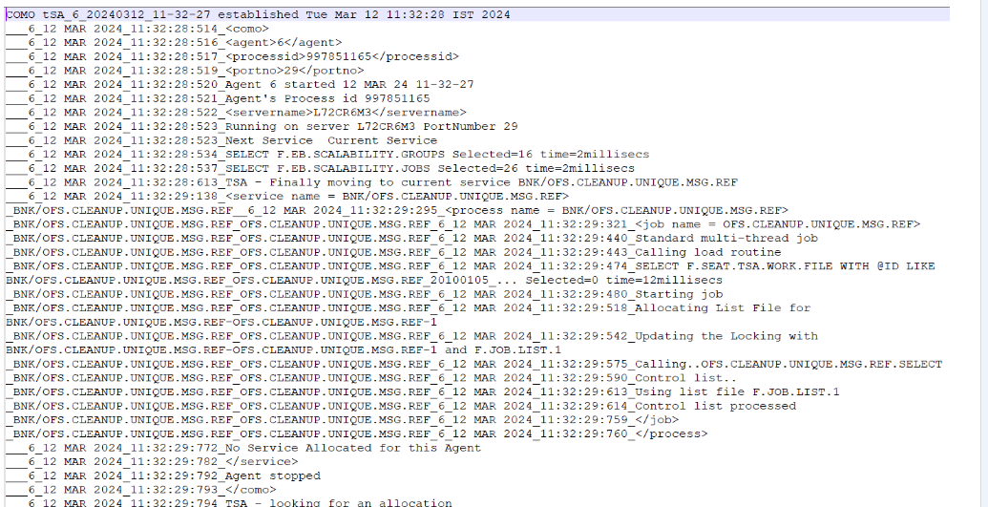

**Service 2 : BNK/OFS.MESSAGE.SERVICE**

The above configured services are executed successfully and hence the COB is processed without any fatal

[Configured service did not run during the business day and triggers a COB](https://docs.temenos.com/docs/Solutions/T24_Transact/Infrastructure/EB/System_Core/COB/Verify_Precob.htm)

**Service 1 : BNK/AC.RESERVATION.TIDY.UP.SERVICE**

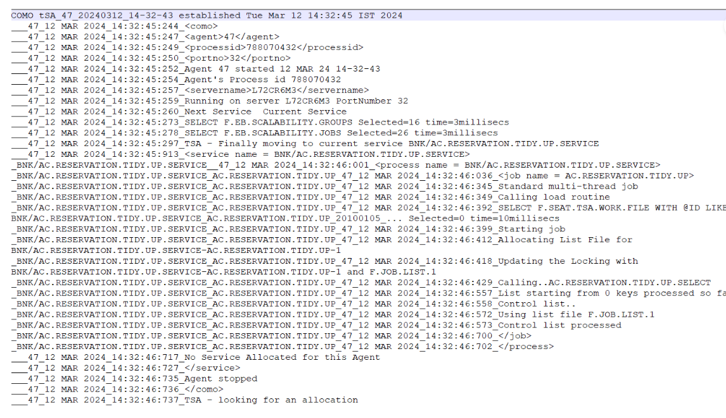

**Service 2 : BNK/OFS.CLEANUP.UNIQUE.MSG.REF** (did not run during the business day)

The service 2 enabled with *Pre Cob Check* is not executed during the business day, the COB raises a fatal error as given below.

**JOB.LIST Files**

This topic tells you about how the COB uses JOB.LIST files.

Every job during the COB uses a JOB.LIST file for storing and sharing records for processing between different agents. The JOB.LIST file is dynamically determined based on the availability of agents.

The other agents processing the same job use the allotted list for sharing their load of the job. The JOB.LIST file is empty at the end of the job, which makes it available for a different job.

To define it further, a session starts processing the job by determining the available JOB.LIST file and populates the data to process in the JOB.LIST file. This session along with the other free sessions now shares the load on the JOB.LIST file and processes the job.

**How to execute COB during weekends?**

To run COB during weekends, include the date in the field WRK.WKND.XXXX(XXXX - Month name) of the corresponding HOLIDAY table. The MTH.0X.TABLE (X - Month) field usually holds 'H' for the weekend days. However on setting the WRK.WKND.XXXX with the corresponding weekend dates, the values of the MTH.0X.TABLE will change to 'W'. Therefore mention the working weekend dates in the WRK.WKND.XXXX field as per your requirement for the corresponding month and proceed with the COB. On processing the COB during the weekends (Saturday and Sunday), there will not be any technical impact on the system but however activities like interest calculations and accruals will also be calculated for these days.

**Why is COB slow during EB.EOD.REPORT.PRINT?**

EB.EOD.REPORT.PRINT is  used to produce the reports. It  normally runs in end of each stage (APPLICATION, SYSTEM, REPORTING, START OF DAY, ONLINE) and will produce the reports attached to the DATA field of the job EB.PRINT    
------------------------------------------------------------------------------     
1 BATCH.STAGE....... R100                REPORTING     
3 PROCESS.STATUS.... 0                   READY     
4 BATCH.ENVIRONMENT. F                   FOREGROUND     
6. 1 JOB.NAME....... EB.PRINT     
8. 1 FREQUENCY...... D                   DAILY     
9. 1 NEXT.RUN.DATE.. 12 MAR 2003    
11. 1. 1 DATA........ DET.OVERRIDE    
11. 1. 2 DATA........ TRANS.JOURNAL2    
12. 1 JOB.STATUS..... 0                   READY

In the above case, two reports DET.OVERRIDE, TRANS.JOURNAL2 are added to the DATA field of the job EB.PRINT. The job EB.PRINT will write these two reports to a work file EB.REPORT and the job EB.EOD.REPORT.PRINT, which is coming at the last job in the same stage will read the work file EB.REPORT and produce the reports. Similarly, the job EB.PRINT may be defined in any batch process based on the requirement.

If we generate all the reports in the REPORTING stage, it will take more time. Hence in order to increase the performance, we are printing the reports at the end of each batch stage (APPLICATION, SYSTEM, REPORTING, START OF DAY, ONLINE).

**TSM, Single thread service and COB in Multi-Server Architecture**

Functionality of TSM, Single thread service, COB/multi-thread services in Multi-Server Architecture

In a Multi-server architecture, one TSM from each server has to be started, which in turn will start the tSA agents in respective servers.  
Example: If you have 2 servers, you must start 2 TSMs, one from each server. A single TSM will start and monitor tSA agents only on the same corresponding server where it is running.

For Single-threaded service in Multi-server,  
Regardless of Multiple Application Server or Single, Single threaded service will always run in one agent, even if the is started in two servers, since job list will be locked by one agent at a time, the job will run only in either one of the servers at a time.  
Any agent started in any server for the service that does not acquire the lock will be sleeping waiting for locks  
Therefore, a Single agent will be executed in any one of the application servers.

Auto services will also run in there respective servers once the TSM is started.

A prerequisite to run any service/COB in a multi-server setup is that, we should have MS product(Multi-Server) installed in our area. Kindly check the SPF record. If the product is not there, kindly contact the licensing team <landmcodes@temenos.com> for the product code and install it.

Kindly update the server names in TSA.SERVICE records for at least for TSM and COB records,  
below options, will be available only when we update the server names for respective TSA.SERVICE records:

>For each server name in TSA.SERVICE record, there is a SERVER.STATUS field  
>The particular service/TSM in particular server alone can be stopped by updating corresponding SERVER.STATUS field =INACTIVE in TSA.SERVICE record, leaving the service to run on the other servers.  
>For each server, different TSA.WORKLOAD.PROFILE can be specified for the same service.

**Does T24 allow to update records in USER application during COB?**

To allow the system to update the user record during COB, add .NOD in ADDITIONAL.INFO field at PGM.FILE for USER record.  
Sample screen-shot:  
                    PROGRAM FILE SEE  
      PROGRAM            USER  
-------------------------------------------  
    1 TYPE.............. H  
    2. 1 GB SCREEN.TITLE USER PROFILE  
    3 ADDITIONAL.INFO... .BDA.NOD  
    5 PRODUCT........... EB  
   26 CURR.NO........... 3

**How to fix COB Error - Fatal error in SPOOL.REPORT error UNABLE TO OPEN HOLD FIL**

This error will occur if the printer related variables are not available in tafj.properties. The reports in EB.EOD.ERROR.REPORT writes to the channel PRN1, the same channel should be present in .properties for writing the record to the &HOLD& folder. Also, make sure to provide full rights to the &HOLD& folder in order to write the report.  
  
Sample TAFJ.properties set up for PRINTER:  
**********************************************  
  
#Printers Setup in .properties – Channel 1 to be defined when we want to write to channel 1  
  
temn.tafj.channel.name.0 = PRN0  
  
temn.tafj.driver.name.0 = PRN0  
temn.tafj.driver.device.0 = lp  
temn.tafj.driver.class.0 = com.temenos.tafj.jlp.drivers.jPrinterDriver  
  
temn.tafj.channel.name.1 = PRN1  
  
temn.tafj.driver.name.1 = PRN1  
temn.tafj.driver.device.1 = lp  
temn.tafj.driver.class.1 = com.temenos.tafj.jlp.drivers.jPrinterDriver  
  
Update the above in tafj.properties and execute COB, this will solve the problem.

**List File JOB.LIST not associated to this Job Anymore**

COB Hang LD.EOD.ISSUE.REIMB.ACCRUAL - List File F.JOB.LIST not associated to this Job Anymore

The message JOB.LIST is not associated will occur if the last ID is been processed and the JOB.LIST is allocated to another job and other agents are waiting for the lock on JOB.LIST for the previous job.

This is a normal behavior and will not create any impact.   
   
We can also check the COMO of this job across all agents and you can find the line that select on JOB.LIST would be empty with 0 records indicating that JOB.LIST is processed successfully.

**JOB.LIST files increases in size daily**

JOB.LIST tables are temporary files that are used by the COB/service framework to populate records keys that will be processed by the tSA agents. The data written to these tables depends on the nature of the job that utilizes it. Hence there are chances that these could have larger data/record keys written to it. All these data/record keys will be processed and deleted by the tSA agents after the successful completion of the job. However, this will not reduce the physical size of these JOB.LIST tables consumed in the Table space. File maintenance activity has to be run on these tables periodically. We recommend that you generate a script which would select all the T24 JOB.LIST tables and run the below mentioned shrink commands in a timely fashion to reduce the unclaimed LOB size which is obviously expected in the OLTP environments like T24. The SHRINK option is to shrink the database size without deleting the exiting records. SQL> alter table enable row movement; SQL> alter table shrink space cascade; Note: * Ensure that there are no tSA agent or TSM agent is running during this shrink activity. * Oracle redefinition is a mechanism to make table structure modifications without significantly affecting the availability of the table. Redefining tables online provides a substantial increase in availability compared to traditional methods of redefining tables. With online table redefinition, the shrink activity can be performed when the tSA and TSM agents are running.

**How to release locks in JDBC locking mode**

In order to release the locks for all the records in JDBC locking mode, follow the below steps when there are no USERS logged in and no service is running.

**METHOD - 1:**

Execute the below command from SQL mode of DBTools prompt.

>TRUNCATE TABLE TAFJ_LOCKS

>COMMIT

Make sure all the records are deleted from TAFJ_LOCKS table using a SELECT * FROM TAFJ_LOCKS command.  Further clear (CLEAR-FILE) or verify the F.RECORD.LOCK table entry which holds the application level locked tables.

**METHOD - 2:**

Also you can use the below command to release locks from DBTools>JQL mode:

> RELEASE <SESSION_ID>

NOTE: Take the session id from the LOCKS output.

JDBC locking mode has issues in releasing the lock file. If there is any problem with database connection or if the thread is shutdown the lock will not be released properly.

Please refer to "TAFJ-Lock Manager.pdf" under <TAFJ_HOME>/doc folder for more information.