NON-DISCLOSURE AGREEMENT (NDA)
This Non-Disclosure Agreement ("Agreement") is made and entered into on ______________________ ("Effective Date").

BETWEEN
SwiftIQ Innovations LLP, a Limited Liability Partnership incorporated under the laws of India, hereinafter referred to as the "Company", which expression shall, unless repugnant to the context, include its partners, successors and permitted assigns;
AND
Mr. Dhruv Bhagat, hereinafter referred to as the "Recipient", which expression shall include his heirs, legal representatives and permitted assigns.
The Company and the Recipient are collectively referred to as the "Parties" and individually as a "Party".

1. Purpose
The Recipient may receive access to confidential information while participating in an internship, project, research assignment, software development, product evaluation, discussions, or any other engagement with the Company. This Agreement governs the protection and use of such confidential information.

2. Definition of Confidential Information
Confidential Information includes, but is not limited to:
• Source code, software, APIs, algorithms, libraries and architecture
• Product ideas, prototypes, designs, UI/UX, wireframes and roadmaps
• Business plans, strategies, customer information and vendor information
• Research documents, technical documentation, reports and specifications
• Internal tools, workflows, processes and methodologies
• Financial information
• Trade secrets and intellectual property
• Login credentials, passwords, keys and security-related information
• Any information disclosed verbally, electronically, visually or in writing that is reasonably understood to be confidential.
Confidential Information also includes information belonging to the Company's clients, partners and vendors.

3. Obligations of the Recipient
1. Keep all Confidential Information strictly confidential.
2. Use Confidential Information solely for assigned work.
3. Not disclose Confidential Information to any third party without prior written consent.
4. Exercise reasonable care to protect Confidential Information.
5. Not copy, reproduce, reverse engineer, distribute or exploit Confidential Information except as required for assigned work.
6. Immediately notify the Company of any unauthorized disclosure or suspected breach.

4. Exceptions
Confidential Information does not include information that is publicly available without breach, lawfully known before disclosure, independently developed without using Company information, or required to be disclosed by law (subject to prompt notice where legally permissible).

5. Intellectual Property
All work products, software, documentation, inventions, discoveries, designs, improvements, research findings, reports, source code and other materials created during the engagement that relate to the Company's business shall be the exclusive property of SwiftIQ Innovations LLP. The Recipient assigns all rights, title and interest in such work products to the Company.

6. Return of Materials
Upon completion or termination of the engagement, or upon request, the Recipient shall return all Company materials, permanently delete electronic copies, and confirm such return or deletion upon request.

7. No License
Nothing in this Agreement grants the Recipient any ownership or license in the Company's intellectual property except for the limited right to use Confidential Information for assigned work.

8. Term
This Agreement commences on the Effective Date. Confidentiality obligations shall continue during the engagement and for three (3) years after its termination or completion.

9. Remedies
The Company shall be entitled to seek injunctive relief, damages and any other remedies available under applicable law for any unauthorized disclosure.

10. Governing Law and Jurisdiction
This Agreement shall be governed by the laws of India. Any disputes shall be subject to the exclusive jurisdiction of the courts in Pune, Maharashtra.

11. Entire Agreement
This Agreement constitutes the entire understanding between the Parties regarding confidentiality and supersedes all prior discussions. Any amendment must be in writing and signed by both Parties.

12. Severability
If any provision is held invalid or unenforceable, the remaining provisions shall remain in full force and effect.

Recipient Acknowledgement
Name | Dhruv Bhagat
Signature | 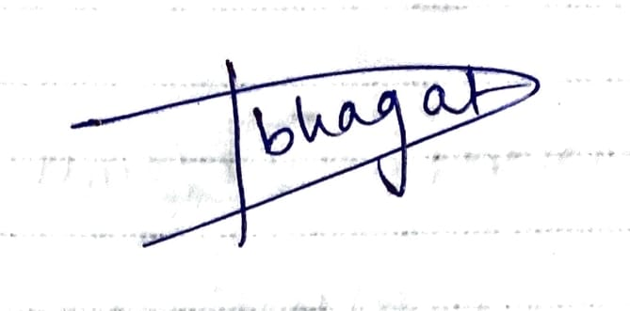  Dhruv Bhagat
Date | 9th July 2026

