**Aim :**

**Apparatus:** Multisim, DSO/CRO, connecting Probes, CRO Probes.

**Theory:**

The signals we use in the real world, such as our voice, are called "analog" signals. To process these signals for digital communication, we need to convert analog signals to "digital" form. While an analog signal is continuous in both time and amplitude, a digital signal is discrete in both time and amplitude. To convert continuous time signal to discrete time signal, a process is used called as sampling. The value of the signal is measured at certain intervals in time. Each measurement is referred to as a sample. Consider an analogue signal x(t) that can be viewed as a continuous function of time, as shown in figure1. We can represent this signal as a discrete time signal by using values of x(t) at intervals of nTs to form x(nTs) as shown in figure 1. We are "grabbing" points from the function x(t) at regular intervals of time, Ts, called the sampling period.

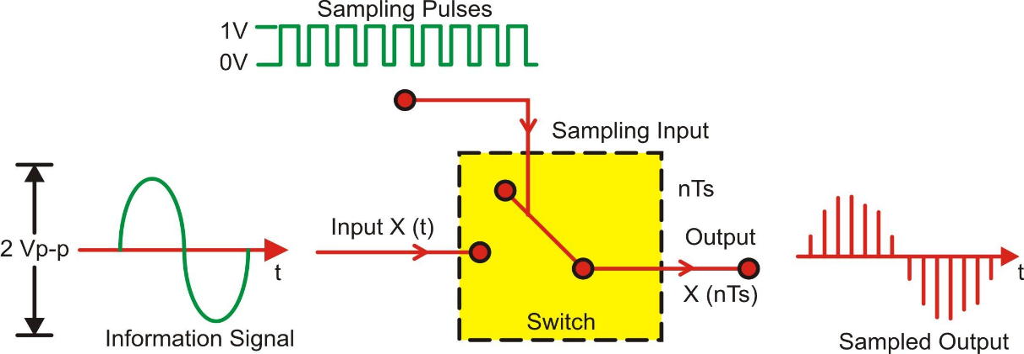

**Figure 1. Basic Sampling Process**

Figure 2 depicts the sampling of a signal at regular interval (period) t=nTs where n is an integer. The sampling signal is a regular sequence of narrow pulses δ (t) of amplitude 1.Figure 3 shows the sampled output of narrow pulses δ (t) at regular interval of time.

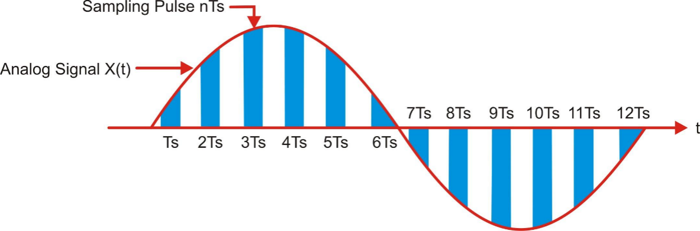

**Figure 2. Sampling of signal at sampling interval (period) Ts**

The time distance Ts is called sampling interval or sampling period, fs=1/Ts is called as sampling frequency (Hz or samples/sec), also called sampling rate.

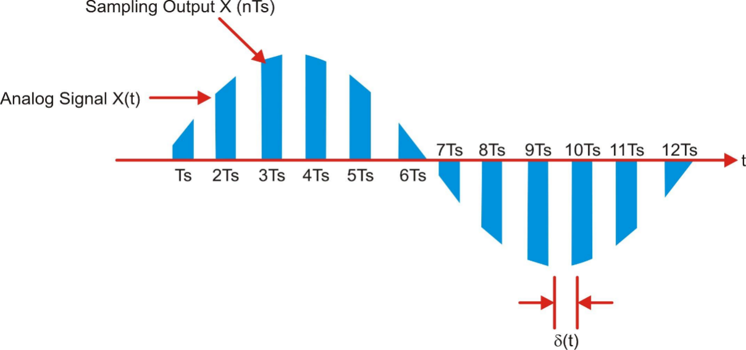

**Figure 3. Sampled Output of narrow pulses δ (t)**

**Multisim Simulation Circuit:**

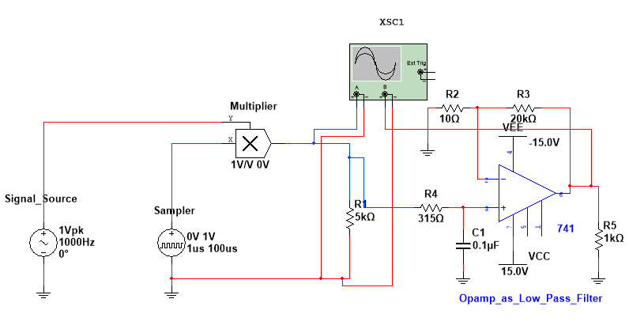

**Procedure:**

Connect the circuit as per the shown in figure above.

**Step-1 Basic Sampling & Reconstruction**

1. Set the signal source frequency 1KHz and sampler frequency 100KHz (Time period = 100us).
2. Set the pulse width of sampler 1 micro second.
3. Observe the sampled output of multiplier on CRO screen.
4. Now observe the reconstructed output of low pass filter at pin no. 6.

**Step-2**

1. Now set the signal source frequency equal to last two digit of your enrollment number (i.e. Enrollment No. 150570111020 then set frequency = 20Hz)
2. Consider the sampler frequency 10 times of your signal frequency (i.e. 20 Hz * 10 = 200 Hz). So set the time period of sampler = 1/f. (i.e. T = 0.005 Sec)
3. Set the Pulse width 1/10th of your time period (i.e. Width = 0.0005sec)
4. Observe the sampled output at multiplier.
5. Adjust the opamp filter frequency as per your signal frequency by changing the values of R and C. (use formula )

**Conclusion:**