**Experiment-10: Perform amplitude modulation and demodulation using AM Transmitter and Receiver.**

**Apparatus:** Multisim

**Theory:**

**Amplitude Modulation**

Amplitude modulation is defined as the process in which amplitude of carrier wave is varied in accordance with the instantaneous values of the modulating signal. The envelope of the modulating wave has the same shape as the base band signal. This experiment investigates the generation of double sideband amplitude modulated (AM) waveforms, using the ST2201 Kit.

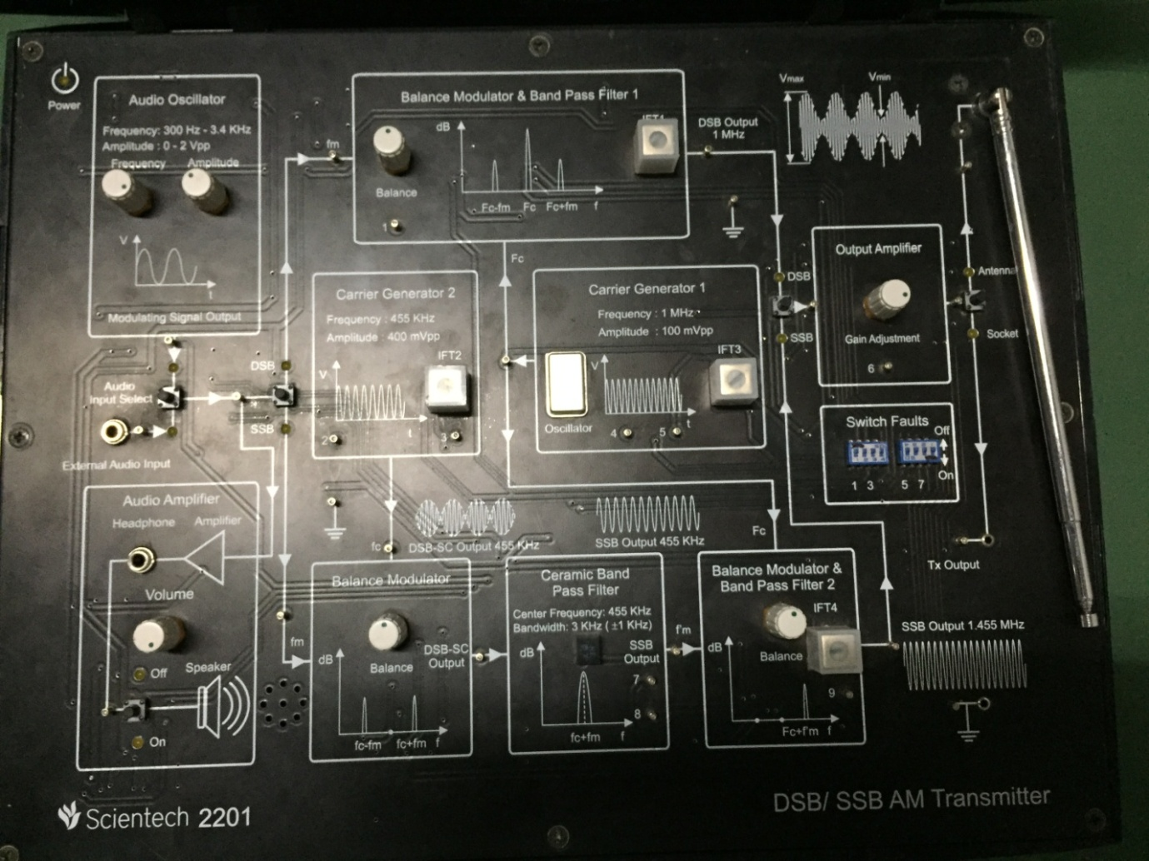

**PROCEDURE:**

|  |  |
| --- | --- |
| 1 | Connect following links:  a. Link between sine o/p terminal of audio generator and MOD i/p terminal of balanced modulator.  b. Link between carrier oscillator of 1MHz to the Balanced Modulator. |
| 2 | Connect DSO/CRO channel-1 at sine output terminal. Connect ground of probe to ground terminal of audio generator. Adjust amplitude of sine wave to 1vpp and audio frequency to 1KHz. |
| 3 | Connect DSO/CRO channel-2 RF o/p terminal of RF oscillator. Connect ground of probe to ground terminal of RF oscillator. Adjust output of probe to ground terminal of RF oscillator to 1 MHz and amplitude to 6vpp. |
| 4 | Now connect DSO/CRO channel 2 at AM MOD O/P terminal of balanced modulator. Trigger DSO/CRO by channel-1.The amplitude modulated wave will be observed. |

**Amplitude Demodulation**

The process of detection provides a means of recovering the modulating signal from modulated signal. Demodulation is the reverse process of modulation. Since the envelope of an AM wave has the same shape as the message signal, independent of the carrier frequency and phase, demodulation can be accomplished by extracting envelope.

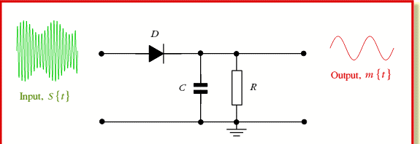

An increased time constant RC results in a marginal output follows the modulation envelope. A further increase in time constant the discharge curve become horizontal if the rate of modulation Envelope during negative half cycle of the modulation voltage is faster than the rate of voltage RC combination ,the output fails to follow the modulation resulting distorted output is called as “Diagonal Peak Clipping”.

The depth of modulation is greater than unity and circuit impedance is less than circuit load (Rl>Zm) results in clipping of negative peaks of modulating signal. It is called “negative Peak clipping. “

A **product detector** is a type of demodulator used for AM. Rather than converting the envelope of the signal into the decoded waveform like an envelope **detector**,

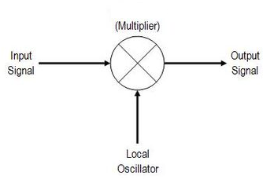

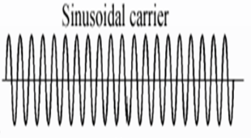

The **product detector** takes the **product** of the modulated signal and a local oscillator frequency to detect the modulating signal hence the name is **product detector.**

**Procedure:**

|  |  |
| --- | --- |
| 1 | Tune the receiver circuit at the frequency that is transmitted by transmitter circuit by tuning capacitor. |
| 2 | The receiving signal is given to the RF Amplifier circuit to amplifier the signal. |
| 3 | The output of RF Amplifier circuit is connected to the Mixer to generate the IF Frequency. |
| 4 | The IF Frequency is given to the demodulation circuit to demodulate the received signal. |
| 5 | The Demodulated signal is observed in the DSO/CRO channel 1 at the output terminal of the demodulated circuit. |

**Multisim Simulation Circuit:**

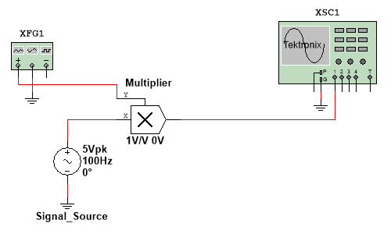

**Procedure:**

1. Set the signal source frequency equal to last two digits of your enrollment number (Hz).
2. Set the carrier frequency on function generator to to last two digits of your enrollment number (KHz).
3. Observe the AM envelop of CRO screen.
4. Vary the offset voltage of signal source and observe the effect on modulation index.
5. Vary the waveform type sinusoidal/square/triangular from function generator and observe the effect on carrier.

**Output Wave form :**

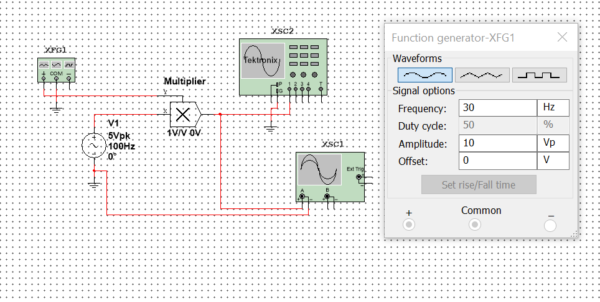

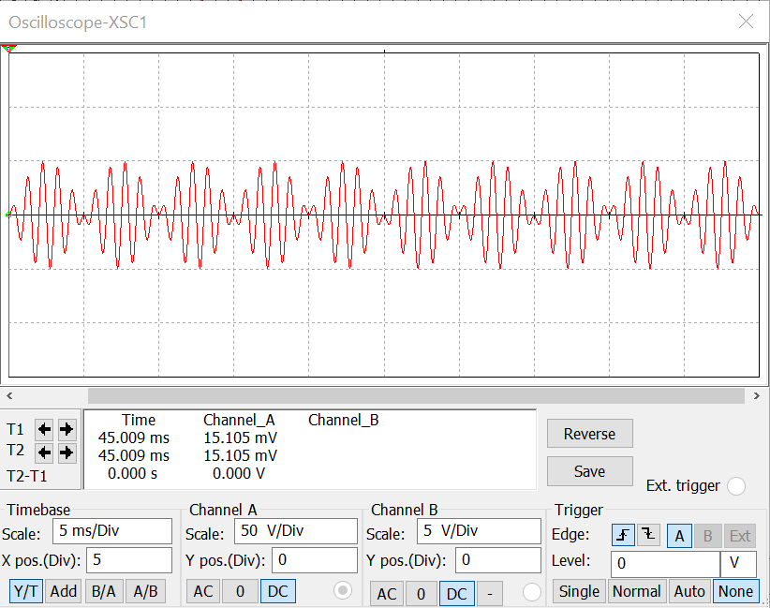

**Observation:**

**Conclusion:**

**Experiment No: 10 Post Lab Exercise**

|  |  |  |
| --- | --- | --- |
| **Q-1**. | **Identify category of Under modulated carrier, perfect modulated carrier and over modulated carrier for the given images. Also draw demodulated signal for all modulated carrier at receiver side.** | |
|  | F:\SUBJECT\adc marwadi\pre-post ex\iwmages.jpg |  |
|  | F:\SUBJECT\adc marwadi\pre-post ex\index.jpg |  |
|  | F:\SUBJECT\adc marwadi\pre-post ex\images.jpg |  |
|  | F:\SUBJECT\adc marwadi\pre-post ex\image2.jpg |  |
|  |  |  |
|  | F:\SUBJECT\adc marwadi\pre-post ex\issmages.jpg |  |
|  | F:\SUBJECT\adc marwadi\pre-post ex\imag4es.png |  |

|  |  |  |  |  |  |
| --- | --- | --- | --- | --- | --- |
| **Q-2.** | **Choose characteristic, Advantage, disadvantage of AM categories and classify in respective place.** | | | | |
|  | * Bandwidth requirement-2fm, * complex receiver required, * lowest transmitter power required among all three. * It requires same bandwidth as in DSB-FC, * It need bandwidth equal to baseband signal bandwidth, * Most inefficient in terms of power, * It does not allowed simple diode detector to demodulate carrier, * It saves 66.66% power. * It is preferable In broadcasting application for low cost receiver. | | | | |
|  |  | | |  | |
|  | **DSB – FC** | | **DSB - SC** | | **SSB - SC** |
|  |  | |  | |  |
|  |  | |  | |  |
|  |  | |  | |  |
|  |  | |  | |  |
|  |  | |  | |  |
|  |  | |  | |  |
| **Q-3.** | **Mark true/false for the given statement. Correct statement if you found it false.** | | | | |
|  | (a) | In amplitude modulation amplitude of carrier is change according to instantaneous value of modulating signal. | | | |
|  |  | | |  | |
|  |  | | |  | |
|  | (b) | To transmit signal we need modulating signal, carrier signal and modulator circuit. | | | |
|  |  | | |  | |
|  |  | | |  | |
|  | (c) | In Filter method of sideband suppression technique first filter at low frequency and up-convert at high frequency is preferable. | | | |
|  |  | | |  | |
|  |  | | |  | |
|  | (d) | Trapezoid method is used to measure amplitude of demodulated signal. | | | |
|  |  | | |  | |
|  |  | | |  | |
|  | (e) | In AM transmitter kit audio amplification is achieved by use of IC……. And Audio signal generates by IC……… | | | |
|  |  | | |  | |
|  |  | | |  | |
|  |  | |  | |  |
|  |
|  |
|  |
|  | | | | | |