**Aim: To perform Digital carrier Modulation & Demodulation – Amplitude Shift Keying (ASK).**

**Apparatus:** Multisim

**Theory:**

In digital modulation, an analog carrier signal is modulated by a digital bit stream. Digital modulation methods can be considered as digital-to-analog conversion, and the corresponding demodulation or detection as analog-to-digital conversion. To be able to transmit the data over long distance, we have to modulate the signal that is varying phase, frequency or amplitude according to the digital data. At the receiver separate the signal and the digital information by the process of demodulation.

**Amplitude Shift Keying (ASK) Technique**

The simplest method of modulating a carrier with a data stream is to change the amplitude of the carrier wave every time the data changes. This modulation technique is known as Amplitude Shift Keying. The simplest way of achieving amplitude shift keying is by switching 'ON' the carrier whenever the data bit is '1' & switching it 'OFF' whenever the data bit is '0' i.e. the transmitter outputs the carrier for a' 1 ' & totally suppresses the carrier for a '0'. This technique is also known as ON-OFF keying. Figure 1 illustrates the amplitude shift keying for the given data stream. Thus, Data = 1 carrier transmitted, Data = 0 carrier suppressed.

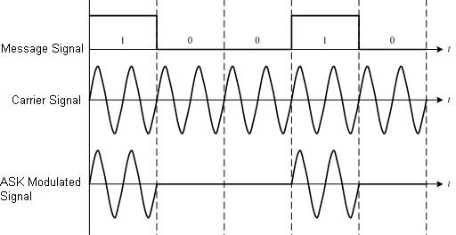

**Figure 1. Amplitude Shift Keying modulation waveform**

The ASK waveform is generated by a balanced modulator circuit, also known as a linear multiplier as shown in the figure 2 given below. As the name suggests, the device multiplies the instantaneous signal at its two inputs. The output voltage being product of the two input voltages at any instance of time. One of the inputs is AC coupled 'carrier' wave of high frequency. Generally, the carrier wave is a sinusoidal signal since any other waveform would increase the bandwidth, without providing any advantages.

|  |
| --- |
|  |

**Figure 2. Amplitude Shift Keying Modulator**

The data stream applied is unipolar i.e. 0 volts for logic '0' & + 5 Volts for logic '1'.The output of balanced modulator is a sine wave, unchanged in phase when a data bit ‘l' is applied to it and is zero when the data bit '0' is applied. The ASK modulation result in a great simplicity at the receiver. The method to demodulate the ASK waveform is to rectify it, pass it through the filter & ‘shape up’ the resulting waveform. The output is the original datastream.Figure3shows the functional blocks required in order to demodulate the ASK wave format receiver.

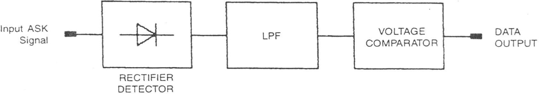

**Figure 3. Amplitude Shift Keying Demodulator**

**Write advantages and limitations of Amplitude Shift Keying Modulation:**

**Procedure:**

1. Apply input signal (t.p. 4) to the modulation input of carrier modulation circuit (t.p. 27).

2. Apply the carrier signal (t.p. 16) from carrier generation circuit to carrier input of carrier . modulation circuit (t.p. 26)

3. Observe the output (t.p. 28) on CRO screen and analyze the waveform

4. Change the carrier offset knob and observe the effect on output waveform on CRO.

5. Change the modulation offset knob and observe the effect on output waveform on CRO.

6. Change the gain knob and observe the effect on output waveform on CRO.

**Step-2**

1. For demodulating the signal, apply the output of modulator kit t.p. 36 to the ASK . . . demodulator kit input at t.p. 21 of trainer kit ST2157.

2. Connect the output of demodulator (t.p. 22) to low pass filter at t.p. 23.

3. Connect the output of filter t.p. 24 to the data squaring circuit input at tp. 46.

4. Set the comparator threshold by changing knob if required.

5. Observe the demodulated output at t.p. 46

**Multisim Simulation Circuit:**

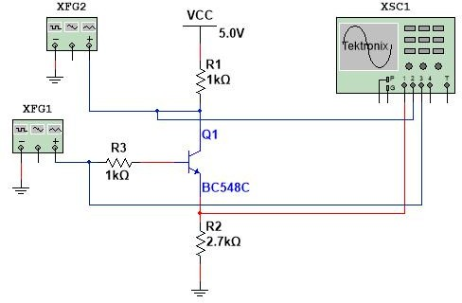

**Procedure:**

1. Set the squarewave on Function generator with frequency XFG1 to last two digits of . . your enrollment number (KHz).

2. Set the sinewaves on function generator with frequency XFG2 to ten times of last two . digits of your enrollment number. (i.e. Enrollment No. 150570111015 then 15*10 = . . 150KHz).

3. Observe the ASK output waveforms on CRO.

4. Change the frequency and wave shapes and observe the effect on CRO screen.

**Output Wave form :**

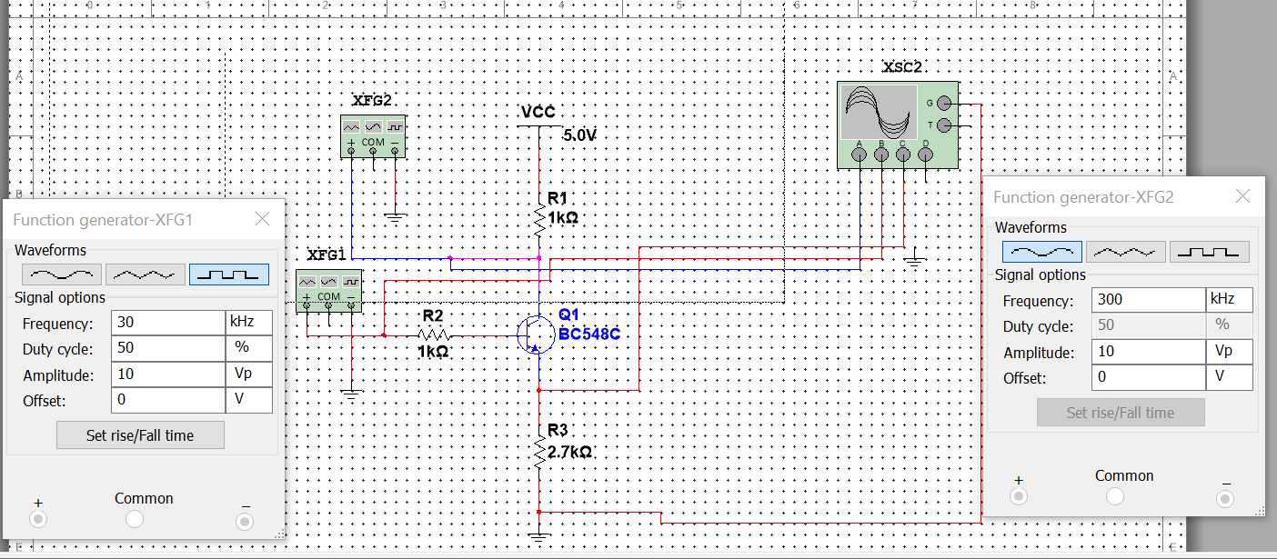

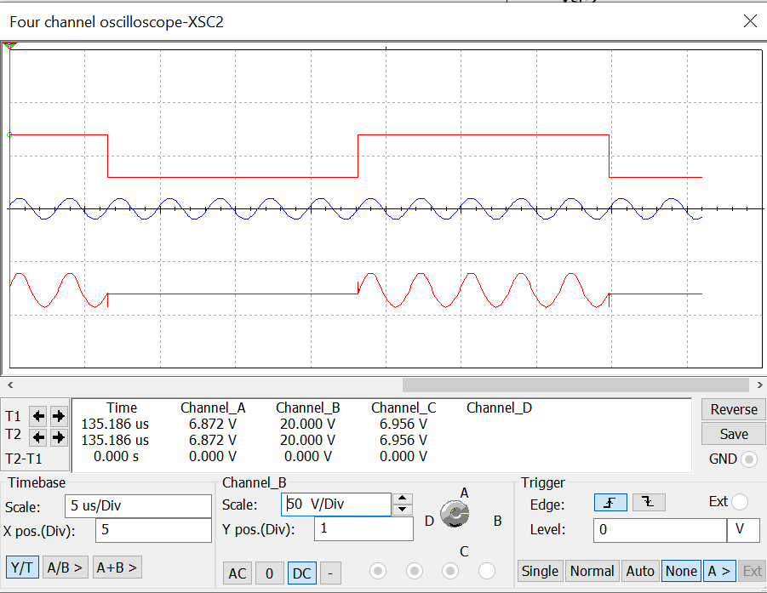

**Observation:**

**Conclusion:**

**Experiment No: 5 Post Lab Exercise**

**Q.1 Draw the output waveform for given bit sequence.**

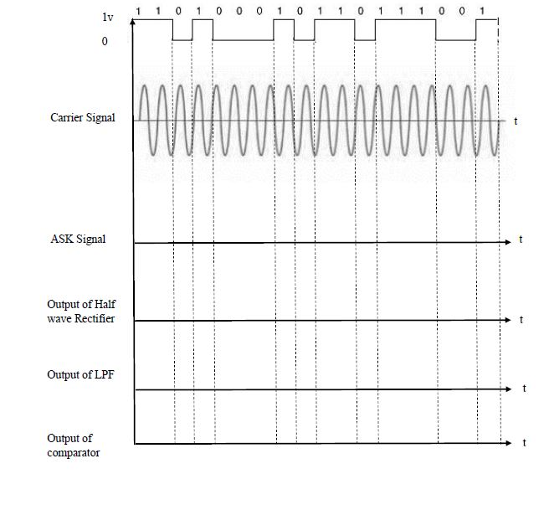

**Q.2 Draw the output waveform of comparator for given input signal.**

