**Experiment 6: To perform Digital carrier Modulation & Demodulation –**

**Frequency Shift Keying (FSK).**

**Apparatus:** Multisim

**Theory:**

In frequency shift keying, the carrier frequency is shifted in steps (i.e. from one frequency to another) corresponding to the digital modulation signal. If the higher frequency is used to represent data '1' & lower frequency for data '0', the resulting Frequency shift keying waveform appears as shown in figure 1. Thus Data = 1 high frequency, Data = 0 low.

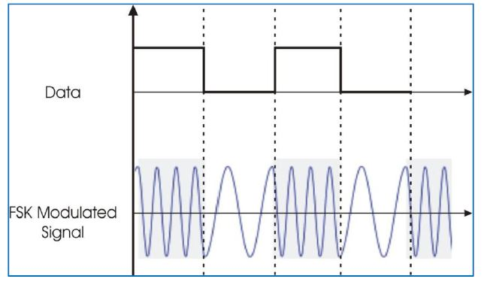

**Figure 1. Frequency Shift Keying modulation waveform**

On a closer look at the FSK waveform, it is apparent that it can be represented as the sum of

two ASK waveforms. This is illustrated in figure 3.

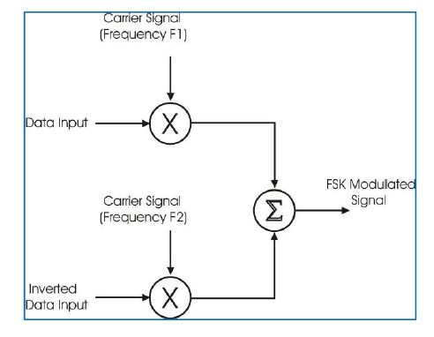

**Figure 2. Frequency Shift Keying Modulator**

The functional blocks required in order to generate the FSK signal is as shown in figure 2. There are two ASK modulator, each has different carrier frequencies but the digital data is inverted in one of the modulator. These two different ASK modulated signal are applied to the summing amplifier to get FSK modulated signal.

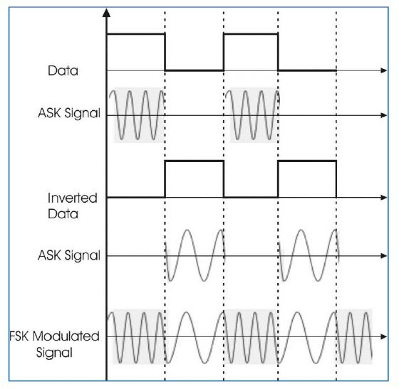

**Figure 3. Generation of FSK Waveform from the sum of two ASK Waveforms**

The demodulation of FSK waveform can be carried out by a phase locked loop. As known, the phase locked loop tries to 'lock' to the input frequency. It achieves this by generating corresponding output voltage to be fed to the voltage controlled oscillator, if any frequency deviation at its input is encountered. Thus the PLL detector follows the frequency changes & generates proportional output voltage. The output voltage from PLL contains the carrier components. Therefore the signal is passed through the low pass filter to remove them The resulting wave is rounded to be used for digital data processing.

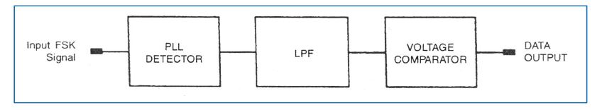

**Figure 4. Frequency Shift Keying Demodulator**

Also, the amplitude level may be very low due to channel attenuation. The signal is 'Shaped Up' by feeding it to the voltage comparator. The functional block diagram of FSK demodulator is shown in figure 4.

**Advantages and limitations of Frequency Shift Keying Modulation**

Since the amplitude change in FSK waveform does not matter, this modulation technique is very reliable even in noisy & fading channels. But there is always a price to be paid to gain that advantage. The price in this case is widening of the required bandwidth. The bandwidth increase depends upon the two carrier frequencies used & the digital data rate. Also, for a given data, the higher the frequencies & the more they differ from each other, the wider the required bandwidth. The bandwidth required is at least doubled than that in the ASK modulation. This means that lesser number of communication channels for given band of frequencies.

**Multisim Simulation Circuit:**

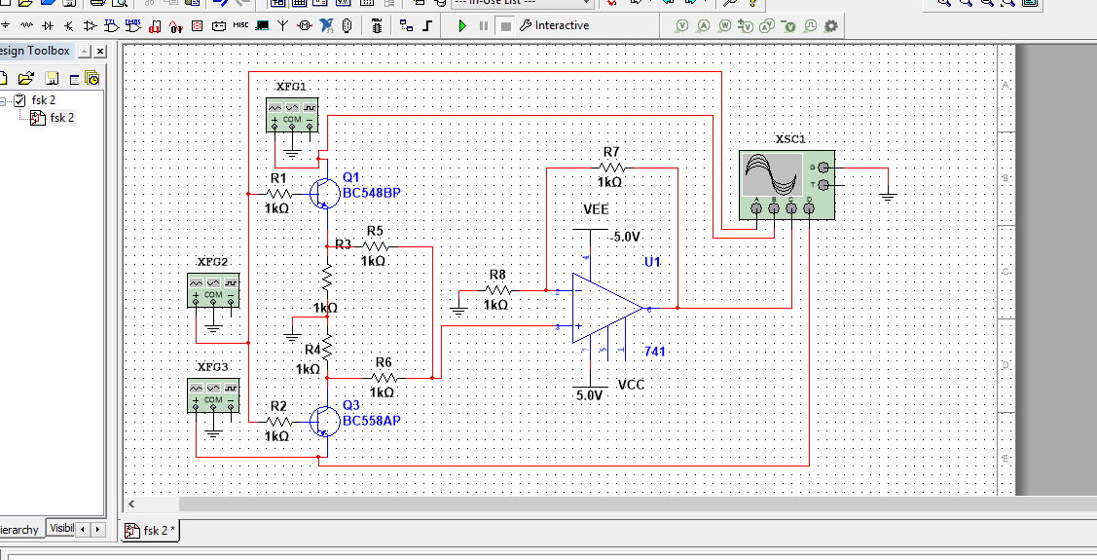

**Procedure:**

**Step-1**

1. Set the function generator XFG1 frequency to 4 KHz sine wave and amplitude 3 Vp.

2. Set the function generator XFG2 frequency to 500Hz square wave and amplitude 5 Vp.

3. Set the function generator XFG3 frequency to 1KHz sine wave and amplitude 3 Vp.

3. Observe the output and take screen shot with proper specification.

**Step-2**

1. Change the frequency of XFG1 as last two digits of your enrollment no.

3. Observe the effect on modulated wave on your CRO screen.

**Output Wave form :**

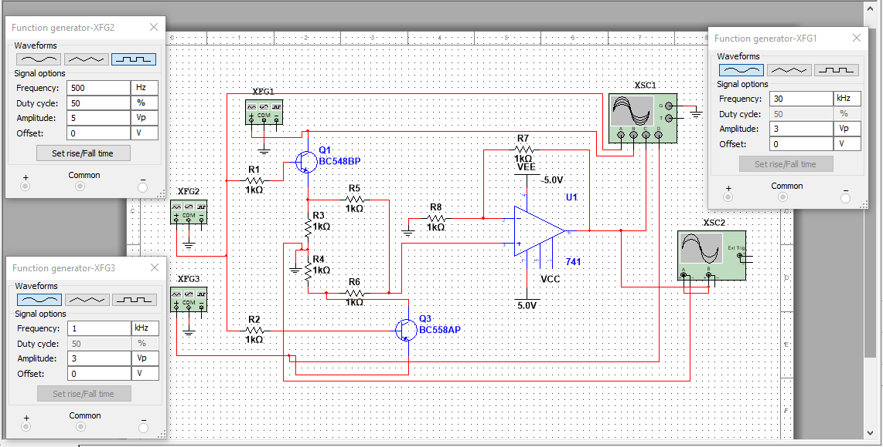

**Observation:**

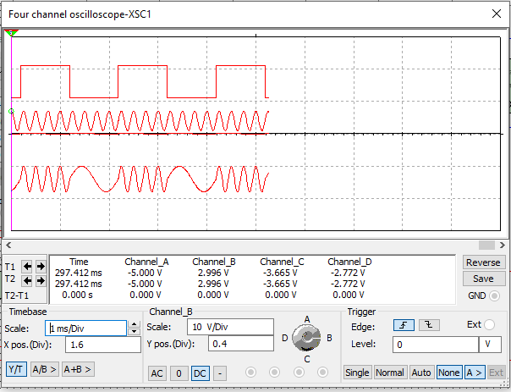

**Conclusion:**

**Experiment No 6: Post Lab Exercise**

**Q.1 Draw the output waveform of Inverting amplifier**

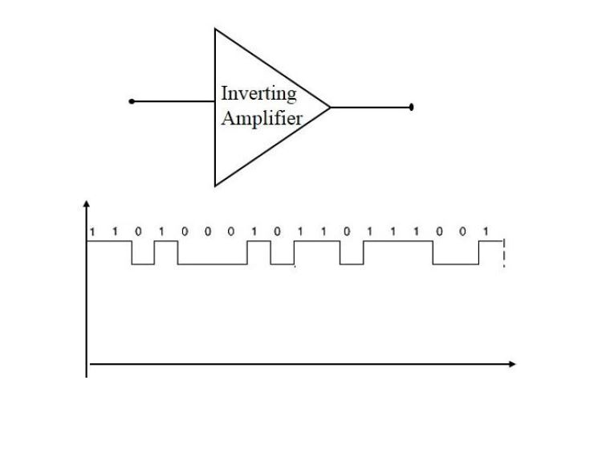

**Q.2 Draw the output waveform.**

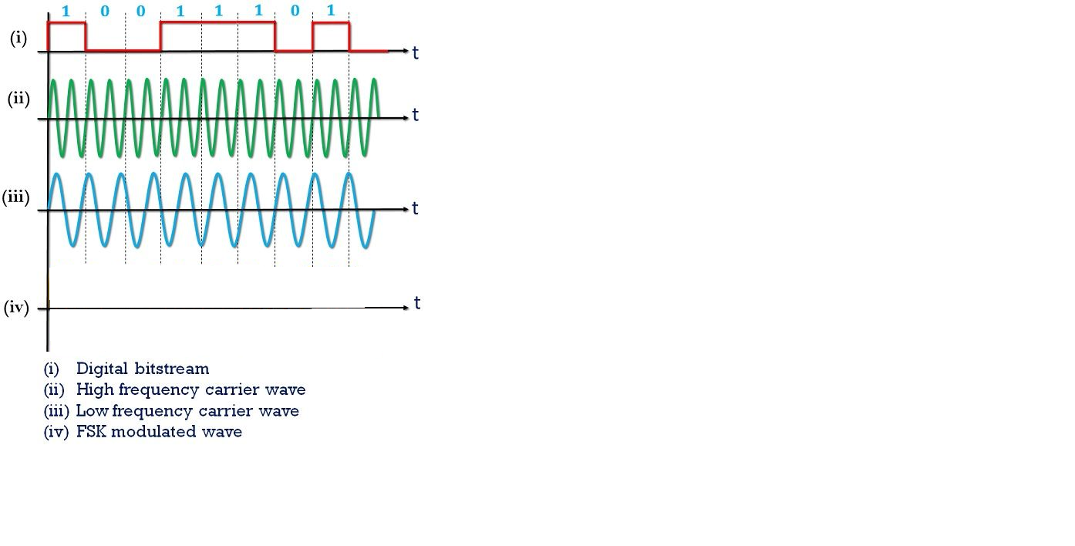

**Q.3 Draw the output waveform as per given figure.**

