**Experiment-7: To perform Digital carrier Modulation & Demodulation –**

**Phase Shift Keying (PSK).**

**Apparatus:** Multisim

**Theory:**

Phase shift keying involves the phase change of the carrier wave between 0 and 180 in accordance with the data levels to be transmitted. Phase shift keying is also known as phase reversal keying (PRK). The PSK waveform for a given data is as shown in figure 1.

For Binary PSK

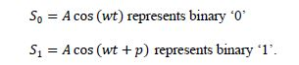



**Figure 1. Phase Shift Keying Waveform**

Functionally, the PSK modulator is very similar to the ASK modulator. Both uses balanced modulator to multiply the carrier with the modulating signal. But in contrast to ASK technique, the digital signal applied to the modulation input for PSK generation is bipolar i.e. have equal positive and negative voltage levels. When the modulating input is positive the output of modulator is a sine wave in phase with the carrier input. Whereas for the negative voltage levels, the output of modulator is a sine wave which is shifted out of phase by 180 from the carrier input. This happens because the carrier input is now multiplied by the negative constant level.. The functional block representation of the PSK modulator is shown in the figure 2.

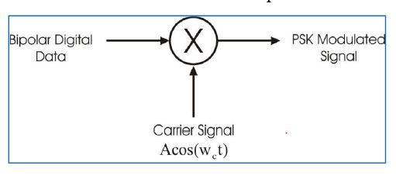

**Figure 2. Phase Shift Keying Modulator**

For PSK signal demodulation the square loop detector circuit is used. The PSK

demodulator is as shown in figure 3.

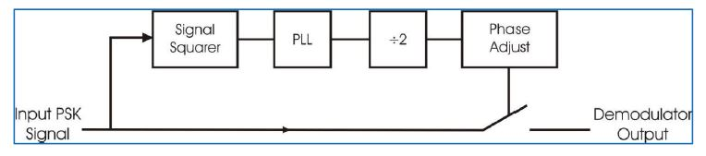

**Figure 3. Phase Shift Keying Demodulator**

The incoming PSK signal with 0 & 180 phase changes is first fed to the signal squarer, which multiplies the input signal by itself. The output of this block is a signal of having twice the frequency to that of the input carrier frequency. As the frequency of the output doubled, the 0 & 180 phase changes are reflect as 0 & 360 phase changes. Since phase change of 360 is same as 0 phase change, it can be said that the signal squarer simply removes the phase transitions from the original PSK waveform.

The PLL block locks to the frequency of the signal square output & produces a clean square wave output of same frequency. To derive the square wave of same frequency as the incoming PSK signal, the PLL output is divided by two.

The following phase adjust circuit allows the phase of the digital signal to be adjusted with respect to the input PSK signal. Also its output controls the closing of an analog switch. When the output is high the switch closes & the original PSK signal is switched through the detector. When the output of phases adjust block is low, the switch opens & the output of detector output falls to 0 Volts. The demodulator output contains positive half cycles when the PSK input has one phase & only negative half cycles when the PSK input has another phase. The phase adjust potentiometer is adjusted properly. The average level information of the demodulator output which contains the digital data information is extracted by the following low pass filter. The low pass filter output is too rounded to be used for digital processing. Therefore it is 'Squared Up' by a voltage comparator.

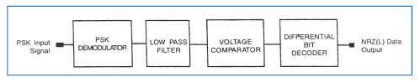

**Figure 4. Phase Shift Keying Receiver System**

Since the sine wave is symmetrical, the receiver has no way of detecting whether the incoming phase of the signal is 0 or 180 This phase ambiguity create two different possibilities for the receiver output i.e. the final data stream can be either the original data stream or its inverse. This phase ambiguity can be corrected by applying some data conditioning to the incoming stream to convert it to a form which recognizes the logic levels by changes that occur & not by the absolute value. One such code is NRZ (M) where a change or the absence of change conveys the information. A change in level represents data '1' & no change represents data '0'. This NRZ (M) waveform is used to change the phase at the modulator. The comparator output at receiver can again be of two forms, one being the logical inverse of the other. But now it is not the absolute value in which we are interested. Now the receiver simply locks for changes in levels, a level change representing a '1' and no level changes representing a '0' thus the phase ambiguity problem does not makes difference any more. This is known as differential phase shift keying. This process is known as differential encoding.

**Multisim Simulation Circuit:**

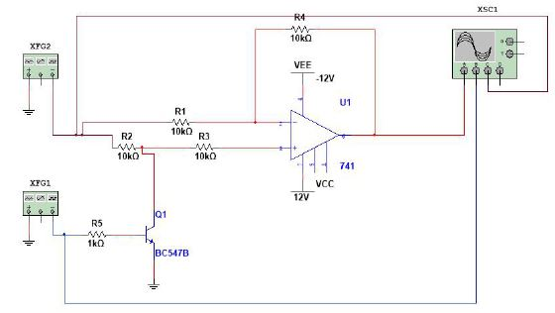

**Procedure:**

**Step-1**

1. Set the function generator XFG1 frequency to 10Hz square wave and amplitude 5 Vp.

2. Set the function generator XFG2 frequency to 50Hz sine wave and amplitude 5 Vp.

3. Observe the output of opamp, input signals of XFG1 and XFG2 on CRO screen.

**Step-2**

1. Change the frequency of XFG1 as last two digits of your enrollment no.

2. Change the frequency of XFG2 as last two digits * 10 of your enrollment no.

3. Observe the effect on PSK modulated wave on your CRO screen.

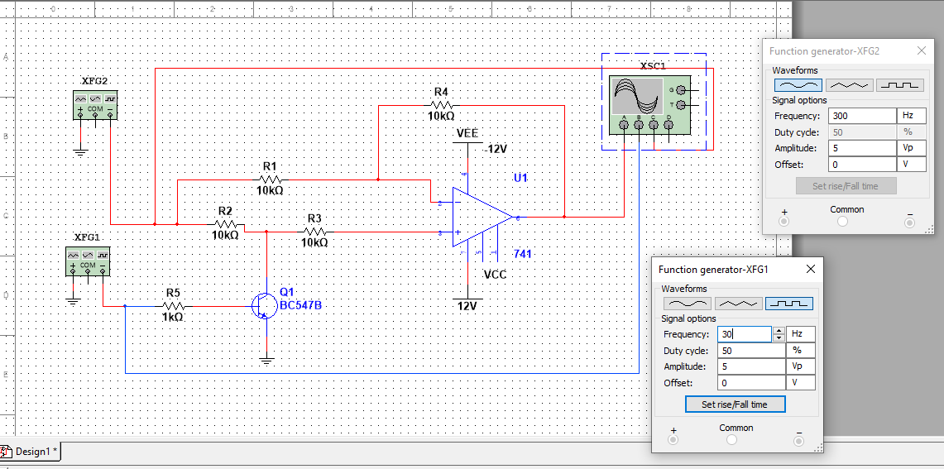

**Output Wave form :**

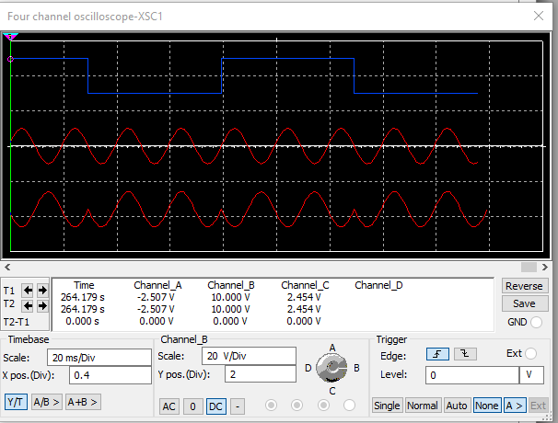

**Observation:**

**Conclusion:**

**Experiment No: 7 Post Lab Exercise**

**Draw the output waveform for given bit sequence.**

