|  |  |
| --- | --- |
| **Practical: 1** | **To study for the installation of Anaconda, jupyter notebook and Configuration of Google Colab Environment.** |
|  |

**Program:**

|  |  |
| --- | --- |
| **Practical: 2** | **Write a program to demonstrate different number datatypes in python.** |
|  |

**Program**:

a = 54

b = 54.2

c = "DK Patel"

print(type(a))

print(type(b))

print(type(c))

**OUTPUT:**

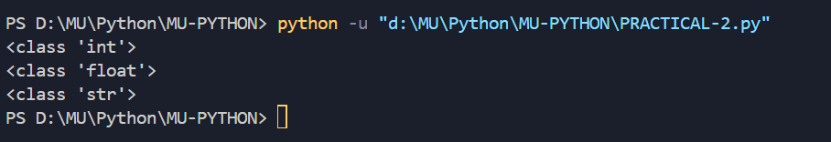

|  |  |
| --- | --- |
| **Practical: 3** | **Write a program that uses for loop to print all the odd, even numbers in the range input by user.** |
|  |

**Program**:

x = int(input("Enter the range for number:"))

print("Odd numbers between 0 and ", x)

*for* i *in* range(0, x):

*if* i % 2 != 0:

        print(i)

print("Even numbers between 0 and ", x)

*for* i *in* range(0, x):

*if* i % 2 == 0:

        print(i)

**OUTPUT:**

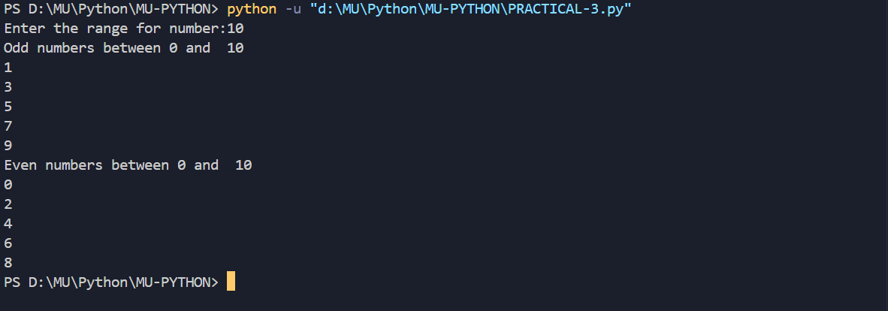

|  |  |
| --- | --- |
| **Practical: 4** | **Write a program to create, concatenate and print a string and accessing substring from a given string.** |
|  |

**Program**:

first_name = input("Enter First Name:")

second_name = input("Enter Second Name:")

concatenate_str = first_name+" "+second_name

print("Hello",concatenate_str)

**OUTPUT:**

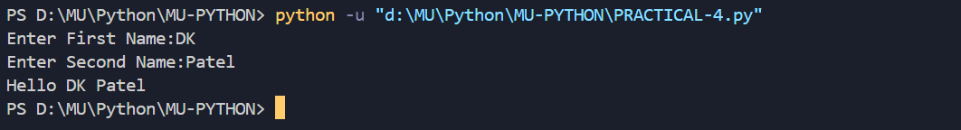

|  |  |
| --- | --- |
| **Practical: 5** | **Write a python program to create, append and remove lists in python.** |
|  |

**Program**:

My_List = ["DKpatel",10,"3EP1",9726411336,30]

print(My_List)

My_List.append("India")

print(My_List)

My_List.remove(9726411336)

print(My_List)

**OUTPUT:**

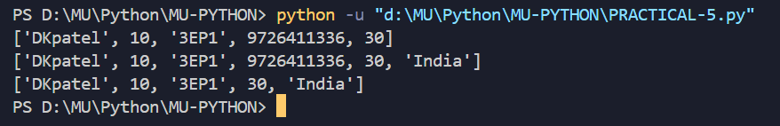

|  |  |
| --- | --- |
| **Practical: 6** | **Write a program to demonstrate working with tuples in python.** |
|  |

**Program**:

|  |  |
| --- | --- |
| **Practical: 7** | **Write a program to demonstrate working with dictionaries in python.** |
|  |

**Program**:

|  |  |
| --- | --- |
| **Practical: 8** | **Python program to map two lists into a dictionary.** |
|  |

**Program**:

|  |  |
| --- | --- |
| **Practical: 9** | **Python program to count the frequency of words appearing in a string using a dictionary.** |
|  |

**Program**:

|  |  |
| --- | --- |
| **Practical: 10** | **Write a program to demonstrate the File handling functionality in python.** |
|  |

**Program**:

|  |  |
| --- | --- |
| **Practical: 11** | **Python program to read the contents of a file in reverse order.** |
|  |

**Program**:

|  |  |
| --- | --- |
| **Practical: 12** | **Write a python program to demonstrate matrix operations using numpy library.** |
|  |

**Program**:

|  |  |
| --- | --- |
| **Practical: 13** | **Write a program to implement all the import and data handling functionalities of Pandas library in Python.** |
|  |

**Program**:

|  |  |
| --- | --- |
| **Practical: 14** | **Write a program to implement all the 2D visualization functionalities of MatPlotLib in Python.** |
|  |

**Program**: