**Mini Project Report on**



**LIBRARY MANAGEMENT SYSTEM**



**Submitted in partial fulfillment of the requirement for the award of the degree of**

**BACHELOR OF TECHNOLOGY**

**IN**

**COMPUTER SCIENCE & ENGINEERING**

**Submitted by:**

**Student Name: Dhruv Goyal**

**University Roll No.:2018789**

***Under the Mentorship of***

**Ms. Tanusha Mittal**

**(Associate Professor)**



**Department of Computer Science and Engineering**

**Graphic Era (Deemed to be University)**

**Dehradun, Uttarakhand**

**January 2023**



**CANDIDATE’S DECLARATION**

I hereby certify that the work which is being presented in the project report entitled **“Library Management System”** in partial fulfillment of the requirements for the award of the Degree of Bachelor of Technology in Computer Science and Engineeringof the Graphic Era (Deemed to be University), Dehradun shall be carried out by the under the mentorship of **Ms.Tanusha Mittal , Associate Professor**, Department of Computer Science and Engineering, Graphic Era (Deemed to be University), Dehradun.

Name: Dhruv Goyal University Roll no.:2018789 **signature**

**Table of Contents**

|  |  |  |
| --- | --- | --- |
| **Chapter No.** | **Description** | **Page No.** |
| Chapter 1 | Introduction |  |
| Chapter 2 | Literature Survey |  |
| Chapter 3 | Methodology |  |
| Chapter 4 | Result and Discussion |  |
| Chapter 5 | Conclusion and Future Work |  |
|  | References |  |

**Chapter 1**

**Introduction**

A library is a treasure trove of knowledge and a hub of intellectual growth, where individuals can access a wide range of resources to quench their thirst for information. However, the efficient organization and management of a library can be a daunting task, especially in today's digital age. That is where a Library Management System (LMS) comes into play.

However, in many parts of world, it is found that many small-scale industries use pen and paper to keep and maintain a record despite of existence of many advanced technology systems which can perform these works which are slightly costlier for these low-level industries to implement. This report discusses making a system for solving books lost issues for them. This system will be able to mark attendance of each employee and calculate the time period of books issued by them at the end of month. The benefits of implementing an LMS are numerous. It allows librarians to maintain accurate records of the library's holdings, track the circulation of materials, and generate insightful reports for informed decision-making. Patrons can conveniently search for resources, place holds, renew items, and receive notifications, all from the comfort of their own devices. Furthermore, LMS platforms enable libraries to adapt to changing user needs, incorporate emerging technologies, and foster a digital learning environment. It is time saving and perform error free calculation. By, harnessing the power of technology, libraries can enhance their efficiency, accessibility, and user experience, ensuring that knowledge remains accessible to all in this ever-evolving digital era.

* 1. **Introduction**

A Library Management System is a comprehensive software solution that streamlines various library tasks, from cataloging and circulation to patron management and resource organization. By utilizing MySQL as the backend database and PHP as the programming language for web development, libraries can efficiently manage their collections, enhance user experience, and embrace the digital transformation of the library ecosystem.

MySQL, a widely-used open-source relational database management system, provides a scalable and secure foundation for storing and retrieving vast amounts of library data. It offers features such as data integrity, transaction support, and powerful querying capabilities, ensuring efficient management and organization of library resources. With MySQL, libraries can create a centralized repository for catalog records, user information, circulation history, and other essential data. PHP, a popular server-side scripting language, is seamlessly integrated with MySQL to develop dynamic web applications for the Library Management System. PHP enables the creation of user-friendly interfaces, interactive search functionalities, and personalized features to enhance the user experience. Its versatility allows for the integration of various technologies and APIs, facilitating the incorporation of e-books, online databases, and other digital resources into the library's collection.

The combination of MySQL and PHP empowers librarians and staff with a range of functionalities, including advanced search capabilities, real-time circulation management, automated notifications, and detailed reporting. Teachers and Students can conveniently access the library's catalog, place holds, renew items, and even receive personalized recommendations through the intuitive web interface. Additionally, the extensibility of PHP allows libraries to adapt the system to their specific needs, integrating additional modules, implementing security measures, and scaling the system as their requirements evolve.

**Chapter 2**

**Literature Survey**

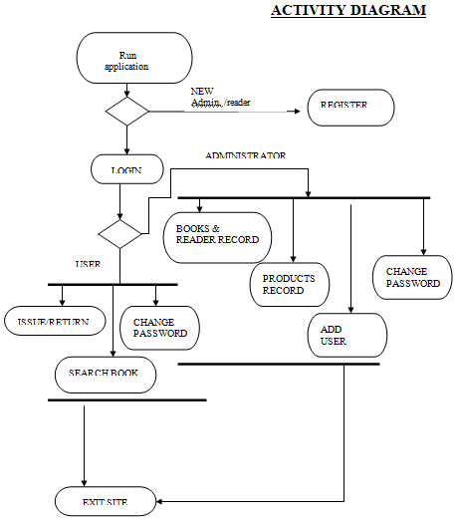

The software for the library management system aids in the reduction of operational costs. Manually managing a library is time-consuming and involves a significant quantity of paperwork. The requirement for people and stationery is reduced when using an automated system. As a result, operational costs are reduced. Both the user and the librarian benefit from the system. The user can search for books in the library with just a few clicks. The librarian can easily respond to questions about book availability. The process of adding, removing, or editing the database is straightforward. It is simple to add new members and to cancel existing ones. Within a few hours, the stock of books in the library can be checked and verified. In comparison to the manual system, the automated system saves a significant amount of time.

When a user or management begins a study of the software utilizing an existing system, the analysis begins. All book transactions are done manually in our current system. As a result, it takes longer to complete a transaction such as borrowing or returning a book, as well as to look for members and books. Another significant drawback is that producing the list of books borrowed and available in the library would take more time; today, all data are verified in one day. As a result, we can conclude that rapid report generation is not achievable. It's difficult to track down a book. The information about the issue and return of the books is not kept up to date. Because information is not available in the database, no central database can be constructed. As a result of the feasibility research, we chose to computerize the manual library management system.

Discuss the latest research work done by various authors related to the proposed work.

**Chapter 3**

**Methodology**

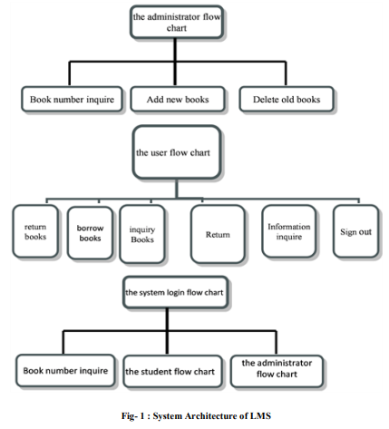

Database management systems have become vital for organizations to manage large databases and to perform transactions upon such large data. These database applications not only store data, but also manage them, synchronize them, and help in information retrieval without errors. They reduce manual efforts and enhance the quality of information retrieval services. Due to this reason, they are widely used in almost all sectors. Libraries are popular places where there are numerous books to keep track of. Not only books but the librarian is also required to keep track of users, books that were taken, due dates, etc. Making manual entries and keeping track of due dates is not easy when the user’s size is more. Thus, this work implements a library management system database application that helps the librarian manage all tasks in an efficient and user-friendly manner.

The project vision/aim is to come up with a library management system database application that does the jobs of the librarian like maintaining book records, maintaining user records, due dates, fines, etc. efficiently and in a quick time without errors.

The project scope is:

* To have a user-friendly and easy-to-use database application for library management.
* To have an application that secures data records.
* To have an application that generates reports on books, due reports, fine reports, etc. easily.
* To have an application that can track the user activities and their records easily.
* To have an application that reduces the errors and efforts of the librarian.
* The application shall have a login and password for allowing only authorized users to access the application.

**HARDWARE AND SOFTWARE REQUIREMENTS**

I. OPERATING SYSTEM : WINDOWS 7 AND ABOVE

II. P II. PROCESSOR : PENTIUM(ANY) OR AMD

ATHALON(3800+- 4200+ DUAL CORE)

III. MOTHERBOARD : 1.845 OR 915,995 FOR PENTIUM 0R MSI

K9MM-V VIA K8M800+8237R PLUS CHIPSET FOR AMD ATHALON

IV. RAM : 512MB+

V. Hard disk : SATA 40 GB OR ABOVE

VI. CD/DVD r/w multi drive combo: (If back up required)

VII. FLOPPY DRIVE 1.44 MB : (If Backup required)

VIII. MONITOR 14.1 or 15 -17 inch

IX. Key board and mouse

X. Printer : (if print is required – [Hard copy])

**SOFTWARE REQUIREMENTS:**

1. Oprating System : either of Windows, Linux, Macintosh, **Solaris**
2. Programing Language : mysql
3. Intermidiate : mysql connector module using xampp server
4. Libraries : panadas, matplotlib, numpy

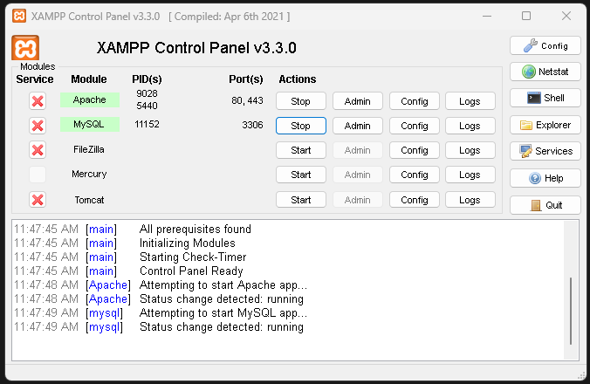

Starting the xampp server to access the localhost for the mysql and php connector.

**CODE:**

SET SQL_MODE = "NO_AUTO_VALUE_ON_ZERO";

SET AUTOCOMMIT = 0;

START TRANSACTION;

SET time_zone = "+00:00";

/*!40101 SET @OLD_CHARACTER_SET_CLIENT=@@CHARACTER_SET_CLIENT */;

/*!40101 SET @OLD_CHARACTER_SET_RESULTS=@@CHARACTER_SET_RESULTS */;

/*!40101 SET @OLD_COLLATION_CONNECTION=@@COLLATION_CONNECTION */;

/*!40101 SET NAMES utf8mb4 */;

-- Database: `lms`

--

-- --------------------------------------------------------

--

-- Table structure for table `admins`

--

CREATE TABLE `admins` (

`id` int(11) NOT NULL,

`name` varchar(100) NOT NULL,

`email` varchar(100) NOT NULL,

`password` varchar(250) NOT NULL,

`mobile` int(10) NOT NULL

) ENGINE=InnoDB DEFAULT CHARSET=utf8mb4;

-- Dumping data for table `admins`

INSERT INTO `admins` (`id`, `name`, `email`, `password`, `mobile`) VALUES

(1, 'admin', 'admin@gmail.com', 'admin@1234', 1148458757);

-- --------------------------------------------------------

--

-- Table structure for table `authors`

--

CREATE TABLE `authors` (

`author_id` int(11) NOT NULL,

`author_name` varchar(250) NOT NULL

) ENGINE=InnoDB DEFAULT CHARSET=utf8mb4;

--

-- Dumping data for table `authors`

--

INSERT INTO `authors` (`author_id`, `author_name`) VALUES

(102, 'M D Guptaa'),

(103, 'Chetan Bhagat'),

(104, 'Munshi Prem Chand');

-- --------------------------------------------------------

--

-- Table structure for table `books`

--

CREATE TABLE `books` (

`book_id` int(11) NOT NULL,

`book_name` varchar(250) NOT NULL,

`author_id` int(11) NOT NULL,

`cat_id` int(11) NOT NULL,

`book_no` int(11) NOT NULL,

`book_price` int(11) NOT NULL

) ENGINE=InnoDB DEFAULT CHARSET=utf8mb4;

--

-- Dumping data for table `books`

--

INSERT INTO `books` (`book_id`, `book_name`, `author_id`, `cat_id`, `book_no`, `book_price`) VALUES

(1, 'Software engineering', 101, 1, 4518, 270),

(2, 'Data structure', 102, 2, 6541, 300);

-- --------------------------------------------------------

--

-- Table structure for table `category`

--

CREATE TABLE `category` (

`cat_id` int(11) NOT NULL,

`cat_name` varchar(100) NOT NULL

) ENGINE=InnoDB DEFAULT CHARSET=utf8mb4;

--

-- Dumping data for table `category`

--

INSERT INTO `category` (`cat_id`, `cat_name`) VALUES

(1, 'Computer Science Engineering '),

(2, 'Novel'),

(4, 'Motivational'),

(5, 'Story');

-- --------------------------------------------------------

--

-- Table structure for table `issued_books`

--

CREATE TABLE `issued_books` (

`s_no` int(11) NOT NULL,

`book_no` int(11) NOT NULL,

`book_name` varchar(200) NOT NULL,

`book_author` varchar(200) NOT NULL,

`student_id` int(11) NOT NULL,

`status` int(11) NOT NULL,

`issue_date` longtext NOT NULL

) ENGINE=InnoDB DEFAULT CHARSET=utf8mb4;

--

-- Dumping data for table `issued_books`

--

INSERT INTO `issued_books` (`s_no`, `book_no`, `book_name`, `book_author`, `student_id`, `status`, `issue_date`) VALUES

(1, 6541, 'Data structure', 'D S Gupta', 4, 1, '0000-00-00 00:00:00'),

(18, 7845, 'half Girlfriend', 'Chetan Bhagat', 2, 1, '2020-04-22');

-- --------------------------------------------------------

--

-- Table structure for table `users`

--

CREATE TABLE `users` (

`id` int(11) NOT NULL,

`name` varchar(50) NOT NULL,

`email` varchar(100) NOT NULL,

`password` varchar(100) NOT NULL,

`mobile` int(10) NOT NULL,

`address` varchar(250) NOT NULL

) ENGINE=InnoDB DEFAULT CHARSET=utf8mb4;

--

-- Dumping data for table `users`

--

INSERT INTO `users` (`id`, `name`, `email`, `password`, `mobile`, `address`) VALUES

(4, 'user', 'user@gmail.com', 'user@1234', 2147483644, 'XYZ Coloney, PQR Nagar , Jaipur'),

(7, 'hemant', 'hemant@gmail.com', 'hemant@123', 2147483644, 'XYZ Coloney, PQR Nagar , Jaipur');

--

-- Indexes for dumped tables

--

--

-- Indexes for table `admins`

--

ALTER TABLE `admins`

ADD PRIMARY KEY (`id`);

--

-- Indexes for table `authors`

--

ALTER TABLE `authors`

ADD PRIMARY KEY (`author_id`);

--

-- Indexes for table `books`

--

ALTER TABLE `books`

ADD PRIMARY KEY (`book_id`);

--

-- Indexes for table `category`

--

ALTER TABLE `category`

ADD PRIMARY KEY (`cat_id`);

--

-- Indexes for table `issued_books`

--

ALTER TABLE `issued_books`

ADD PRIMARY KEY (`s_no`);

--

-- Indexes for table `users`

--

ALTER TABLE `users`

ADD PRIMARY KEY (`id`);

--

-- AUTO_INCREMENT for dumped tables

--

--

-- AUTO_INCREMENT for table `admins`

--

ALTER TABLE `admins`

MODIFY `id` int(11) NOT NULL AUTO_INCREMENT, AUTO_INCREMENT=2;

--

-- AUTO_INCREMENT for table `authors`

--

ALTER TABLE `authors`

MODIFY `author_id` int(11) NOT NULL AUTO_INCREMENT, AUTO_INCREMENT=107;

--

-- AUTO_INCREMENT for table `books`

--

ALTER TABLE `books`

MODIFY `book_id` int(11) NOT NULL AUTO_INCREMENT, AUTO_INCREMENT=9;

--

-- AUTO_INCREMENT for table `category`

--

ALTER TABLE `category`

MODIFY `cat_id` int(11) NOT NULL AUTO_INCREMENT, AUTO_INCREMENT=10;

--

-- AUTO_INCREMENT for table `issued_books`

--

ALTER TABLE `issued_books`

MODIFY `s_no` int(11) NOT NULL AUTO_INCREMENT, AUTO_INCREMENT=19;

--

-- AUTO_INCREMENT for table `users`

--

ALTER TABLE `users`

MODIFY `id` int(11) NOT NULL AUTO_INCREMENT, AUTO_INCREMENT=8;

COMMIT;

/*!40101 SET CHARACTER_SET_CLIENT=@OLD_CHARACTER_SET_CLIENT */;

/*!40101 SET CHARACTER_SET_RESULTS=@OLD_CHARACTER_SET_RESULTS */;

/*!40101 SET COLLATION_CONNECTION=@OLD_COLLATION_CONNECTION */;

The code is divided into various segments . The above piece of code joins all the other segments so that the code runs well on the server php. Java-script is used to achieve a more stable database system.

**Chapter 4**

**Result and Discussion**

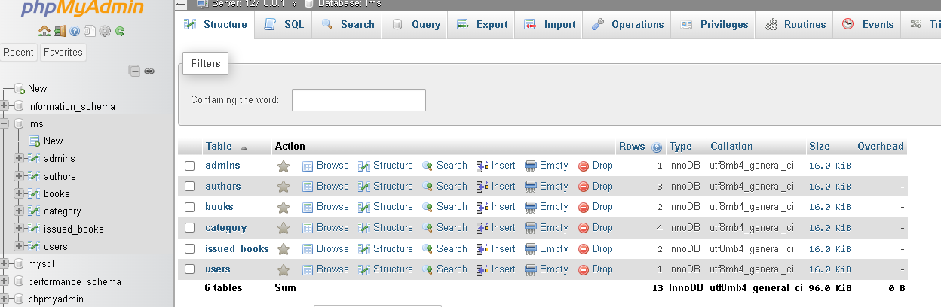

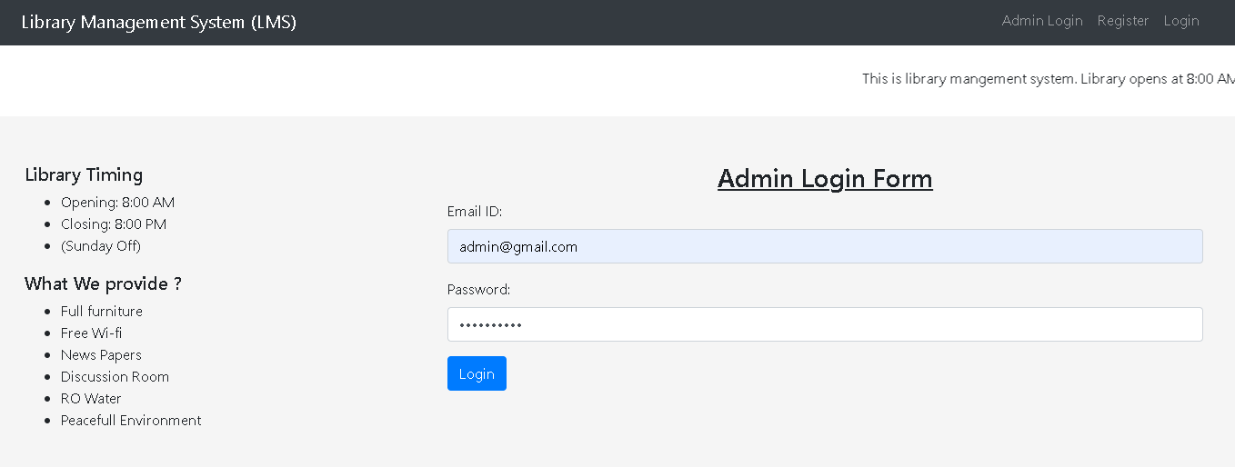

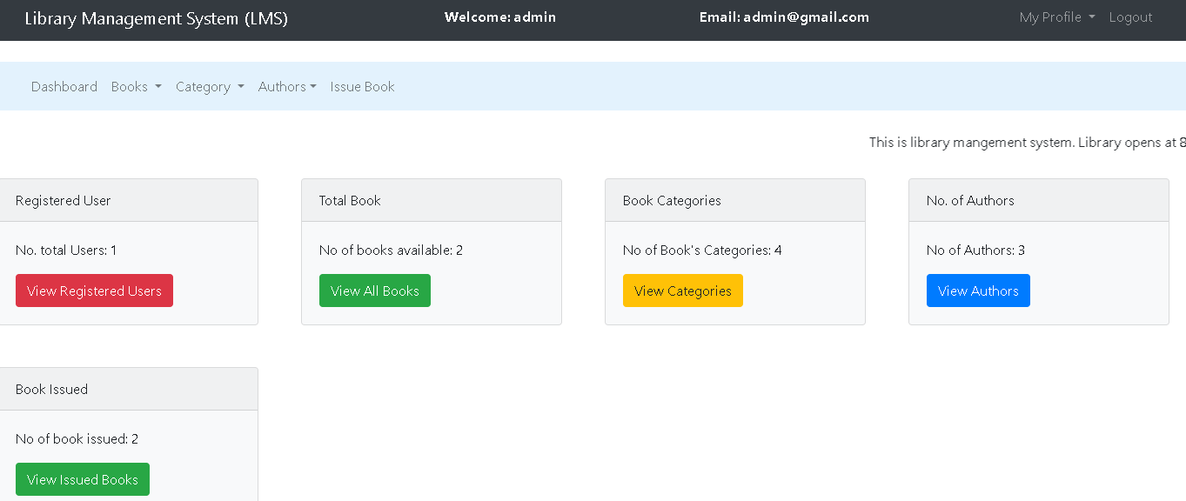

It is a basic type of library management system so that the admin can enter data manually without any errors. We have not made automatic library system as the chances of making mistakes or wrong data input will be increased and the server need to be updated regularly. This system is more reliable as the data was inputted by the admin with proper detail of the book and the user.

The Key challenges the project development may face are as follows:

* The existing data from excel can be imported to MY SQL database. But to ensure referential integrity of the data it is essential that the database follows norms of having the primary key, removing duplicates ensuring consistency, etc. Thus, it may require the excel data to pre-process, convert and then migrate it to MY SQL.
* The end-user may be new to GUI and API usage. Thus, there may be a need to train the end-user with the application.
* Issues may arise from front-end and back-end connectivity. This can be managed through proper coding.
* The system development may face hurdles if its development process is not managed and monitored properly. It is essential to have a Gantt chart with proper milestones to monitor the activities.

**Chapter 5**

**Conclusion and Future Work**

From the above project report on the topic “Library Management System”, I conclude that I am now able to keep and maintain user record and perform various operations on it like adding records, deleting records, graphical representation, searching books, issuing books etc. I have successfully implemented Library Management System.

In future, I would modify my code as per requirement and adding a mail system so that the user is informed in time when he/she have to return the book and also adding a fine system.

**References**

[1] Fundamentals of Database Management Systems Hardcover – Import, 16 March 2004

[2] PHP: The Complete Reference Paperback – 1 July 2017 by Steven Holzner

[3] Php and MYSQL for Dynamic Web Sites: Visual Quickpro Guide (Visual Quickpro Guide (Old Edition)) Paperback – 13 September 2011 by

Larry Ullman

[4] Understanding XAMPP, For Newbies! Kindle Edition by John Henderson

[5] HTML and CSS: Design and Build Websites Paperback – Illustrated, 18 November 2011 by Jon Duckett

[6] https://en.wikipedia.org/wiki/Library_management

[7] JavaScript and JQuery: Interactive Front-End Web Development Paperback – 18 July 2014by Jon Duckett

[8] https://www.indiastudychannel.com/attachments/19785-Library-Management-System-UML- sequence-Diagram

[9] https://phdessay.com/literature-review-on-library-management-system/

[10] PHP & MySQL: Server-side Web Development Hardcover – Import, 24 May 2022by Jon Duckett