1st. Creating a new folder named Assignment 1

## 

2nd. Adding files to that folder (text1, text2, text3)

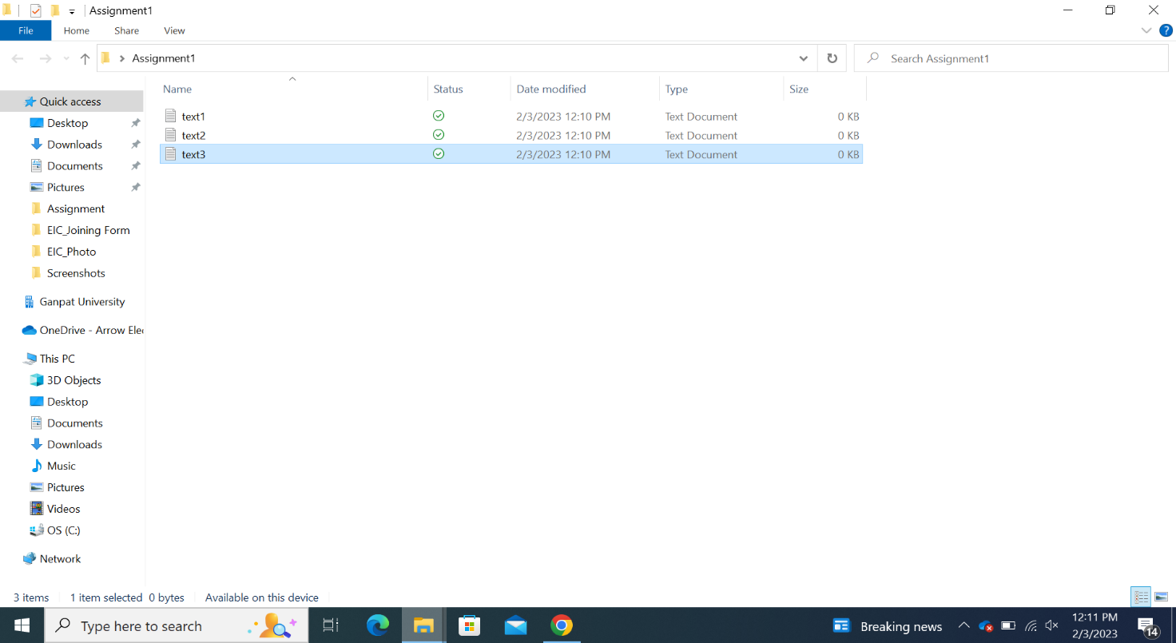

3rd : After creating files, we will add it into the git bash and then commit it

After that we can check status of our files in the git bash

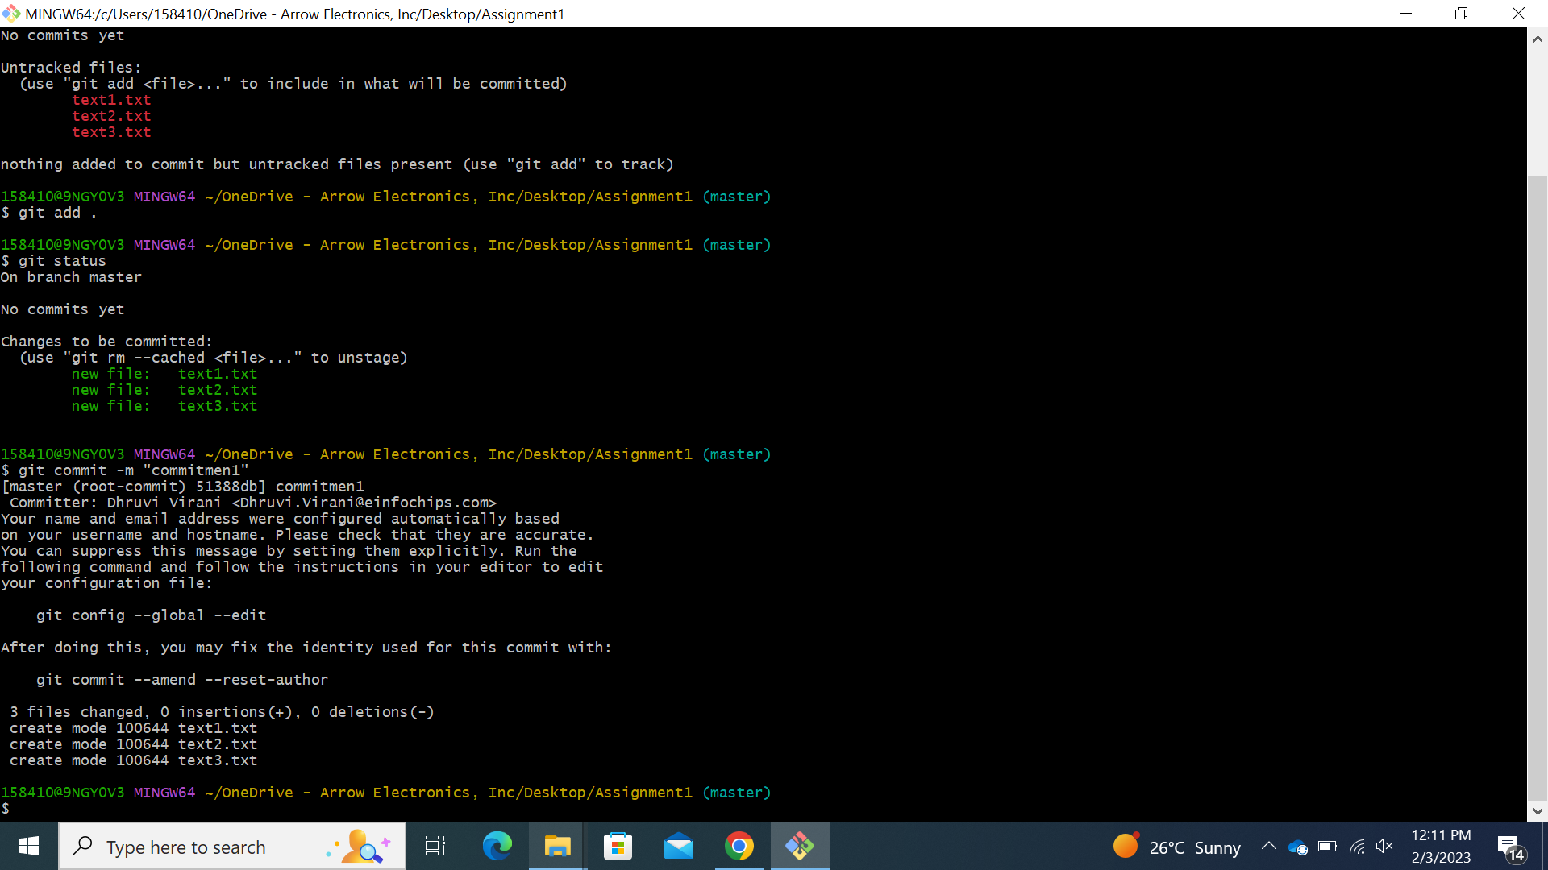

4th : We will make 4 branches under the master branch

* Feature_1
* Feature_2
* Feature_3
* Develop

We can also check that our branches are made or not by writing the command

$ git branch

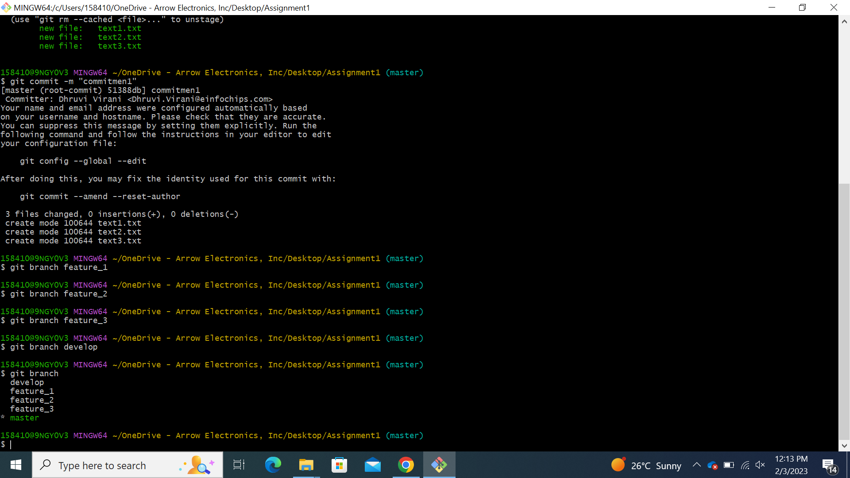

5th

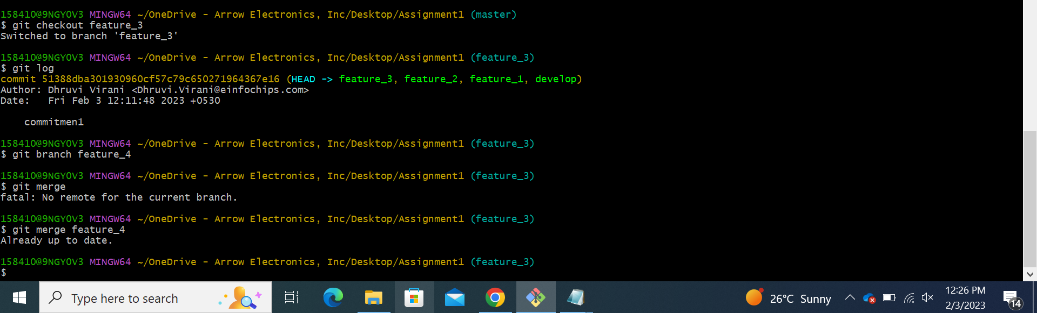

6th

7th

8th



