Aim: Initiate the semester-long StudentHub portal by identifying the problem
scope, user roles, key modules, navigation flow, and minimum 10 pages.
Create a sitemap, low-fidelity wireframe, project folder structure,
README file, and GitHub repository.

Tools/Technology to be Used: draw.io app

Theory Logic The core concept is to analyze StudentHub requirements and design
its basic project structure using sitemap, wireframe, user roles, navigation flow,
folder structure, README, and GitHub before actual implementation.
Output:
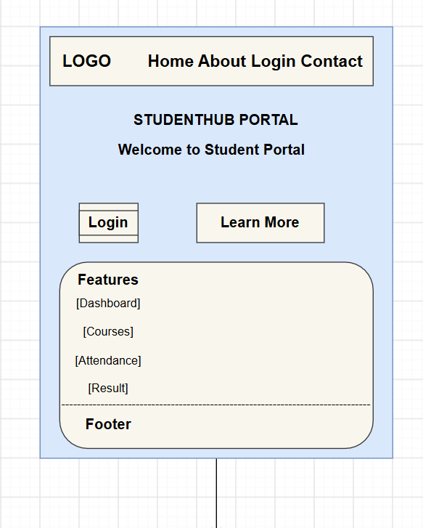
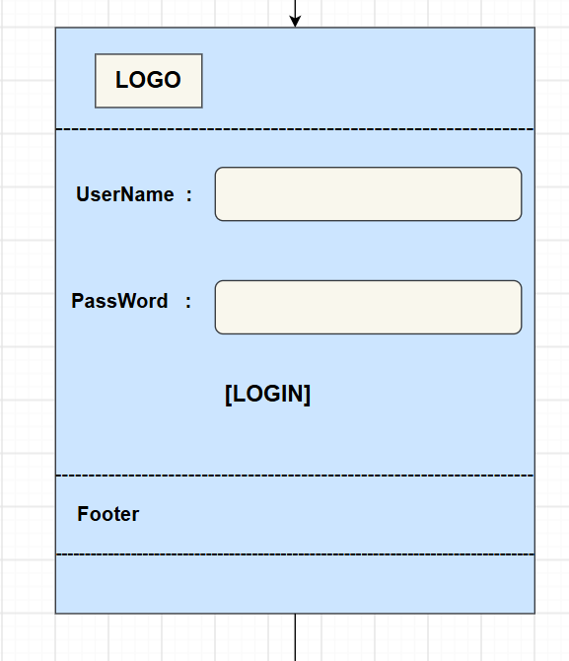
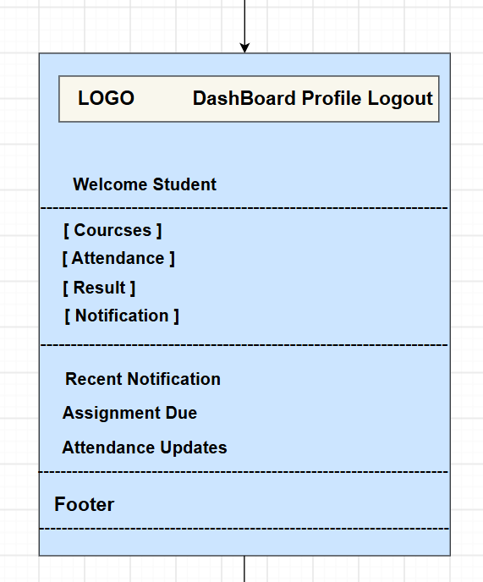
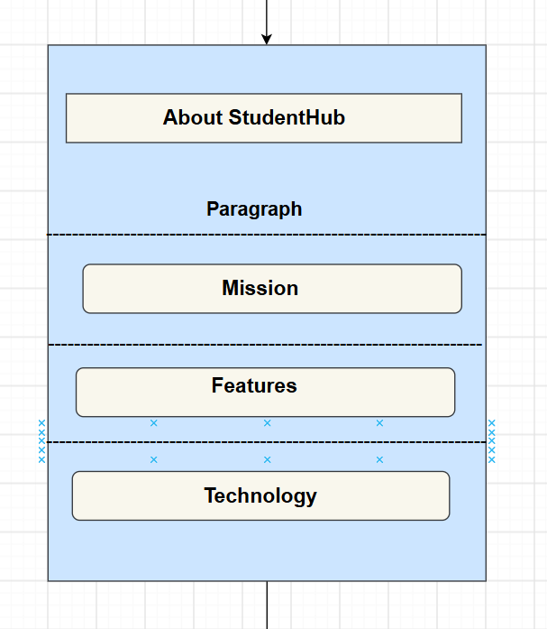
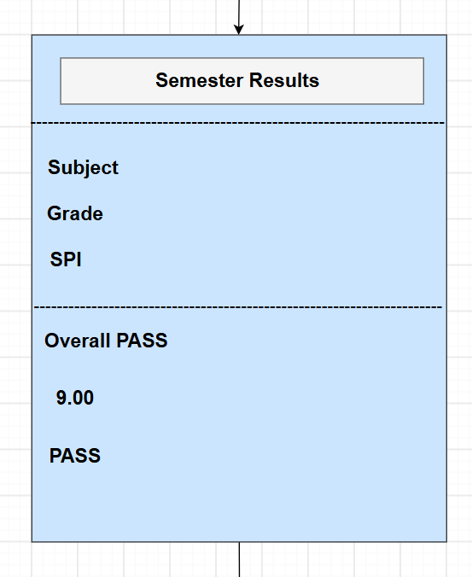
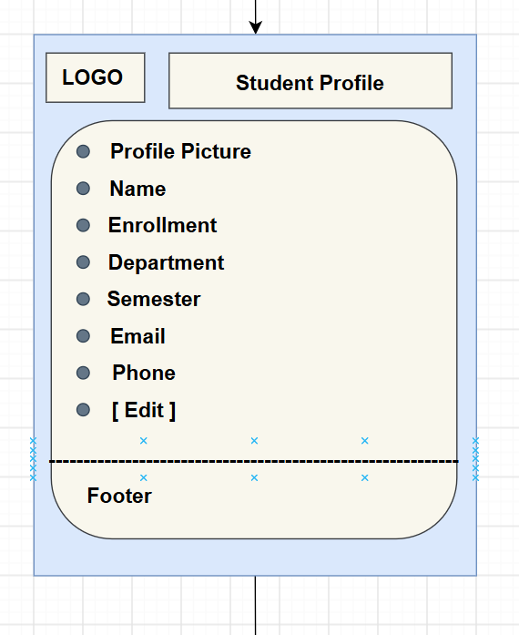
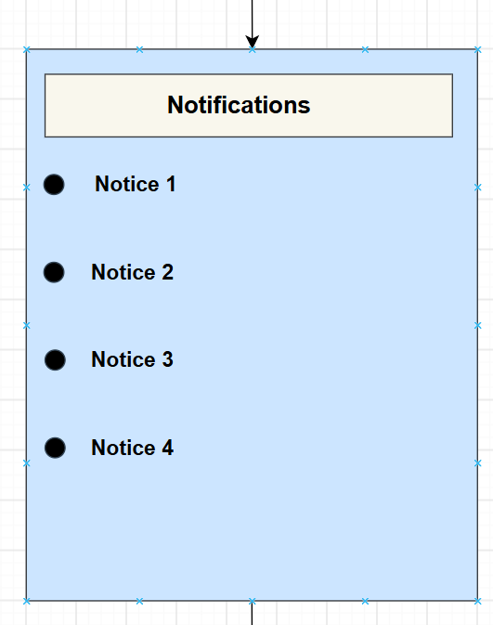
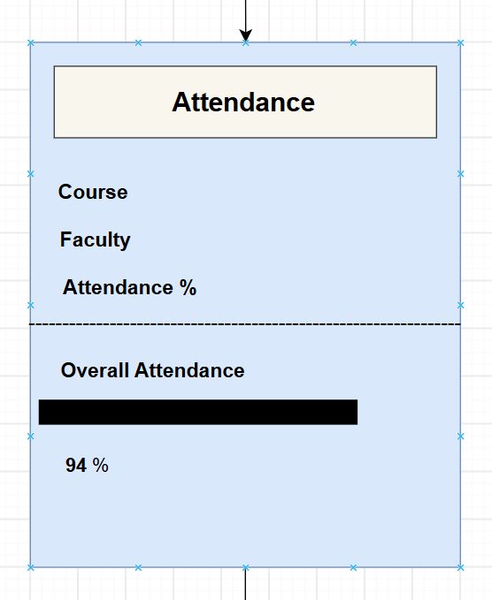
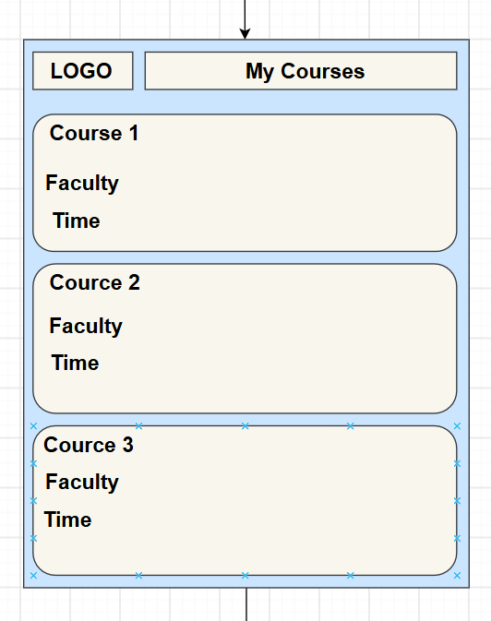
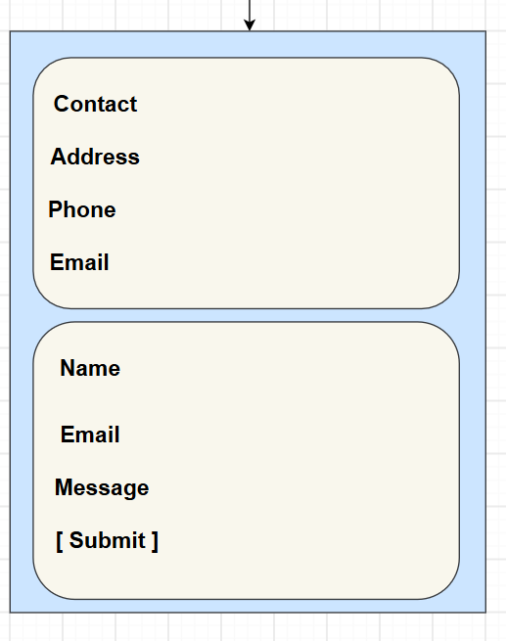

Question-Answer:
- What is URL and parts of URL?
URL is the address of a web resource.
Parts: Protocol (https), Domain (example.com), Port (optional), Path (/page), Query (?), Fragment (#).
- How does HTML file processed in web browser?
Browser sends request → server sends HTML → browser parses it → builds DOM → applies
CSS/JS → displays page.
- How will page navigation flow managed among all HTML pages?
Managed using hyperlinks <a href="">, navbar, menus, and proper page linking structure.
- How will GitHub commits be maintained after each practical?
After each practical: git add → git commit -m "message" → git push.
Use proper messages and folders to track work.

Conclusion:
https://github.com/Dhruvi-Rupala/ITUE203

