**Name :- Vavadiya Dhruvi Mahesbhai**

**Roll No :- ICT3 -65**

**Subject :- Open source web development**

**Github Link :-** <https://github.com/Dhruvi-Vavadiya/65_DhruviVavadiya_304_A3>

**1) Develop a Shopping cart in PHP with following requirements:**

**Admin Site:**

**1) Login**

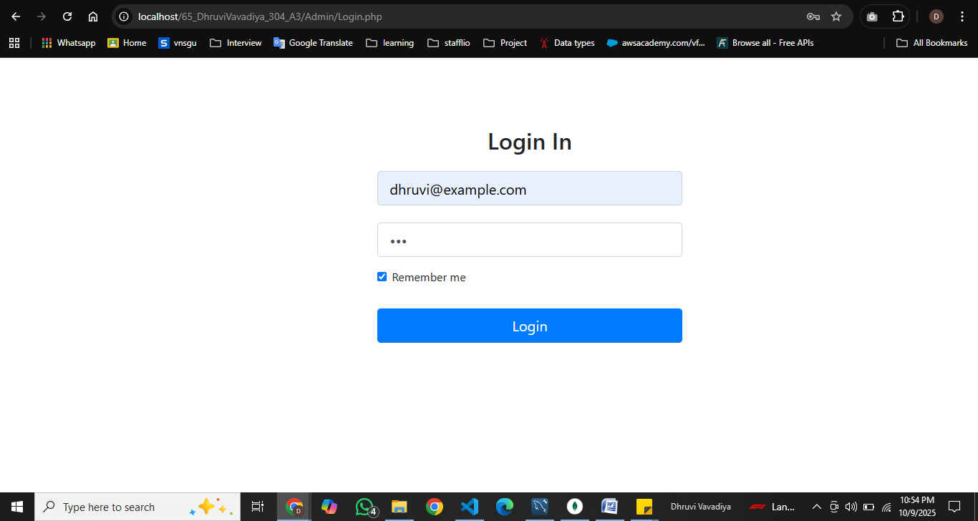

**2) Manage Category (CRUD)**

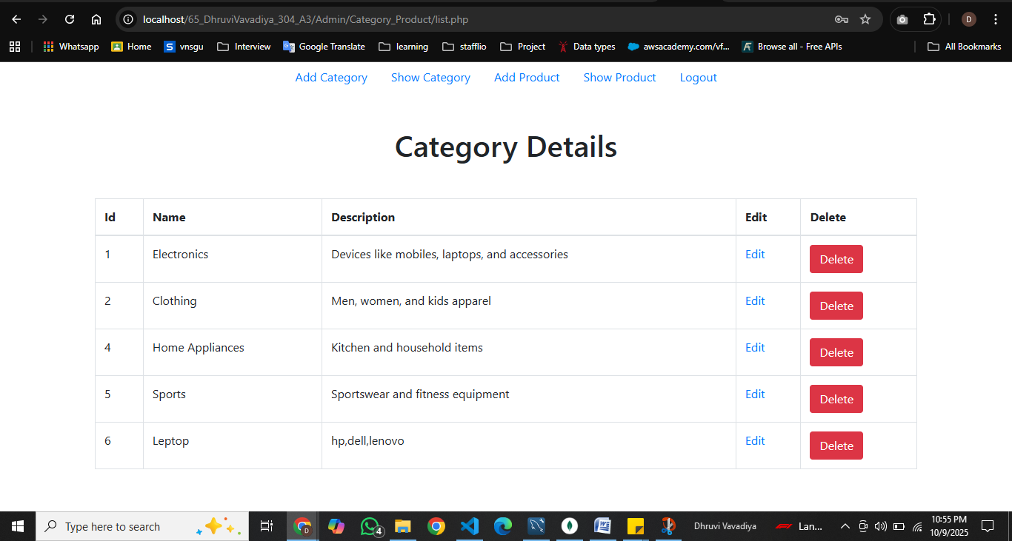

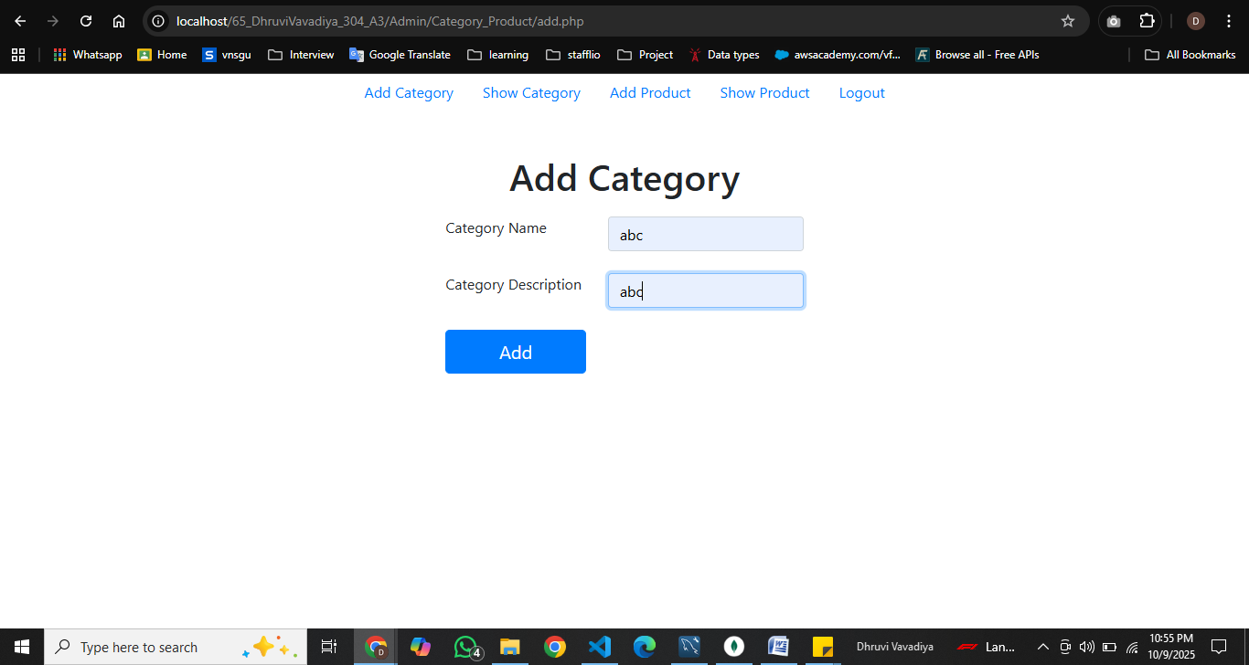

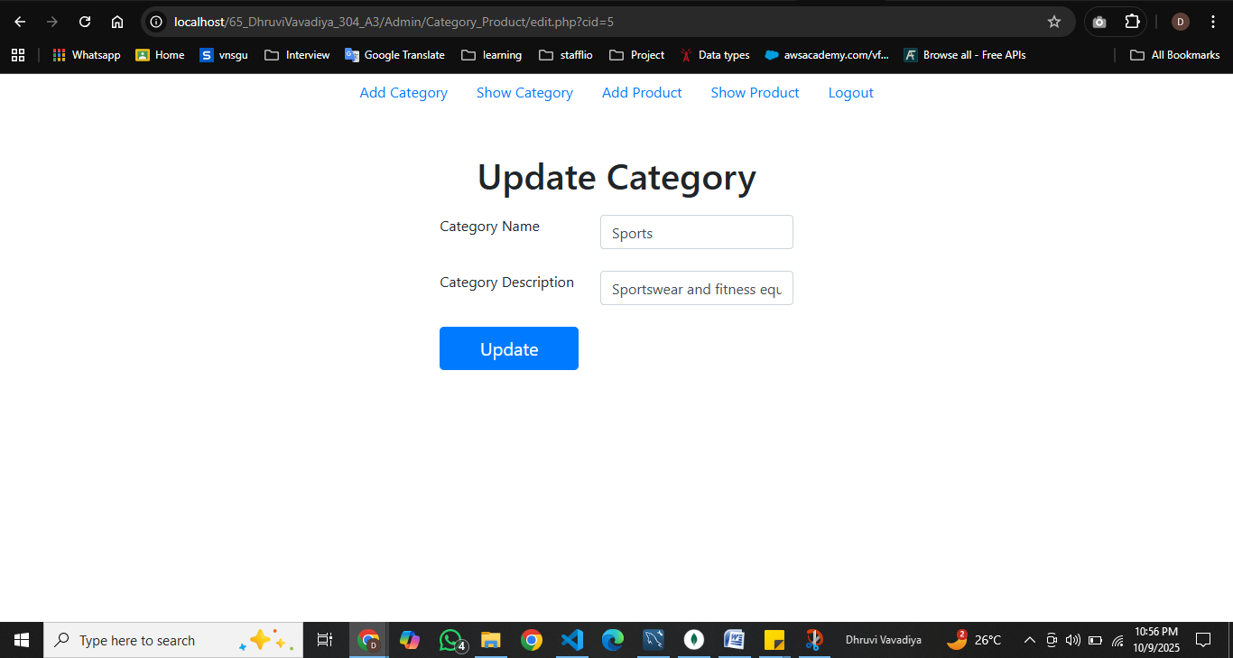

**3) Manage Products (Product data with pictures. Upload picture and resize them)**

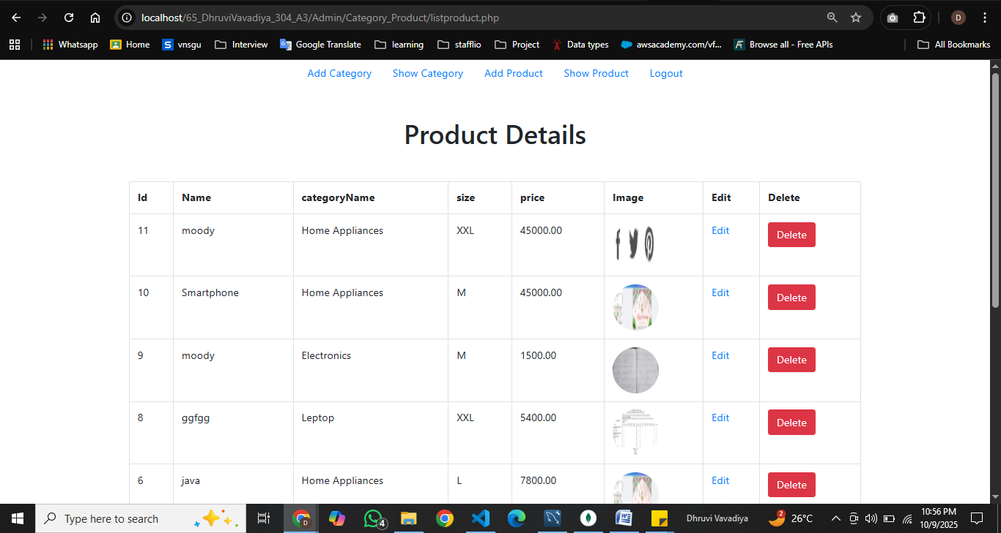

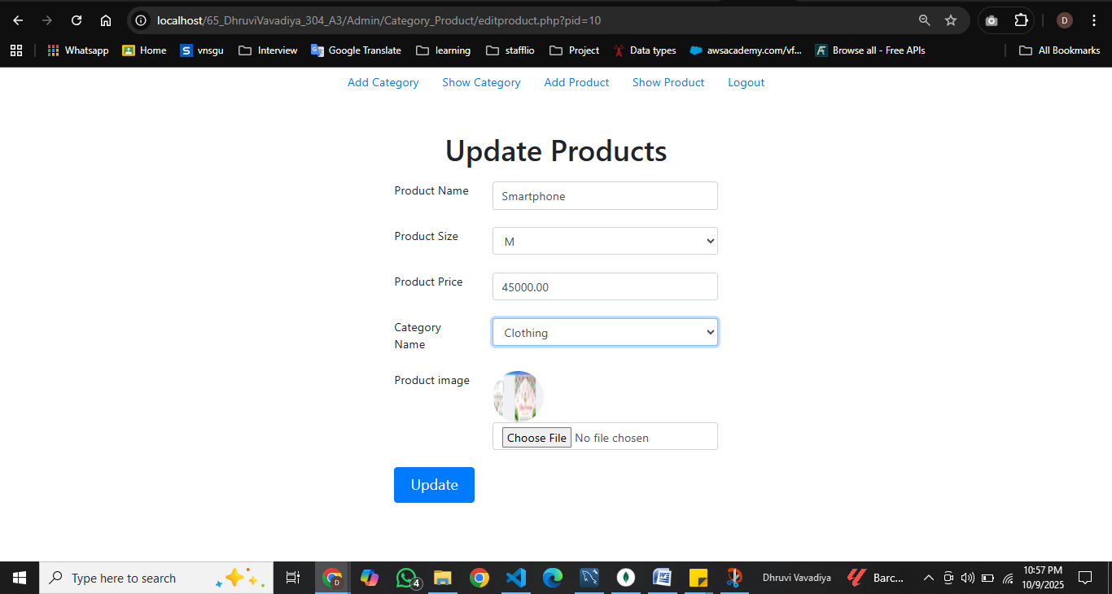

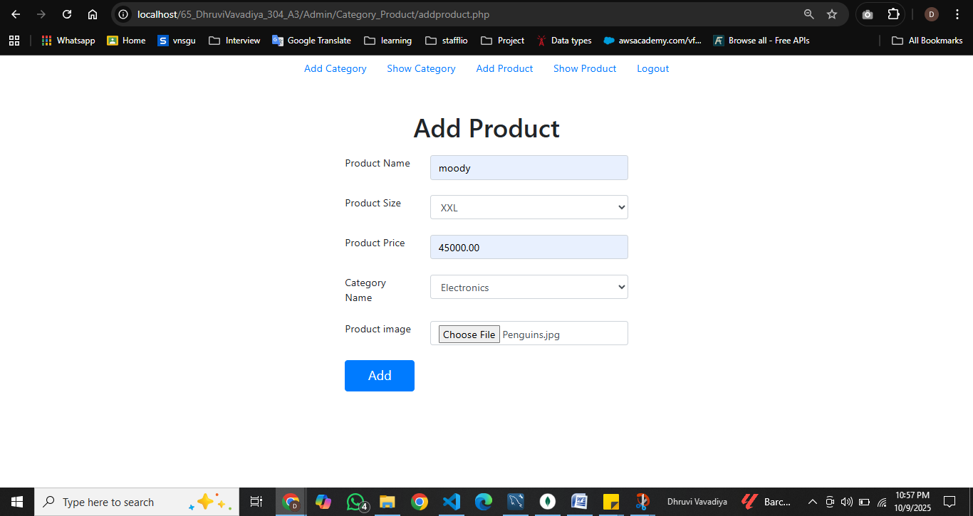

**4) Logout**

**User Site:**

**1) List Categories**

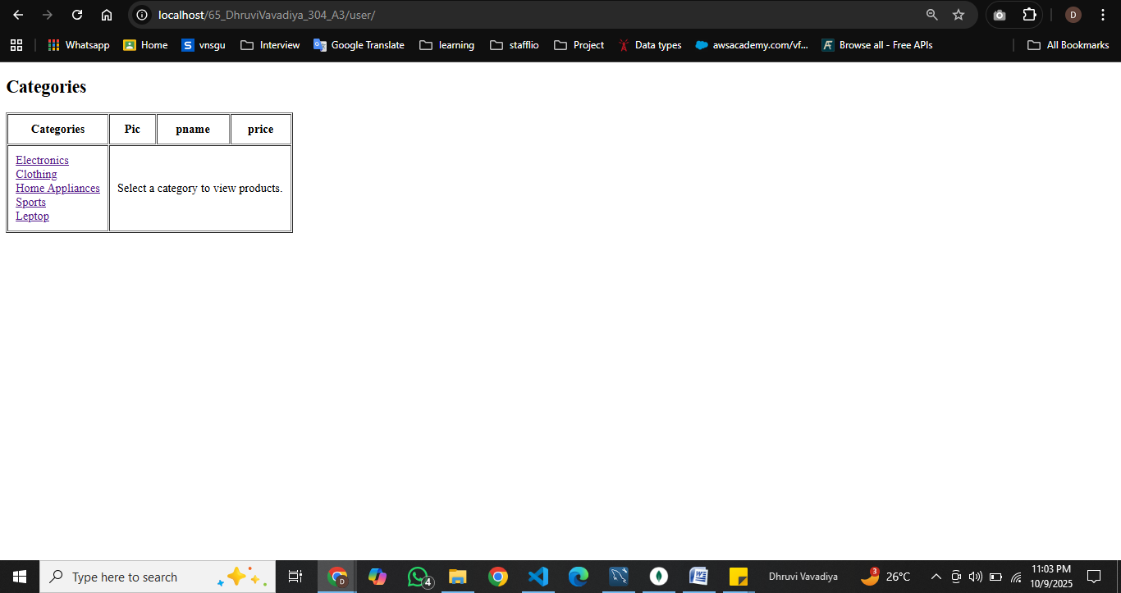

**2) Display products of category whose hyperlink is clicked(Apply pagination, load data with ajax).**

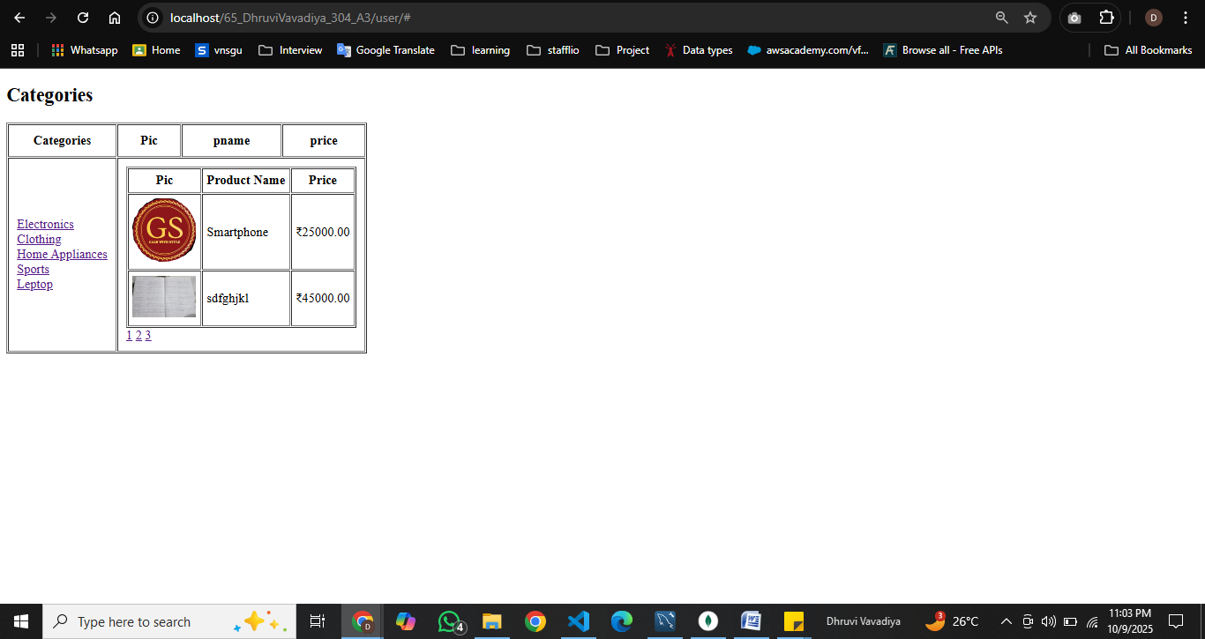

**3) Register user (Use CAPTCHA)**

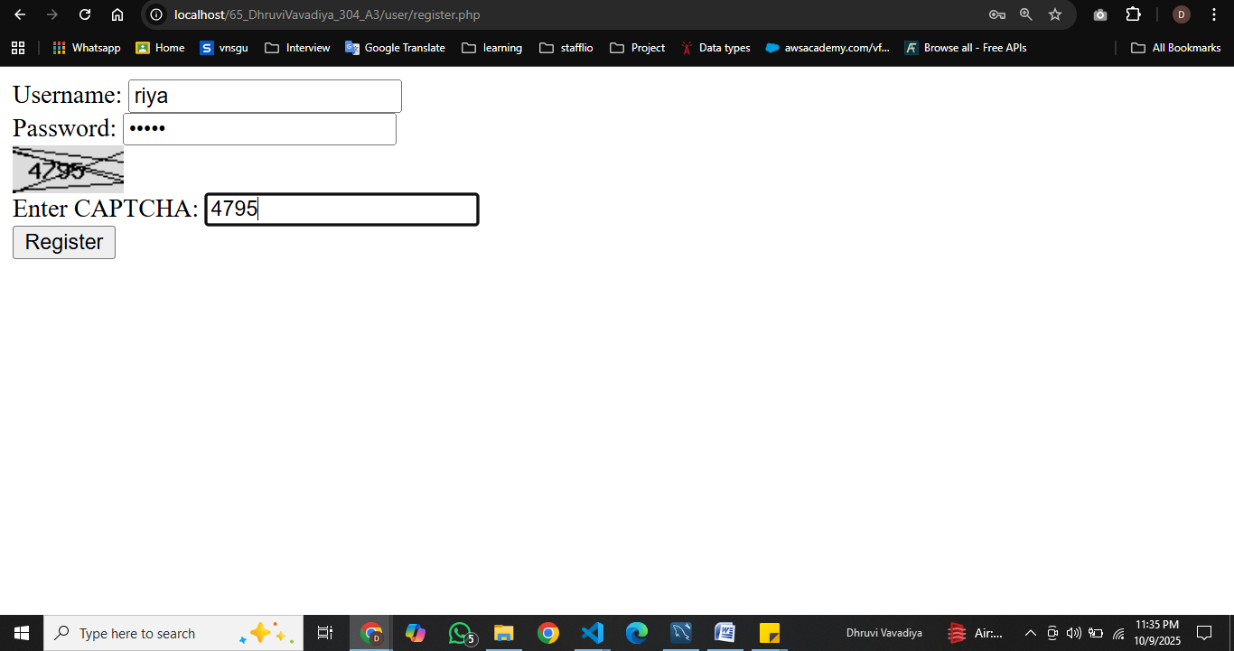

**4) Login**

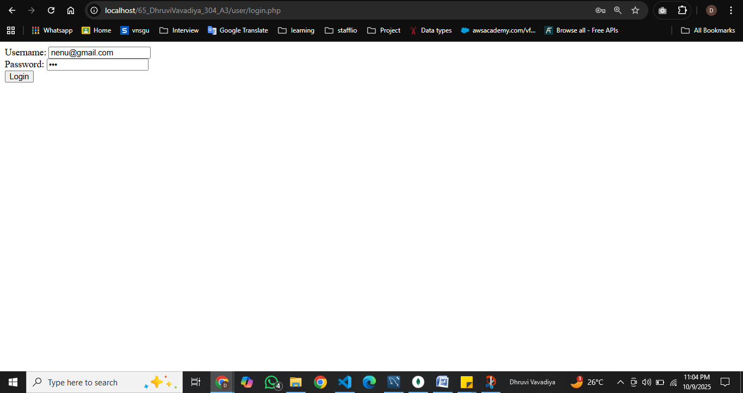

**------------------**

**2) Read data from students.xml file and store them in students table of MySQL.**

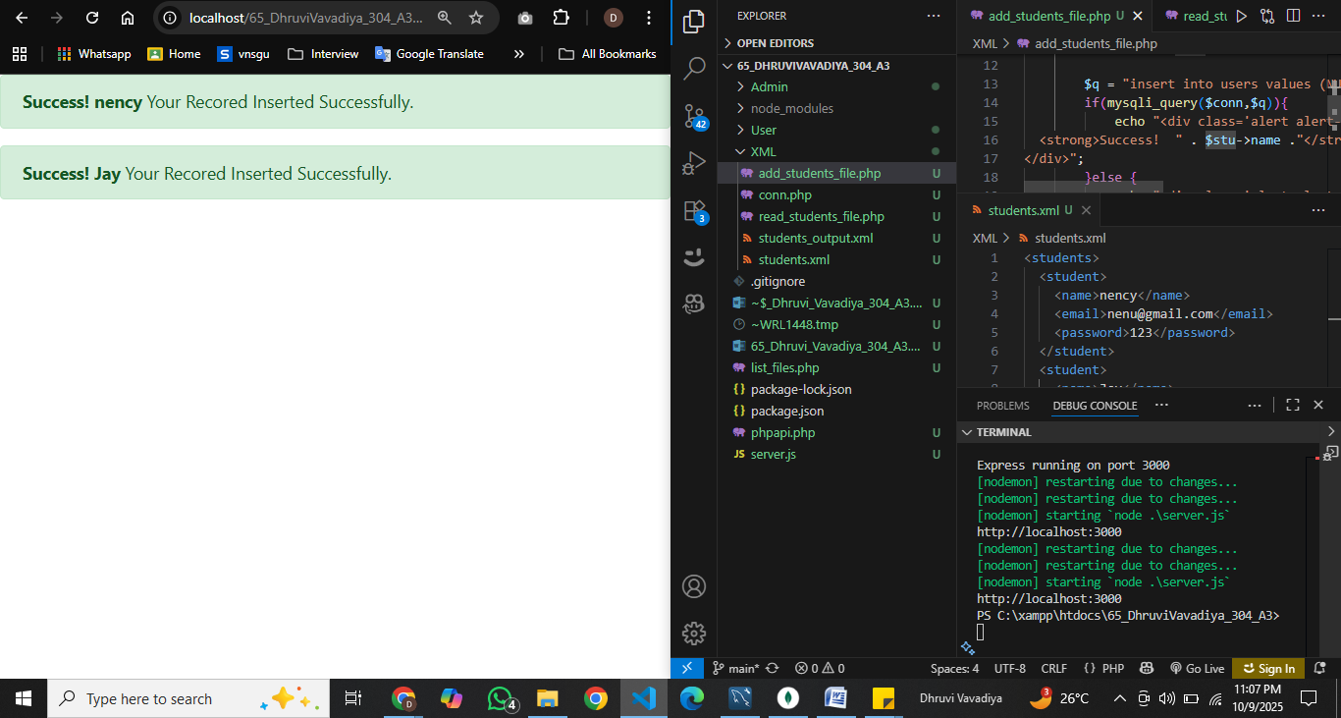

**3) Read data from students table of MySQL and store them in students.xml file.**

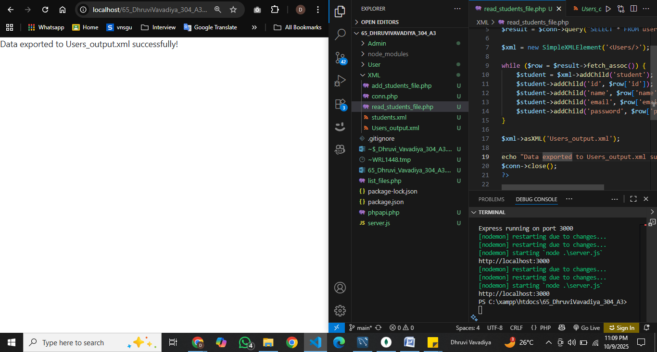

**4) List files in a directory.5) Call express rest api in php.**

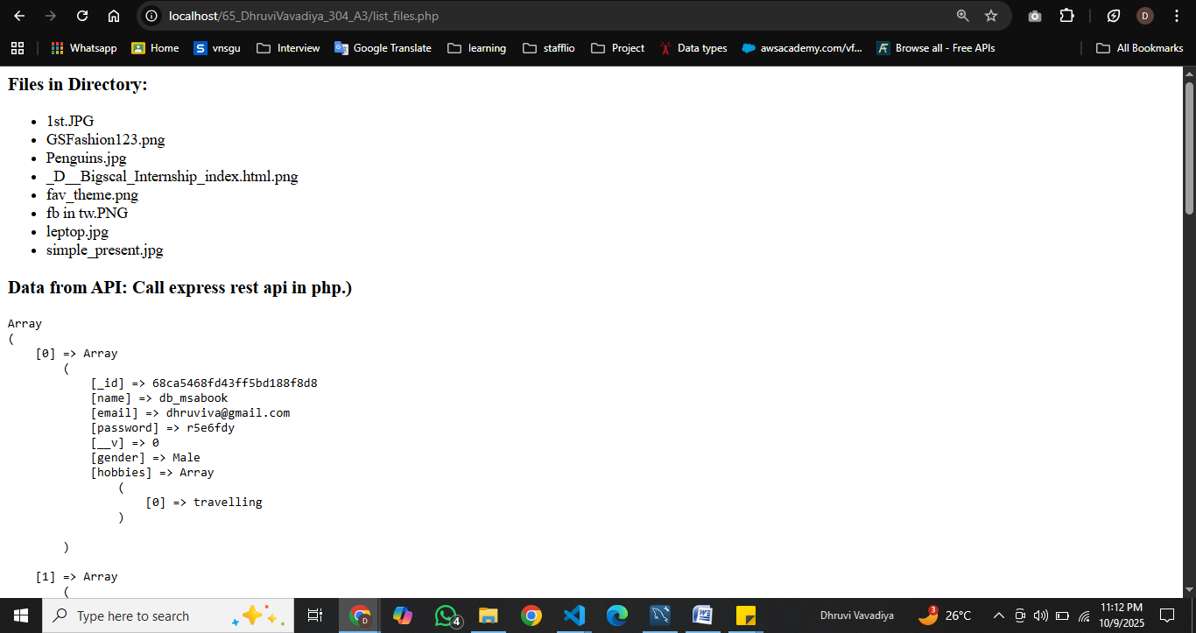

**6) Call php rest api in express.**

