**Name :- Vavadiya Dhruvi Mahesbhai**

**Roll No :- ICT3 -65**

**Subject :- Open source web development**

**Github Link :-** [**https://github.com/Dhruvi-Vavadiya/65_Dhruvi_2025_ICT3**](https://github.com/Dhruvi-Vavadiya/65_Dhruvi_2025_ICT3)

**Published Package Link :-** [**https://www.npmjs.com/package/registration_validation**](https://www.npmjs.com/package/registration_validation)

**Develop nodejs application with following requirements:**

**1.Develop a route "/gethello" with GET method. It displays "Hello NodeJS!!" as response.Make an HTML page and display Call "/gethello" route from HTML page using AJAX call. (Any frontend AJAX call API can be  
used.)**

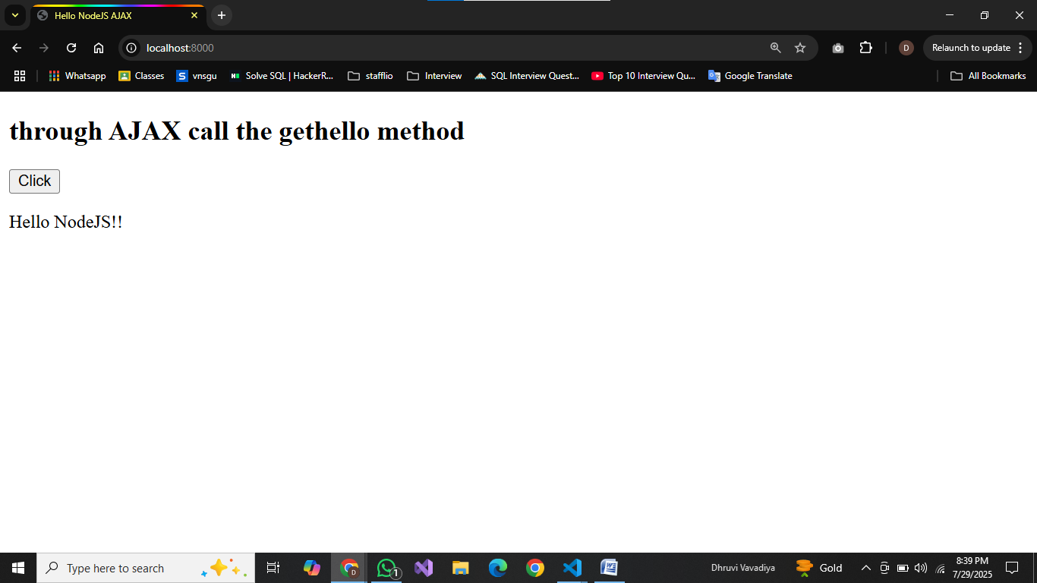  
**2. Develop a web server which serves static resources.**

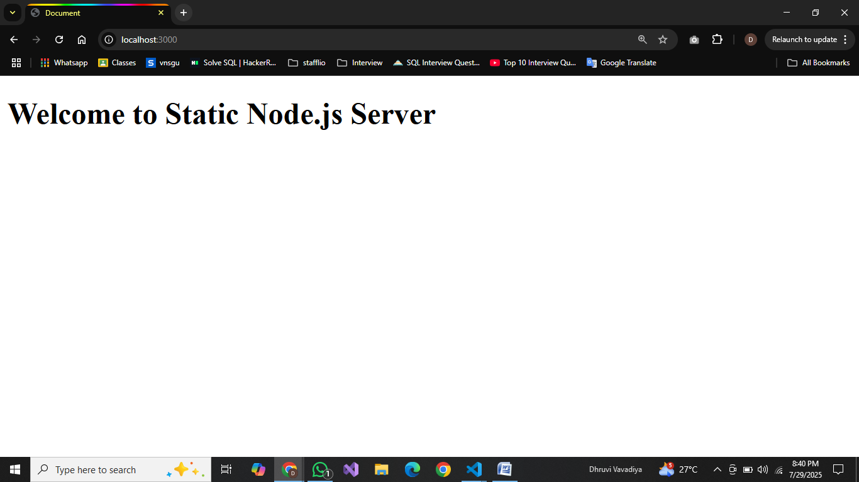

**3. Develop a module for domain specific chatbot and use it in a command line application.**

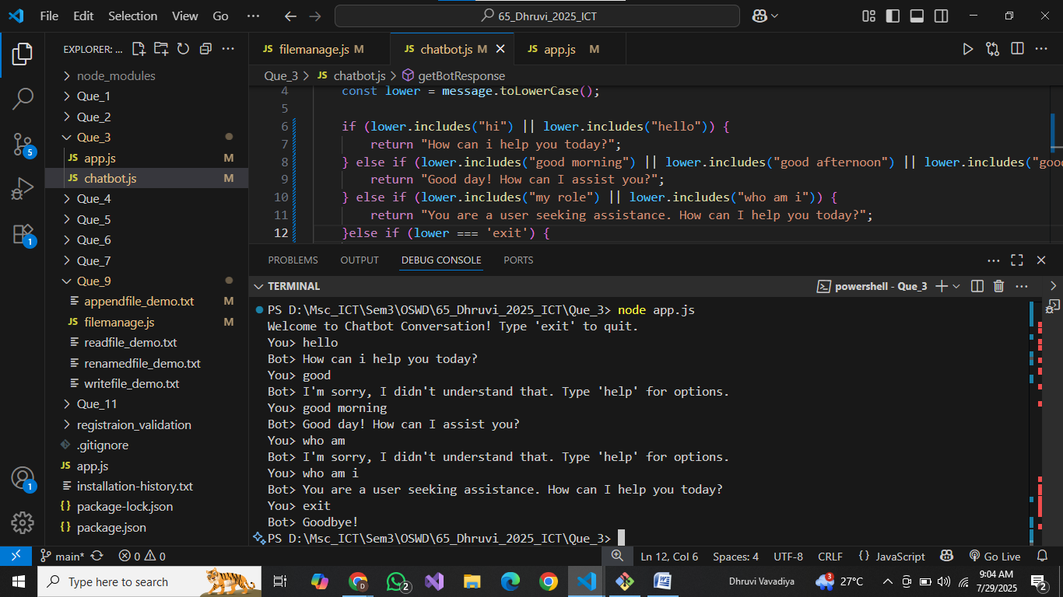

**4. Write a program to create a compressed zip file for a folder.**

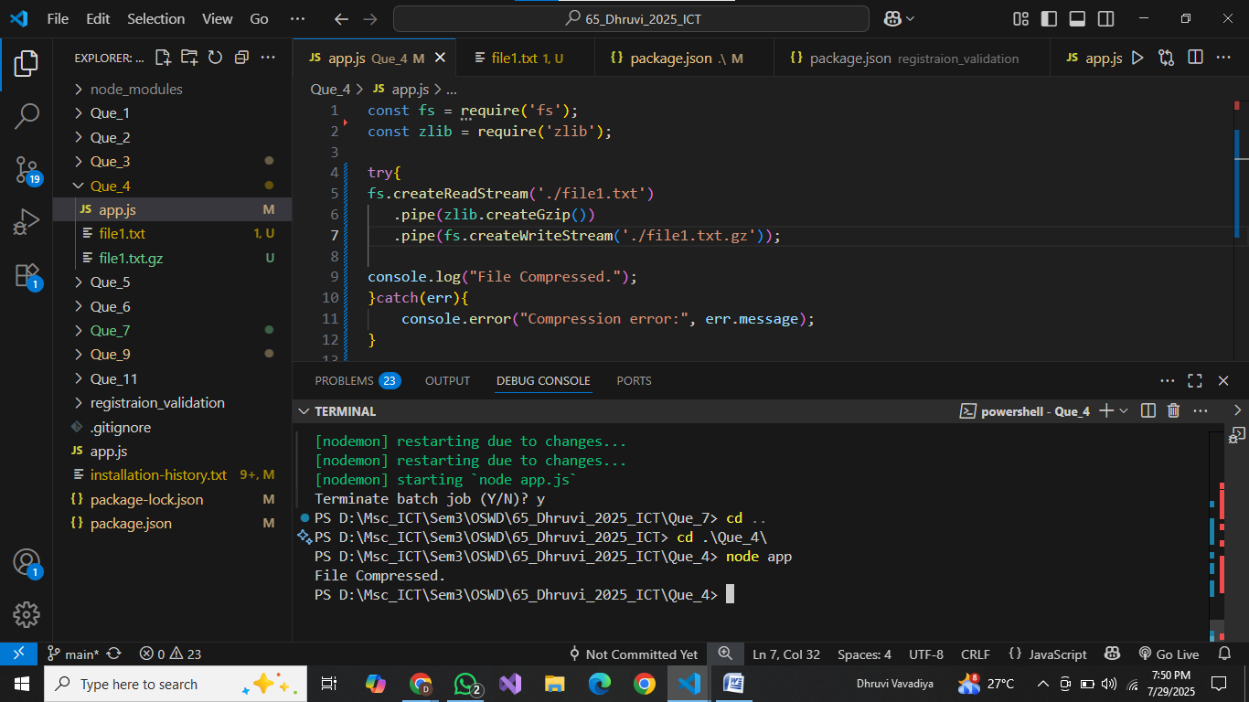  
**5. Write a program to extract a zip file.**

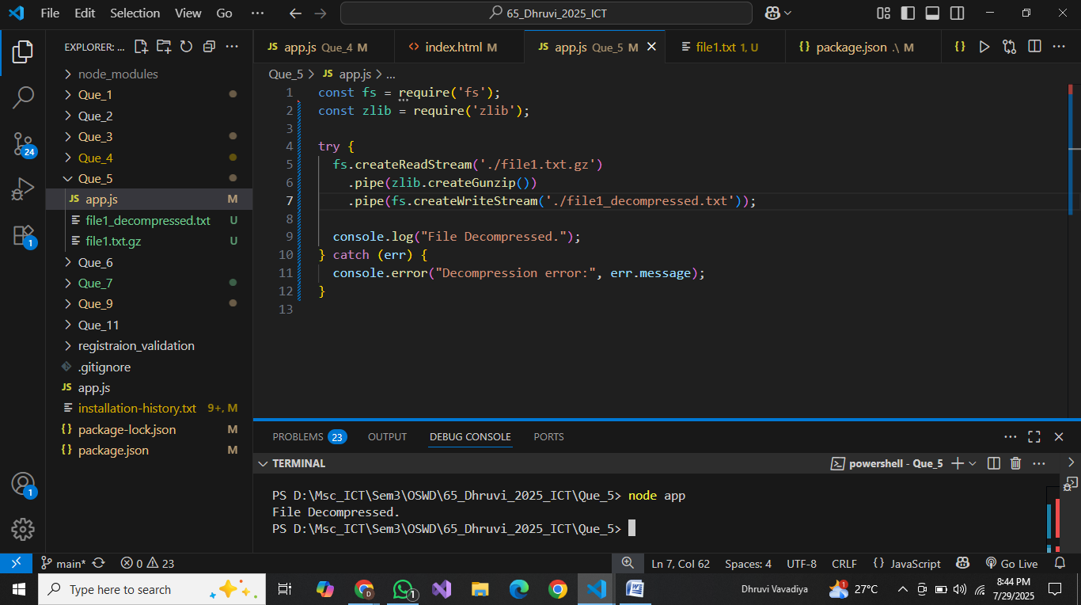

**6. Write a program to promisify fs.unlink function and call it.**

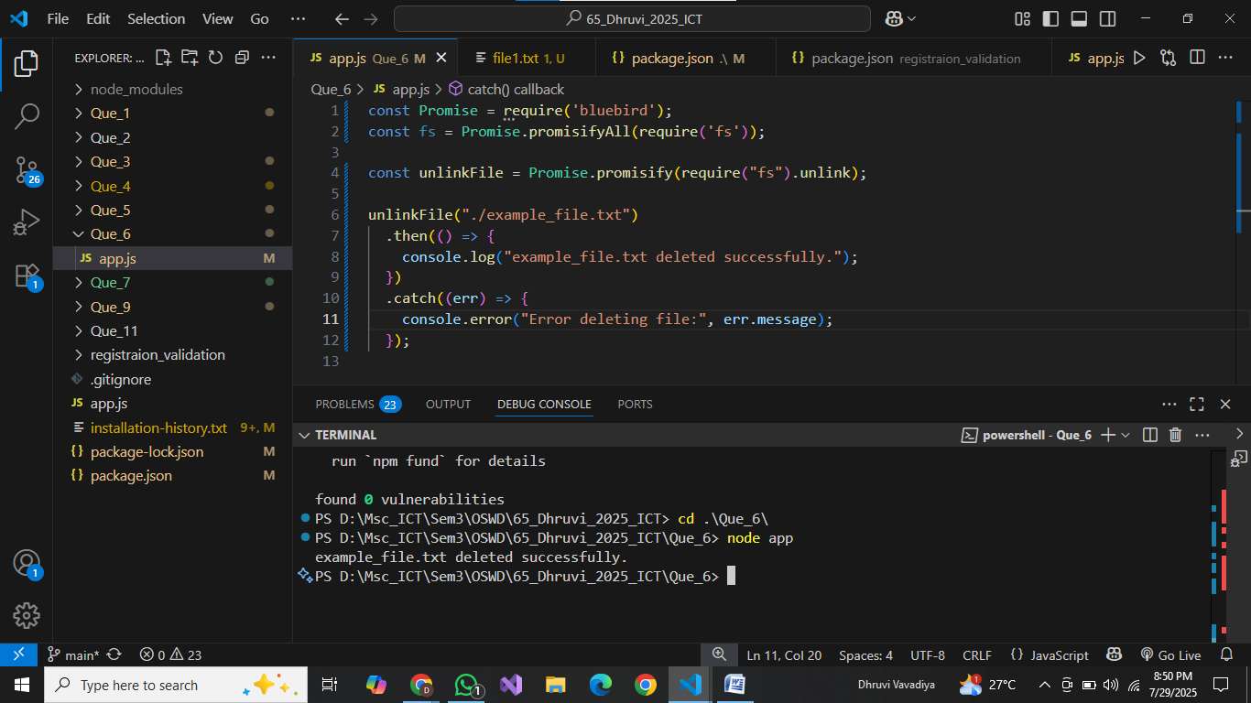

**7. Fetch data of google page using note-fetch using async-await model.**

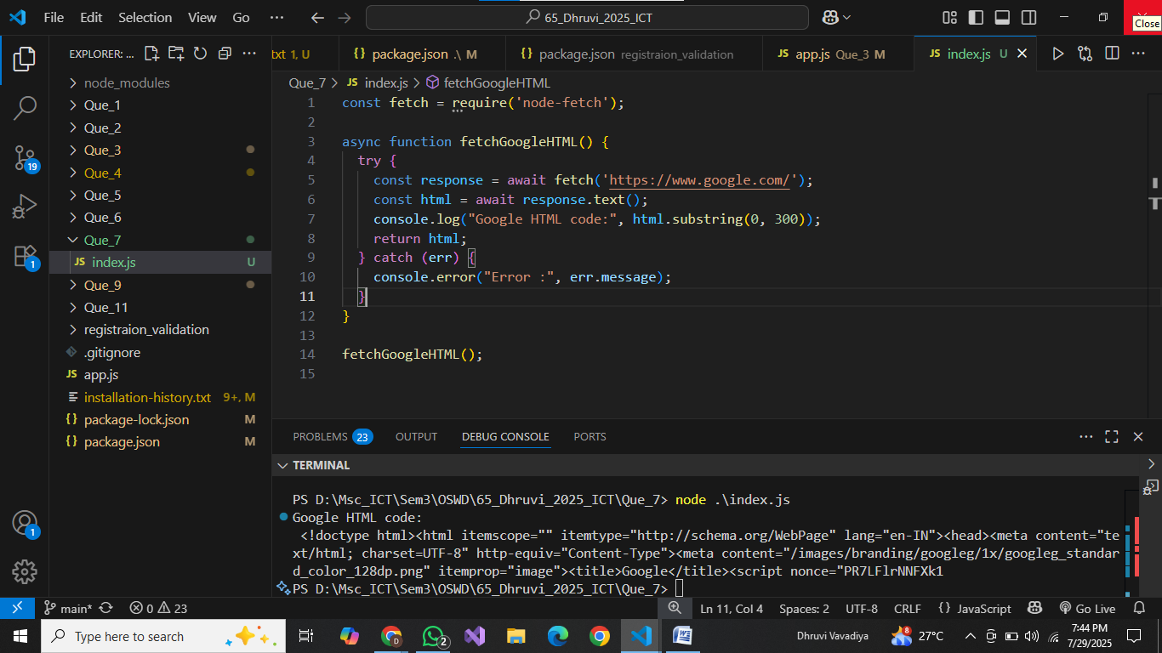  
**8. Set a server script, a test script and 3 user defined scripts in package.json file in your node.js  
application.**

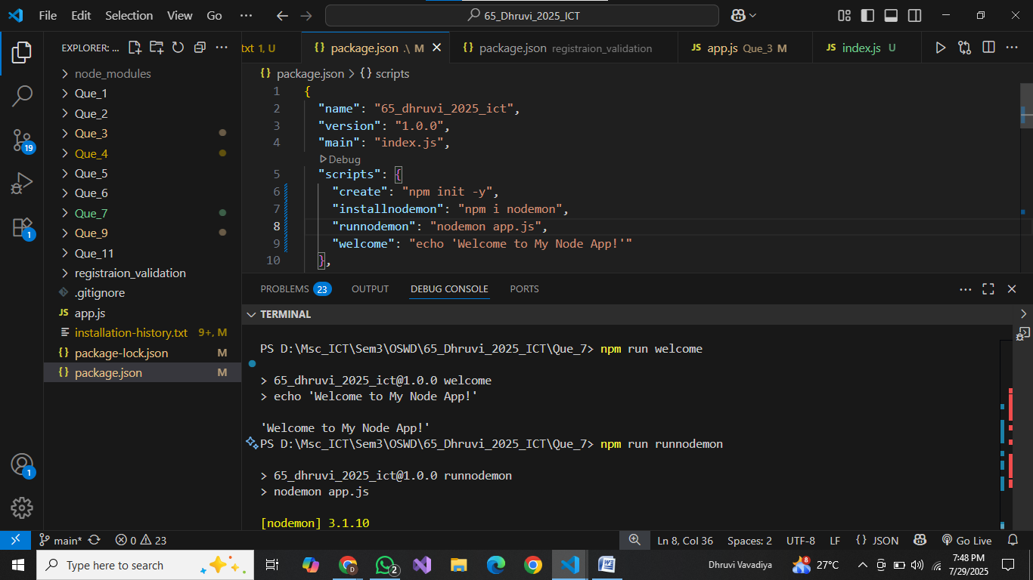  
**9. A program which calls useful functions in fs module.**

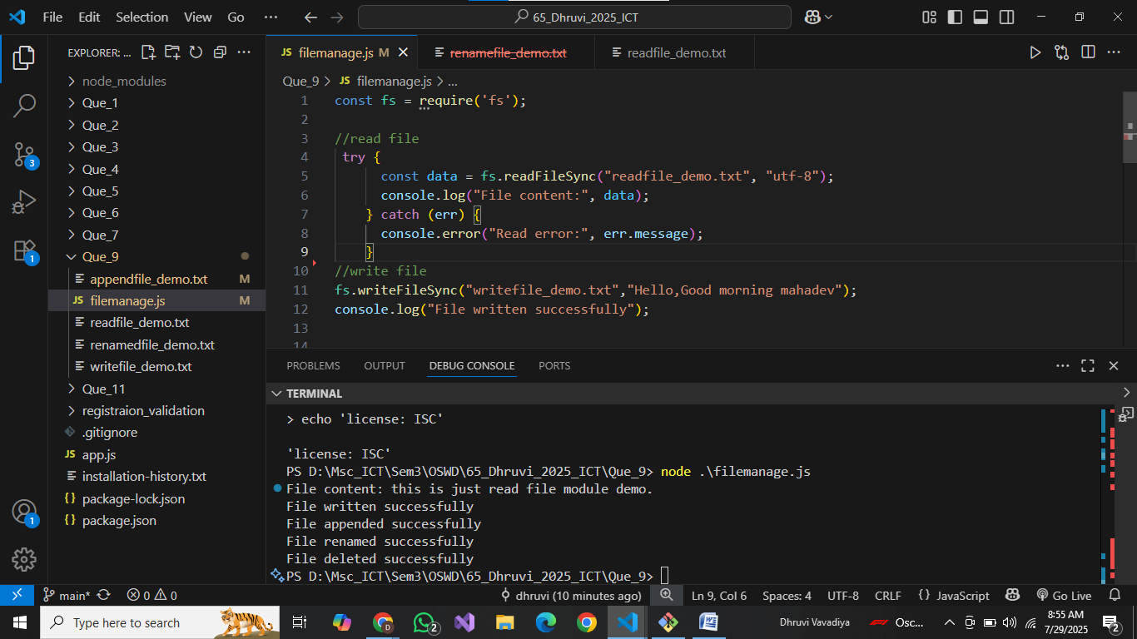

**10. A program which uses global objects in nodejs.**

**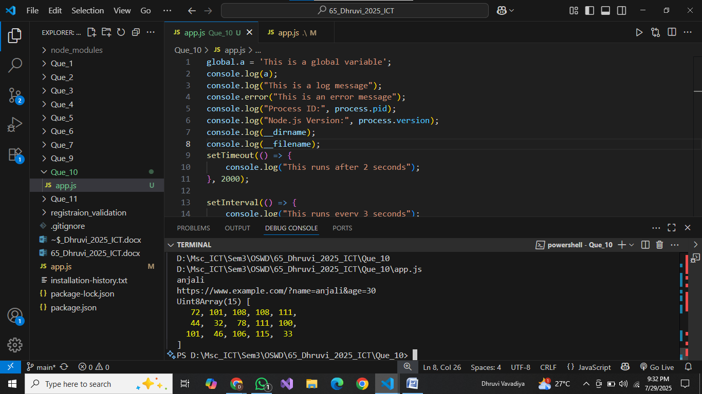  
11. Develop a useful package and publish it on npmjs.com**

**🡺 This is @dhruvivavadiya/registration_validation@1.0.0 packaage are unpublished from my pic and create** [**registration_validation@1.0.0**](mailto:registration_validation@1.0.0) **this package also created by me but forget to tack a screenshort**

