Cookie

1)Create a new cookie ::
Cookie c = new Cookie("unm", "Dhruvi");
2)Set cookie attributes
c.setMaxAge(60*60);
c.setPath("/"); // Cookie is valid for the entire application
- add cookie in response obj
response.addCookie(c);
- Retrieving Cookies:
1.println("Cookie set: " + c.getName() + "=" + c .getValue());
2.Cookie[] c = request.getCookies();
if (c != null) {
for (Cookie cs : c) {
if ("unm".equals(cs.getName())) {
out.println("READ Cookie value: " + cs.getValue());
}
}
} else {
out.println("No cookies found.");
}
Session
- Create session object
HttpSession session = req.getSession();

- set Name and value
session.setAttribute("user_name", "dhruvi");

- get value in the session
String name=(String) session.getAttribute("user_name");

- Invalidating a Session:
session.invalidate();

EXAMPLE :
Step 1 :

HttpSession session = req.getSession();
session.setAttribute("user_name", "dhruvi");

Step 2:

HttpSession session=request.getSession();
String name=(String) session.getAttribute("user_name");
out.println("Session variable and value :: user_name :: "+name+"");

Step 3:

HttpSession session=request.getSession();
session.invalidate();

- Session Tracking Techniques:
1)Cookies
2)URL Rewriting
3)Hidden Form Fields

2)URL

Step 1:

<form action="/CookieMavenEx/Servlet1">
<input type="text" id="id" name="nm">
<button type="submit">Go to Servlet</button>
</form>

Step 2:
String nm = request.getParameter("nm");
out.println("<h1>Hello," + nm + ", welcome to my website session example</h1>");
out.println("<h1><a href='Servlet2?nm="+nm+"'>Go to Servlet2</a></h1>"); //url through

Step 3:
String nm = request.getParameter("nm");
out.println("<h1>Hello," + nm + ", welcome to my website session example</h1>");

3)Hidden form Field

String nm = request.getParameter("nm");
out.println("<form action=\"/SessionMavenEx/Servlet2\">\n" +
//" <input type=\"hidden\" id=\"id\" name=\"unm\" value=\""+nm+"\">\n" +
//" <button type=\"submit\">Go to Servlet</button>\n" +
//" </form>"); //hidden field

- RequestDispatcher

String e=request.getParameter("e");
String p=request.getParameter("p");

if(e.equals("abc") && p.equals("123")){
RequestDispatcher rd=request.getRequestDispatcher("/profilejsp.jsp");
rd.forward(request,response);
}else{
out.println("Email id or pwd dismathed");
RequestDispatcher rd=request.getRequestDispatcher("/index.html");
rd.include(request,response);
}
JSP

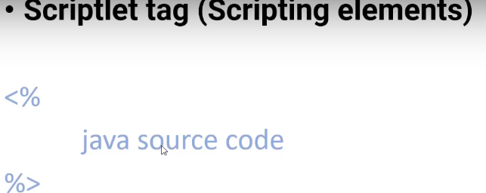
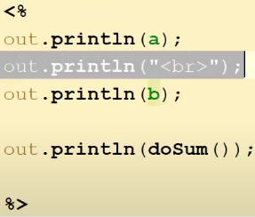
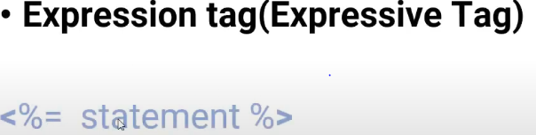
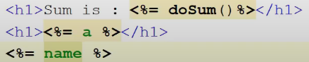
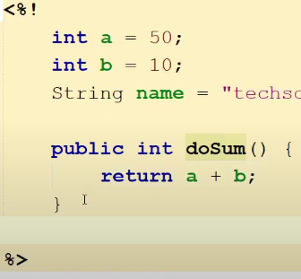
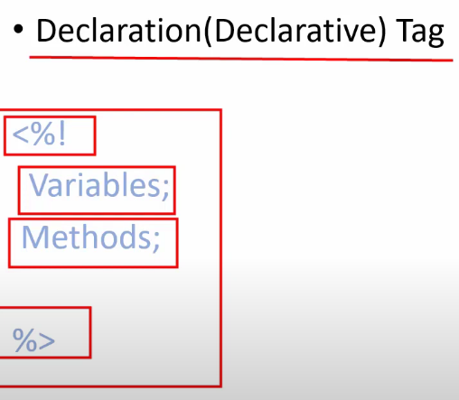

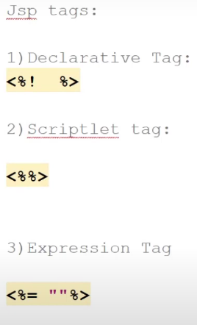

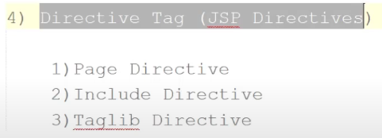
JSF Templeting
- newTemplate.xhtml file
<div id="top" class="top">
<ui:insert name="top">nav bar</ui:insert>
</div>

<div>
<div id="left">
<ui:insert name="left">menu left</ui:insert>
</div>
<div id="content" class="left_content">
<ui:insert name="content">right content</ui:insert>
</div>
</div>

- index.xhtml
<ui:composition template="newTemplate.xhtml">
<ui:define name="top"> Great Things may not look good</ui:define>

<ui:define name="left">
<ul>
<li> One </li>
<li> Two </li>
</ul>
</ui:define>

<ui:define name="content">
<h:form><h:form>
</ui:define>
</ui:composition>

