Cookie

1)Create a new cookie ::
Cookie c = new Cookie("unm", "Dhruvi");
2)Set cookie attributes
c.setMaxAge(60*60);
c.setPath("/"); // Cookie is valid for the entire application
- add cookie in response obj
response.addCookie(c);
- Retrieving Cookies:
1.println("Cookie set: " + c.getName() + "=" + c .getValue());
2.Cookie[] c = request.getCookies();
if (c != null) {
for (Cookie cs : c) {
if ("unm".equals(cs.getName())) {
out.println("READ Cookie value: " + cs.getValue());
}
}
} else {
out.println("No cookies found.");
}
Session
- Create session object
HttpSession session = req.getSession();

- set Name and value
session.setAttribute("user_name", "dhruvi");

- get value in the session
String name=(String) session.getAttribute("user_name");

- Invalidating a Session:
session.invalidate();

EXAMPLE :
Step 1 :

HttpSession session = req.getSession();
session.setAttribute("user_name", "dhruvi");

Step 2:

HttpSession session=request.getSession();
String name=(String) session.getAttribute("user_name");
out.println("Session variable and value :: user_name :: "+name+"");

Step 3:

HttpSession session=request.getSession();
session.invalidate();

- Session Tracking Techniques:
1)Cookies
2)URL Rewriting
3)Hidden Form Fields

2)URL

Step 1:

<form action="/CookieMavenEx/Servlet1">
<input type="text" id="id" name="nm">
<button type="submit">Go to Servlet</button>
</form>

Step 2:
String nm = request.getParameter("nm");
out.println("<h1>Hello," + nm + ", welcome to my website session example</h1>");
out.println("<h1><a href='Servlet2?nm="+nm+"'>Go to Servlet2</a></h1>"); //url through

Step 3:
String nm = request.getParameter("nm");
out.println("<h1>Hello," + nm + ", welcome to my website session example</h1>");

3)Hidden form Field

String nm = request.getParameter("nm");
out.println("<form action=\"/SessionMavenEx/Servlet2\">\n" +
//" <input type=\"hidden\" id=\"id\" name=\"unm\" value=\""+nm+"\">\n" +
//" <button type=\"submit\">Go to Servlet</button>\n" +
//" </form>"); //hidden field

- RequestDispatcher

String e=request.getParameter("e");
String p=request.getParameter("p");

if(e.equals("abc") && p.equals("123")){
RequestDispatcher rd=request.getRequestDispatcher("/profilejsp.jsp");
rd.forward(request,response);
}else{
out.println("Email id or pwd dismathed");
RequestDispatcher rd=request.getRequestDispatcher("/index.html");
rd.include(request,response);
}
JSP

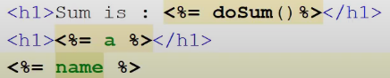
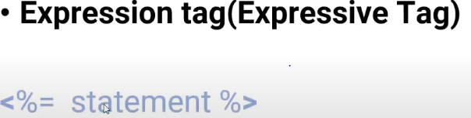
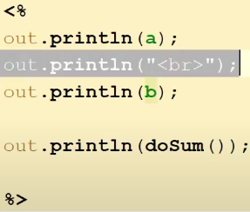
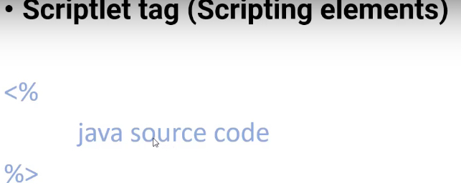
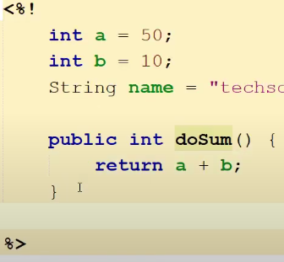
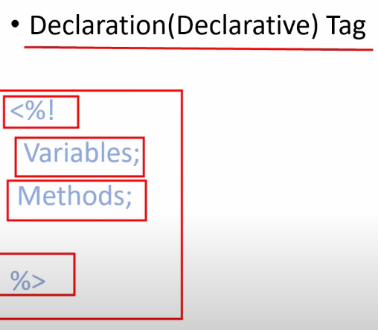

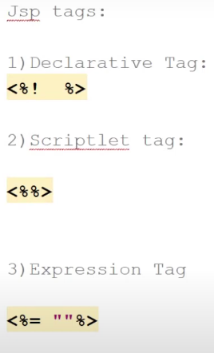

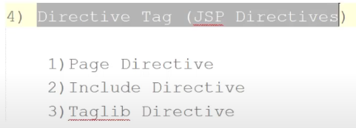
JSF Templeting
- newTemplate.xhtml file
<div id="top" class="top">
<ui:insert name="top">nav bar</ui:insert>
</div>

<div>
<div id="left">
<ui:insert name="left">menu left</ui:insert>
</div>
<div id="content" class="left_content">
<ui:insert name="content">right content</ui:insert>
</div>
</div>

- index.xhtml
<ui:composition template="newTemplate.xhtml">
<ui:define name="top"> Great Things may not look good</ui:define>

<ui:define name="left">
<ul>
<li> One </li>
<li> Two </li>
</ul>
</ui:define>

<ui:define name="content">
<h:form><h:form>
</ui:define>
</ui:composition>

REST
RestClient rfc;
Response rs;

Collection<Restaurants> rest;
GenericType<Collection<Restaurants>> grest;

rfc = new RestClient();

rest = new ArrayList<>();
grest = new GenericType<Collection<Restaurants>>() {};

rs = rfc.getAllRestaurant(Response.class);
rest = rs.readEntity(grest);

for (Restaurants r : rest) {
out.println(" rest id :" + r.getRestaurantId() );
}

Restaurants rest1;
GenericType<Restaurants> grest1;

rest1 = new Restaurants();
grest1 = new GenericType<Restaurants>() {
};

rs = rfc.getRestaurantDetailById(Response.class, "4");
rest1 = rs.readEntity(grest1);
out.println("rest id :" + rest1.getRestaurantId());

INDERT UPDATE DELETE
public void addCity(Integer stateId, String city) {

//1 find the state id
States s = em.find(States.class, stateId);

//2 returns a collection of all cities in that state. get collection of cities
Collection<Cities> cities = s.getCitiesCollection();

//3 Create a New City Object
Cities c = new Cities();

//4 Set State and City Name
c.setStateId(s);
c.setCityName(city);

//5 Add the New City to the Collection
cities.add(c);

//6 Update the State Entity
s.setCitiesCollection(cities);

//7 Persist the New City
em.persist(c);

//8
em.merge(s);

Summary of the Process:
- Find the state entity by its ID.
- Get the collection of cities associated with that state.
- Create a new city object.
- Set the state and city name for the new city.
- Add the new city to the collection of cities for that state.
- Update the state entity with the updated collection of cities.
- Persist the new city to the database.
- Merge the state entity to update it in the database.

}
public void updateAddressToCustomer(Integer addressId, String street, Integer custId) {
Customer c = em.find(Customer.class, custId);
Address a = null;
for (Address addr : c.getAddressCollection()) {
if (addr.getAddressId().equals(addressId)) {
a = addr;
break;
}
}
a.setStreet(street);
em.merge(a);
}
public void RemovemenuItems(Integer itemId) {
Menuitems ms = em.find(Menuitems.class, itemId);
em.remove(ms);
}

public Collection<States> getAllStates() { //simple collection
return em.createNamedQuery("States.findAll").getResultList();
}
public Collection<Address> getAddressByState(String state) { //string value through
return em.createNamedQuery("Address.findByState").setParameter("state",state).getResultList();
}

public Collection<Cities> getAllCitiesByStateId(Integer stateId) { //parameter
States s = em.find(States.class, stateId); //stateid FK
return s.getCitiesCollection(); //city table
}
1}
Collection<Cities> cities = abl.getAllCitiesByStateId(2);
for (Cities c : cities) {
out.println("<br/> id :" + c.getCityId() + "State id"+ c.getStateId() +" City : " + c.getCityName());
}
2}
Collection<States> state = abl.getAllStates();
out.println("<table border='2'>");
out.println("<tr><td> ><td>s id</td><td>state name</td></tr>");
for(States s : state){
Collection<Cities> ci = abl.getAllCitiesByStateId(s.getStateId());
for(Cities c : ci){
out.println("<tr>");
out.println("<td>" + c.getCityId()+ "</td>");
out.println("<td>" + c.getCityName()+ "</td>");
out.println("<td>" + s.getStateId()+ "</td>");
out.println("<td>" + s.getStateName()+ "</td>");
out.println("</tr>");
} }
Public Customer getCustomerFromAddress(Integer addressId);

public Customer getCustomerFromAddress(Integer addressId) {
Address a = em.find(Address.class, addressId);
return a.getCustomer();
}

Customer c1 = pbl.getCustomerFromAddress(4);
out.println("<h1 align='center'>getCustomerFromAddress<h1/><br/>customer id :: " + c1.getCustomerID() + "<br/>cfnm ::" + c1.getFirstName() + "<br/>clnm ::" + c1.getLastName());

public Collection<Emp> allEmp();
// return em.createNamedQuery("Emp.findAll").getResultList();

public Collection<Emp> getEmpByEmpName(String ename); //multi reord enm="dhruvi" dhruvi name vala badha record ave
// return em.createNamedQuery("Emp.findByEname").setParameter("ename", ename).getResultList();

public Collection<Emp> getAllEmpByDid(Integer did); //emp and dept all record using FK PK
// Dept d = em.find(Dept.class, did);
// return d.getEmpCollection();

Emp getEmpByEmpID(Integer eid); // one rocred at a time eid=3 3rd record ave
// Emp e = em.find(Emp.class, eid);
// return e;

user
PBKDF2WithHmacSHA256:2048:ooL0ULgBf6Fq0YurXBIKMjWWrqOukulRBqAXzFjExys=:Gh8g16d69tWZVltJVRc17GweywmXVr1+eTl7FyKgdxQ=

Admin
PBKDF2WithHmacSHA256:2048:uS4W774WdYj872LVuRSMujHdgqEVf7yPGZw6MGbgKI8=:VVT3CD1wfVvkQ7ct2eCNWUKr6GuMFztvJPOUgD1MybU=

Owner
PBKDF2WithHmacSHA256:2048:setjQvVtcfGDgJw8pgmbOPBWPqKjmJSaVXpEnfR6jhY=:MKIcAN9nYkARN9OZiSMBPCELv4E0T1KSTIvepgLFpwk=

