Practical Assignment-2
Name | Vavadiya Dhruvi Maheshbhai
Cource | Msc.ICT(sem-1)
Roll No : | 73
Subject | 101(Frontend Development using ReactJs)

jQuery Practical Questions:
1. Create a simple HTML form with fields for name, email, and a submit button. Field name
and email should have relevant validation. Use jQuery to prevent the form from submitting
when the submit button is clicked and instead display an alert with the form data.
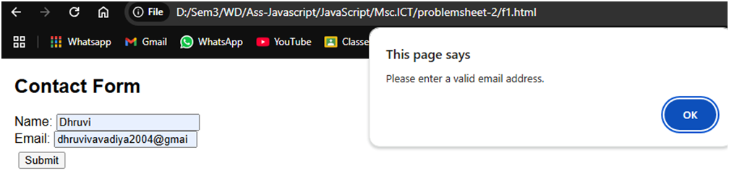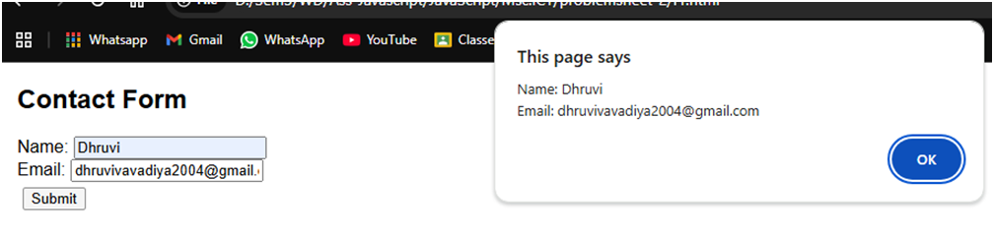
2. Create an HTML page that includes two dropdown menus (combos): one for selecting states
and another for displaying cities. When the user selects a state from the primary combo, the
secondary combo (cities) should dynamically update to display cities relevant to the selected
state.
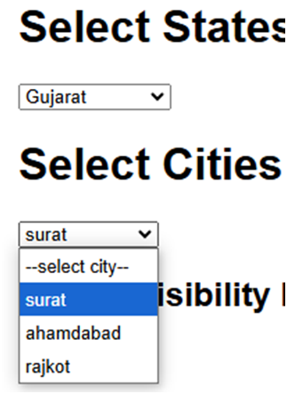
3. Write jQuery code to toggle the visibility of a div element when a button is clicked. The div
should start as hidden, and clicking the button should alternate between showing and hiding
it.

4. Create a basic image slider using jQuery. Users should be able to click &quot;Next&quot; and &quot;Previous&quot;
buttons to navigate between a series of images displayed on a webpage.
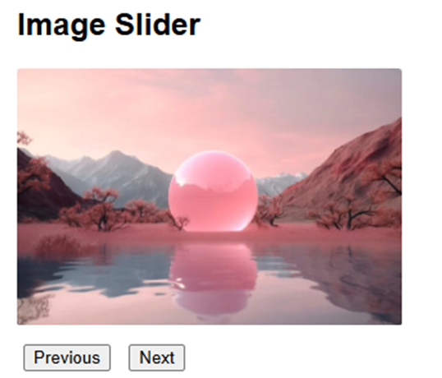
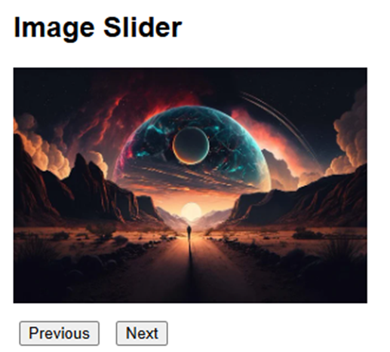
5. Implement a simple client-side validation using jQuery. Check if a text input field is empty
when a form is submitted. If it&#39;s empty, display an error message next to the input field.
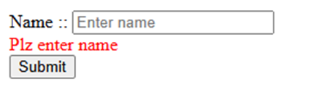
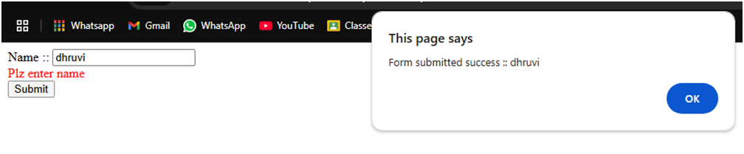
AJAX Practical Questions:
6. Develop a webpage that retrieves and displays data from a public JSON API (e.g., a list of
books, movies, or weather information) using AJAX. Display this data in a visually appealing
manner on the page.
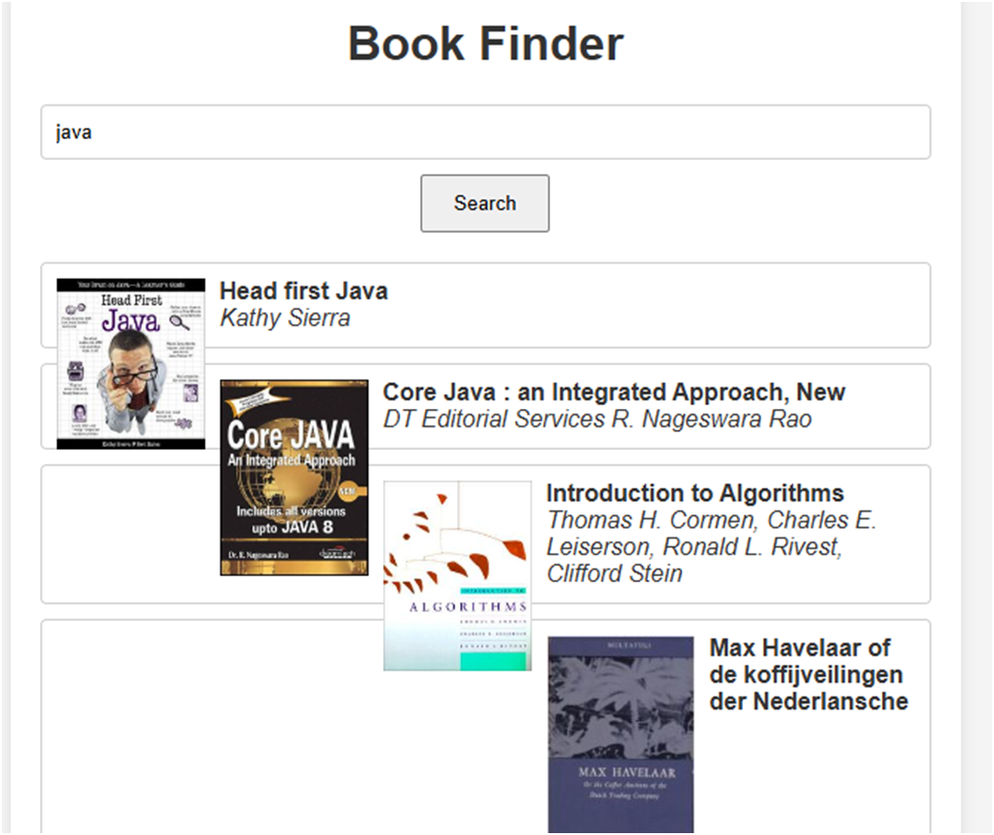
7. Create an autocomplete search feature using AJAX and jQuery. When users start typing a query into a search input field, dynamically fetch and display matching results from an API as dropdown suggestions.
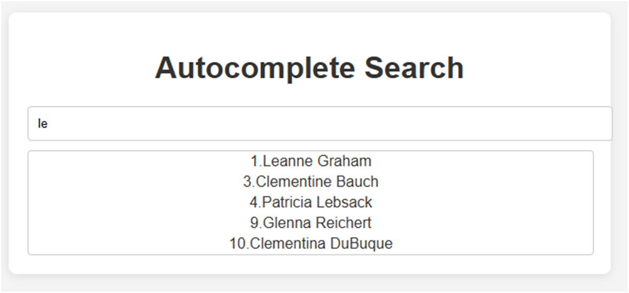
8. Build a real-time chat application using AJAX to send and receive messages without refreshing the page. Messages should be displayed on the page as they are sent and received.
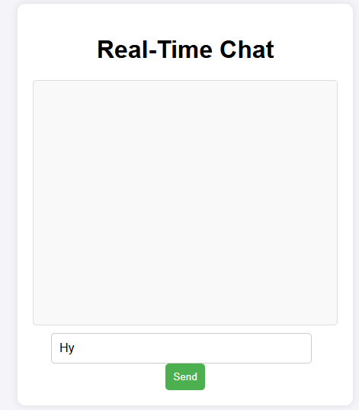
9. Design a &quot;Load More&quot; button that, when clicked, fetches additional content from an API and appends it to an existing list on the webpage. Implement pagination using AJAX.
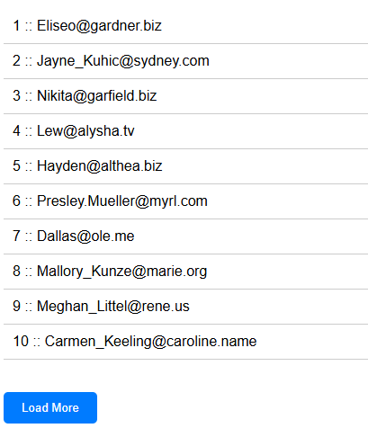
10. Develop a weather app that allows users to enter a city name and retrieve weather data from a weather API using AJAX. Display the temperature, weather description, and an icon representing the weather condition.
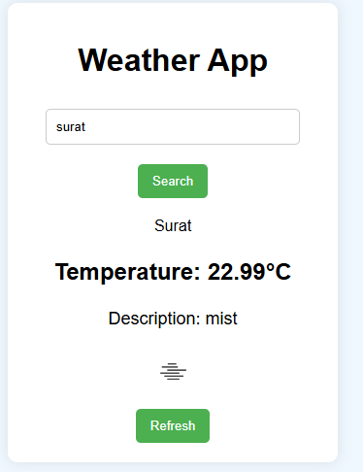
- CODE ::-
jQuery Practical Questions Code :
<!DOCTYPE html>
<html lang="en">

<head>
<meta charset="UTF-8">
<meta name="viewport" content="width=device-width, initial-scale=1.0">
<title>First Question</title>
<script src="https://code.jquery.com/jquery-3.6.0.min.js"></script>
<style>
#toggleDiv {
display: none;
padding: 20px;
border: 1px solid #ccc;
margin-top: 10px;
}
body {
font-family: Arial, sans-serif;
margin: 20px;
}
#slider {
width: 300px;
height: 200px;
overflow: hidden;
position: relative;
margin-bottom: 10px;
}
#slider img {
width: 100%;
height: auto;
display: none;
position: absolute;
top: 0;
left: 0;
}
#slider img.active {
display: block;
}
button {
margin: 5px;
}
</style>
</head>

<body>
<div class="form-container">
<h2>Contact Form</h2>
<form id="contact-form">
<label for="name">Name:</label>
<input type="text" id="name" name="name">
<br>

<label for="email">Email:</label>
<input type="email" id="email" name="email">
<br>

<button type="submit">Submit</button>
</form>
</div>
<h1>Select States</h1>
<select name="state" id="state">
<option value="">--select state--</option>
<option value="Gujarat">Gujarat</option>
<option value="Maharashtra">Maharashtra</option>
<option value="Rajasthan">Rajasthan</option>
</select>
<h1>Select Cities</h1>
<select name="city" id="city" disabled>
<option value="">--select city--</option>
</select>
<h2>Toggle Visibility Example</h2>
<button id="toggleButton">Toggle Div</button>

<div id="toggleDiv">
This is the content of the div that can be toggled.
</div>
<h2>Image Slider</h2>

<div id="slider">
<img src="https://gratisography.com/wp-content/uploads/2024/03/gratisography-funflower-800x525.jpg" alt="Image 1">
<img src="https://fps.cdnpk.net/images/home/subhome-ai.webp?w=649&h=649" alt="Image 2">
<img src="https://cdn.pixabay.com/photo/2023/03/15/20/46/background-7855413_640.jpg" alt="Image 3">
</div>

<button id="prevButton">Previous</button>
<button id="nextButton">Next</button>

<form action="" id="fomr">
<label for="">Name ::</label>
<input type="text" name="name" id="name" placeholder="Enter name"><br>
<div id="error" style="display: none;">Plz enter name</div>
<input type="submit" value="Submit" id="submit">
</form>

<div class="container">
<h1>Book Finder</h1>
<input type="text" id="search" placeholder="Search for books...">
<button id="search-btn">Search</button>
<div id="results" class="results"></div>
</div>

<script>
$(document).ready(function () {
$('#contact-form').on('submit', function (event) {
event.preventDefault();

const name = $('#name').val().trim();
const email = $('#email').val().trim();
alert(email);

if (name === "") {
alert("Please enter your name.");
return;
}

const emailPattern = /^[^\s@]+@[^\s@]+\.[^\s@]+$/;
if (!emailPattern.test(email)) {
alert("Please enter a valid email address.");
return;
}

alert(`Name: ${name}\nEmail: ${email}`);
});
});
$(document).ready(function () {
const cities = {
Gujarat: ['surat', 'ahamdabad', 'rajkot'],
Maharashtra: ['mumbai', 'pune', 'nagpur'],
Rajasthan: ['jaipur', 'udaipur', 'jodhpur']
}

$("#state").on("change", function () {

const seleState = $(this).val();
const city = $("#city");

city.empty().append(`<option value="">--select city--</option>`);

if (seleState) {
city.prop("disabled", false);

cities[seleState].forEach(element => {
city.append(`<option value="${element}">${element}</option>`);
});
} else {
city.prop("disabled", true);
}
});

});
$(document).ready(function () {
$('#toggleButton').on('click', function () {
$('#toggleDiv').toggle();
});
});
$(document).ready(function() {
let currentIndex = 0;
const images = $('#slider img');
const totalImages = images.length;
images.eq(currentIndex).addClass('active');

$('#nextButton').on('click', function() {
images.eq(currentIndex).removeClass('active');
currentIndex = (currentIndex + 1) % totalImages;
images.eq(currentIndex).addClass('active');
});

$('#prevButton').on('click', function() {
images.eq(currentIndex).removeClass('active');
console.log("without count :: "+currentIndex);
currentIndex = (currentIndex - 1 + totalImages) % totalImages;
images.eq(currentIndex).addClass('active');
});
});
document.addEventListener('contextmenu', event => event.preventDefault());

$(document).ready(function(){
$("#fomr").on("submit",function(e){
e.preventDefault();

const nm=$("#name").val().trim();
console.log(nm);

if(nm == ''){
alert("don't need to empty this field");
$("#error").css("display","block");
$("#error").css("color","red");
}else{
alert("Form submitted success :: "+nm);

}
});
});
$(document).ready(function () {
$('#search-btn').click(function () {
const query = $('#search').val();
if (query) {
fetchBooks(query);
} else {
alert('Please enter a search term.');
}
});

function fetchBooks(query) {
const apiUrl = `https://openlibrary.org/search.json?q=${encodeURIComponent(query)}`;

$.ajax({
url: apiUrl,
method: 'GET',
success: function (data) {
displayResults(data.docs);
},
error: function () {
$('#results').html('<p>Error retrieving data.</p>');
}
});
}

function displayResults(books) {
$('#results').empty();
if (books.length > 0) {
books.forEach(book => {
const title = book.title || 'No title available';
const author = book.author_name ? book.author_name.join(', ') : 'Unknown author';
const cover = book.cover_i ? `https://covers.openlibrary.org/b/id/${book.cover_i}-M.jpg` : 'https://via.placeholder.com/100x150?text=No+Image';

$('#results').append(`
<div class="book">
<img src="${cover}" alt="Cover">
<div>
<strong>${title}</strong><br>
<em>${author}</em>
</div>
</div>
`);
});
} else {
$('#results').html('<p>No books found.</p>');
}
}
});

</script>
</body>

</html>

AJAX Practical Questions Code:
6.
<!DOCTYPE html>
<html lang="en">

<head>
<meta charset="UTF-8">
<meta name="viewport" content="width=device-width, initial-scale=1.0">
<title>Book Finder</title>

<style>
body {
font-family: Arial, sans-serif;
background-color: #f4f4f4;
color: #333;
margin: 0;
padding: 0;
}

.container {
width: 80%;
max-width: 600px;
margin: 50px auto;
padding: 20px;
background: white;
border-radius: 8px;
box-shadow: 0 2px 10px rgba(0, 0, 0, 0.1);
text-align: center;
}

input {
padding: 10px;
width: calc(100% - 22px);
border: 1px solid #ccc;
border-radius: 4px;
margin-bottom: 10px;
}

button {
padding: 10px 20px;
cursor: pointer;
}

.results {
margin-top: 20px;
}

.book {
border: 1px solid #ccc;
border-radius: 4px;
padding: 10px;
margin: 10px 0;
text-align: left;
}

.book img {
max-width: 100px;
margin-right: 10px;
float: left;
}

</style>
<script src="https://code.jquery.com/jquery-3.6.0.min.js"></script>
</head>

<body>
<div class="container">
<h1>Book Finder</h1>
<input type="text" id="search" placeholder="Search for books...">
<button id="search-btn">Search</button>
<div id="results" class="results"></div>
</div>
<script>
$(document).ready(function () {
$('#search-btn').click(function () {
const query = $('#search').val();
if (query) {
fetchBooks(query);
} else {
alert('Please enter a search term.');
}
});

function fetchBooks(query) {
const apiUrl = `https://openlibrary.org/search.json?q=${encodeURIComponent(query)}`;

$.ajax({
url: apiUrl,
method: 'GET',
success: function (data) {
displayResults(data.docs);
},
error: function () {
$('#results').html('<p>Error retrieving data.</p>');
}
});
}

function displayResults(books) {
$('#results').empty();
if (books.length > 0) {
books.forEach(book => {
const title = book.title || 'No title available';
const author = book.author_name ? book.author_name.join(', ') : 'Unknown author';
const cover = book.cover_i ? `https://covers.openlibrary.org/b/id/${book.cover_i}-M.jpg` : 'https://via.placeholder.com/100x150?text=No+Image';

$('#results').append(`
<div class="book">
<img src="${cover}" alt="Cover">
<div>
<strong>${title}</strong><br>
<em>${author}</em>
</div>
</div>
`);
});
} else {
$('#results').html('<p>No books found.</p>');
}
}
});

</script>
</body>

</html>

7.
<!DOCTYPE html>
<html lang="en">

<head>
<meta charset="UTF-8">
<meta name="viewport" content="width=device-width, initial-scale=1.0">
<title>Autocomplete Search</title>
<style>
body {
font-family: Arial, sans-serif;
background-color: #f4f4f4;
color: #333;
}

.container {
width: 80%;
max-width: 600px;
margin: 50px auto;
padding: 20px;
background: white;
border-radius: 8px;
box-shadow: 0 2px 10px rgba(0, 0, 0, 0.1);
text-align: center;
}

input {
padding: 10px;
width: 100%;
border: 1px solid #ccc;
border-radius: 4px;
margin-bottom: 10px;
}

.suggestions {
border: 1px solid #ccc;
border-radius: 4px;
background: white;
z-index: 1000;
width: 100%;
max-height: 200px;
overflow-y: auto;
display: none;
}

.suggestion-item {
padding: 2px;
cursor: pointer;
}

.suggestion-item:hover {
background-color: #e0e0e0;
}
</style>
<script src="https://code.jquery.com/jquery-3.6.0.min.js"></script>
</head>

<body>
<div class="container">
<h1>Autocomplete Search</h1>
<input type="text" id="search" placeholder="Start typing..." value="le">
<div id="suggestions" class="suggestions"></div>
</div>
<script>
$(document).ready(function () {
$('#search').on('input', function () {
const query = $(this).val();
if (query.length > 1) {
fetchSuggestions(query);
} else {
$('#suggestions').empty().hide();
}
});

function fetchSuggestions(query) {
const apiUrl = `https://jsonplaceholder.typicode.com/users`;
$.ajax({
url: apiUrl,
method: 'GET',
success: function (data) {
$('#suggestions').empty();
const filteredData = data.filter(user => user.name.toLowerCase().includes(query.toLowerCase()));

if (filteredData.length > 0) {
filteredData.forEach(user => {
$('#suggestions').append(`<div class="suggestion-item">${user.id}.${user.name}</div>`); // Use username for suggestions
});
$('#suggestions').show();
} else {
$('#suggestions').empty().hide();
}
},
error: function () {
$('#suggestions').empty().hide();
}
});
}

$(document).on('click', '.suggestion-item', function () {
$('#search').val($(this).text());
$('#suggestions').empty().hide();
});

$(document).on('click', function (e) {
if (!$(e.target).closest('.container').length) {
$('#suggestions').empty().hide();
}
});
});
</script>
</body>

</html>

8.
<!DOCTYPE html>
<html lang="en">
<head>
<meta charset="UTF-8">
<meta name="viewport" content="width=device-width, initial-scale=1.0">
<title>Real-Time Chat</title>
<style>

body {
font-family: Arial, sans-serif;
background-color: #f4f4f9;
display: flex;
justify-content: center;
align-items: center;
height: 100vh;
margin: 0;
}

.chat-container {
background-color: white;
padding: 20px;
border-radius: 10px;
box-shadow: 0 0 10px rgba(0, 0, 0, 0.1);
width: 400px;
text-align: center;
}

.chat-box {
height: 300px;
overflow-y: auto;
background-color: #f9f9f9;
border: 1px solid #ddd;
padding: 10px;
margin-bottom: 10px;
border-radius: 5px;
}

#message-input {
padding: 10px;
width: 80%;
font-size: 16px;
margin-right: 10px;
border-radius: 5px;
border: 1px solid #ccc;
}

#send-btn {
padding: 10px;
background-color: #4CAF50;
color: white;
border: none;
border-radius: 5px;
cursor: pointer;
}

#send-btn:hover {
background-color: #45a049;
}

.message {
padding: 5px;
margin: 5px 0;
background-color: #e0f7fa;
border-radius: 5px;
}

</style>
</head>
<body>
<div class="chat-container">
<h1>Real-Time Chat</h1>
<div id="chat-box" class="chat-box"></div>
<input type="text" id="message-input" placeholder="Type a message..." />
<button id="send-btn">Send</button>
</div>

<script>

document.addEventListener("DOMContentLoaded", () => {
const chatBox = document.getElementById('chat-box');
const messageInput = document.getElementById('message-input');
const sendButton = document.getElementById('send-btn');

function displayMessage(message) {
const messageElement = document.createElement('div');
messageElement.classList.add('message');
messageElement.textContent = message;
chatBox.appendChild(messageElement);
chatBox.scrollTop = chatBox.scrollHeight;
}

function sendMessage() {
const message = messageInput.value.trim();
if (message) {

const xhr = new XMLHttpRequest();
xhr.open('POST', '/send', true);
xhr.setRequestHeader('Content-Type', 'application/json');
xhr.onload = function () {
if (xhr.status === 200) {
displayMessage(message);
messageInput.value = '';
}
};
xhr.send(JSON.stringify({ message: message }));
}
}

sendButton.addEventListener('click', sendMessage);

function loadMessages() {
const xhr = new XMLHttpRequest();
xhr.open('GET', '/messages', true);
xhr.onload = function () {
if (xhr.status === 200) {
const messages = JSON.parse(xhr.responseText);
chatBox.innerHTML = '';
messages.forEach(message => {
displayMessage(message.message);
});
}
};
xhr.send();
}

loadMessages();
setInterval(loadMessages, 2000);
});

</script>
</body>
</html>

const express = require('express');
const bodyParser = require('body-parser');
const app = express();
const PORT = 3000;

let messages = [];

app.use(bodyParser.json());
app.use(express.static('public'));

app.get('/messages', (req, res) => {
res.json(messages);
});

app.post('/send', (req, res) => {
const message = req.body.message;
if (message) {
messages.push({ message: message, time: new Date() });
res.status(200).json({ status: 'success', message });
} else {
res.status(400).json({ status: 'error', message: 'No message content' });
}
});

app.listen(PORT, () => {
console.log(`Server running at http://localhost:${PORT}`);
});

9.
<!DOCTYPE html>
<html lang="en">

<head>
<meta charset="UTF-8">
<meta name="viewport" content="width=device-width, initial-scale=1.0">
<title>Load More Example</title>
<style>
body {
font-family: Arial, sans-serif;
}

#item-list {
list-style-type: none;
padding: 0;
}

#item-list li {
padding: 10px;
border-bottom: 1px solid #ccc;
}

#loadbtn {
padding: 10px 20px;
margin: 20px 0;
cursor: pointer;
background-color: #007bff;
color: white;
border: none;
border-radius: 5px;
}

#loadbtn:hover {
background-color: #0056b3;
}
</style>
</head>

<body>
<div id="content">
<ul id="item-list">
</ul>
</div>
<button id="loadbtn">Load More</button>

<script src="https://code.jquery.com/jquery-3.6.0.min.js"></script>

<script>
$(document).ready(function () {

let cPage=1;

function fetchItems(cPage){
$.ajax({
url: `https://jsonplaceholder.typicode.com/comments?_limit=5&_page=${cPage}`,
method :'GET',
dataType:'json',
success : function (data){
if(data.length > 0){
data.forEach(ele => {
$("#item-list").append(`<li>${ele.id} :: ${ele.email}</li>`);
});
}else{
$("#loadbtn").hide();
}
},
error : function (){
alert("FEtching data is not responding");
}
})
}

fetchItems(cPage);

$("#loadbtn").click(function(){
cPage++;
fetchItems(cPage);
})
});
</script>
</body>

</html>

10.
<!DOCTYPE html>
<html lang="en">
<head>
<meta charset="UTF-8">
<meta name="viewport" content="width=device-width, initial-scale=1.0">
<title>Weather App</title>
<style>
/* style.css */
body {
font-family: Arial, sans-serif;
background-color: #f0f8ff;
display: flex;
justify-content: center;
align-items: center;
height: 100vh;
margin: 0;
}

.weather-container {
text-align: center;
background-color: #fff;
padding: 20px;
border-radius: 10px;
box-shadow: 0 0 15px rgba(0, 0, 0, 0.1);
width: 300px;
}

#city-input {
padding: 10px;
width: 80%;
margin: 10px 0;
border: 1px solid #ccc;
border-radius: 5px;
}

#search-btn, #refresh-btn {
padding: 10px 15px;
margin-top: 10px;
background-color: #4CAF50;
color: white;
border: none;
border-radius: 5px;
cursor: pointer;
}

#search-btn:hover, #refresh-btn:hover {
background-color: #45a049;
}

.weather-info {
margin-top: 20px;
}

#temperature {
font-size: 24px;
font-weight: bold;
}

#description {
font-size: 18px;
}

#weather-icon {
width: 50px;
height: 50px;
}

</style>
</head>
<body>
<div class="weather-container">
<h1>Weather App</h1>
<input type="text" id="city-input" placeholder="Enter city name" />
<button id="search-btn">Search</button>
<div id="weather-info" class="weather-info">
<p id="city-name"></p>
<p id="temperature"></p>
<p id="description"></p>
<img id="weather-icon" src="" alt="" />
</div>
<button id="refresh-btn">Refresh</button>
</div>

<script>

document.addEventListener("DOMContentLoaded", () => {
const apiKey = '601698c3c85962be7ee2dbfb4bc01c4e';
const cityInput = document.getElementById('city-input');
const searchButton = document.getElementById('search-btn');
const refreshButton = document.getElementById('refresh-btn');
const weatherInfo = document.getElementById('weather-info');
const cityNameElement = document.getElementById('city-name');
const temperatureElement = document.getElementById('temperature');
const descriptionElement = document.getElementById('description');
const weatherIconElement = document.getElementById('weather-icon');

function fetchWeather(city) {
const url = `https://api.openweathermap.org/data/2.5/weather?q=${city}&appid=${apiKey}&units=metric`;

const xhr = new XMLHttpRequest();
xhr.open('GET', url, true);
xhr.onload = function () {
if (xhr.status === 200) {
const weatherData = JSON.parse(xhr.responseText);
updateWeatherDisplay(weatherData);
} else {
alert('City not found. Please try again.');
}
};
xhr.send();
}

function updateWeatherDisplay(data) {
const { name, main, weather } = data;

cityNameElement.textContent = `${name}`;

temperatureElement.textContent = `Temperature: ${main.temp}°C`;

descriptionElement.textContent = `Description: ${weather[0].description}`;

const iconUrl = `https://openweathermap.org/img/wn/${weather[0].icon}.png`;
weatherIconElement.src = iconUrl;
weatherIconElement.alt = weather[0].description;
}

searchButton.addEventListener('click', () => {
const city = cityInput.value.trim();
if (city) {
fetchWeather(city);
} else {
alert('Please enter a city name.');
}
});

refreshButton.addEventListener('click', () => {
const city = cityInput.value.trim();
if (city) {
fetchWeather(city);
}
});

fetchWeather('London');
});

</script>
</body>
</html>

- GitHub Link :-
https://github.com/Dhruvi-Vavadiya/ReactJS/blob/main/Practical_Assignment_2.docx

