Practical Assignment-3
Name | Vavadiya Dhruvi Maheshbhai
Cource | Msc.ICT(sem-1)
Roll No : | 73
Subject | 101(Frontend Development using ReactJs)

- Build a Small Task Management Website in React.js

- Create a small website for managing tasks. The website should have the following features:

- Class Components: Implement a class component called TaskManager that will serve as the main container for managing tasks. This component should have a state to store the list of tasks.
- APP.JS :-
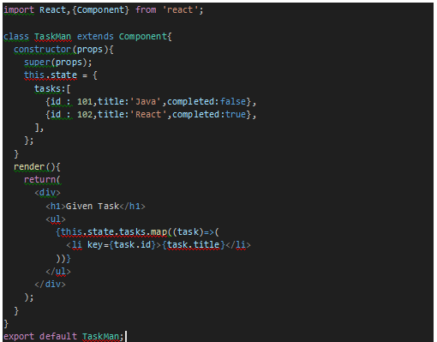
- Output :-
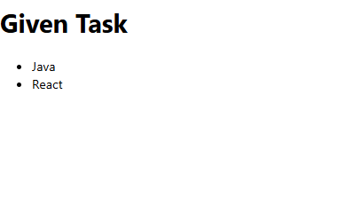
- Functional Components: Create a functional component called TaskList responsible for displaying a list of tasks. It should receive the list of tasks as props from the TaskManager component.
- Second.js :-
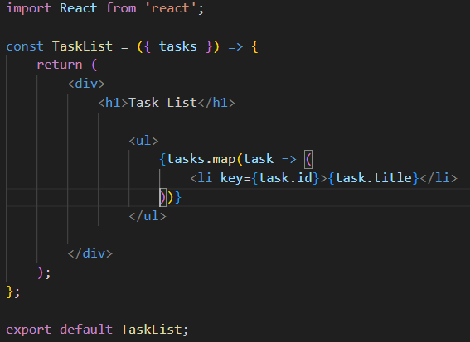
- APP.JS :-
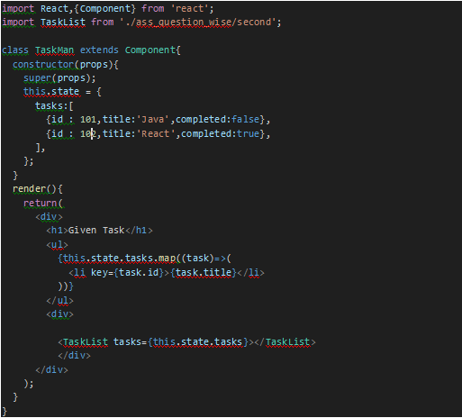
- Output :-
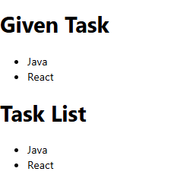

- Nested Components: Inside the TaskList component, create a child component called TaskItem that represents an individual task.
- Code:-
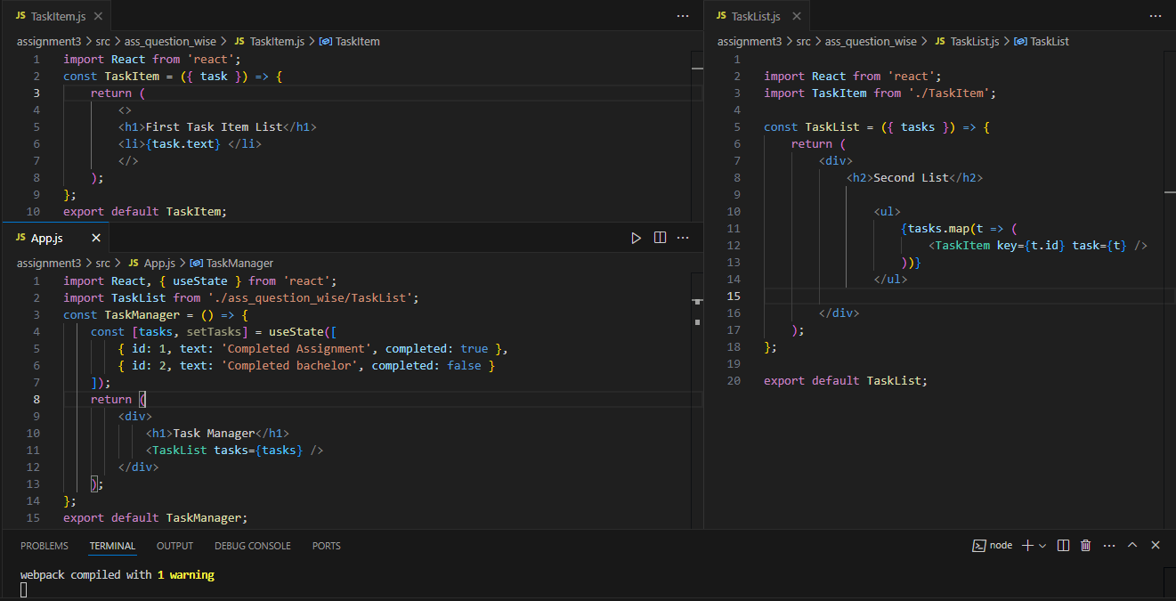
- Output :-
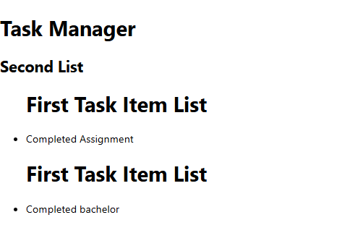

- Conditional and Looping Constructs: Implement conditional rendering in the TaskList component. If there are no tasks, display a message like &quot;No tasks to display.&quot; Use a loop (e.g., map) to render each TaskItem.
- CODE :-
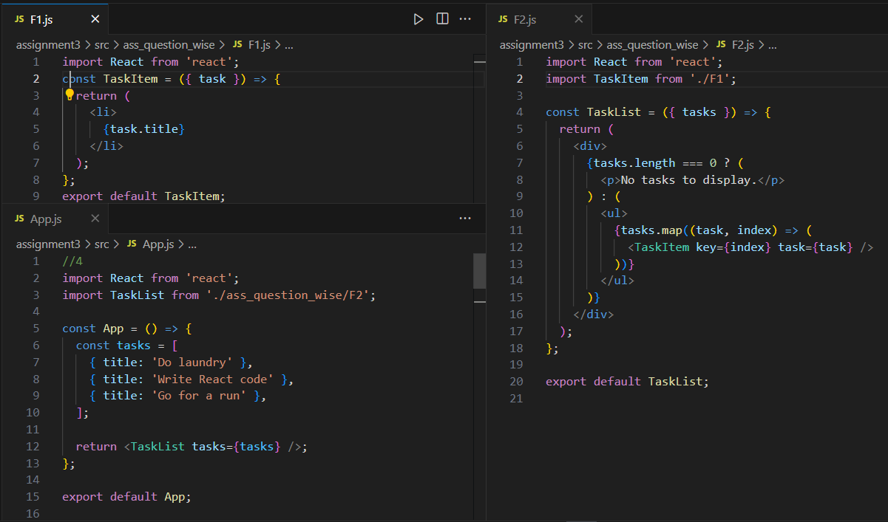
- Output :-
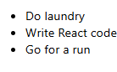

- State: In the TaskManager component, manage the list of tasks using state. Initially, you can provide some sample tasks within the state.
- APP.JS :-
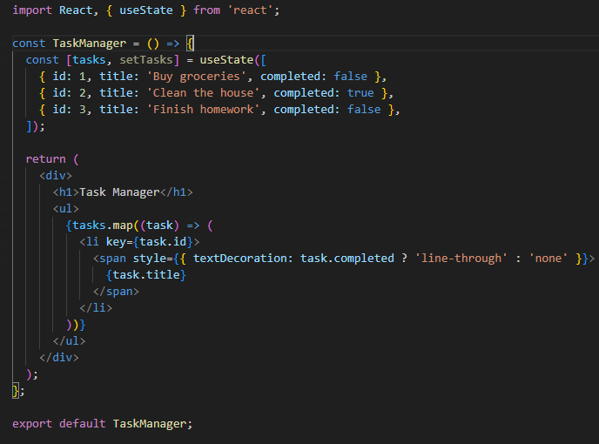
- Output :-
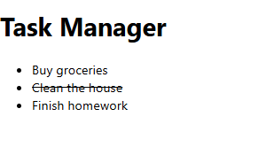

- Props: Pass the list of tasks as props from the TaskManager component to the TaskList component. Each TaskItem should receive a task object as a prop.
  - CODE :-
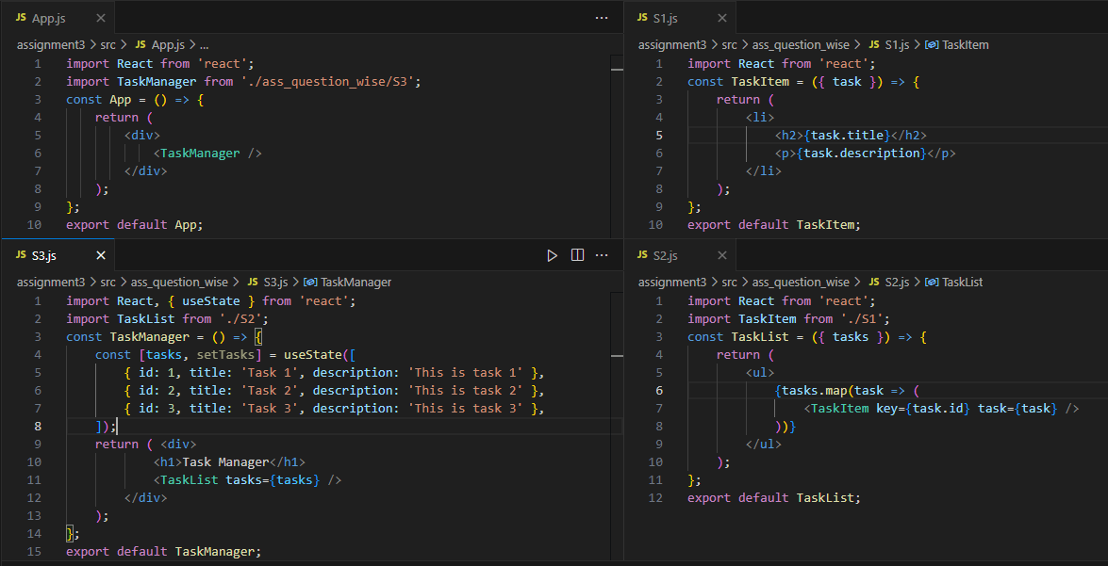
  - Output :-
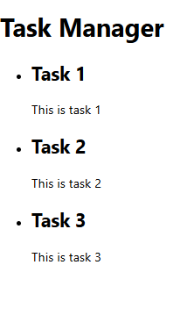
- Form (Controlled Component): Create a form component called TaskForm within the TaskManager component. This form should allow users to add new tasks. Use controlled components to manage form input values.
  - APP.JS :-
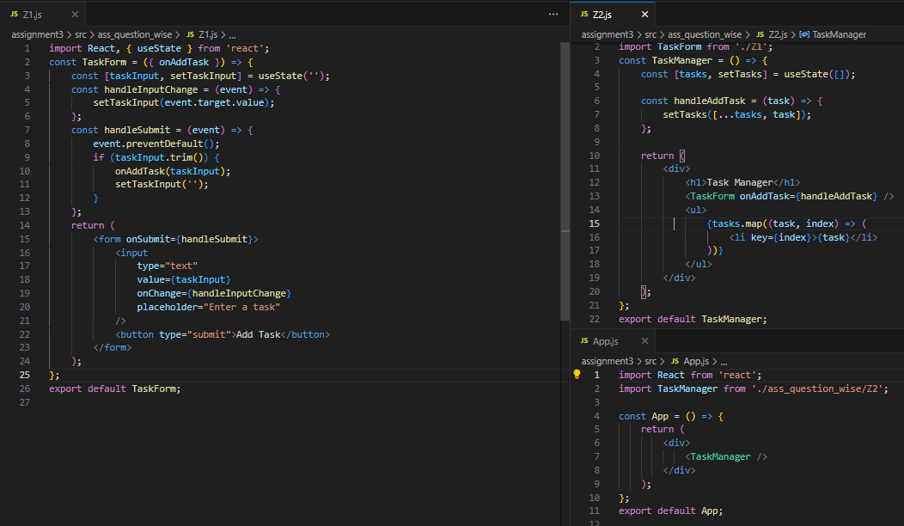
  - Output :-
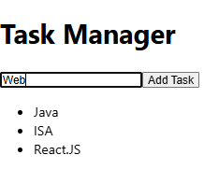
- GitHub Link :-
https://github.com/Dhruvi-Vavadiya/ReactJS/blob/main/Practical_Assignment_3.docx

