**Practical Assignment-3**

|  |  |
| --- | --- |
| **Name** | **Vavadiya Dhruvi Maheshbhai** |
| **Cource** | **Msc.ICT(sem-1)** |
| **Roll No :** | **73** |
| **Subject** | **101(Frontend Development using ReactJs)** |

* **Build a Small Task Management Website in React.js**
* **Create a small website for managing tasks. The website should have the following features:**

1. Class Components: Implement a class component called TaskManager that will serve as the main container for managing tasks. This component should have a state to store the list of tasks.

* **APP.JS :-**

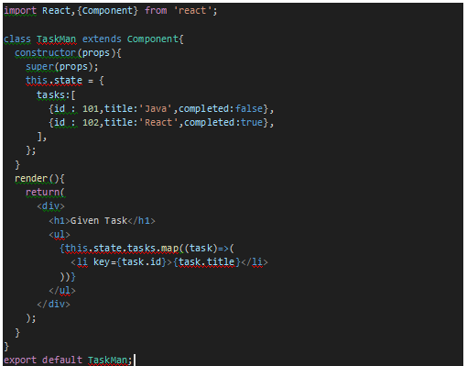

* **Output :-**

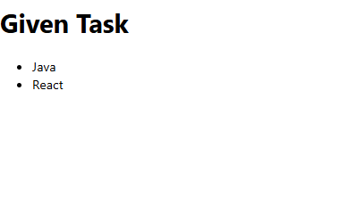

1. Functional Components: Create a functional component called TaskList responsible for displaying a list of tasks. It should receive the list of tasks as props from the TaskManager component.

* **Second.js :-**

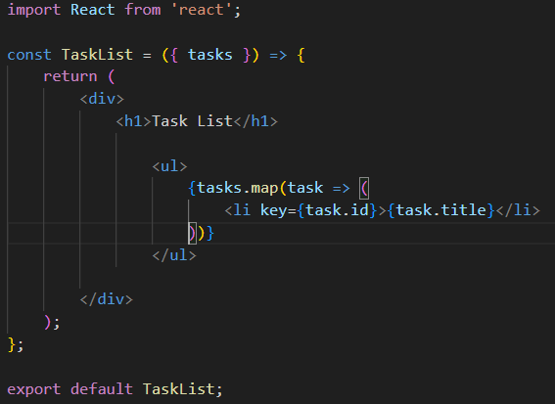

* **APP.JS :-**

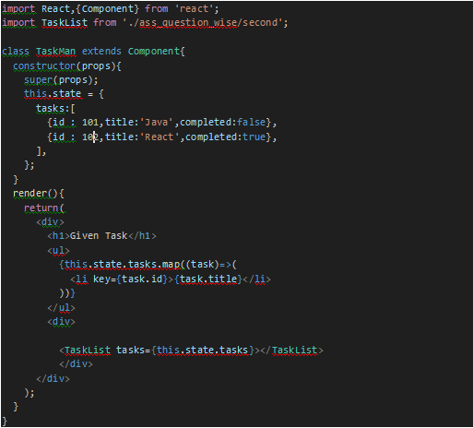

* **Output :-**

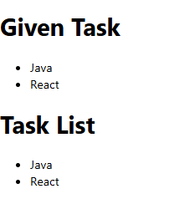

1. Nested Components: Inside the TaskList component, create a child component called TaskItem that represents an individual task.

* **Code:-**

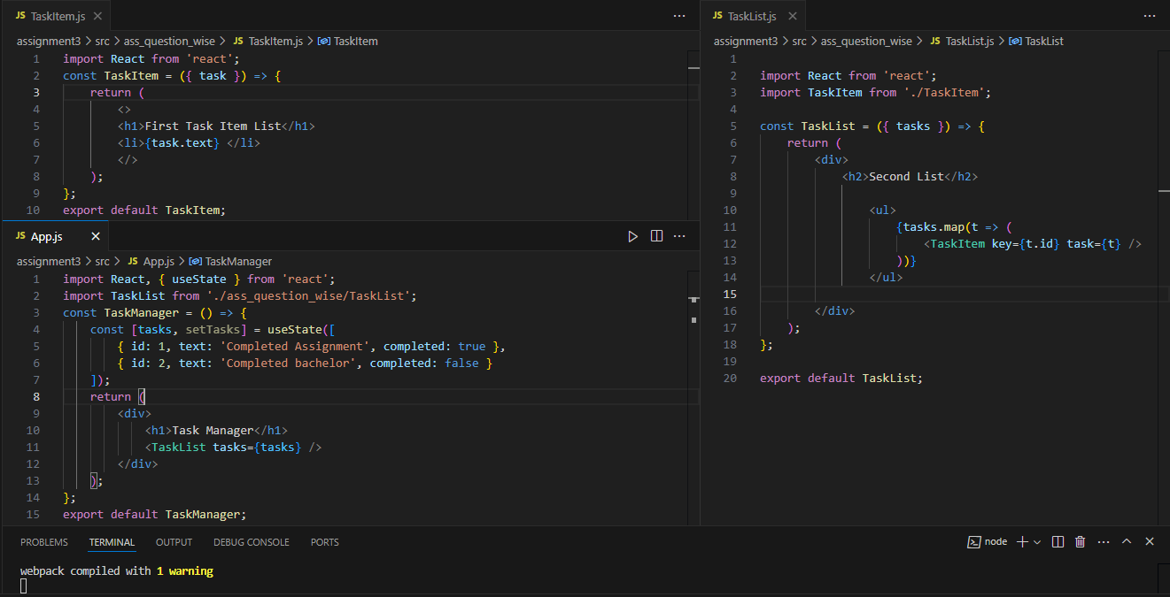

* **Output :-**

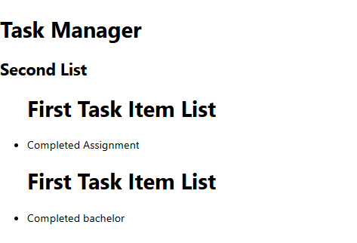

1. Conditional and Looping Constructs: Implement conditional rendering in the TaskList component. If there are no tasks, display a message like &quot;No tasks to display.&quot; Use a loop (e.g., map) to render each TaskItem.

* **CODE :-**

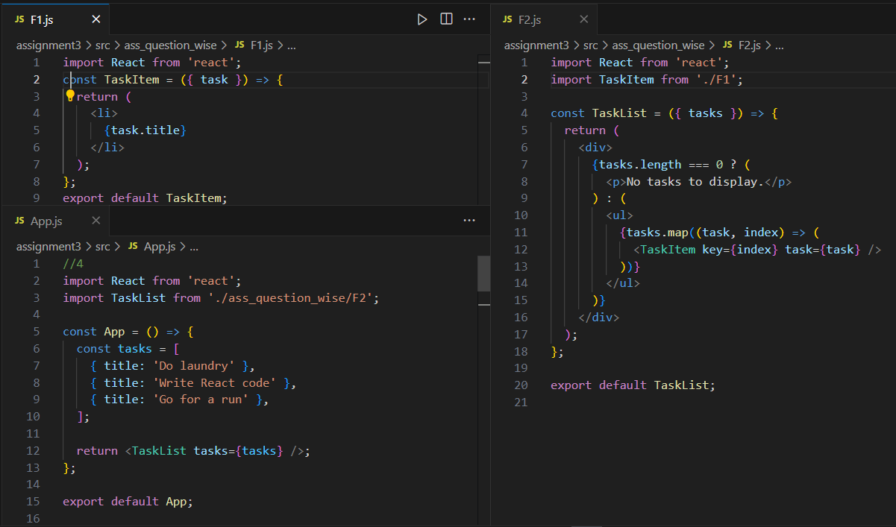

* **Output :-**

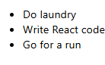

1. State: In the TaskManager component, manage the list of tasks using state. Initially, you can provide some sample tasks within the state.

* **APP.JS :-**

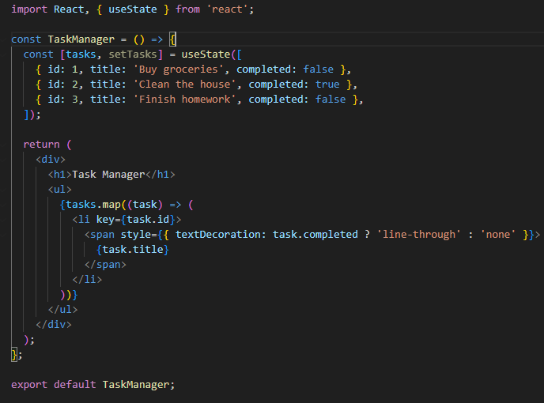

* **Output :-**

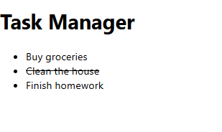

1. Props: Pass the list of tasks as props from the TaskManager component to the TaskList component. Each TaskItem should receive a task object as a prop.
   * **CODE :-**

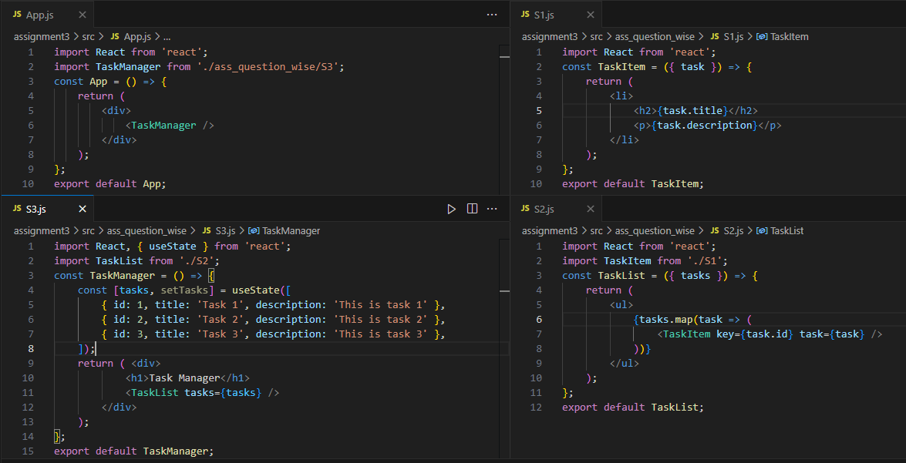

* + **Output :-**

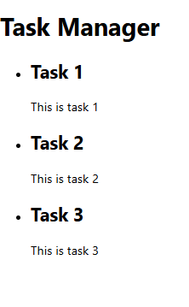

1. Form (Controlled Component): Create a form component called TaskForm within the TaskManager component. This form should allow users to add new tasks. Use controlled components to manage form input values.
   * **APP.JS :-**

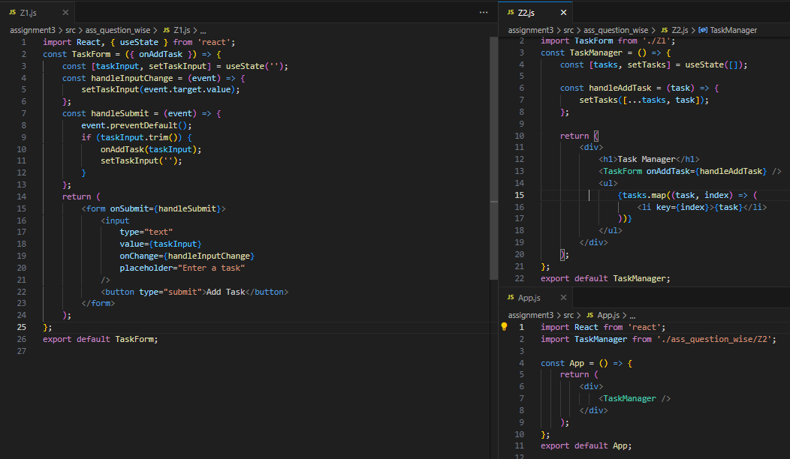

* + **Output :-**

