Prevention of Duplicate Products in Whishlist.

Overview :
In the present scenario, if we add the same product multiple times, it will take and increase the quantity. So in this implementation if a user adds one product to the wishlist, next he/she will get an icon to remove the product from the wishlist if they try to add the same product again and they can remove that product from the wishlist.

Frontend :

- Once a product is added, text will be changed from “Add to wishlist” to “Remove from wishlist” and vice-versa.
- This is done at PLP and as well as PDP.
- After every action a message is displayed whether it is removed/added from the wishlist.

Working :

- In the product list page, for every product we have a button called “Add to Wishlist”.
- If a user wants to add the product to wishlist i.e., save for later they can add it here.
- Once a product is added, it cannot be added again.
- If the user tries to add a product again, in the place of “Add to wishlist” the user will be able to see “Remove from Wishlist.
- In PDP by clicking on “Remove from wishlist” product will be removed from Wishlist
- In PLP by clicking on heart shape users can add/remove products.

Details :

- Before adding the product to the wishlist.

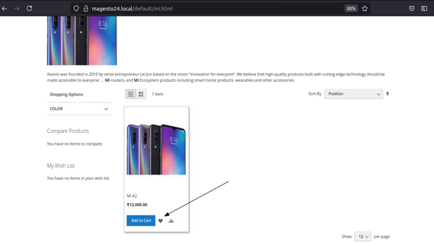
Figure 1: Product List Page

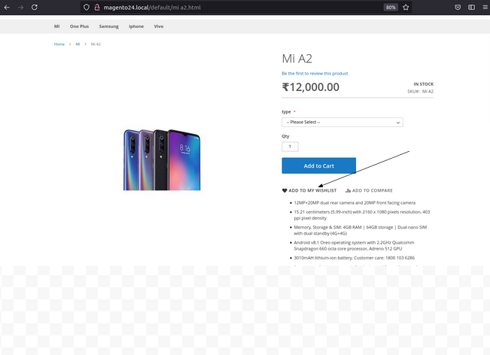
Figure 2 : Product Display Page

- After a Product is added to the wishlist, My Wishlist page is rendered and a message will be displayed.
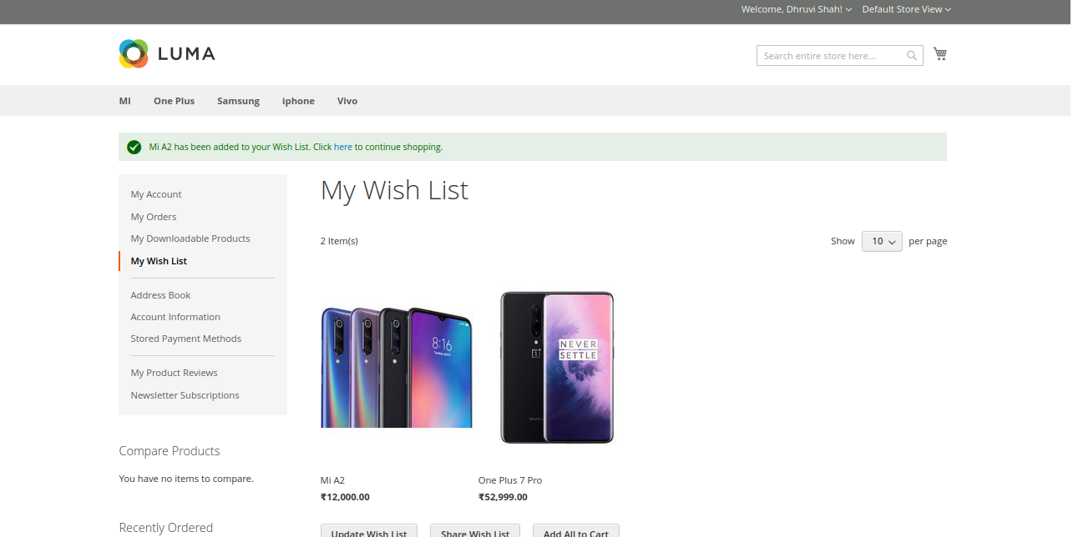
Figure 3 : My Wishlist after adding product.

- If Product is already present in the wishlist.

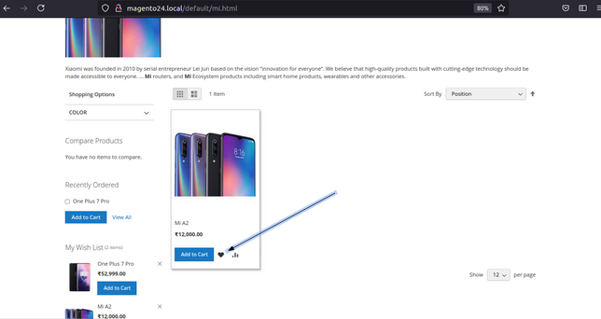
Figure 4 : Product List Page

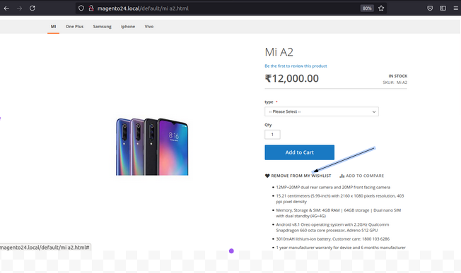
Figure 5 : Product Display Page

- When Removed from wishlist from PDP

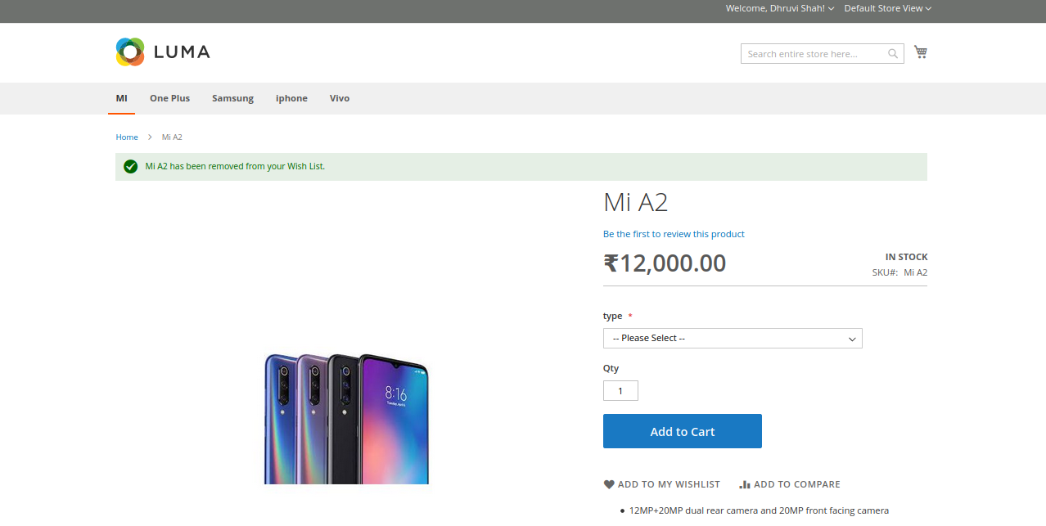
Figure 6 : After removing from the wishlist(PDP).

- When Removed from wishlist from PLP
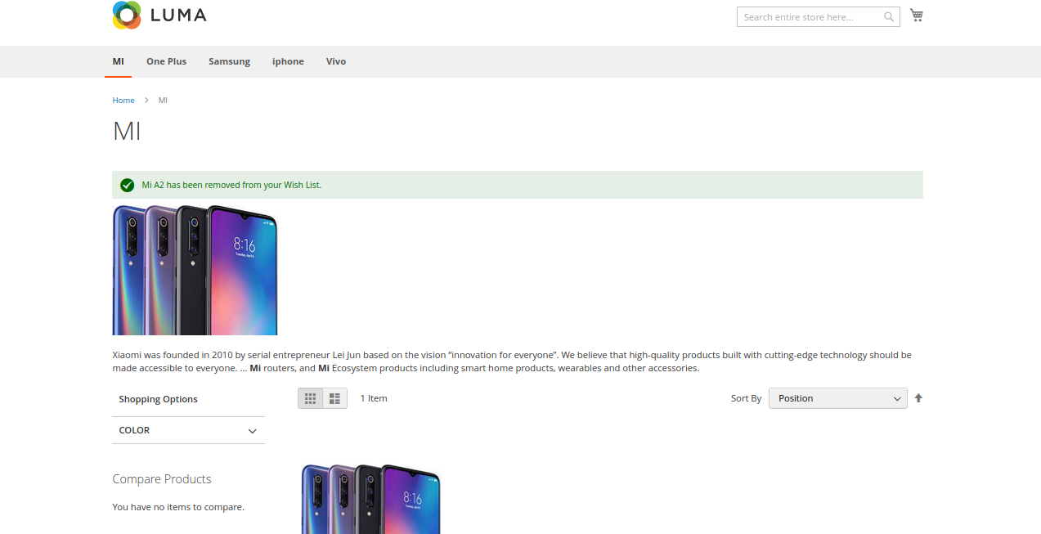
Figure 7 : After removing from the wishlist(PLP).

