


G H PATEL COLLEGE OF ENGINEERING & TECHNOLOGY
(THE CHARUTAR VIDYA MANDAL (CVM) UNIVERSITY)
DEPARTMENT OF COMPUTER ENGINEERING

A MINI PROJECT REPORT ON
" CAMPUS EVENT MANAGEMENT SYSTEM
(CEMS)"

Subject :
Advanced Java Programming (Subject Code: 202045605)
Submitted By:
Bhaktiba Gohil
Enrollment No.: 12402040501012
Dhruvi Patel
Enrollment No.: 12402040501020

Guided By:
Dr. Hetal Gaudani
Assistant Professor
Department of Computer Engineering
GCET, CVM University
Academic Year: 2026-27

TABLE OF CONTENTS
ABSTRACT ……………………………………………………………………………. | 3
1. INTRODUCTION …………………………………………………………………... | 4
2. PROBLEM STATEMENT, OBJECTIVES & SCOPE ………………………….. | 5
3. SYSTEM REQUIREMENTS & TECHNOLOGY STACK ……………………... | 6
4. SYSTEM DESIGN & ARCHITECTURE ………………………………………… | 7
5. DATABASE DESIGN ……………………………………………………………… | 9
6. IMPLEMENTATION DETAILS & WORKING FLOW ……………………….. | 11
7. CODE IMPLEMENTATION ……………………………………………………... | 14
8. OUTPUT & SCREENSHOTS …………………………………………………….. | 16
9. ADVANTAGES & LIMITATIONS OF THE SYSTEM ………………………… | 18
10. CONCLUSION & FUTURE SCOPE ……………………………………………. | 19
REFERENCES ………………………………………………………………………… | 20

ABSTRACT
Higher education institutions regularly organize technical symposiums, cultural festivals, academic seminars, coding hackathons, and skill-building workshops. In traditional campus administration, organizing these activities relies heavily on disjointed manual workflows, such as shared spreadsheets, unstructured paper registrations, decentralized Google Forms, and informal communication channels like messaging groups. These fragmented approaches introduce severe operational bottlenecks, including inadvertent duplicate student registrations, manual participant verification delays, seat overbooking during peak demand, lack of event rule enforcement, difficulty managing multi-member team formations, and a complete absence of real-time administrative analytics.
To systematically resolve these challenges, the Campus Event Management System (CEMS) was developed as an enterprise-grade Java web application. Designed around a robust three-tier Model-View-Controller (MVC) architecture, CEMS centralizes event scheduling, student enrollment, team composition, seat allocation, and institutional reporting within a cohesive digital platform. The presentation tier employs JavaServer Pages (JSP), HTML5, CSS3, and JavaScript to deliver an intuitive interface for students and administrators. The application and business logic layers are engineered using Java Servlets, object-oriented domain models, a decoupled Data Access Object (DAO) layer, and a dedicated Java Event Registration Rule Engine that rigorously enforces institutional policies before confirming any enrollment.
To ensure bulletproof reliability under heavy concurrent registration loads, CEMS integrates Java multithreading synchronization primitives and explicit JDBC transaction boundaries, completely eliminating race conditions and seat overbooking. Furthermore, the system establishes a dual-tier persistence design: standard JDBC with PreparedStatements handles high-throughput transactional seat allocations, while Hibernate 5.4 ORM and Hibernate Query Language (HQL) are leveraged for complex administrative aggregation and institutional analytics. Role-based access control, cryptographic password hashing, and server-side validation protect institutional data integrity. CEMS demonstrates how classical Java enterprise patterns deliver a deterministic, scalable, and audit-compliant event management solution for modern colleges.
Keywords: Java Web Application, Java Servlets, JSP, JDBC Transactions, Concurrency Control, Hibernate ORM, HQL Analytics, Event Registration Rule Engine, Campus Automation.

1. INTRODUCTION
1.1 Background
Extracurricular and co-curricular events constitute a fundamental pillar of university education, fostering technical prowess, innovation, creative arts, and leadership among collegiate cohorts. Throughout an academic calendar, campus organizations, departmental student chapters, and administrative boards orchestrate a dense portfolio of activities ranging from hands-on programming hackathons and scientific paper presentations to cultural stage performances and athletic meets. Efficient administration of these events necessitates precise coordination across participant onboarding, resource reservation, team roster validation, capacity enforcement, and credential tracking.
1.2 Need for the System
Despite rapid digital transformation across collegiate grading and admissions, extracurricular event operations in many institutions remain antiquated. Conventional methods leverage unintegrated tools such as paper registration slips, third-party forms, and ad-hoc spreadsheets managed by student coordinators. These decoupled approaches manifest numerous chronic deficiencies:
- Administrative Friction: Manual verification overheads where student credentials, enrollment statuses, and email addresses must be manually cross-referenced against institutional rolls.
- Capacity Overrun: Vulnerability to race conditions during high-demand event openings, leading to overbooking and venue capacity violations.
- Team Disorganization: Difficulty in managing multi-student team configurations, often leading to unregistered ghost participants, contradictory membership, and partial rosters.
- Reporting Blindspots: Absence of real-time administrative visibility, preventing faculty conveners from evaluating enrollment velocity, capacity utilization, and engagement metrics.
- Policy Inconsistency: Inconsistent policy enforcement regarding late registrations, schedule clashes, and registration cancellations.
1.3 Overview of CEMS
The Campus Event Management System (CEMS) is a specialized web-based application designed to establish a unified, automated, and deterministic operational framework for college event governance. Built natively on the Java platform, CEMS enforces complete separation of concerns by bridging dynamic JSP interfaces with transactional Java Servlets, an enterprise Service/DAO layer, and a relational MySQL database. By implementing a dedicated Java Event Registration Rule Engine and synchronized concurrency control, CEMS ensures that every student registration—whether individual or team-based—is strictly verified against institutional rules, seat limits, and temporal registration windows prior to persistent database commitment.

2. PROBLEM STATEMENT, OBJECTIVES & SCOPE
2.1 Problem Statement
Traditional college event management practices rely heavily on disparate tools such as Google Forms, physical registration desks, spreadsheets, and messaging applications. These decentralized and manual mechanisms consistently result in severe operational failures, including duplicate enrollments, lack of real-time seat tracking, overbooking beyond venue limits, complex and error-prone team member verification, unauthorized registrations past strict deadlines, and an inability to dynamically compile unified participation analytics. Therefore, there is a critical need for a centralized, robust, and concurrent Java web-based application capable of automating the entire event lifecycle while guaranteeing transactional data integrity and deterministic business rule enforcement.
2.2 Objectives of the Project
The development of the Campus Event Management System is guided by the following concrete engineering objectives:
- Centralization: To design and deploy a centralized web-based platform facilitating seamless event publication, participant onboarding, and schedule governance.
- Access Control: To implement role-based access control (RBAC) establishing isolated, authenticated operating environments for students and administrative conveners.
- Automated Validation: To engineer a modular Java Event Registration Rule Engine that automatically validates deadlines, duplicate entries, team size thresholds, and event conflicts.
- Concurrency Control: To eliminate overbooking anomalies during concurrent registration spikes through Java multithreading synchronization and explicit JDBC database transactions.
- Team Management: To automate team event registrations by dynamically fetching verified peer accounts using institutional email lookups, preventing manual identity spoofing.
- Institutional Analytics: To integrate Hibernate 5.4 ORM and HQL to deliver administrative analytics on event turnout, capacity utilization, and popular categories.

2.3 Scope of the Project
The functional scope of CEMS encompasses campus-wide academic and co-curricular event ecosystems within an engineering or university institution. Specifically, the system governs:
- Technical Events: Technical workshops, coding hackathons, coding contests, robotics challenges, and paper presentation symposia requiring individual or multi-participant team structures.
- Academic Seminars: Guest lectures, industry seminars, faculty development programs, and department orientations with fixed seating limits and strict individual registration flows.
- Cultural Festivals: Fine arts competitions, music and dance festivals, drama productions, and debate tournaments supporting both solo participants and multi-member team rosters.
3. SYSTEM REQUIREMENTS & TECHNOLOGY STACK
3.2 Software Requirements
The software platform requirements necessary to compile, deploy, and execute CEMS are specified in Table 3.2.
Layer / Component | Development & Deployment Specification
Operating System | Microsoft Windows 10/11, Ubuntu Linux 20.04+, or macOS
Java Development Kit | Oracle JDK 11 or OpenJDK 11 LTS
Web / Servlet Container | Apache Tomcat 9.0.x (Jakarta Servlet API 4.0 compliant)
Database Server | MySQL Server 8.0 Community Edition
Database Driver | MySQL Connector/J 8.0.x JDBC Driver
ORM Framework | Hibernate ORM 5.4.x Final Core Library
Client Web Browser | Google Chrome 110+, Mozilla Firefox 110+, or Microsoft Edge
Integrated Dev. Env. (IDE) | Visual Studio Code (with Java Extension Pack) / Eclipse IDE / IntelliJ
Table 3.2: Software Requirements Specification
3.3 Technology Stack Summary
Architectural Tier | Technologies Employed | Functional Responsibility
Presentation Tier | JSP, HTML5, CSS3, JavaScript | Dynamic view rendering, user interaction, client input forms
Controller Tier | Java Servlets (HttpServlet) | Request routing, session validation, workflow orchestration
Business / Service Tier | Core Java (OOP, Rule Engine, Threads) | Policy validation, capacity checks, concurrency synchronization
Persistence Tier | JDBC & Hibernate 5.4 ORM | JDBC for transactions/seat locking; Hibernate for analytics
Database Tier | MySQL 8.0 Relational DBMS | Relational persistence, foreign key enforcement, acid transactions
Table 3.3: Technology Stack Summary
3.4 Rationale for Technology Selection
The technology stack was chosen based on architectural determinism, thread safety, and syllabus alignment. Java Servlets and JSP provide a mature, standardized platform for MVC web computing without heavy proprietary framework abstractions. JDBC is explicitly utilized for transactional seat allocations where raw query execution speed, low-level transaction boundaries (commit/rollback), and synchronized locking are essential. Conversely, Hibernate 5.4 is integrated specifically for administrative aggregation, capitalizing on Object-Relational Mapping (ORM) and HQL to abstract multi-table joins when deriving analytics.
4. SYSTEM DESIGN & ARCHITECTURE
4.1 Overall Architecture
CEMS is built upon a decoupled 3-tier Model-View-Controller (MVC) architecture. This structural paradigm guarantees strict separation between UI rendering, business rule processing, and persistence.
- Presentation Tier (View): Composed of JSP pages enriched with CSS3 and vanilla JavaScript. JSPs render dynamically using standard JavaBean data transfer objects (DTOs) passed through the Servlet request context.
- Controller & Business Tier (Controller/Model): Java Servlets act as controllers, parsing incoming HTTP GET/POST requests, enforcing session credentials, and delegating execution to the Service Layer and Java Event Registration Rule Engine.
- Persistence & Database Tier (Model): Implements a decoupled Data Access Object (DAO) architecture. Transactional seat operations are routed through JDBC PreparedStatements, while administrative metrics are queried through Hibernate 5.4 ORM sessions.
4.2 System Architecture Diagram
The end-to-end structural communication between client browsers, web containers, application services, and persistent databases is illustrated in Figure 4.1.
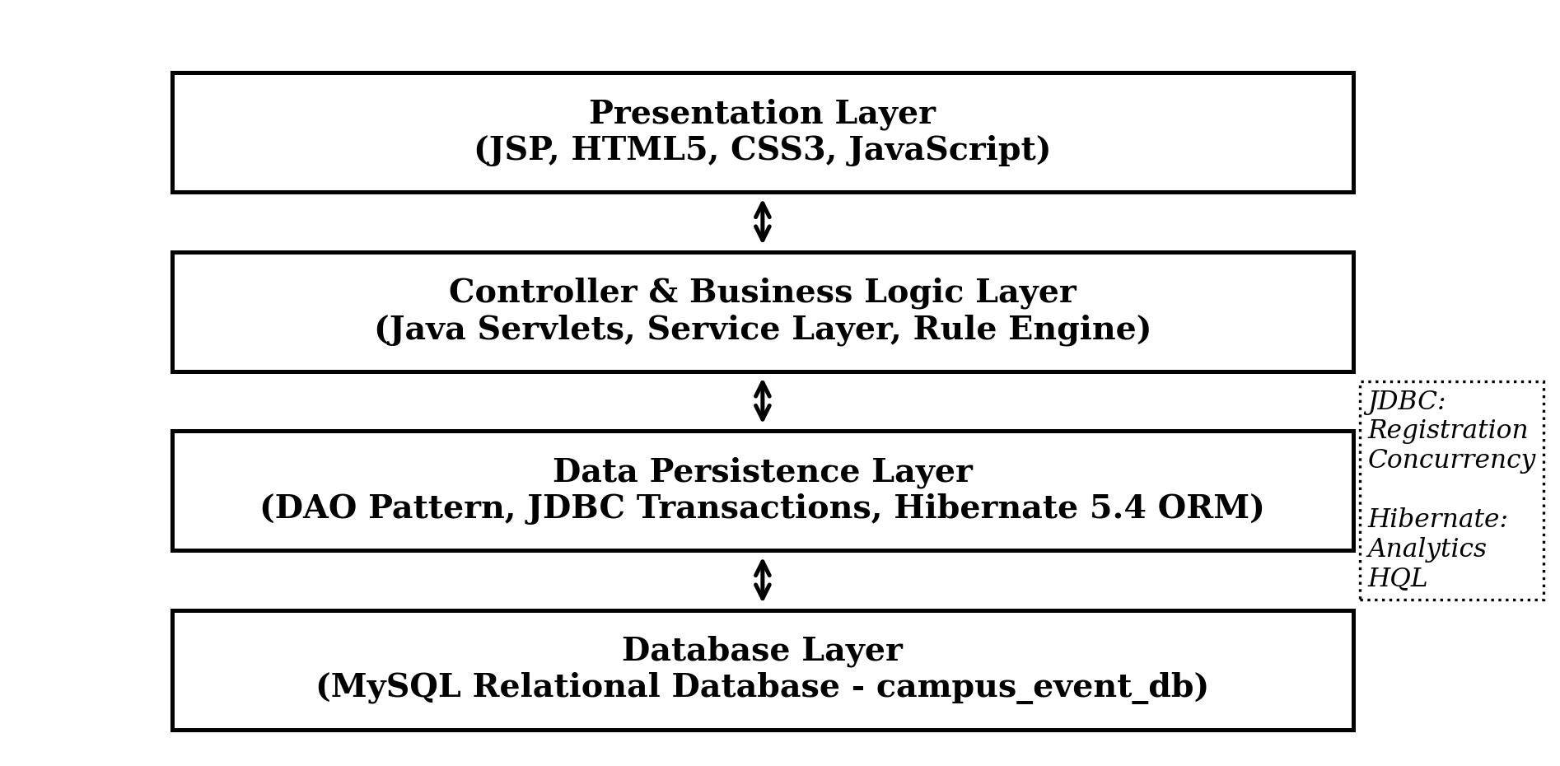
Figure 4.1: Three-Tier System Architecture of CEMS
4.3 System Modules
The operational landscape of CEMS is organized into modular functional units:
- Authentication Module: Governs user registration, credential hashing, login authentication, session establishment, and role-based access gating (Student vs. Admin).
- Event Governance Module: Permits administrators to schedule events, configure participant capacities, define deadlines, and set team size thresholds.
- Event Registration Rule Engine: Executes automated pre-registration policy checks including deadline verification, capacity inspection, duplicate entry detection, and event conflict logic.
- Concurrent Seat Allocation: Coordinates thread-safe capacity decrementing and enrollment record insertion under atomic transactional control.
- Team Formation Module: Enables team leaders to build rosters by querying existing registered student accounts via email, validating roster limits and duplicate memberships.
- Administrative Analytics: Leverages Hibernate ORM and HQL to aggregate turnout rates, event popularity, and capacity utilization for institutional reporting.
4.4 Core Operational Workflow
When an authenticated student initiates an event registration, the request is directed to the registration controller Servlet. The Servlet extracts session tokens to identify the user and invokes the Rule Engine. If all business rules evaluate successfully, the request enters the synchronized seat allocation block. The database transaction executes atomically: verifying available capacity, decrementing available seats, inserting the registration record, and committing the transaction. Any violation triggers a complete rollback and presents a descriptive error message to the student.

5. DATABASE DESIGN
5.1 Database Overview
The persistence tier of CEMS is hosted on a relational MySQL database named campus_event_db. The database schema is engineered in Third Normal Form (3NF) to completely prevent update anomalies, avoid redundant data storage, and guarantee strict referential integrity across all entities.
5.2 Main Tables
Table 5.1 outlines the primary relational tables, their functional roles, primary keys, and foreign key dependencies within the campus_event_db database schema.
Table Name | Primary Key | Foreign Keys | Description & Operational Purpose
users | user_id | None | Stores student and admin credentials (name, unique email, hashed password, role).
events | event_id | None | Stores event metadata: title, description, date/time, capacity, registered_count, deadline, type.
registrations | reg_id | user_id, event_id, team_id | Maintains enrollment records; tracks individual and team enrollments, timestamp, and status.
teams | team_id | event_id, leader_id | Maintains team entities for collaborative events, associating team names with designated leaders.
team_members | member_id | team_id, user_id | Junction table mapping registered student members to their corresponding team entity.

Table 5.1: Database Schema Overview (campus_event_db)
5.3 Entity Relationships
The structural cardinality and relational constraints linking the core database entities are diagrammed in Figure 5.1.
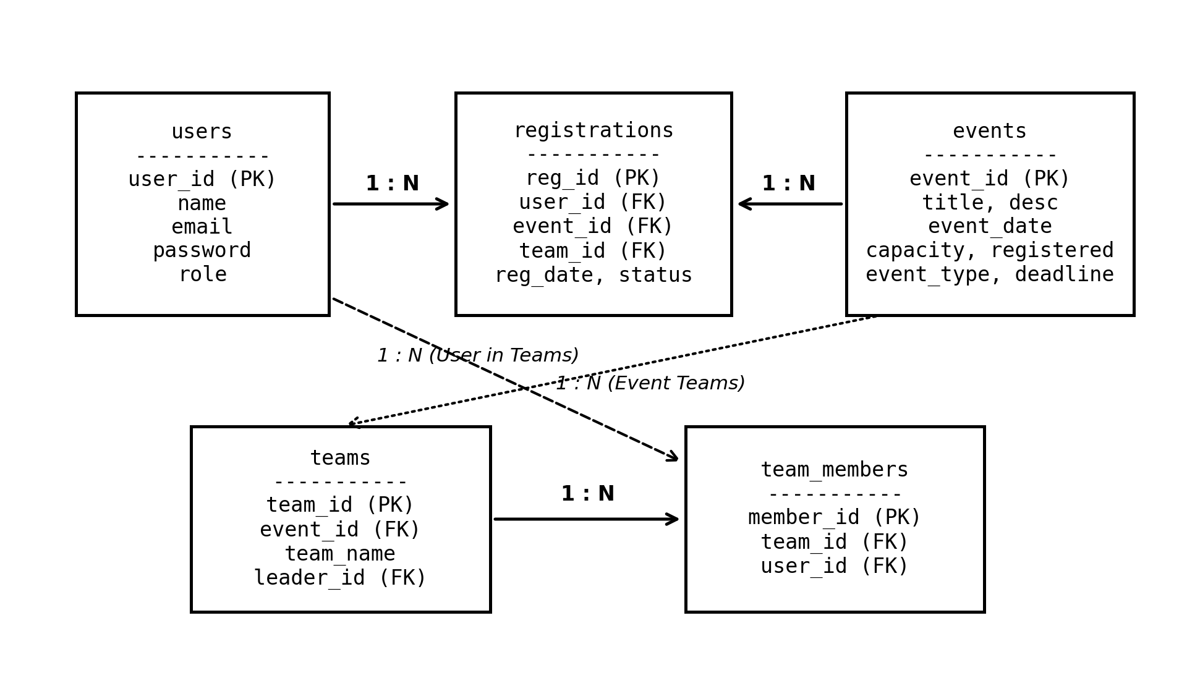
Figure 5.1: Entity-Relationship Diagram of CEMS Database Schema
5.4 Data Integrity
Data consistency is enforced across the database schema through explicit constraints and transactional boundaries:
- Primary Key Constraints: Surrogate auto-increment integer keys (user_id, event_id, reg_id, team_id, member_id) guarantee row uniqueness and optimized B-Tree index traversal.
- Referential Integrity: Cascading foreign keys link registrations to users and events. Deleting or modifying parent records without resolving dependencies is strictly restricted.
- Unique Constraints: A unique constraint on users.email prevents duplicate account creations. Similarly, composite unique logic enforces single enrollments per student per event.
- Transactional Integrity: Multi-table write operations (such as registering all team members while updating seat allocations) execute under explicit ACID database transactions.

6. IMPLEMENTATION DETAILS & WORKING FLOW

6.1 User Authentication and Event Management
CEMS provides separate authentication and access control for Students and Administrators. During login, AuthServlet validates the submitted email and password using SHA-256 hashing and a parameterized JDBC query. On successful login, an HttpSession stores the user ID, name, email, and role. Server-side filters restrict access according to the user's role, and session.invalidate() is used during logout.
Administrators manage the complete event lifecycle through dedicated servlets and DAO classes. They can create, update, cancel, and manage events with details such as title, description, venue, date, time, capacity, registration deadline, event type, and team size limits.

6.2 Individual Event Registration
The student selects an available event and submits the registration request through RegistrationServlet. The request is first processed by the Java Event Registration Rule Engine, which validates the registration deadline, duplicate registration, event capacity, event conflict, and other applicable conditions.
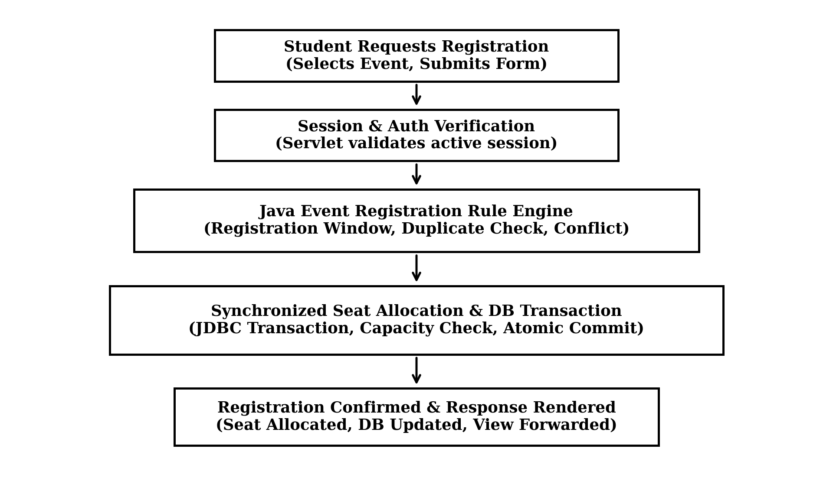
After successful validation, the registration service performs seat allocation using Java synchronization and a database transaction. The event's registered count and registration record are updated together. If any operation fails, the transaction is rolled back to maintain database consistency.
Figure 6.1: Complete Event Registration Processing Flow

6.3 Java Event Registration Rule Engine
CEMS centralizes registration validation in a dedicated Java Rule Engine instead of scattering conditions across servlets. The main rules are:
- Registration Window: Checks whether registration is still open.
- Duplicate Registration: Prevents a student from registering for the same event more than once.
- Capacity: Rejects registration when the event is full.
- Event Conflict: Checks for overlapping confirmed registrations.
- Team Size: Validates minimum and maximum team limits.
- Team Membership: Prevents duplicate membership in the same event.
- Cancellation: Allows cancellation only within the permitted period.
This approach keeps the registration logic centralized and reusable.

6.4 Concurrent Seat Allocation
CEMS handles simultaneous registration requests to prevent overbooking. The critical seat allocation operation is synchronized at the Java service layer, while JDBC transactions use SELECT ... FOR UPDATE to lock the event record during seat allocation.

6.5 Team Event Registration
For team events, the student becomes the Team Leader and provides a team name. Additional members are selected using their registered email addresses. The system searches the users table through UserDAO and displays the verified name instead of allowing the leader to manually enter it.
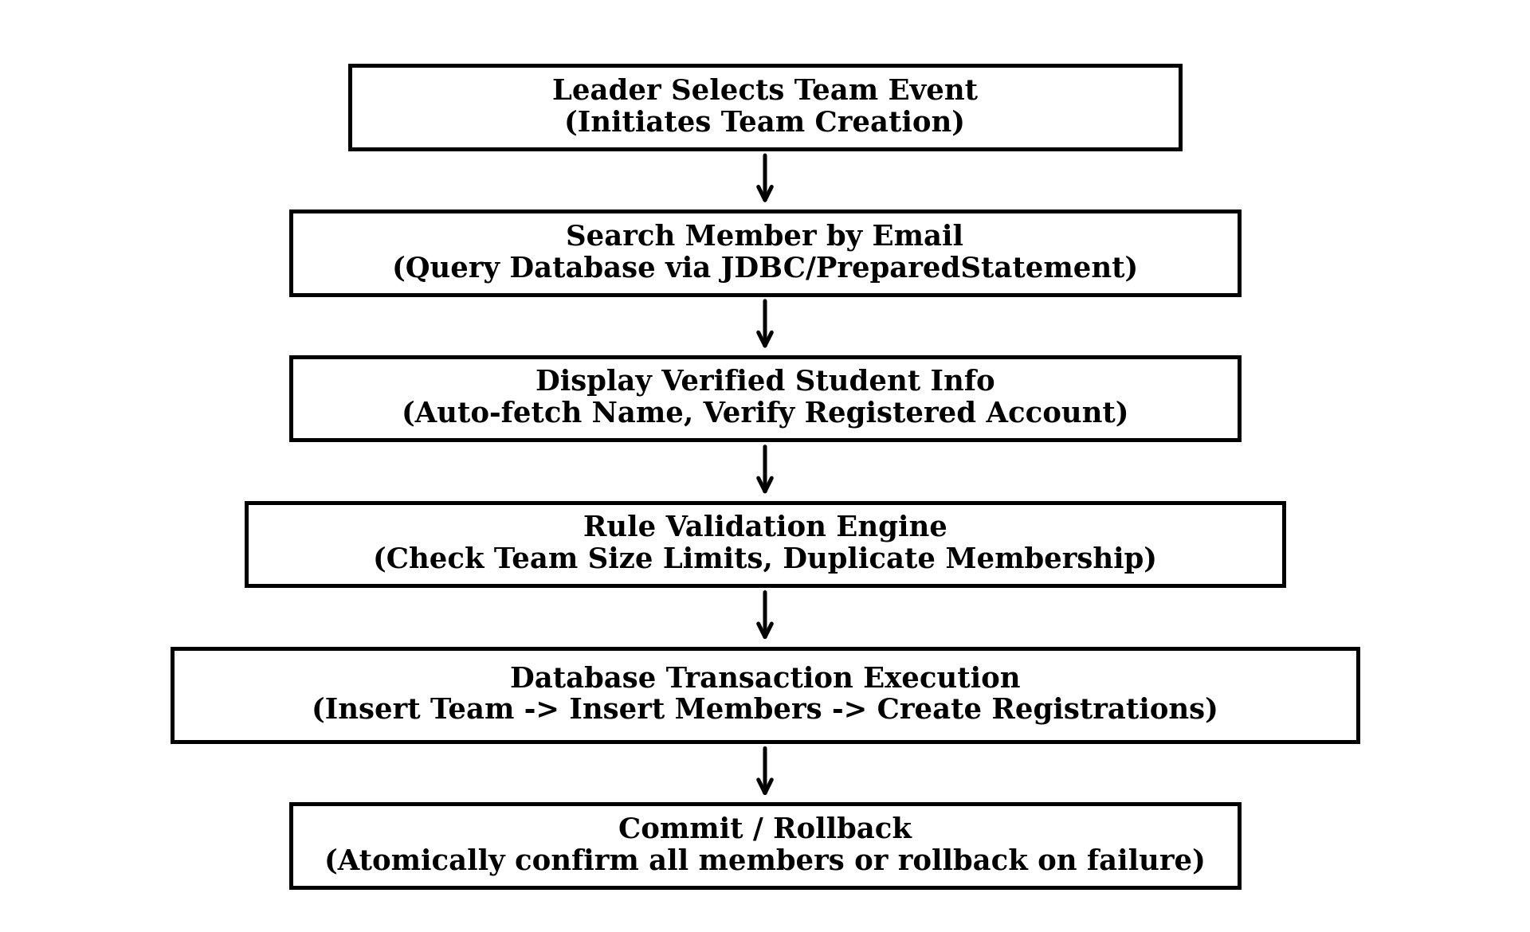

Figure 6.2: Team Formation and Verified Member Registration Flow

6.6 Registration Cancellation
Students can cancel eligible registrations from the My Registrations section. The Rule Engine checks the cancellation deadline before processing the request. On successful cancellation, the registration status is updated to CANCELLED and the event's registered count is adjusted within a transaction. For team registrations, the related team records are also handled according to the cancellation process.

6.7 Hibernate Analytics and HQL
JDBC is used for transactional operations such as registration and seat allocation, while Hibernate 5.4 is used for administrative analytics. Hibernate maps database tables to Java entities such as User, Event, Registration, Team, and TeamMember using annotations including @Entity, @Table, @Id, @ManyToOne, and @OneToMany.
The admin dashboard uses HQL for object-oriented reporting, such as total events, registrations, event-wise participation, category distribution, and capacity utilization. This demonstrates the use of ORM and HQL without replacing the existing JDBC-based transaction layer.

6.8 Security Implementation
CEMS applies multiple security measures throughout the application:
- Password Hashing: Passwords are stored using SHA-256 hashing with salt.
- SQL Injection Prevention: JDBC PreparedStatement is used for database queries.
- Role-Based Authorization: Java filters restrict Student and Admin operations.
- Session Management: Sessions are invalidated during logout.
- Input Validation: Server-side validation checks submitted form data before processing.
7. CODE IMPLEMENTATION
This chapter contains structured placeholders for the core technical Java source files that implement the primary architectural components of CEMS. These placeholders designate where actual production code should be inserted prior to final academic binding.
7.1 Database Connection & Data Access Object (DAO)

package com.campusevent.dao;
import com.campusevent.model.User;
import com.campusevent.util.DBConnection;
import com.campusevent.util.PasswordUtil;
public boolean registerUser(User user) {
String sql = "INSERT INTO users (name, email, password, role) VALUES (?, ?, ?, ?)";
Connection conn = null;
PreparedStatement pstmt = null;

try {
conn = DBConnection.getConnection();
pstmt = conn.prepareStatement(sql);
pstmt.setString(1, user.getName().trim());
pstmt.setString(2, user.getEmail().trim().toLowerCase());
String hashedPassword = PasswordUtil.hashPassword(user.getPassword());
pstmt.setString(3, hashedPassword);
String role = (user.getRole() != null && !user.getRole().trim().isEmpty()) ? user.getRole().toUpperCase() : "STUDENT";
pstmt.setString(4, role); System.err.println("UserDAO.registerUser SQL Error: " + e.getMessage());
e.printStackTrace();
return false;
} finally {DBConnection.closeResources(conn, pstmt);
} catch (SQLException e) {
System.err.println("UserDAO.isEmailExists SQL Error: " + e.getMessage());
e.printStackTrace();
} finally { DBConnection.closeResources(conn, pstmt, rs);
}
return false;
} public int getTotalStudentsCount() {
String sql = "SELECT COUNT(*) FROM users WHERE role = 'STUDENT'";
Connection conn = null;
PreparedStatement pstmt = null;
ResultSet rs = null;
return 0;
}

7.4 Team Registration Transaction Management

package com.campusevent.dao;

import com.campusevent.model.Team;
import com.campusevent.model.TeamMember;
import com.campusevent.model.User;
import com.campusevent.util.DBConnection;

import java.sql.Connection;
import java.sql.PreparedStatement;
import java.sql.ResultSet;
import java.sql.SQLException;
import java.sql.Statement;
import java.util.ArrayList;
import java.util.List;

/**
* Data Access Object for Team and Team Member operations.
* Handles database transactions for atomic team registration and cancellation.
*/
public class TeamDAO {

private EventDAO eventDAO = new EventDAO();

return new TransactionResult(true, "Team '" + teamName + "' registered successfully with " + teamSize + " members!");
} catch (Exception e) {System.err.println("TeamDAO.registerTeamAtomic Transaction Error: " + e.getMessage());
e.printStackTrace();
Connection conn = null;
PreparedStatement pstmt = null;
ResultSet rs = null;
return team; }pstmtSelectTeam.setInt(1, eventId); pstmtSelectTeam.setInt(2, leaderUserId);
rsTeam = pstmtSelectTeam.executeQuery();
if (!rsTeam.next()) {

rsMembers = pstmtSelectMembers.executeQuery();
public boolean success;
public String message;
public TransactionResult(boolean success, String message) {
this.success = success;
this.message = message;
}
}
}

8. OUTPUT & SCREENSHOTS
This chapter provides structured placeholders for the visual output and interface screenshots of the deployed Campus Event Management System. Actual application screen captures should be inserted within the designated frames below.
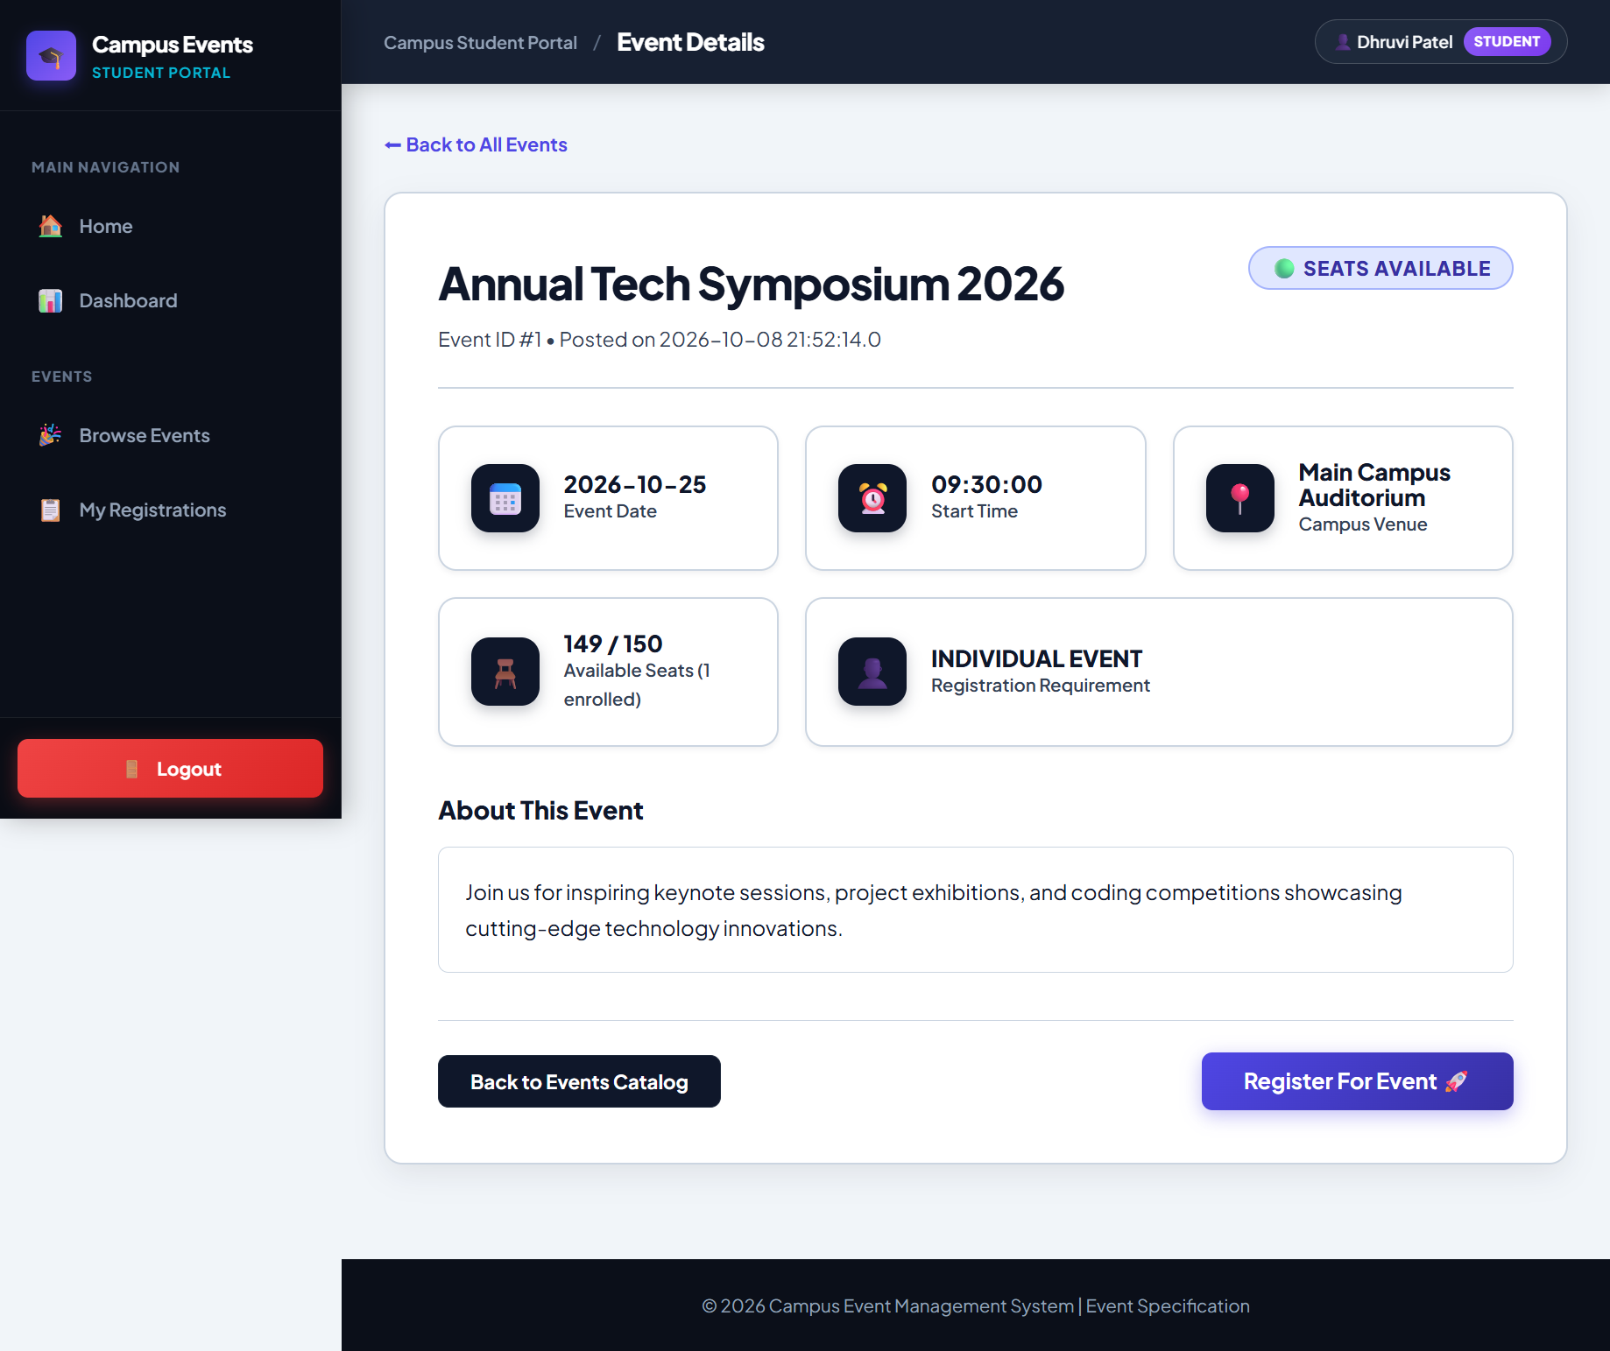  FIGURE 8.1: AUTHENTICATION INTERFACE (LOGIN PAGE) | 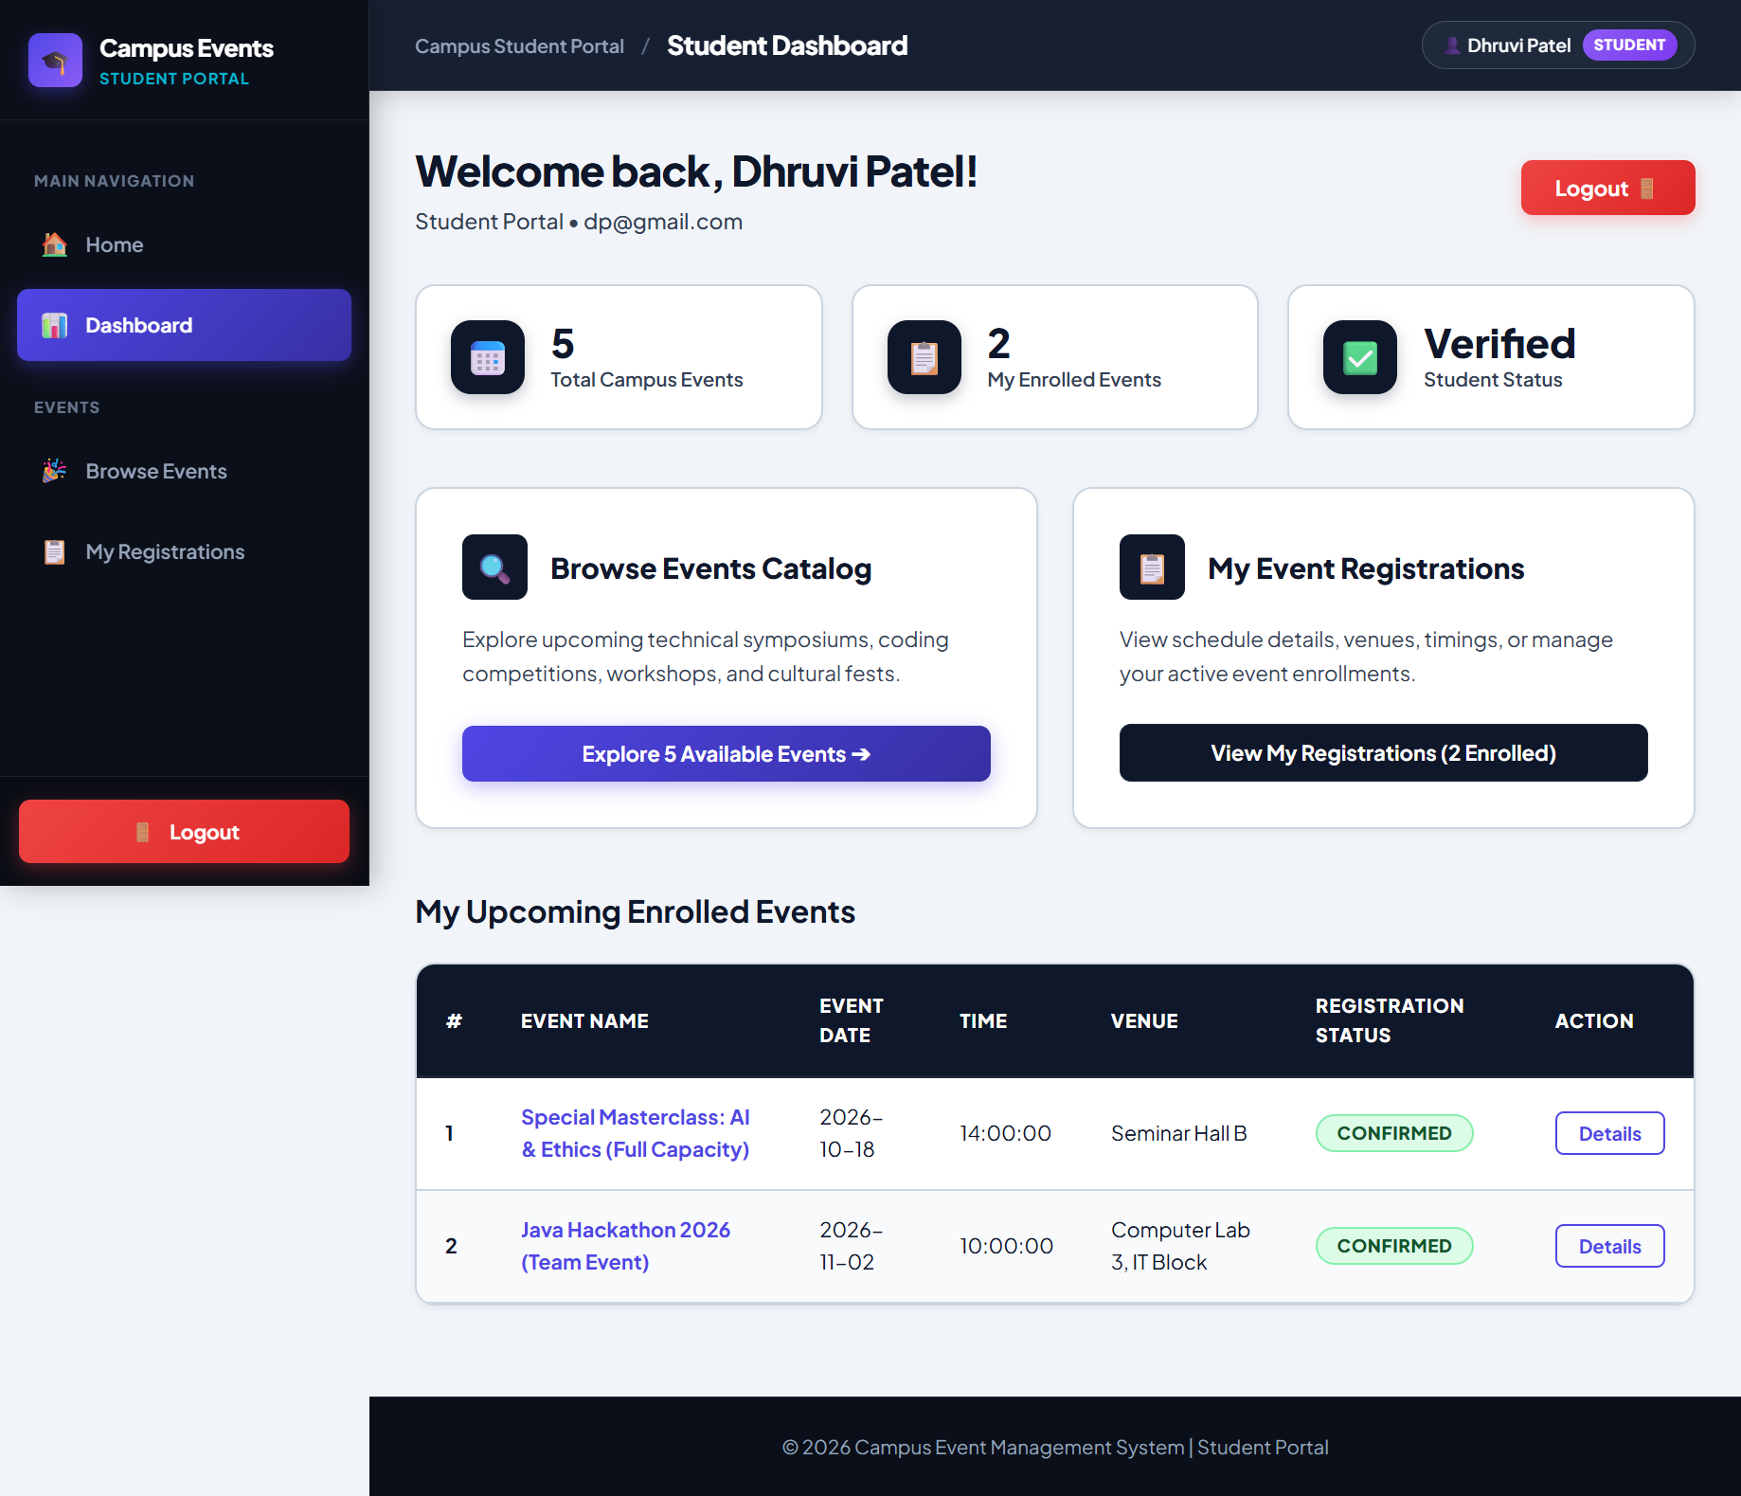  FIGURE 8.2: STUDENT DASHBOARD & EVENT CATALOG
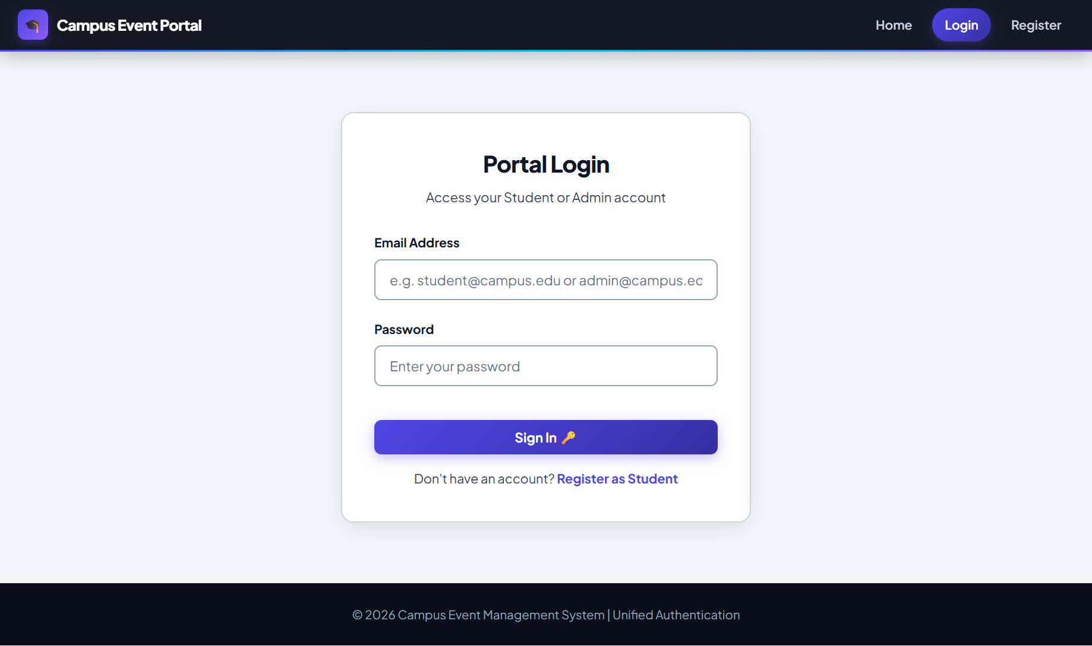  FIGURE 8.3: INDIVIDUAL EVENT REGISTRATION INTERFACE | 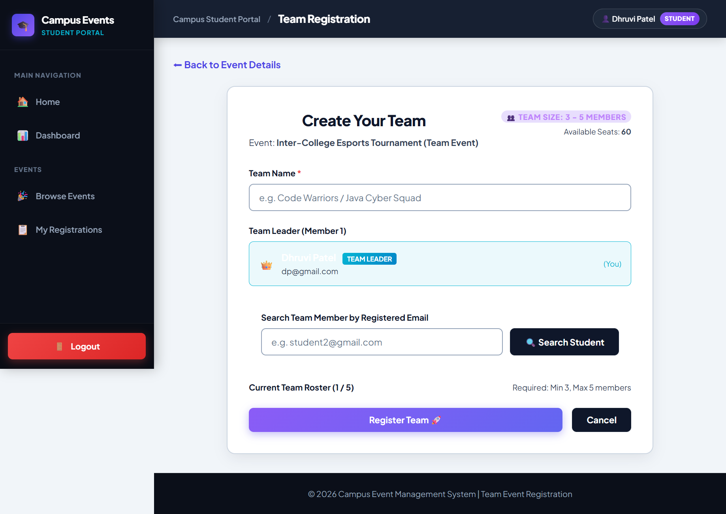  FIGURE 8.4: TEAM FORMATION & MEMBER SELECTION INTERFACE
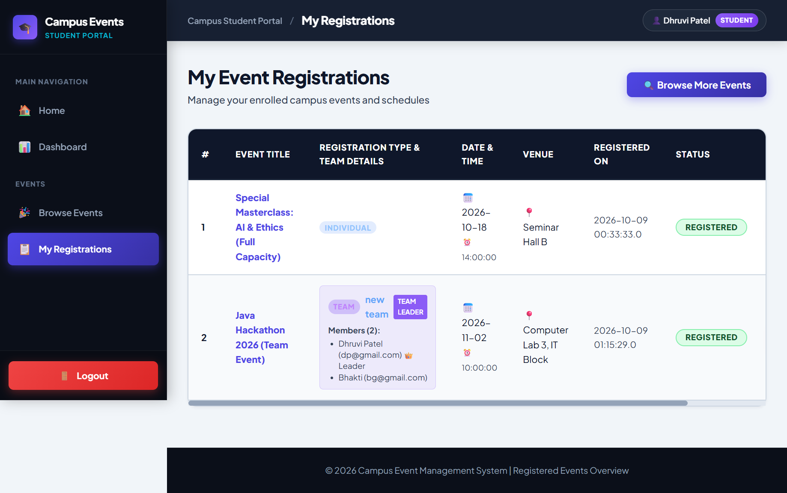  FIGURE 8.5: STUDENT REGISTRATION MANAGEMENT (MY REGISTRATIONS) | 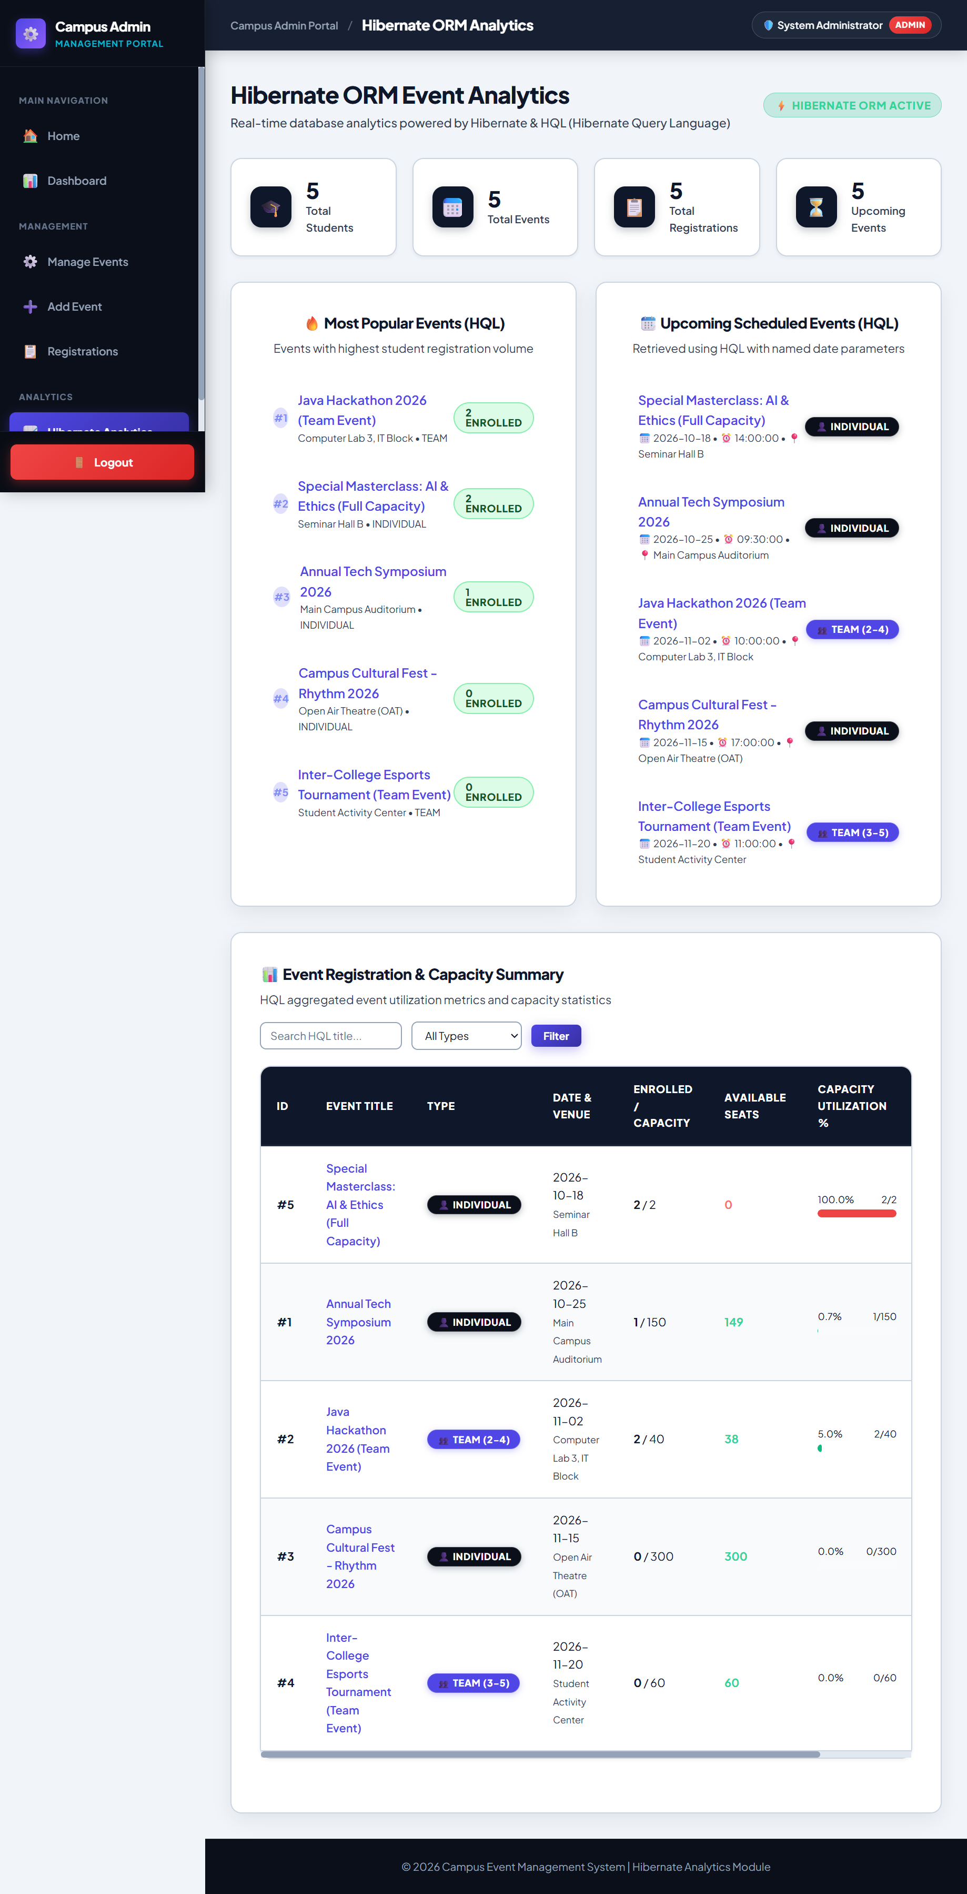  FIGURE 8.6: ADMINISTRATIVE ANALYTICS DASHBOARD

9. ADVANTAGES & LIMITATIONS OF THE SYSTEM
9.1 Advantages of CEMS
The Campus Event Management System delivers substantial operational and architectural benefits over traditional manual event coordination:
- 1. Centralized Management: Eliminates fragmented tools by providing a single, standardized platform for event publication, registration, and administrative monitoring.
- 2. Reduced Manual Work: Replaces manual paper handling, spreadsheet maintenance, and messaging group coordination with automated server-side processing.
- 3. Duplicate Prevention: The Rule Engine rigorously enforces unique constraints, preventing students from registering multiple times for the same activity.
- 4. Controlled Seat Allocation: Synchronized concurrency locks and atomic database transactions ensure strict adherence to venue seating limits, eliminating overbooking.
- 5. Streamlined Team Rosters: Automates collaborative team formation through database-verified email lookups, ensuring legitimate student rosters and eliminating fake entries.
- 6. High Concurrency Handling: Multi-threaded worker threads handle concurrent traffic spikes during popular event openings without data corruption or race conditions.
- 7. Automated Policy Validation: Pre-registration checks (deadlines, capacity, schedule clashes) execute automatically before database writes occur.
- 8. Real-Time Analytics: Hibernate ORM and HQL enable faculty conveners to generate aggregated turnout reports, capacity utilization statistics, and engagement trends.
9.2 Limitations of the System
To maintain technical objectivity, several operational boundaries of the current implementation are acknowledged:
- Campus-Scale Optimization: The application architecture is optimized for single-campus local area network (LAN) and intranet environments; distributed multi-campus synchronization is not implemented.
- Notification Infrastructure: The system does not integrate external third-party transactional SMS or automated push notification gateways, relying on internal web dashboard notices.
- Payment Processing: In accordance with the current academic mini-project specification, paid event ticketing and external payment gateway integrations (e.g., Razorpay, Stripe) are excluded.
- Mobile Application: The current web interface is optimized for desktop and tablet browsers; native Android and iOS mobile applications are not part of the current build.

10. CONCLUSION & FUTURE SCOPE
10.1 Conclusion
The Campus Event Management System (CEMS) successfully addresses the longstanding operational challenges associated with traditional, manual collegiate event administration. By replacing disjointed spreadsheets, paper forms, and unvalidated messaging channels with a centralized, web-based platform, CEMS introduces deterministic governance across the complete campus event lifecycle. The project provides an effective, secure, and user-friendly portal for both student participants and faculty conveners.
From an engineering perspective, the system showcases the practical deployment of enterprise Java technologies within a three-tier MVC architecture. The presentation layer built with JSP seamlessly interfaces with Java Servlets and a decoupled DAO persistence tier. The implementation of the Java Event Registration Rule Engine guarantees rigorous, automated validation of deadlines, duplicate registrations, and team size boundaries. Furthermore, by pairing Java multithread synchronization with atomic JDBC transaction management, the system completely resolves race conditions and seat overbooking during peak demand.
Finally, the complementary integration of Hibernate 5.4 ORM demonstrates how modern object-relational mapping and HQL can be utilized for administrative intelligence without sacrificing low-level transactional speed. In summary, CEMS fulfills all defined project objectives, delivering a robust, maintainable, and scalable software solution tailored to higher education institutions.
10.2 Future Scope
While CEMS completely fulfills its mini-project objectives, several architectural enhancements can be explored in future development phases:
- QR-Code Attendance Verification: Integrating dynamic QR code generation upon confirmed registration to facilitate rapid, contactless attendance verification at venue entrances using mobile scanners.
- Automated Email Notifications: Incorporating automated JavaMail API integration to dispatch confirmation receipts, event updates, and schedule changes directly to institutional student inboxes.
- Calendar Synchronization: Developing RESTful export endpoints to synchronize confirmed event schedules with standard calendar platforms such as Google Calendar and Outlook.
- Native Mobile Client: Developing dedicated cross-platform mobile client applications (Android/iOS) to offer push notifications and on-the-go registration.
- Cloud Containerization: Migrating the application from local servlet containers to cloud-native platforms (e.g., AWS Elastic Beanstalk, Docker containers) to support elastic auto-scaling.

REFERENCES
The design, architecture, and implementation of the Campus Event Management System are informed by the following academic and technical literature:
[1] Oracle Corporation, "Java Platform, Standard Edition (Java SE) Documentation & Concurrency Utilities, Oracle Technology Network, 2023. [Online]. Available: https://docs.oracle.com/en/java/javase/".
[2] Oracle Corporation, "Java Servlet Specification, Version 4.0, Jakarta EE Platform, Eclipse Foundation, 2020. [Online]. Available: https://jakarta.ee/specifications/servlet/4.0/".
[3] JavaServer Pages, "JavaServer Pages (JSP) 2.3 Specification, Eclipse Foundation, 2021. [Online]. Available: https://jakarta.ee/specifications/pages/2.3/".
[4] Hibernate Community, "Hibernate ORM 5.4 User Guide: Object-Relational Mapping & Hibernate Query Language (HQL), Red Hat Inc., 2022. [Online]. Available: https://hibernate.org/orm/documentation/5.4/".
[5] MySQL AB / Oracle, "MySQL 8.0 Reference Manual: InnoDB Storage Engine, ACID Transactions, and Row-Level Locking, Oracle Corporation, 2023. [Online]. Available: https://dev.mysql.com/doc/refman/8.0/en/".
[6] E. Gamma, R. Helm, R. Johnson, and J. Vlissides, "Design Patterns: Elements of Reusable Object-Oriented Software, Addison-Wesley Professional, Boston, MA, 1994.".
[7] C. Horstmann and G. Cornell, "Core Java Volume I & II - Fundamentals and Advanced Features, 11th ed., Prentice Hall, Upper Saddle River, NJ, 2019.".
[8] B. Goetz, T. Peierls, J. Bloch, J. Bowbeer, D. Holmes, and D. Lea, "Java Concurrency in Practice, Addison-Wesley Professional, Boston, MA, 2006.".
[9] A. Silberschatz, H. F. Korth, and S. Sudarshan, "Database System Concepts, 7th ed., McGraw-Hill Education, New York, NY, 2019.".
[10] Apache Software Foundation, "Apache Tomcat 9 Architecture and Configuration Guide, 2023. [Online]. Available: https://tomcat.apache.org/tomcat-9.0-doc/".

