**Module 1**

SE – OVERVIEW OF IT INDUSTRY

(Q-1) What is software? And What is Software Engineering?

🡪 Software is a set of instructions, data or programs used to operate computers Ans execute specific tasks.

🡪 Software is a generic term used to refer applications.

Example: Ms WORD, POWER POINT, ETC

🡪 Software engineering is branch of computer science that deals with design development testing management software applications

🡪 There are three types of software engineering

1) Front-end engineering

2) Back-end engineering

3) full stack engineering

(Q-2) Explain types of software?

🡪 There are two types of software

|  |  |
| --- | --- |
| System Software | Application Software |
| • System software is mainly designed for managing system resources. | Application software is designed to accomplish tasks for specific purposes. |
| • Programming of system software is complex. | Programming of application software is comparatively easy. |
| • computer cannot run without system software. | A computer can easily run without application software. |

(Q-3) What is SDLC? Explain each phase of SDLC?

* The Software Development Life Cycle (SDLC) is a structured process that enables the production of high-quality, low-cost software, in the shortest possible production time.
* The goal of the SDLC is to produce superior software that meets and exceeds all customer expectations and demands.

**SDLC**

1. **PLANNING:-**

* **The team creates an overview of the project, determines requirements.**
* **In this phase, the project scope, objectives, timelines, resources, and potential risks are identified and analysed.**
* **Planning Key stakeholders collaborate to define the project requirements and create a roadmap for the development process.**

1. **DEFINING:-**

* **Defining By keeping tabs on performance, the team identifies any problems or areas where improvements can be made.**
* **During this phase, the project requirements gathered in the planning phase are further analysed and refined.**
* **This involves studying the current system (if any), identifying user needs, and documenting functional and non-functional requirements.**

1. **DESIGN:-**

* **This is where your average web developer or front-end developer comes in, who creates designs.**
* **In this phase, the system architecture and design specifications are created based on the requirements gathered in the analysis phase.**
* **3. This includes designing the software components, data models, user interfaces, and system workflows.**

1. **IMPLEMENT ACTION:-**

* **Also known as the coding phase, this is where the actual development of the software takes place.**
* **Developers write code according to the design specifications, following coding standards and best practices.**
* **Implement action Unit testing is often performed during this phase to ensure individual components work as expected.**

1. **TESTING:-**

* **The purpose of this stage is to emphasize the use of automated tests to prevent defects in the software.**
* **In this phase, the software is rigorously tested to identify and fix any defects or bugs. This includes both functional testing to ensure the software meets the specified requirements.**
* **5. as well as non-functional testing to assess performance, security, usability, and other quality attributes.**

1. **MAINTENACE:-**

* **software monitoring stage is important as it involves the imperative of safeguarding data and ensuring optimum performance.**
* **The final phase involves maintaining and supporting the software after it has been deployed. This includes addressing any issues or bugs that arise.**
* **Maintenance implementing updates or enhancements, and providing ongoing technical support to users.**

(Q-4) What is DFD? Create a DFD diagram of Flipkart?

* DFD stands for **Data Flow Diagram**. It's a graphical representation of the flow of data within a system.
* illustrating how data moves from one process to another, where it's stored, and how it's transformed along the way.
* DFDs are commonly used in software engineering and systems analysis to visualize the structure and behaviour of a system or process.

* What data is system processes.
* What transformation are performed.
* What data are stored.
* What results are produced, Etc.

* DFD Use Some Symbols.

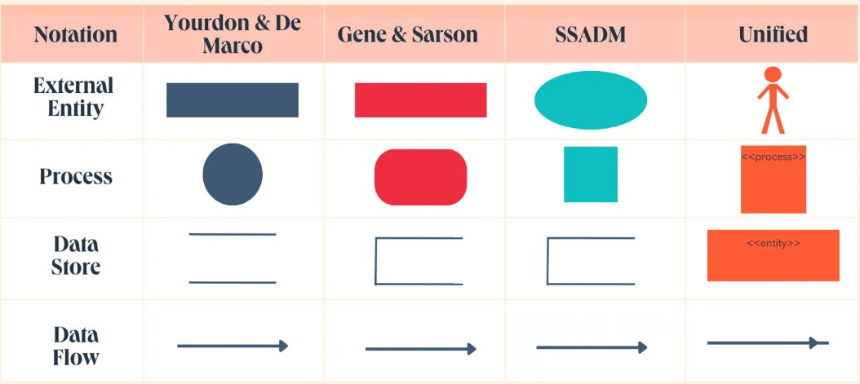

* Flipkart Diagram

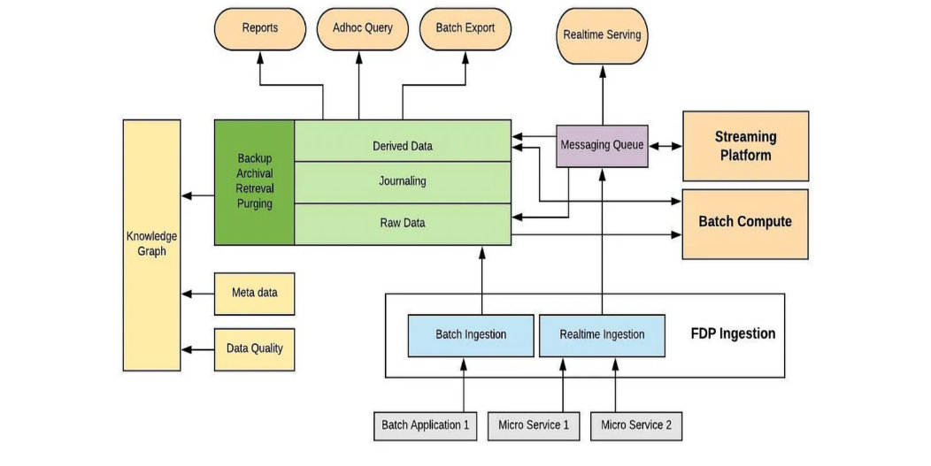

(Q-5) What Is a Flow Chart? Create Addition to make a flowchart?

* A flowchart is a graphical representation of a process or algorithm. It uses different shapes to represent -different steps or actions and arrows to show the flow of the process.
* Each step is represented by a rectangle with rounded corners, and the arrows indicate the flow of the process. The "Input" steps are represented by parallelograms, and the "Output" step is represented by a parallelogram with its sides reversed.

Input Number 1,

Number

Sum =Number1 + Number2

Print Sum

(Q-6) What is use case Diagram? Create a use case on payment of Paytm?.

* Use-case diagrams describe the high-level functions and scope of a system
* These diagrams also identify the interactions between the system and its actors

**System**

* Use Case Diagram for Payment of Paytm, A use case diagram example developed for a Payment system.
* Use this design as a use case diagram example for teaching.
* The design can also be customized as a use case diagram template, with Visual Paradigm's use case diagram tool use case diagram.