**AI-Powered Meeting Notes Summarizer and Sharer**

**Project Overview:**

The AI-powered meeting notes summarizer and sharer is a full-stack application designed to streamline meeting documentation. Users can upload or manually enter meeting transcripts, provide a custom prompt, and generate structured summaries using AI. These summaries are editable and can be shared via email.

**Approach:**

The project focuses on creating a functional full-stack application that leverages AI to summarize meeting transcripts efficiently. The main objective is to reduce manual effort in creating summaries, highlight key action items, and facilitate quick sharing via email. Minimalistic design and modular architecture ensure maintainability and scalability.

**Features:**

* **Core Features**

1. **Transcript Upload**

* Users can upload text files containing meeting transcripts or paste raw text.
* File formats supported: .txt, .docx (optional enhancement).

1. **Custom Instructions / Prompt**

* Users can provide specific instructions for the AI, such as:
* Summarize in bullet points
* Highlight action items
* Provide an executive summary

1. **AI-Powered Summary Generation**

* The AI generates a structured summary according to the user-provided prompt.
* Summary is displayed on the UI in an editable format.

1. **Editable Summary**

* Users can make modifications to the AI-generated summary before sharing.

1. **Sharing via Email**

* Users can send the final summary to multiple recipients via email.
* Basic email validation to ensure correct addresses.

**Tech Stack:**

| **Layer** | **Technology** | **Purpose** |
| --- | --- | --- |
| Frontend | React | UI for uploading transcripts, editing summaries, and sharing |
| Backend | Node.js + Express | Handles AI requests, summary generation, and email sending |
| AI Integration | Gemini API | Summarization based on prompt |
| Database | MongoDB | Store uploaded transcripts, summary drafts and email transection details |
| Email Service | Nodemailer | Sending summary emails |
| State Management | React state | Manage transcript and summary data on frontend |

**Application Flow:**

* **Upload Transcript**
  + User selects a file or pastes transcript.
  + File is sent to backend via HTTP POST while click to `**Upload transcript**` if manually inserted then it send text and create a .txt file else use same file and store in backend.
* **Input Custom Prompt**
  + User provides instructions for summarization.
  + Prompt is sent alongside transcript.
* **Generate Summary**
  + Backend sends the transcript + prompt to AI API.
  + AI returns a structured summary.
* **Edit Summary**
  + User can directly edit the summary in a summary editor area.
* **Share via Email**
  + User inputs recipient email addresses.
  + Backend sends summary with transcript and prompt as email using email service.

**Workflow Diagram:**

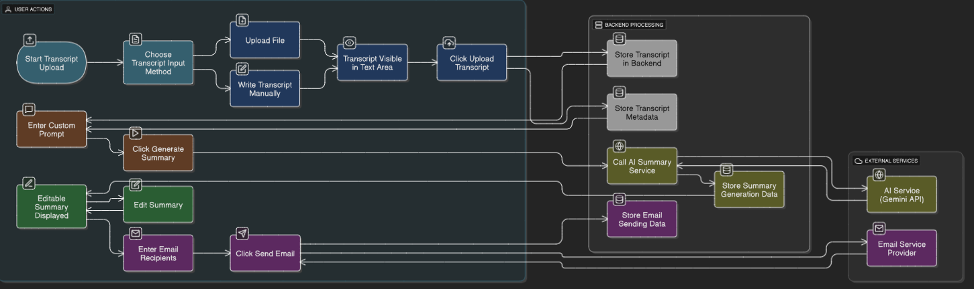

[This diagram shows the step-by-step flow of the AI-powered meeting notes summarizer.]

**Summary:**

This project focuses on functionality over design, providing a lightweight, full-stack application that uses AI to generate structured meeting summaries and allows sharing via email. The modular design ensures easy future enhancements, including adding more AI capabilities or integrating with other productivity tools.