Dharmsinh Desai University, Nadiad

Faculty of Technology

Department of Computer Engineering



**ASSIGNMENT 10**

Subject: Smart Device Programming

**Submitted To:**

Prof. Jignesh Shah

CE Department

**Submitted By:**

Sherathiya Dhruvi A.

Student ID:20CEUOS006

Roll No.: CE126

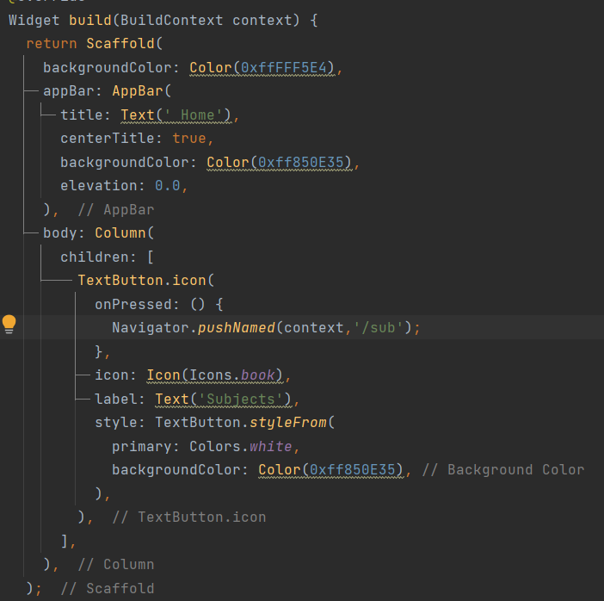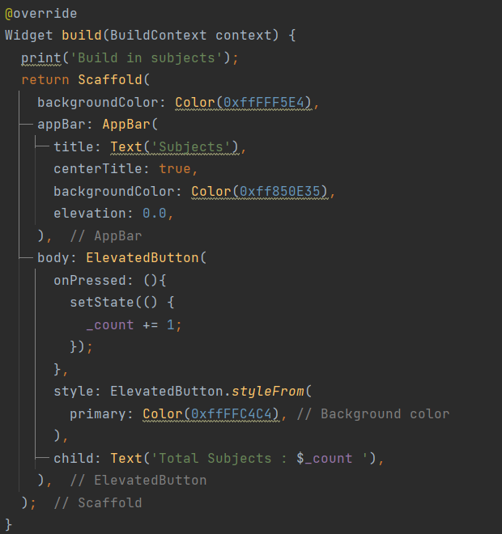

Subjects.dart home.dart

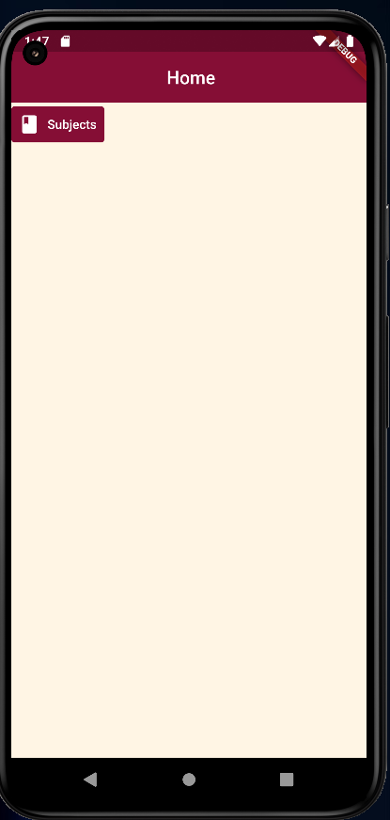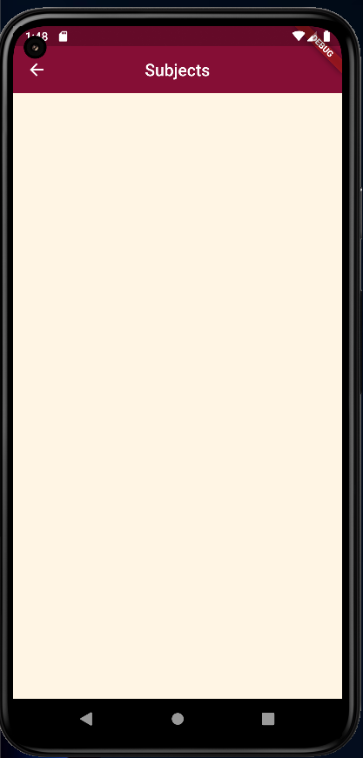

We have set counter such that each time we will press button it will increment number of subjects and print line in colsole.

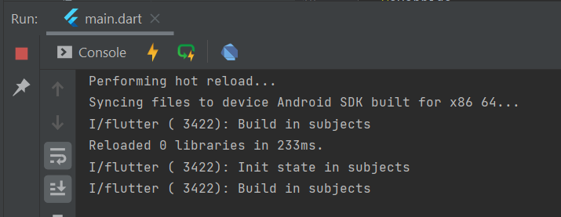

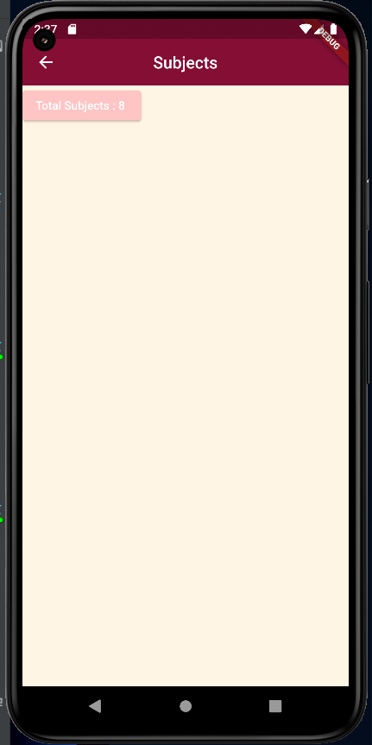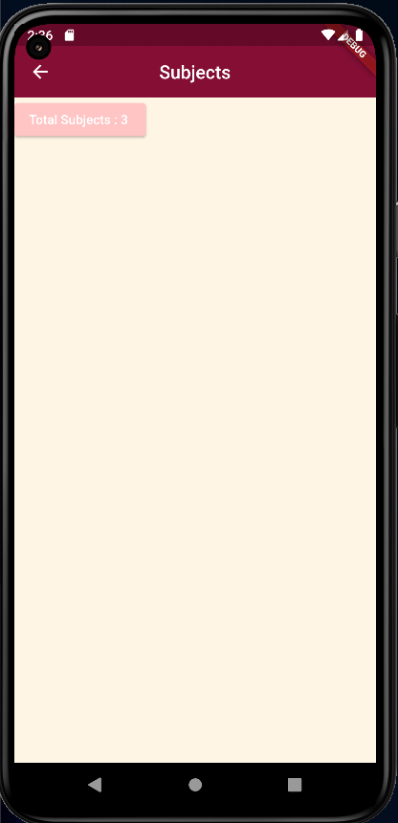

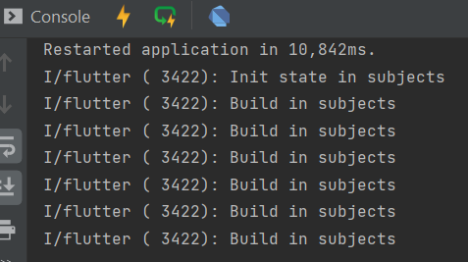

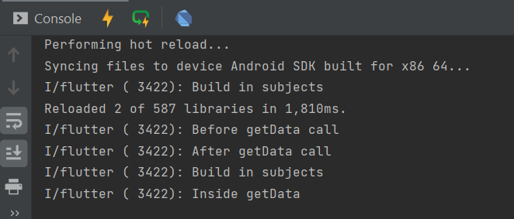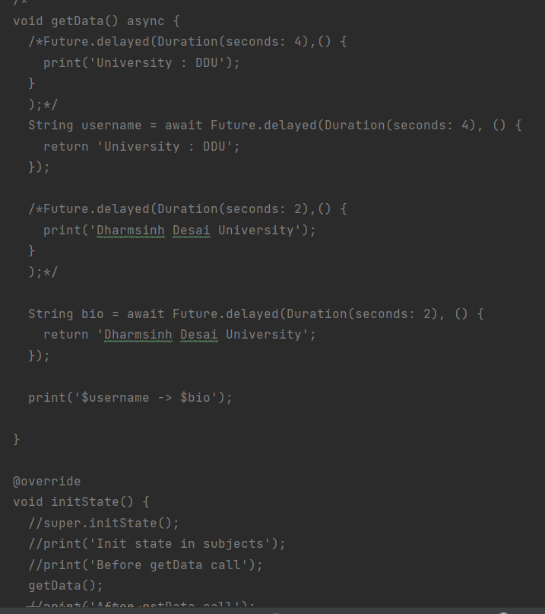

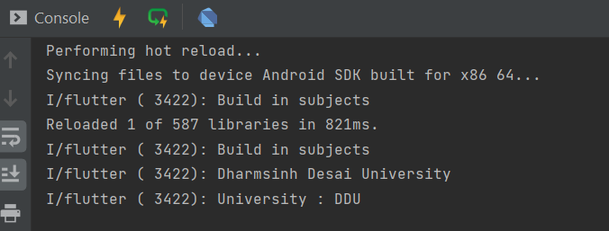

Using async await output would be as below:

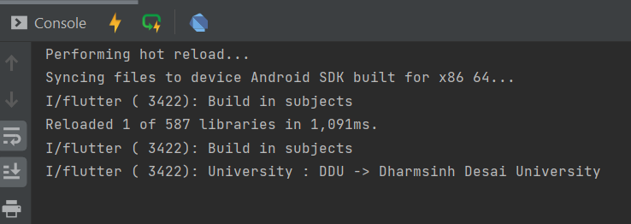

Now we will use fake api for json. Below is the code for that. In code, we have defined one method using async await in order to get synchronized outout. The final output would be shown in console.

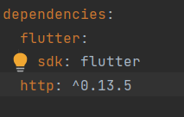First print statement will print whole response fetched by api. Then second statement will print data part. In third statement we are printing only title from all the data.

Add this code into pubspec.yaml in order to include http package.

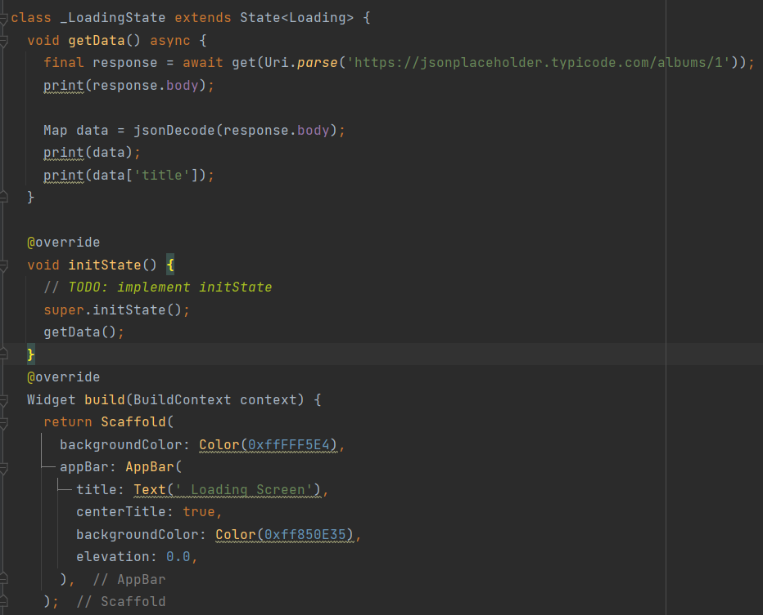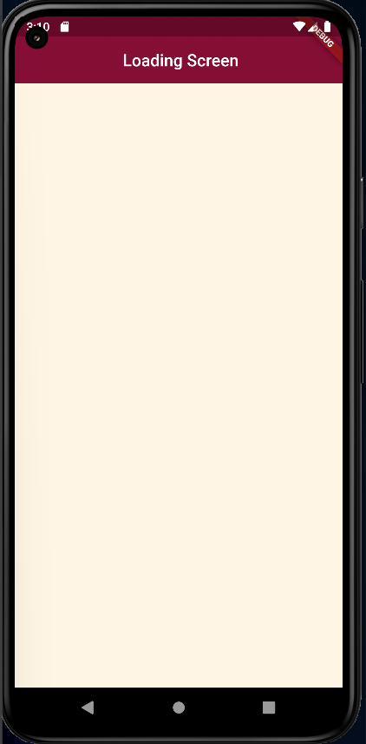

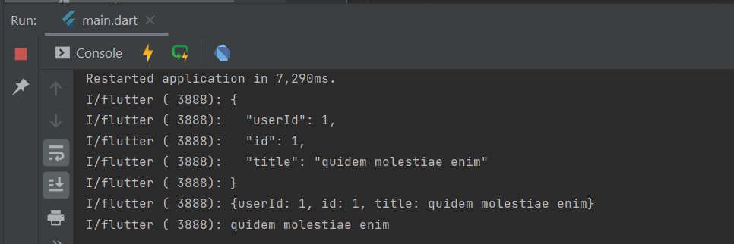

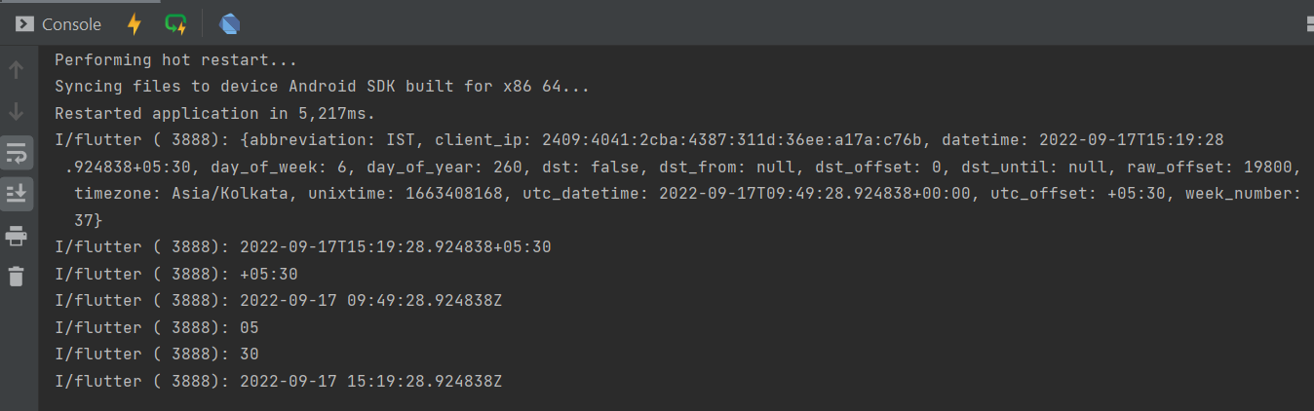World Time API

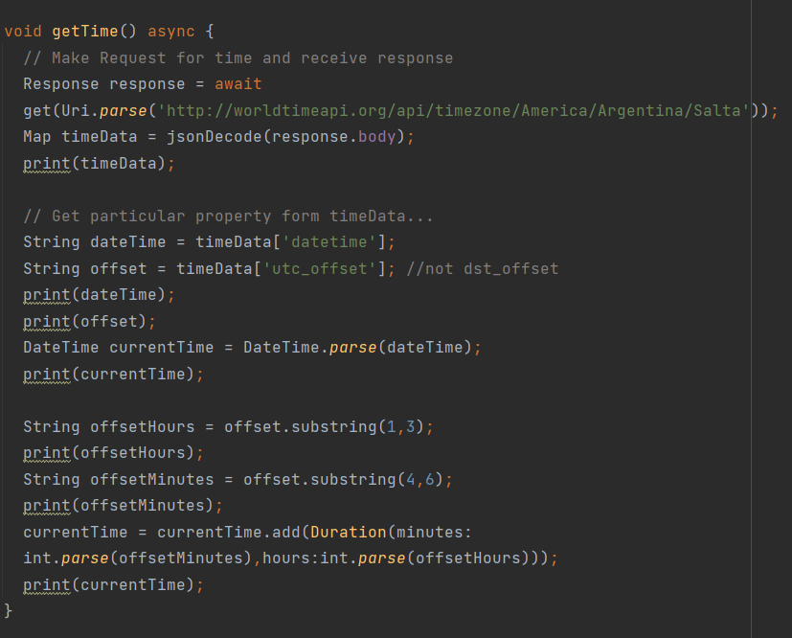

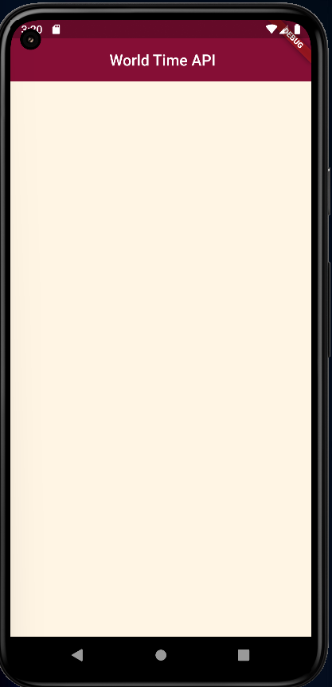

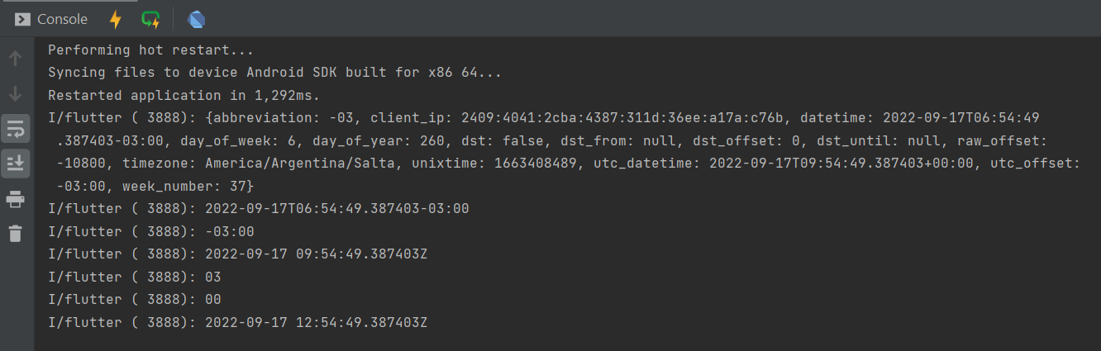We can set any region. First we have retrived time of Kolcutta, Then Salata.

Now we will print this time on our device screen. For that create two files and add below code into it.

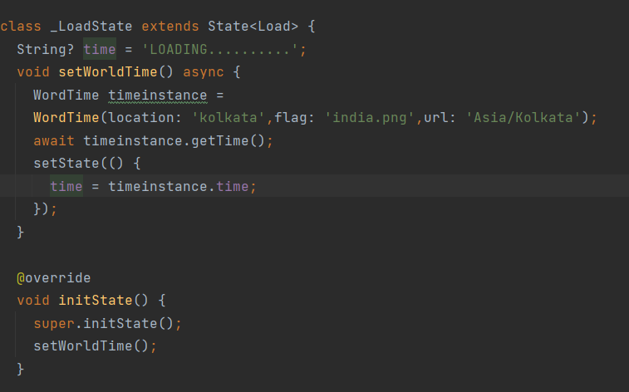

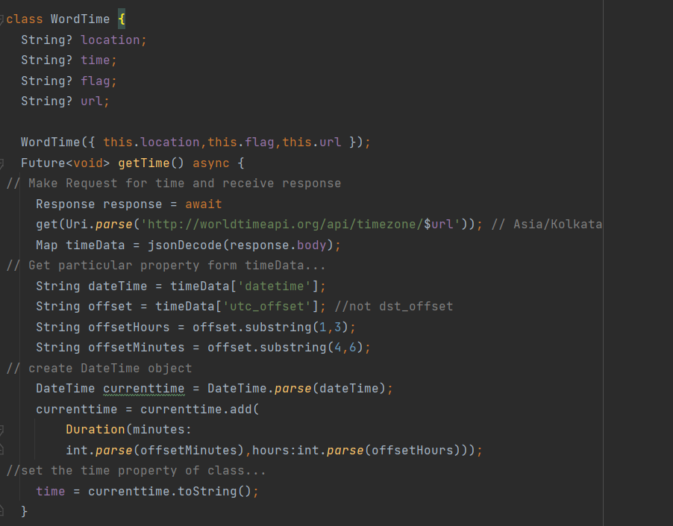

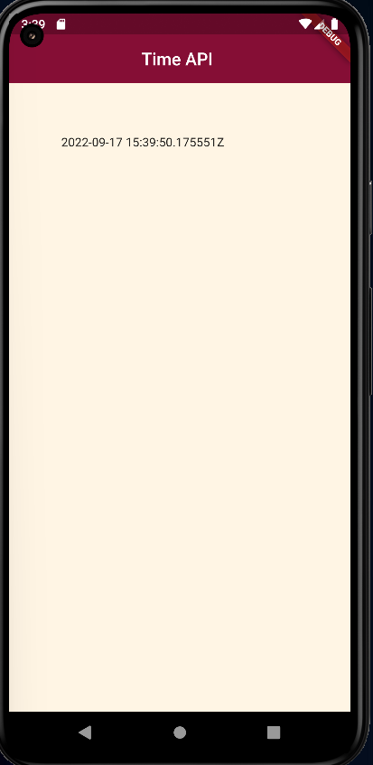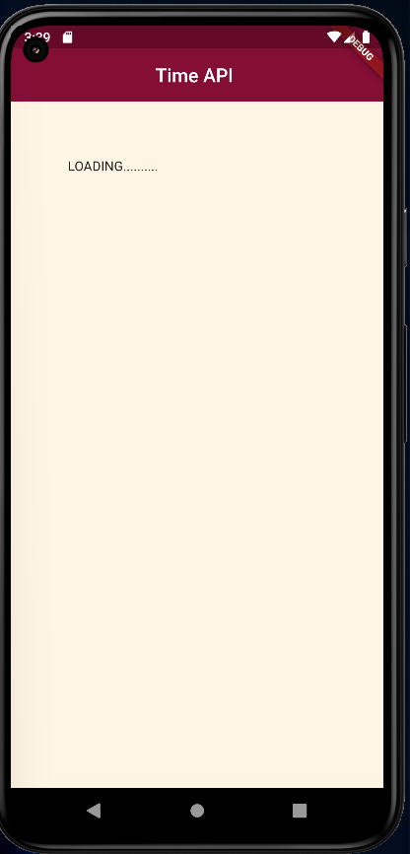

GitHub Link:

<https://github.com/DhruviSherathiya/SmartDeviceProgramming/tree/main/Lab10>