Dharmsinh Desai University, Nadiad

Faculty of Technology

Department of Computer Engineering



**ASSIGNMENT 11**

Subject: Smart Device Programming

**Submitted To:**

Prof. Jignesh Shah

CE Department

**Submitted By:**

Sherathiya Dhruvi A.

Student ID:20CEUOS006

Roll No.: CE126

Code test 1: Handling Error: Try Catch

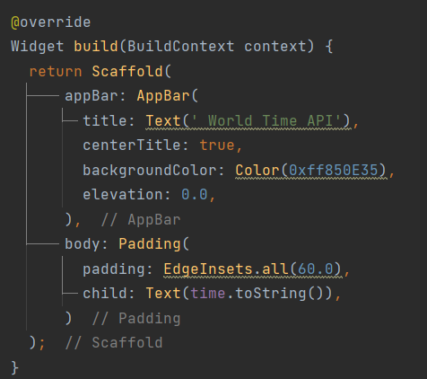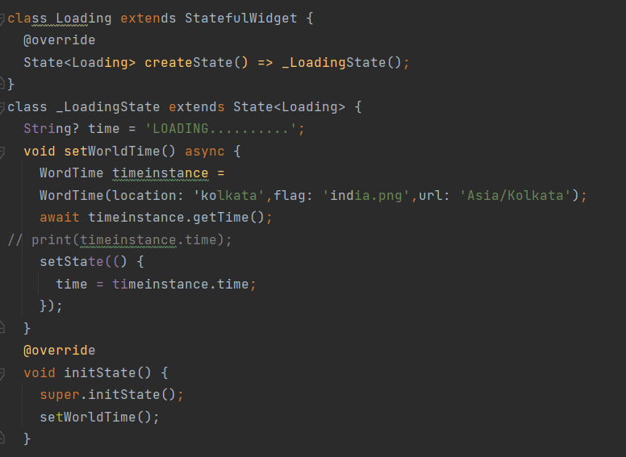Using the world-time API, continue developing the app that we started in the last lab.

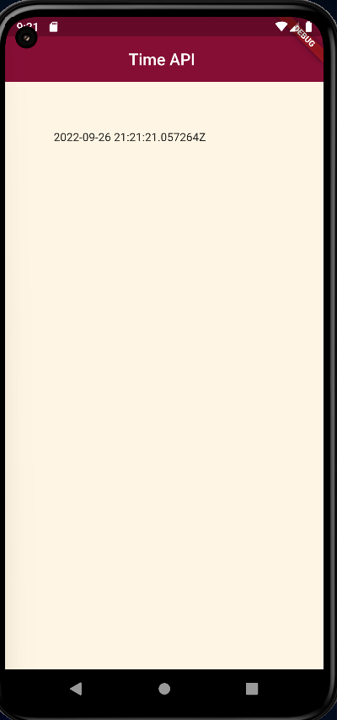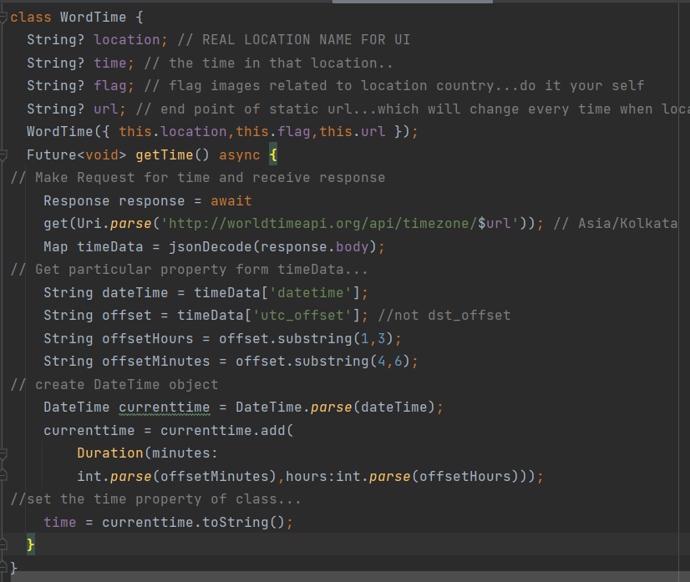a

Now we will add error handling. For that first of all make some intentionality mistake. i.e. Remove one character from API string



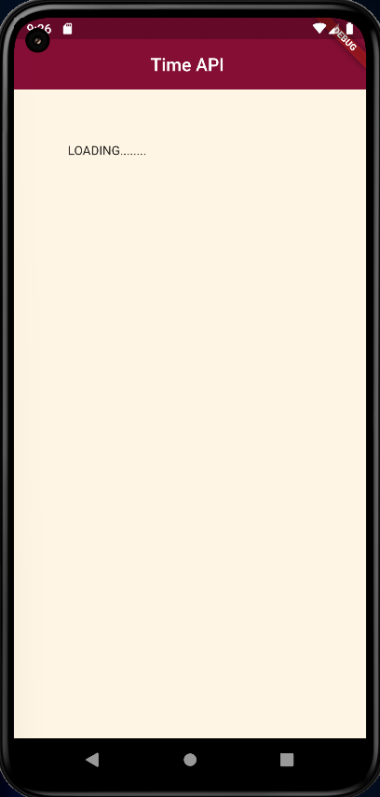Then output will be as shown below. Here in output we can see that loading is printing. So we need to do something that will display error accordingly. Here on error we are setting time value to some appropriate message. So that it can be displayed there.

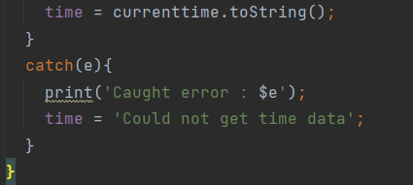

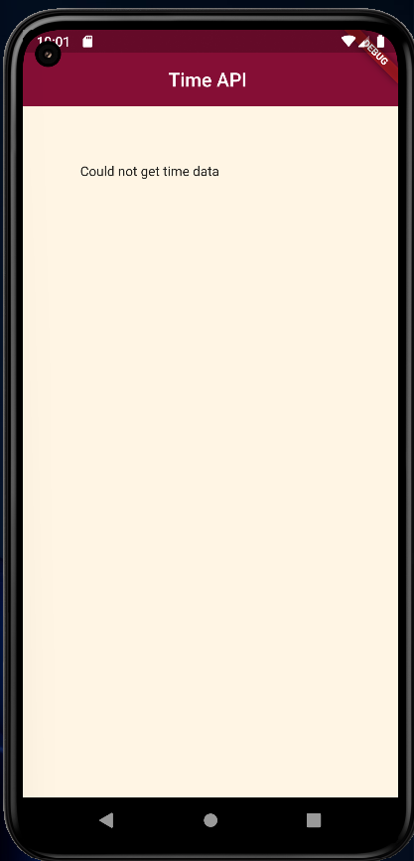So if there is some issue in fetching time then we can set time value as shown above. So updated output would be …

Code test 2: Data passing between route

Code test 3: Formatting and showing data—dates

Do some modifications in loading.dart file as shown below.

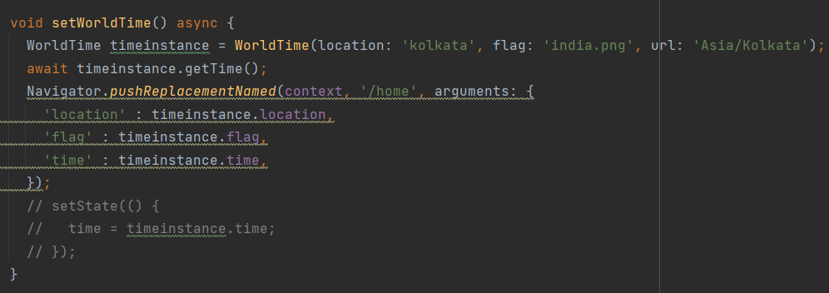

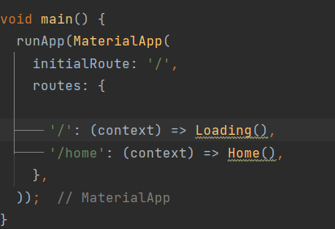Here we are using routing with passing some additional arguments into it. So in home.dart file we can access location, flag and time field.

Basic routing

Now we will perform some formatting steps using intl. For that we need to add it into pubspec.yaml

Import intl in time.dart file and change accordingly that file.

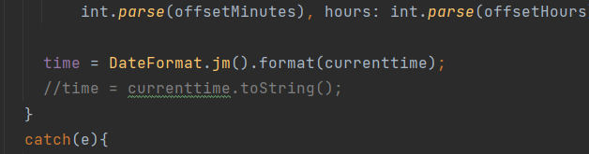

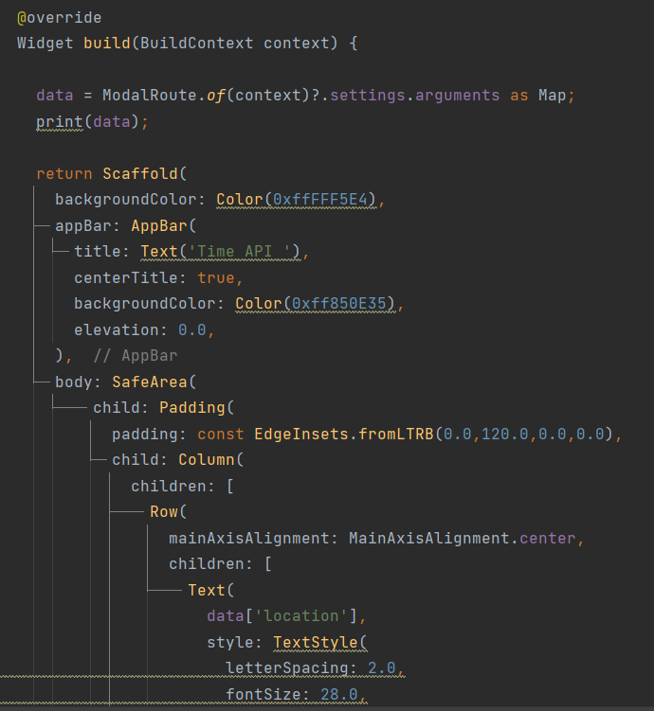Now home.dart file would contains below code.

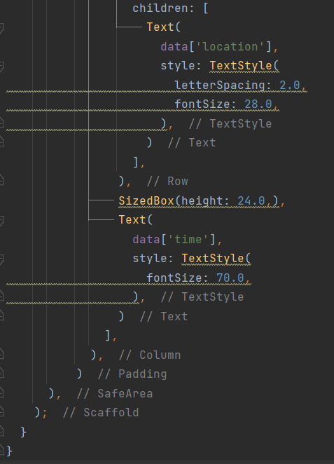

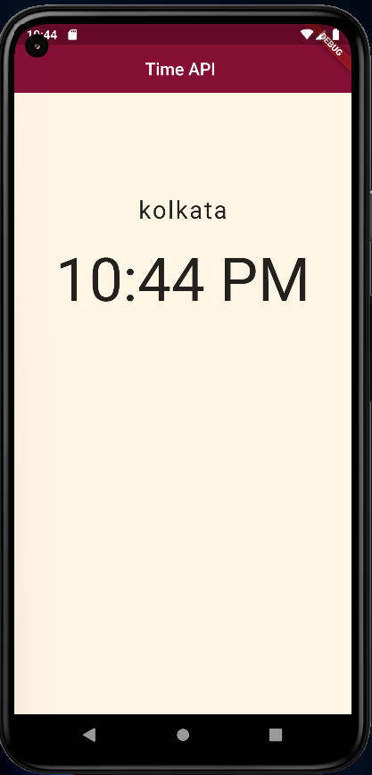Final Output:

Code test 4: Using spinners for loading page

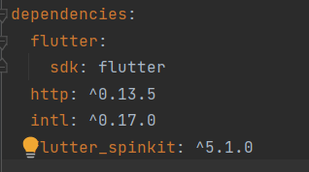Add flutter spinkit into pubspec.yaml file and import it into loading file.

Now we will use flutter spinner for loading and after data fetched current time and location will be displayed.

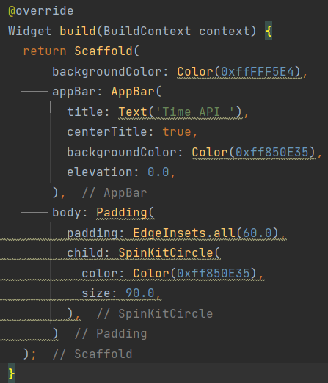

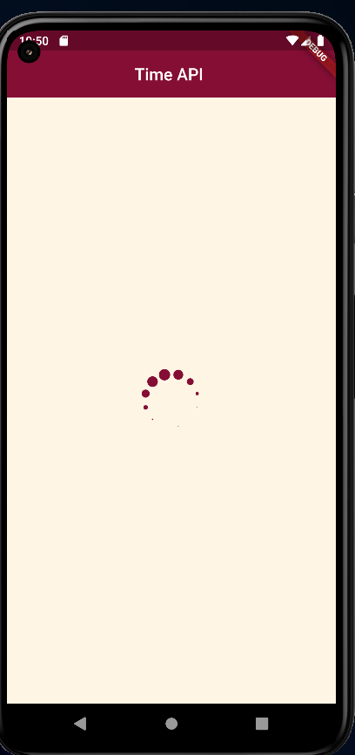

GitHub repository link: