Dharmsinh Desai University, Nadiad

Faculty of Technology

Department of Computer Engineering



**ASSIGNMENT 12**

Subject: Smart Device Programming

**Submitted To:**

Prof. Jignesh Shah

CE Department

**Submitted By:**

Sherathiya Dhruvi A.

Student ID:20CEUOS006

Roll No.: CE126

We will continue our clock app from previous lab. Now we will add background image in it based on current time. For time 6 AM to 8 PM we can set background image of day and otherwise night. This can be done through Boolean variables.

Add the below Boolean variable isDayTime in time.dart file.

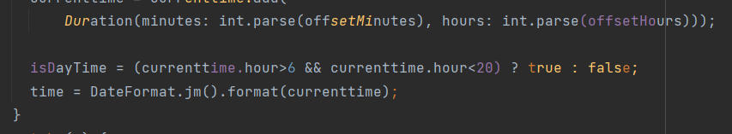

Now, in home.dart file set background image based on this variable.

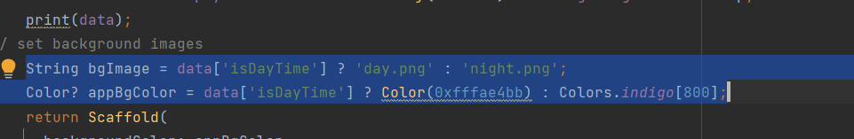

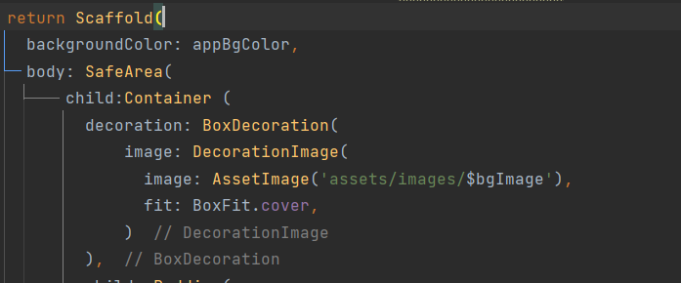

And similarly make changes in loading.dart file

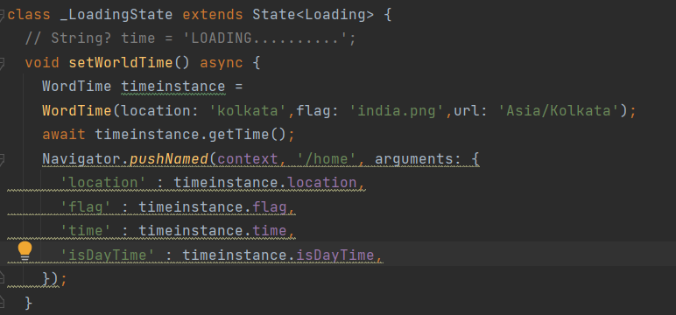

Add below code in pubspec.yaml file and add necessary images and flags for that.

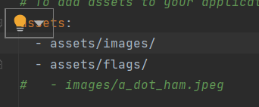

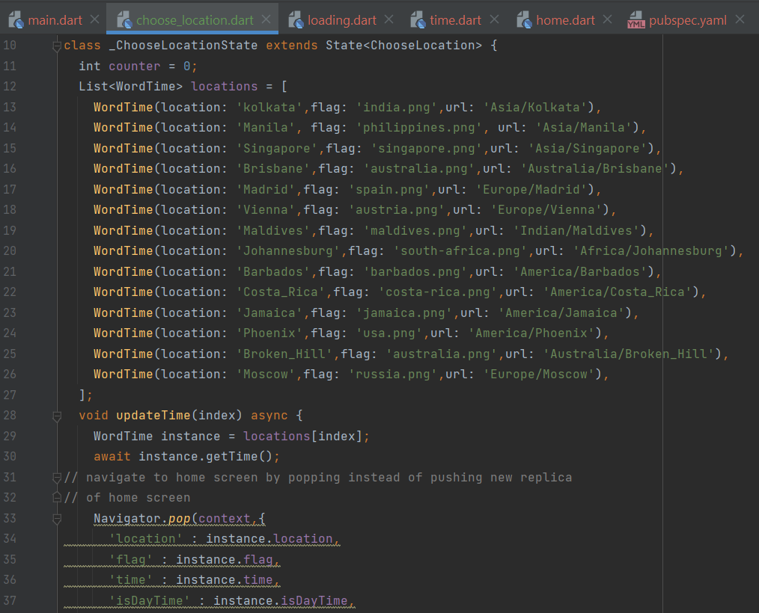

Now when we click on edit location the below page would be displayed.

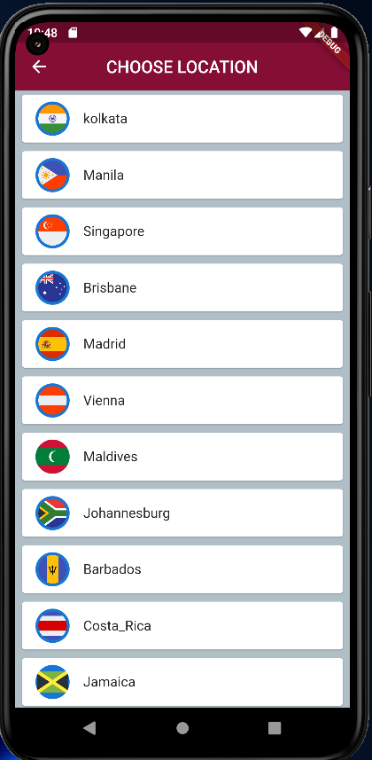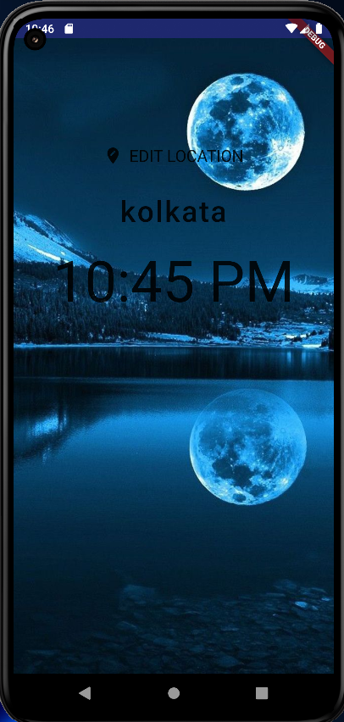.

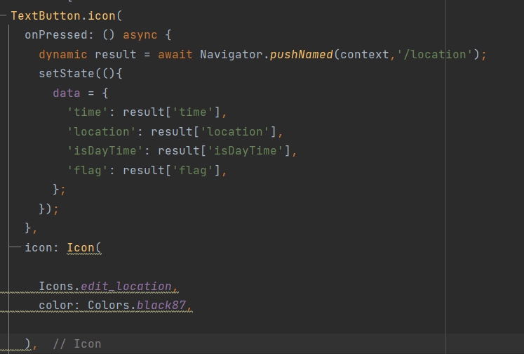

Make some changes in home.dart file again that will change data of current location based on our choice and would display time according to that.



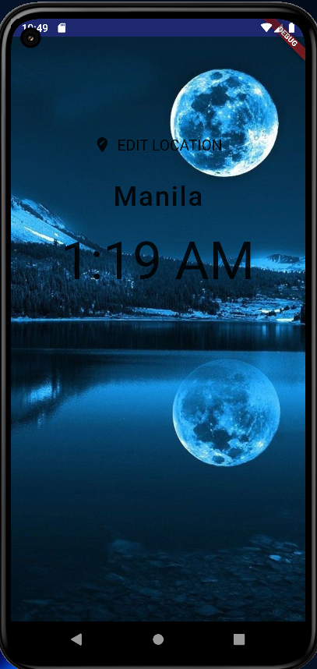

If we choose Manila from the list of locations result would be as shown in the image.

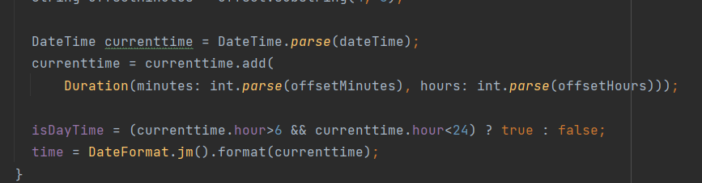At last we will check our code for the day time. For that currently we are changing criteria for displaying day image.

Result:

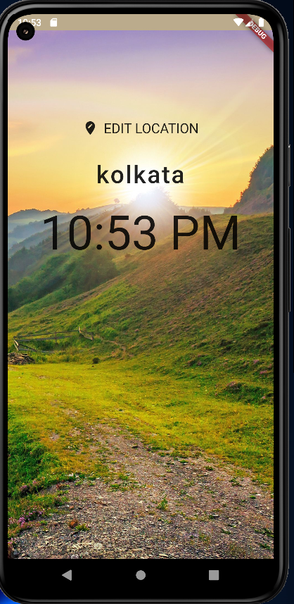

GitHub repository link:

[Click here](https://github.com/DhruviSherathiya/SmartDeviceProgramming/tree/main/Lab12)