Dharmsinh Desai University, Nadiad

Faculty of Technology

Department of Computer Engineering



**ASSIGNMENT 8**

Subject: Smart Device Programming

**Submitted To:**

Prof. Jignesh Shah

CE Department

**Submitted By:**

Sherathiya Dhruvi A.

Student ID:20CEUOS006

Roll No.: CE126

Code Test 1: Padding

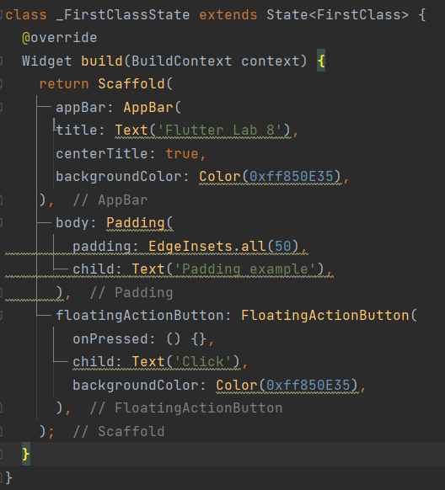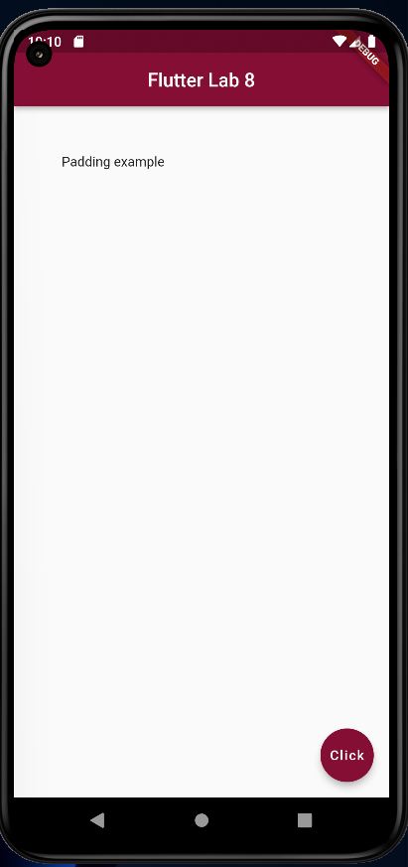In flutter there is a Padding widget for specifying padding property. The below code will add padding of 50 to all sides of text.

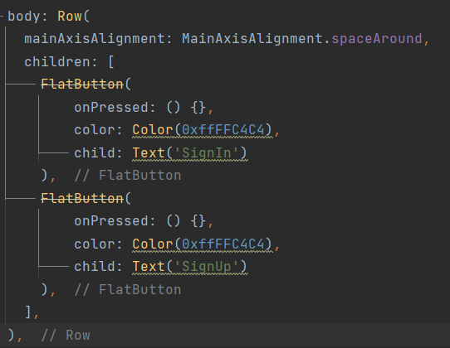Row is a widget that displays its children in a horizontal array. Below is the example for the same. In below code we have created two flat button inside row widget. So both buttons are children of row. Output of code will contain two buttons in same row. But inside row we have specified one property named mainAxisAlignment and sets it to spaceAround. So this will align buttons accordingly.

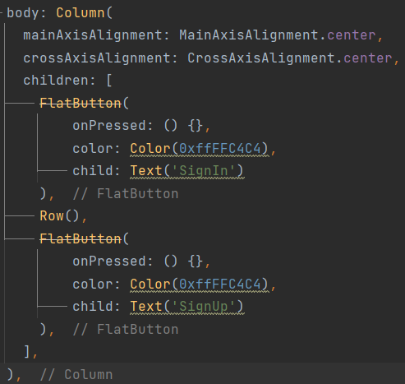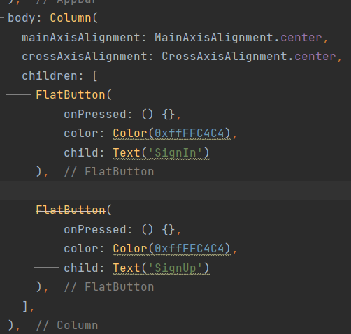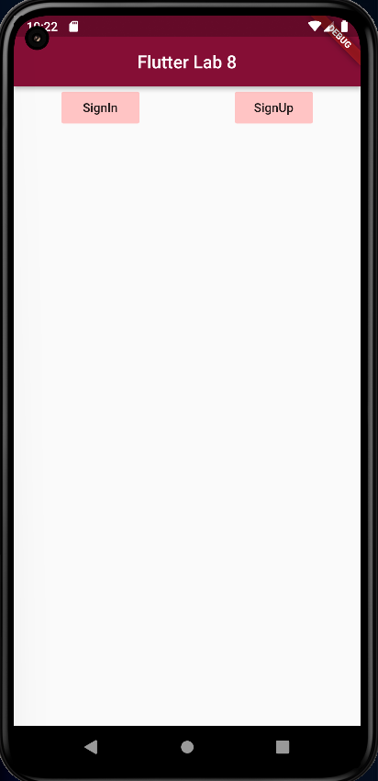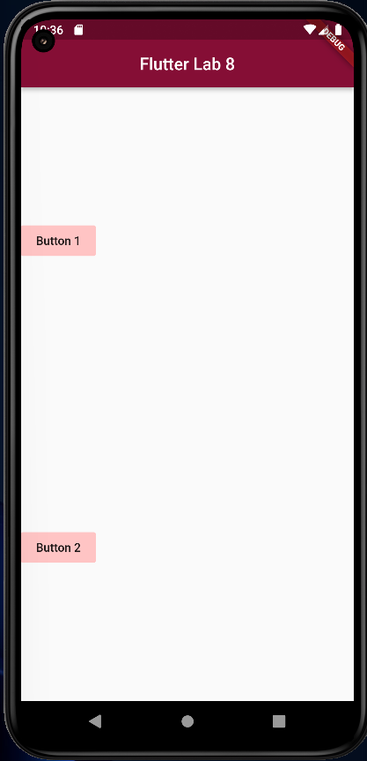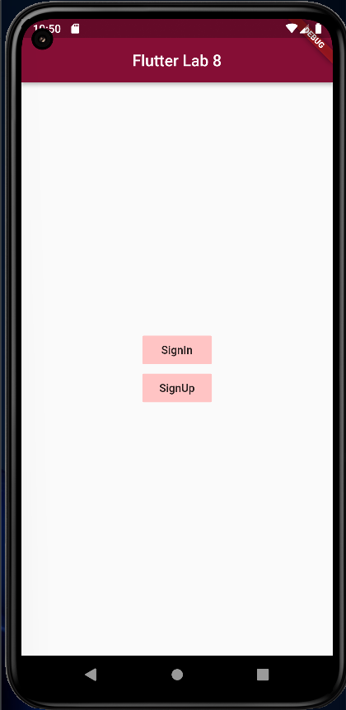In above middle image we are using Column widget. This widget is same as row but it will display buttons in one column. For better creativity of grid we can use both row and column with each other. So inside column widget just add row widget between two buttons. Then the output will be as shown in above last screen.

Now we will add two more buttons into row widget.

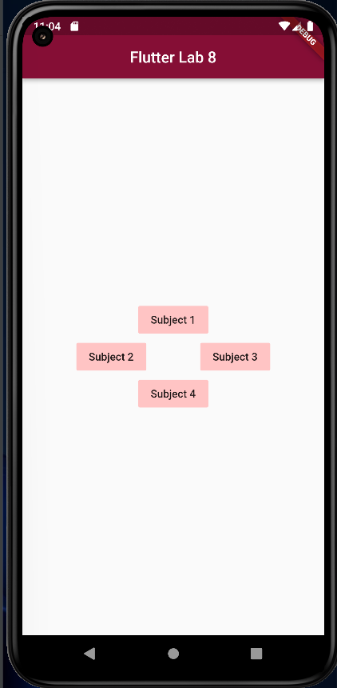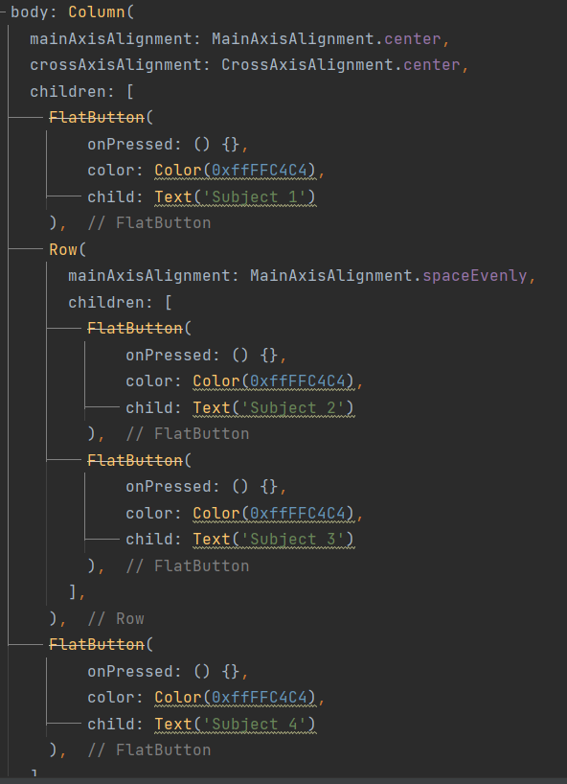a

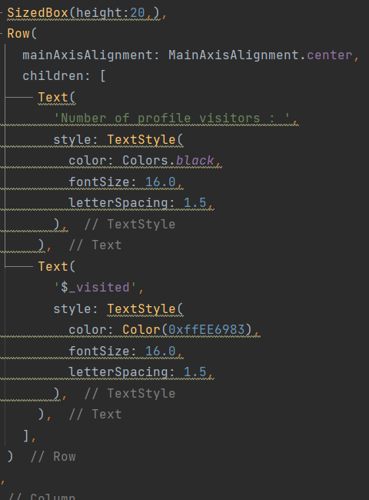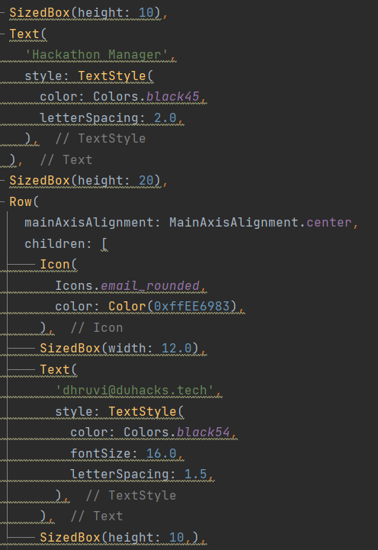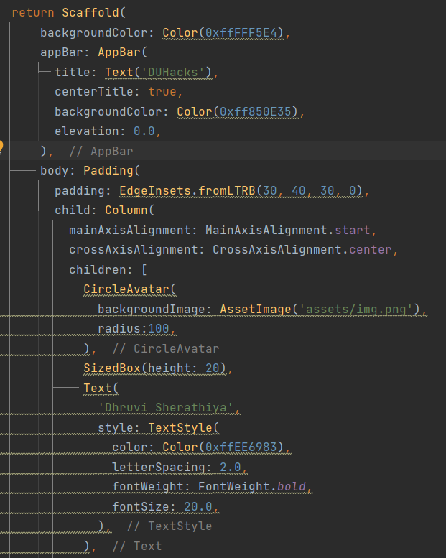Now we will create some profile page using above all concepts.

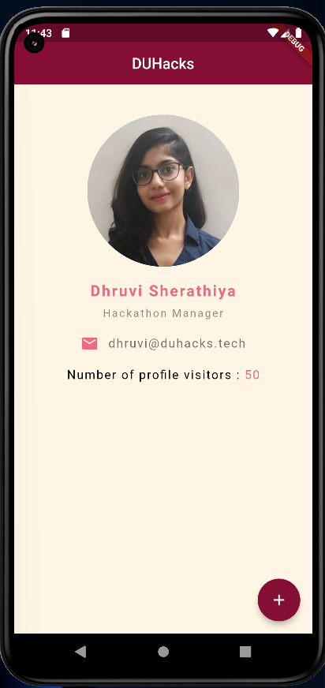For the image added in that code we need to specify out image folder inside pubspec.yaml file in assests property.

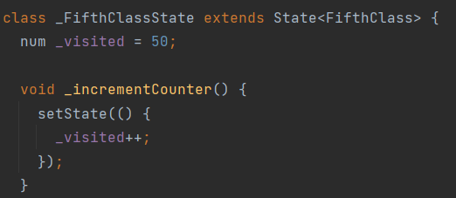In this image initially we have counter value 50. When we click on the add button below it will increase number of profile visitors. This thing can be achieved using setState() property. Because each time we use setState property build would be run.

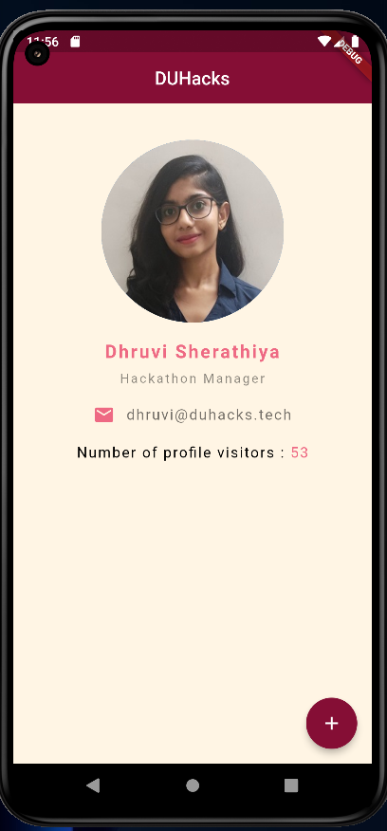

This setState() method we can use only with stateful widget. For stateless widget there is no such property.

Now we will create onother dart file and create list inside class.

After that we will display each item of the list through looping.

Write below code outside of widget but inside class.

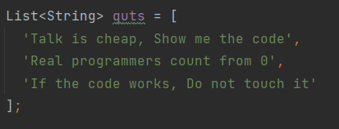

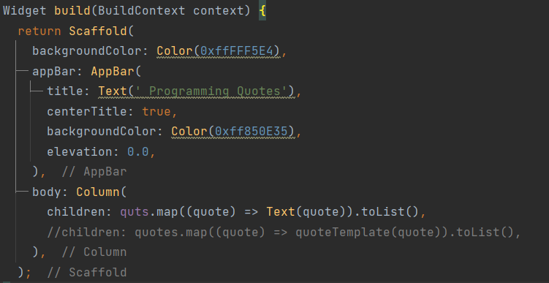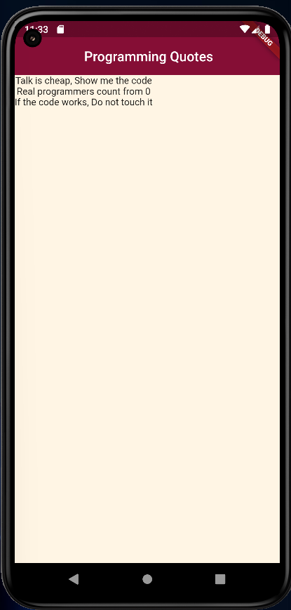

We will create one widget for diaplaying this quotes properly. Add below method inside class. And then call it for each item of the list.

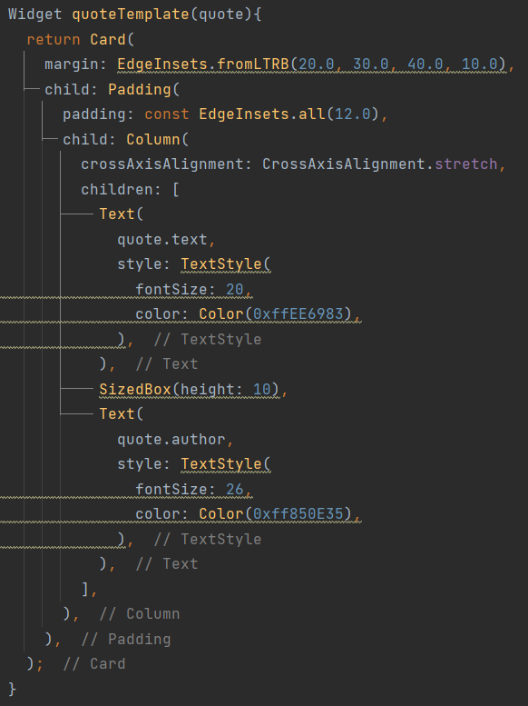

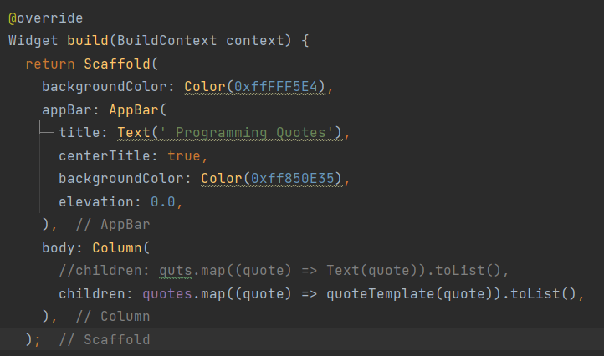

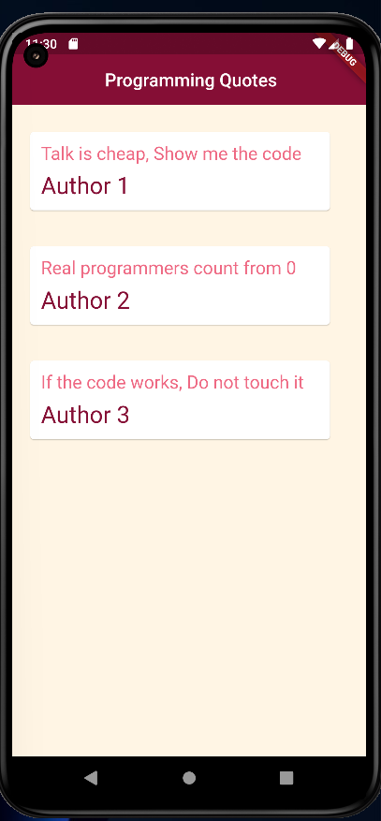

GitHub Repository Link:

<https://github.com/DhruviSherathiya/SmartDeviceProgramming/tree/main/Lab8>