Dharmsinh Desai University, Nadiad

Faculty of Technology

Department of Computer Engineering



**ASSIGNMENT 9**

Subject: Smart Device Programming

**Submitted To:**

Prof. Jignesh Shah

CE Department

**Submitted By:**

Sherathiya Dhruvi A.

Student ID:20CEUOS006

Roll No.: CE126

Now we will create one class Quote inside quote.dart file. And move out quote template widget to another file. So this will be better approach.

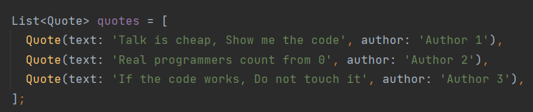

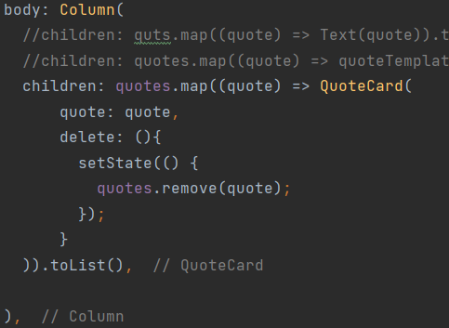

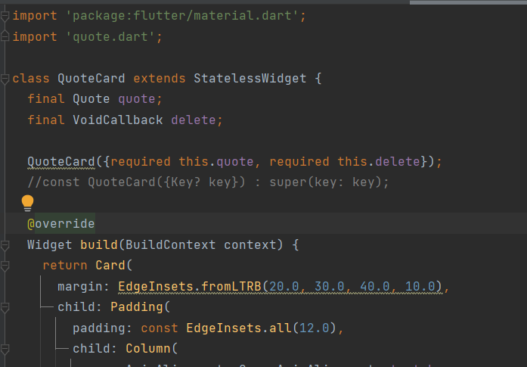All the designing code inside QuoteCard widget. And this is inside file quote_card.dart.

Here we can delete quotes by just press the button. Because onpress property of button is doing the task of removing quote. Anyway we can come back to our original state by just doing hot restart.

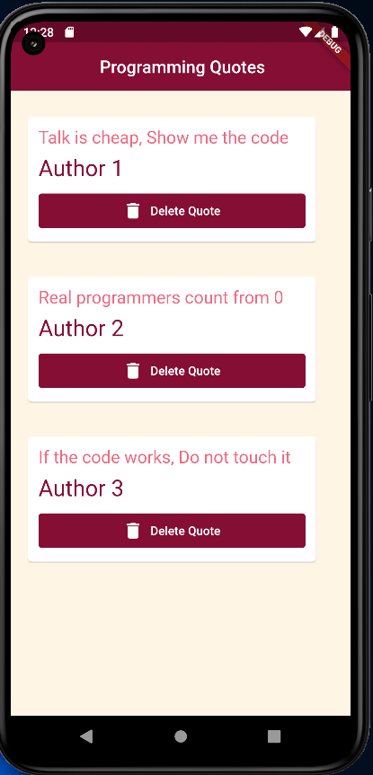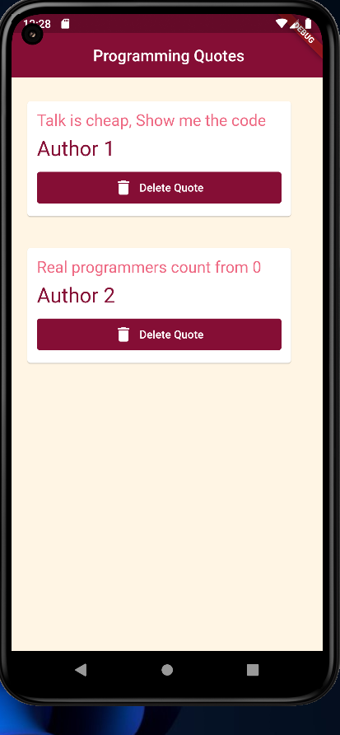a

Now we will see routing in flutter. Using this we can switch from one page to another. Write below code in main.dart file and create one file named home.dart, it is necessary to import it in main.dart.

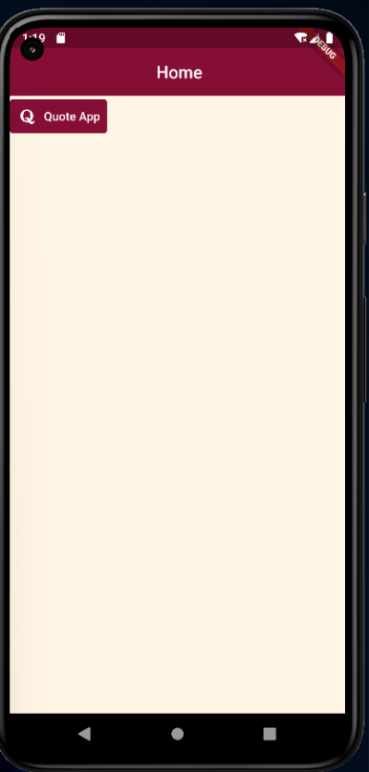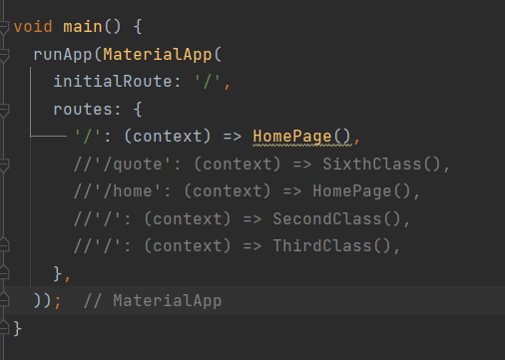

Set onpressed property of this button such that after clicking on that button we can move to our previous quote app.

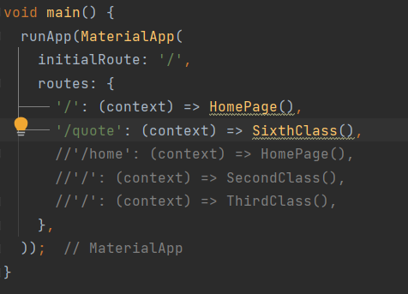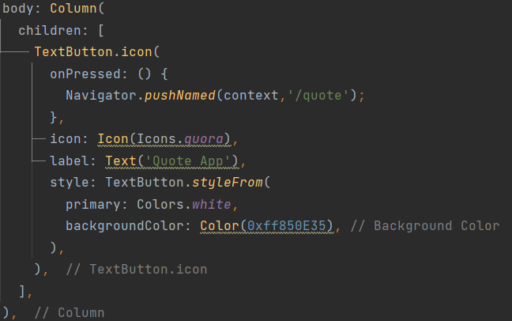

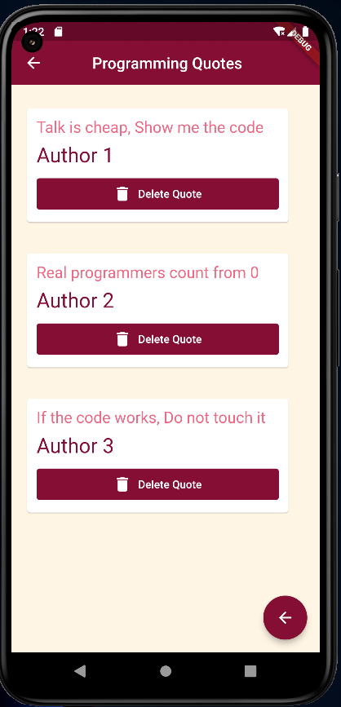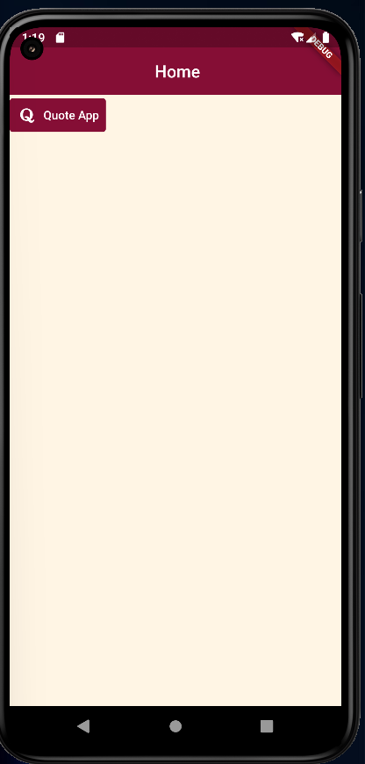

We can go back to home page by just pressing back arrow.

On click Quote App