PROJECT DOCUMENTATION REPORT
Visualizing Housing Market Trends

Project Title | Visualizing Housing Market Trends
Repository | https://github.com/Dhruvidi-Chundawat/Visualizing-Housing-Market-Trends
Tech Stack | Tableau, Python (Flask), JavaScript, CSS, HTML
Architecture | Frontend / Backend Separated
Report Date | March 6, 2026
Document Version | v2.0
Status | Completed

1. Executive Summary
This document provides comprehensive project documentation for the Visualizing Housing Market Trends project developed for ABC Company. The project has been restructured with a clean separation of frontend and backend concerns, delivering an improved, modular architecture compared to previous iterations.

Using Tableau for data visualization and a Python/Flask backend paired with a JavaScript-rich frontend, the solution enables ABC Company stakeholders to explore and interpret housing market dynamics through interactive dashboards embedded in a professional web application.

2. Project Overview

2.1 Project Information

Project Name | Visualizing Housing Market Trends
Repository URL | https://github.com/Dhruvidi-Chundawat/Visualizing-Housing-Market-Trends
Primary Analytics Tool | Tableau (House_Analytics.twbx)
Backend Framework | Python / Flask
Frontend | JavaScript, CSS, HTML
Architecture Pattern | Frontend / Backend Separated
Version Control | Git / GitHub
Document Version | v2.0

2.2 Project Objectives
The project addresses the following business challenges for ABC Company:
- Understand the key factors influencing house prices and sales trends.
- Analyze the correlation between years since renovation and total sales.
- Evaluate house age distribution across different renovation statuses.
- Identify patterns in housing features (bedrooms, bathrooms, floors) relative to house age.
- Deliver an interactive, browser-accessible dashboard with a decoupled, maintainable architecture.

2.3 Key Stakeholders
Real Estate Analysts | Primary consumers of visual insights; use data to identify pricing and renovation patterns.
Marketing Teams | Leverage housing trends to develop targeted buyer campaigns and positioning strategies.
Company Executives | Strategic decision-makers relying on high-level KPIs and trend summaries for competitive planning.

3. Technical Architecture

3.1 Architecture Overview
The new version of the project adopts a clean frontend/backend separation, improving maintainability, scalability, and developer experience. The system consists of three primary layers:
- Backend Layer: Python/Flask server handling API routes, data serving, and Tableau integration logic.
- Frontend Layer: JavaScript-driven UI with CSS styling and HTML templates for rich, interactive user experiences.
- Analytics Layer: Tableau workbook providing all data visualizations, dashboards, and storyboards.

3.2 Language & Technology Breakdown
The following table reflects the actual language composition of the repository as reported by GitHub:

Language / Technology | Usage % | Role in Project
CSS | 54.7% | Styling and visual design of the frontend web application.
JavaScript | 40.9% | Frontend interactivity, Tableau embed handling, and dynamic UI components.
Python | 2.9% | Flask backend — routing, API endpoints, and server-side logic.
HTML | 1.5% | Base page structure and Jinja2 template markup.

3.3 Full Technology Stack
Data Visualization | Tableau Desktop / Tableau Public
Backend | Python 3.x with Flask web framework
Frontend Scripting | JavaScript (ES6+)
Frontend Styling | CSS3 (54.7% of codebase)
Markup | HTML5
Version Control | Git / GitHub
Deployment | Tableau Public (embed) + Flask server

4. Repository Structure & File Documentation
The repository adopts a professional two-folder structure separating frontend and backend concerns:

File / Directory | Type | Description
backend/ | Directory | Contains all Python/Flask server-side code including routes, API logic, and data-serving endpoints for the web application.
frontend/ | Directory | Contains all client-side code including JavaScript modules, CSS stylesheets, and HTML templates for the user interface.
frontend/ (CSS) | CSS Stylesheets | Accounts for 54.7% of the codebase — handles all visual layout, theming, responsive design, and component styling.
frontend/ (JavaScript) | JS Modules | Accounts for 40.9% of the codebase — manages Tableau embed logic, UI interactivity, and dynamic page behavior.
frontend/ (HTML) | HTML Templates | Base page structure and template files rendered by the Flask backend via Jinja2 or served statically.
.gitignore | Git Config | Specifies files and directories excluded from version control (e.g., virtual environments, cache files, secrets).

5. Data Overview

5.1 Dataset Description
The project is powered by a pre-processed housing dataset (Transformed_Housing_Data2.csv) containing cleaned and transformed housing market records. Key metrics derived from the data include:
- Count of transformed housing data records
- Average sales price across all records
- Total basement square footage
- Sales distribution by years since renovation
- House age segmented by renovation status
- Feature-based distributions: bedrooms, bathrooms, and floors

5.2 Data Preparation Steps
- Collection of raw housing market data
- Connection of the dataset to Tableau for initial profiling
- Data type validation and field transformation
- Creation of calculated fields (house age, years since renovation, price bins)
- Filter and aggregation configuration for optimal dashboard performance

6. Visualization Scenarios
Four core visualization scenarios were developed within the Tableau workbook to address project objectives:

Scenario 1: Overall Data Overview
Visualization Type: Summary / KPI Cards
Presents high-level summary metrics including record count, average sales price, and total basement area. Provides stakeholders with a foundational snapshot of the dataset scale and key indicators.

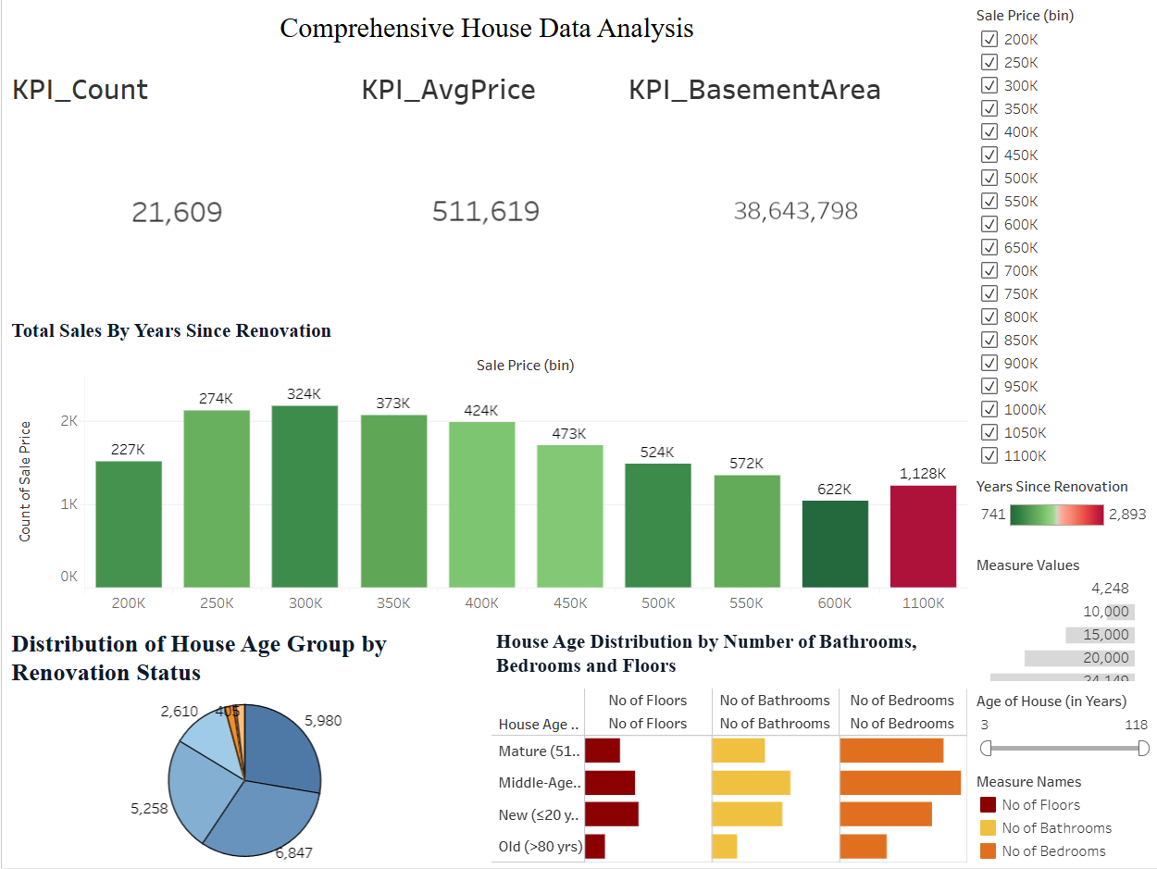

Scenario 2: Total Sales by Years Since Renovation
Visualization Type: Histogram
Illustrates the distribution of total sales against the number of years since a property was last renovated. Enables identification of how renovation recency correlates with price ranges and buyer demand patterns.

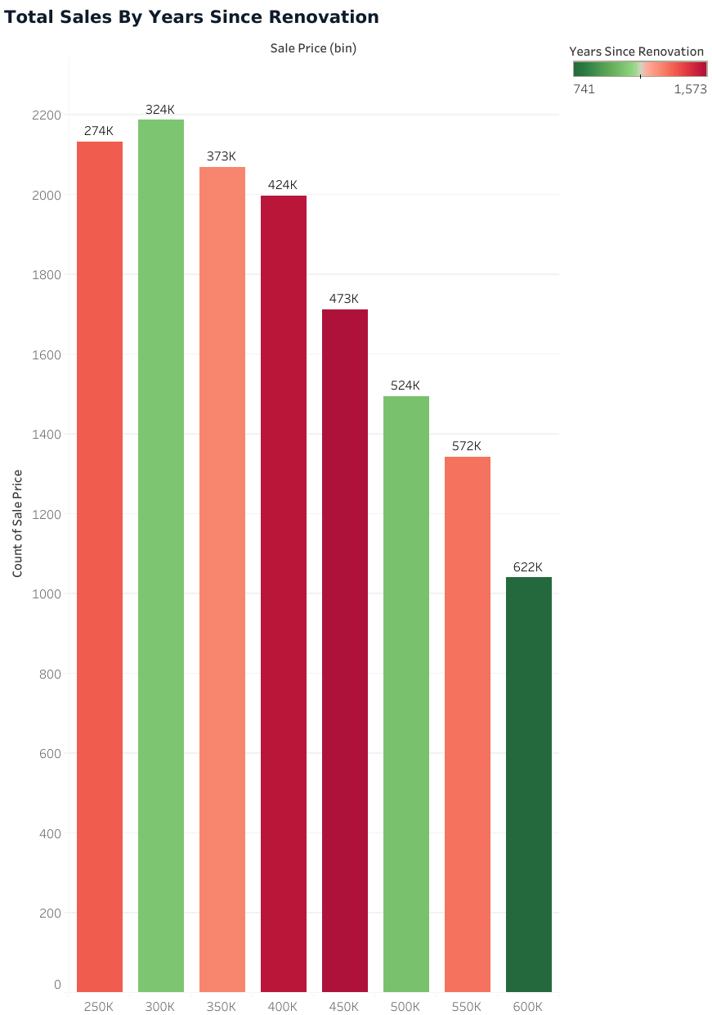

Scenario 3: Distribution of House Age by Renovation Status
Visualization Type: Pie Chart
Segments housing inventory by age group and renovation status, showing the proportion of renovated versus non-renovated properties across different age categories. Assists in assessing renovation prevalence within the housing inventory.

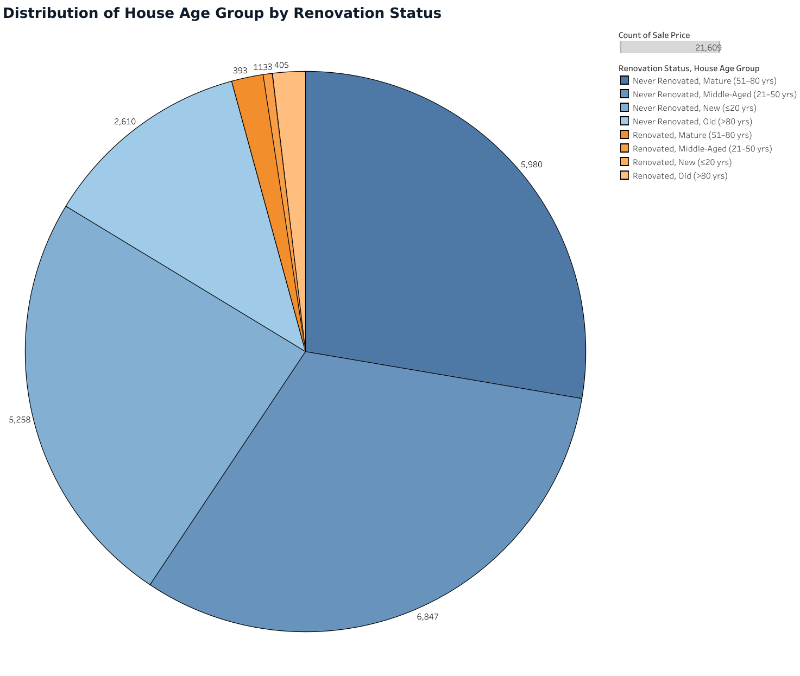

Scenario 4: House Age Distribution by Number of Bathrooms, Bedrooms, and Floors
Visualization Type: Grouped Bar Chart
Categorizes house age distribution by bedroom count, bathroom count, and number of floors — revealing how housing features vary across different age groups and helping stakeholders identify long-term preference trends.

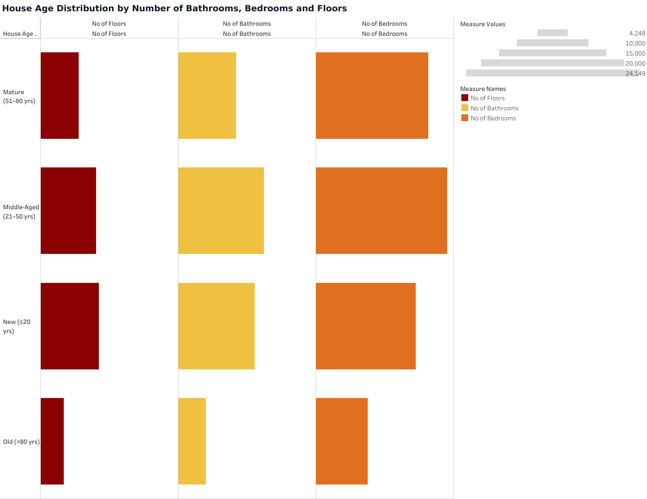

7. Project Activities & Deliverables
All planned project activities have been completed and are reflected in the repository. The table below documents the full project lifecycle:

# | Activity / Task | Description | Status
1 | Data Collection | Collected and sourced the housing dataset for analysis. | Completed
2 | Connect Data with Tableau | Established data source connection within the Tableau workbook. | Completed
3 | Data Preparation | Cleaned, transformed, and prepared data for accurate visualization. | Completed
4 | Data Visualizations | Created all 4 individual charts and graphs in Tableau. | Completed
5 | Dashboard Creation | Assembled visualizations into interactive Tableau dashboards. | Completed
6 | Dashboard Responsiveness | Configured responsive layouts for different screen sizes. | Completed
7 | Storyboard Creation | Built a Tableau story presenting insights in a narrative sequence. | Completed
8 | Performance Testing – Data Filters | Validated data filter behaviour and cross-view filtering. | Completed
9 | Performance Testing – Calculated Fields | Verified accuracy of all calculated fields in Tableau. | Completed
10 | Performance Testing – Visualizations | Confirmed completeness and correctness of all graphs. | Completed
11 | Web Integration (Publishing) | Published dashboards and storyboard to Tableau Public. | Completed
12 | Backend Development (Flask) | Developed Python/Flask backend with API routes in backend/ folder. | Completed
13 | Frontend Development (JS/CSS) | Built interactive frontend with JavaScript and CSS in frontend/ folder. | Completed
14 | Frontend–Backend Integration | Connected frontend UI to Flask backend and embedded Tableau views. | Completed
15 | Repository Restructure | Reorganised project into clean frontend/backend architecture on GitHub. | Completed

8. Web Integration

8.1 Backend (Flask — Python)
The backend/ directory contains the Flask web application responsible for:
- Defining URL routes and serving responses to frontend requests
- Providing API endpoints that supply data or configuration to the frontend
- Rendering or directing Jinja2 HTML templates
- Handling any server-side processing required before data is displayed

8.2 Frontend (JavaScript + CSS + HTML)
The frontend/ directory houses the complete client-side codebase:
- JavaScript (40.9%): Manages Tableau embed logic, event handling, dynamic content loading, and user interaction flows.
- CSS (54.7%): Provides all visual styling including layout, typography, colour theming, responsive breakpoints, and component design.
- HTML (1.5%): Base page templates providing document structure, rendered by Flask or served statically.

8.3 Tableau Public Embedding
The Tableau dashboards and storyboard are published to Tableau Public and embedded within the frontend pages via JavaScript embed code. This approach allows:
- Live, interactive visualizations accessible from any modern browser
- No Tableau Desktop licence required for end users
- Seamless integration within the ABC Company branded web interface

9. Performance Testing
Data Filters | All interactive filters tested for correct data segmentation and cross-view filter propagation.
Calculated Fields | All calculated fields reviewed for formula accuracy — including house age, renovation year derivation, and price binning logic.
Visualizations / Graphs | All four visualization scenarios verified for correctness, visual consistency, and completeness across dashboard and storyboard views.

10. Project Conclusion
The Visualizing Housing Market Trends project has been successfully completed for ABC Company. The project has been elevated with a professional frontend/backend architecture, an enriched JavaScript-driven UI, and comprehensive CSS styling — all version-controlled in the updated GitHub repository.

Key deliverables achieved:
- 4 Tableau visualization scenarios covering sales trends, renovation impact, and feature analysis.
- Interactive Tableau dashboards and storyboard published to Tableau Public.
- Modular Flask backend (backend/) for server-side routing and data serving.
- Rich JavaScript + CSS frontend (frontend/) for an engaging, responsive user experience.
- Full integration of Tableau embeds within the custom web application.

The complete project is version-controlled and available at:
https://github.com/Dhruvidi-Chundawat/Visualizing-Housing-Market-Trends

This document serves as the official project record and reference guide for all stakeholders involved in the Visualizing Housing Market Trends initiative.

